APPENDIX 2:

Figure 1: Reported POCUS use across Canada

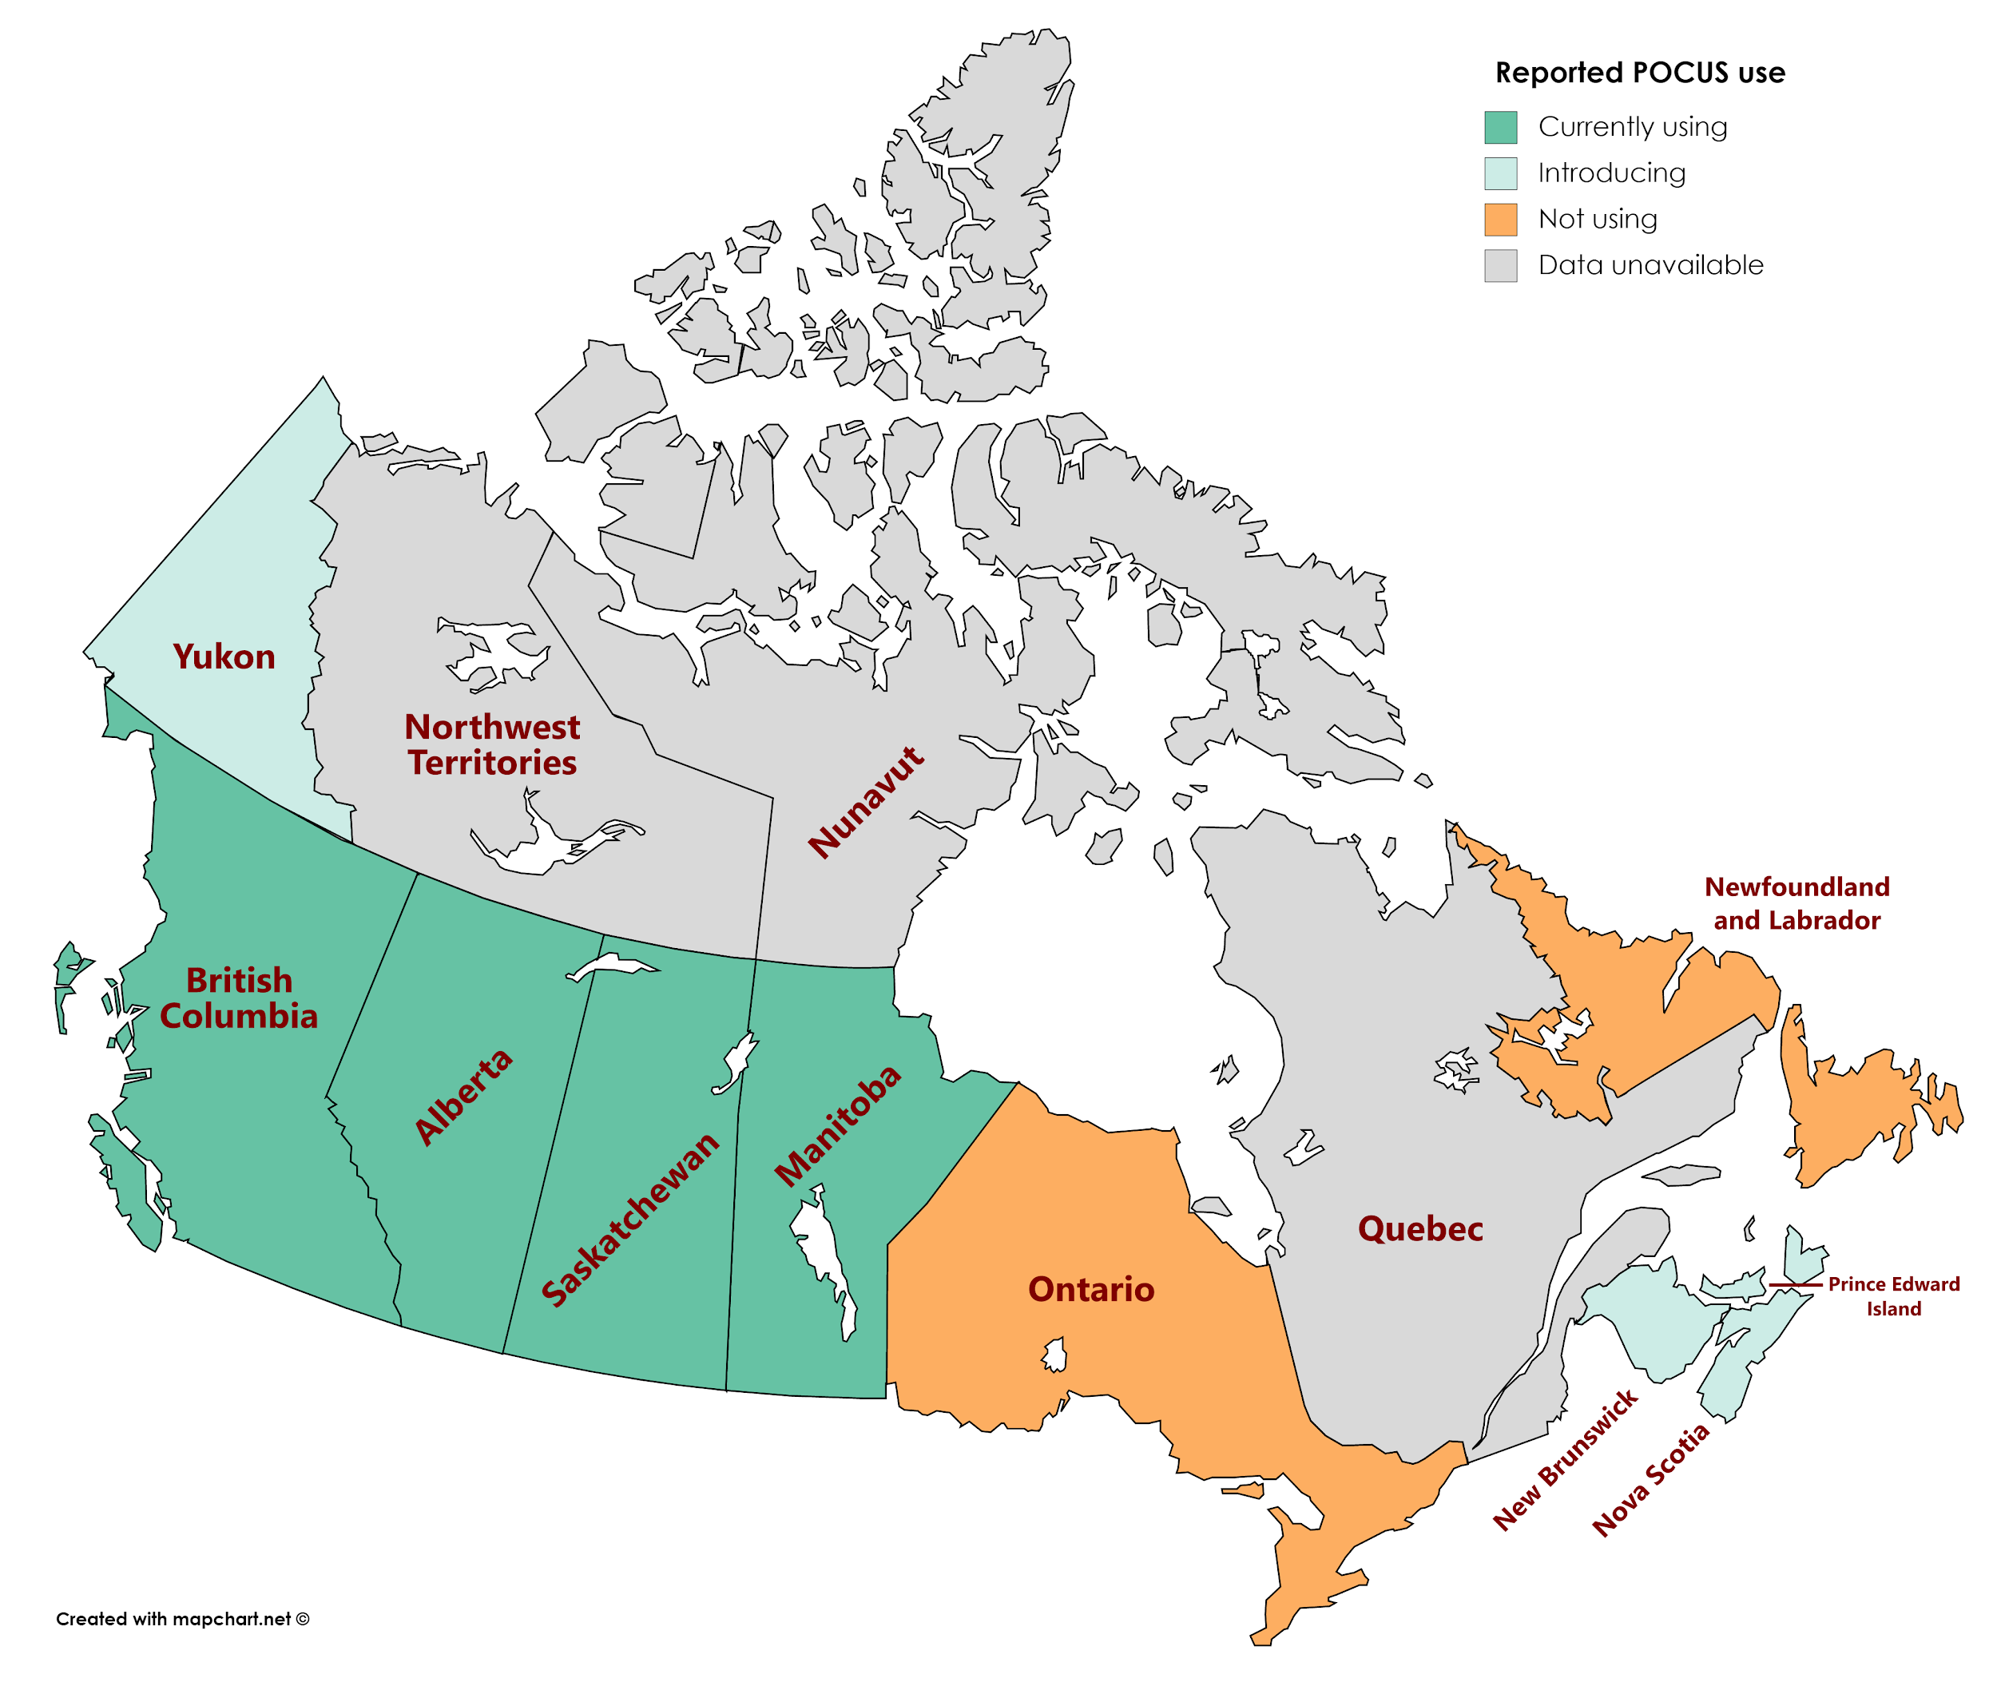

Figure 1: Geographical breakdown of AMS POCUS use in Canada.
*BC: POCUS use reported for all bases
*AB: POCUS use reported for 3/13 bases, 10/13 do not intend to utilize POCUS
*SK: POCUS use reported for 2/3 bases, 1/3 introducing

Figure 2: Barriers to POCUS

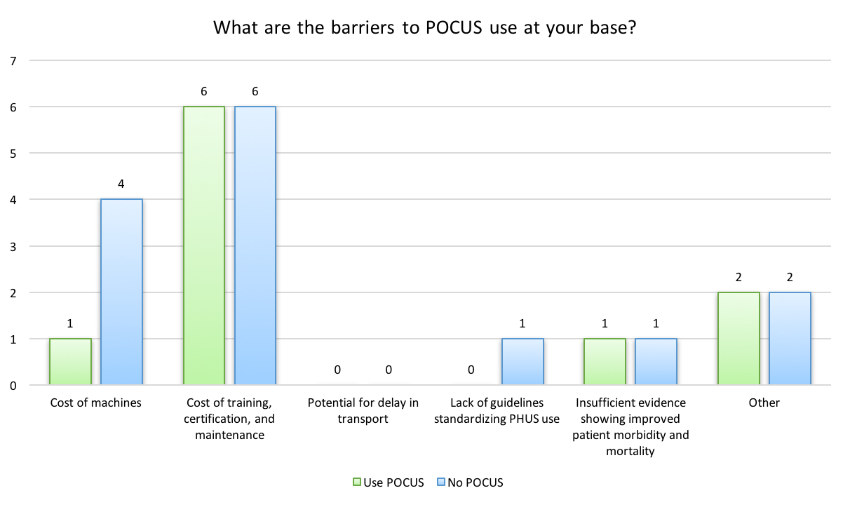
Figure 2: Barriers to POCUS use by presence of POCUS

Figure 3: Scan acquisition
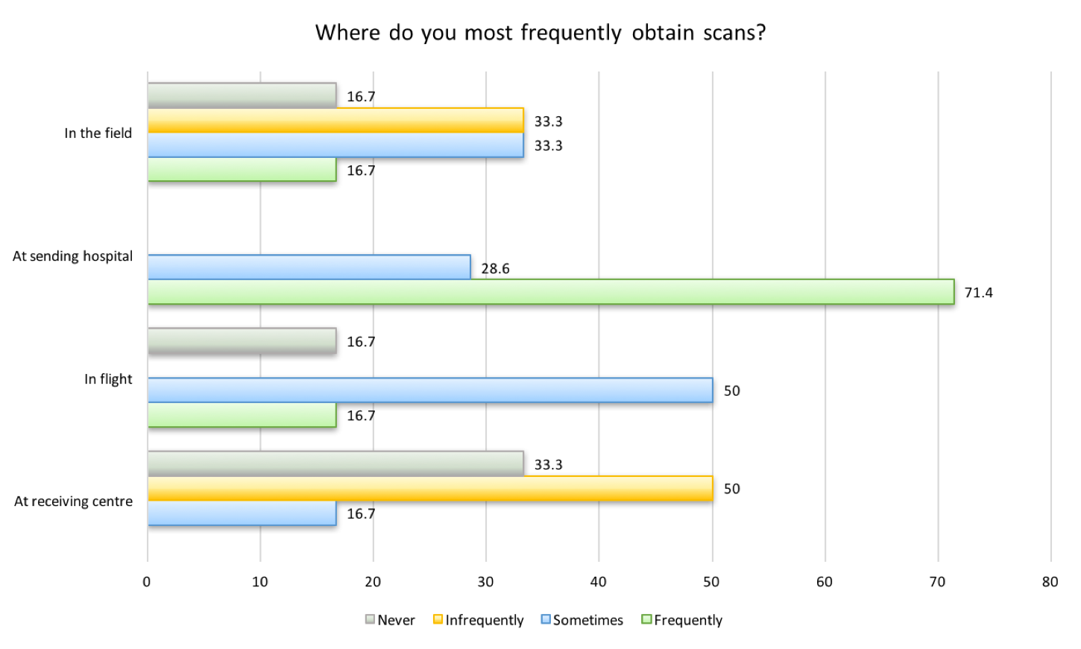
Figure 3: Frequency of scan acquisition location (by percentage of AMS directors responding)

Figure 4: POCUS use

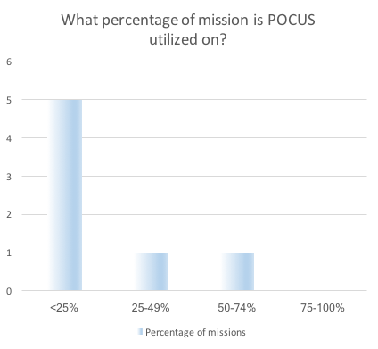
Figure 4: Percentage of missions with POCUS utilization(by number of directors utilizing POCUS)
*Unfortunately the design of the survey was such that we were not able to find out the exact percentage of POCUS use.

Figure 5: POCUS applications

Figure 5: Type of indications for which POCUS is used (by percentage of Directors responding).

Figure 6: Quality control measures
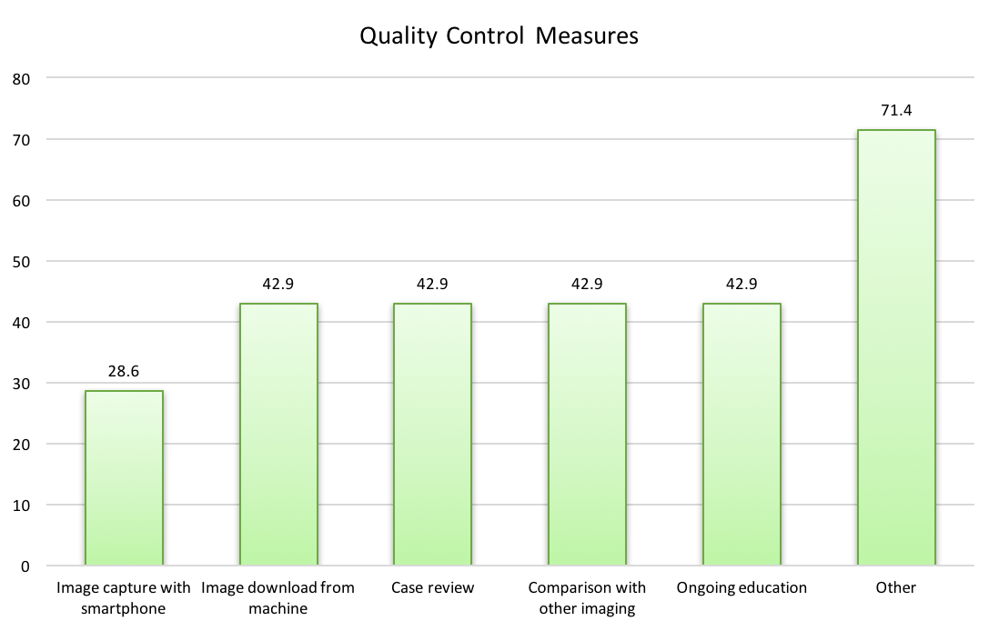
Figure 5: Type of quality control measures being used (by percentage of directors responding)

