Supplementary Table 1: Gait Speed & Grip Strength Test Protocols

|  |  |
| --- | --- |
| Test | Protocol |
| Grip Strength | A well-lit, unobstructed hallway in the ED was used for this test. With their feet just behind the 0-meter start line, patients were instructed to walk at a comfortable pace past the 5-meter finish line. Patients were permitted to use aids such as a cane or walker. A digital stopwatch was used to record the time from the first footfall after the start line to the first footfall after the finish line. This sequence was repeated 3 times, allowing sufficient time for recuperation between trials. The average of the 3 times was represented as a continuous variable in m/s. Secondarily, the time was dichotomized according to the pre-established cutoff of 6 s (0.83 m/s) validated in previous studies focusing on older cardiac patients(11). |
| Gait Speed | A Jamar© hand dynamometer was used and adjusted to fit each patient’s hand size. With their elbow flexed at 90 degrees, patients were instructed to squeeze the dynamometer with as much force as possible, being careful to squeeze only once for each measurement. As with the gait speed test, this sequence was repeated 3 times, once with each hand and a third time with the stronger hand. The strongest of the 3 trials was retained and represented as a continuous variable in kg. Secondarily, grip strength was dichotomized according to the pre-established cutoff of 30 kg for men and 20 kg for women validated in previous studies as above(11). |

Supplementary Table 2: Baseline Characteristics of Enrolled and Non-Enrolled Patients

|  |  |  |  |
| --- | --- | --- | --- |
|  | Enrolled Study Patients N=150 | Other Eligible Patients N=2010 | P-value |
| Age, years | 81.2 ± 4.9 | 82.0 ± 5.4 | 0.06 |
| Female sex | 51% | 53% | 0.55 |
| Married | 56% | 52% | 0.40 |
| Ambulance arrival | 13% | 17% | 0.20 |
| Triage level  1  2  3  4  5 | 0%  9%  35%  45%  11% | 0%  10%  38%  38%  14% | 0.45 |
| ED length of stay, hours | 7.6 ± 7.1 | 8.5 ± 12.4 | 0.20 |

Supplementary Figure 1: Distribution of Grip Strength in the ED Study Cohort

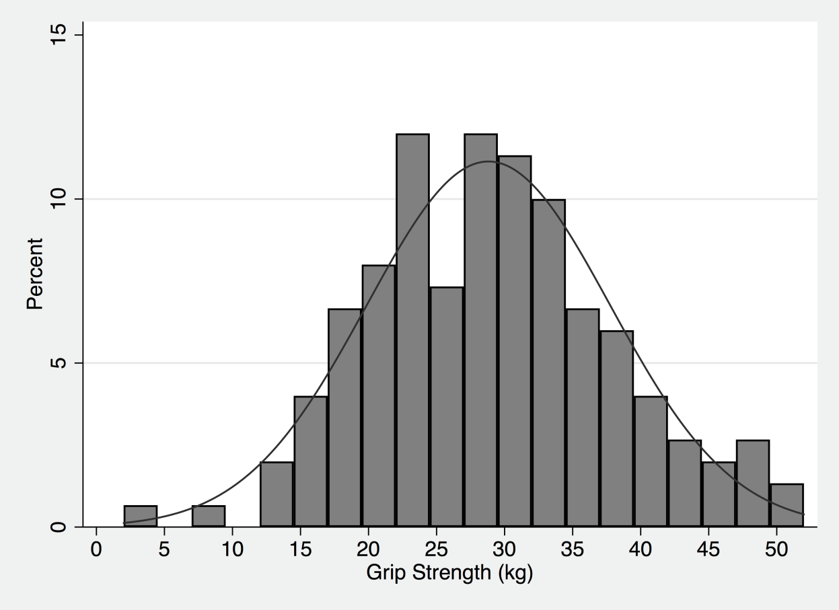

Caption: Grip strength was normally distributed with a mean of 28.8 ± 8.9 kilograms (kg). The mean grip strength for Canadian men and women aged 60-79 years in the community is 40 kg and 24 kg, respectively (https://www150.statcan.gc.ca/). The cutoff used to define weak grip strength in men and women in this study were <30 kg and <20 kg, respectively.

Supplementary Figure 2: Distribution of Gait Speed in the ED Study Cohort

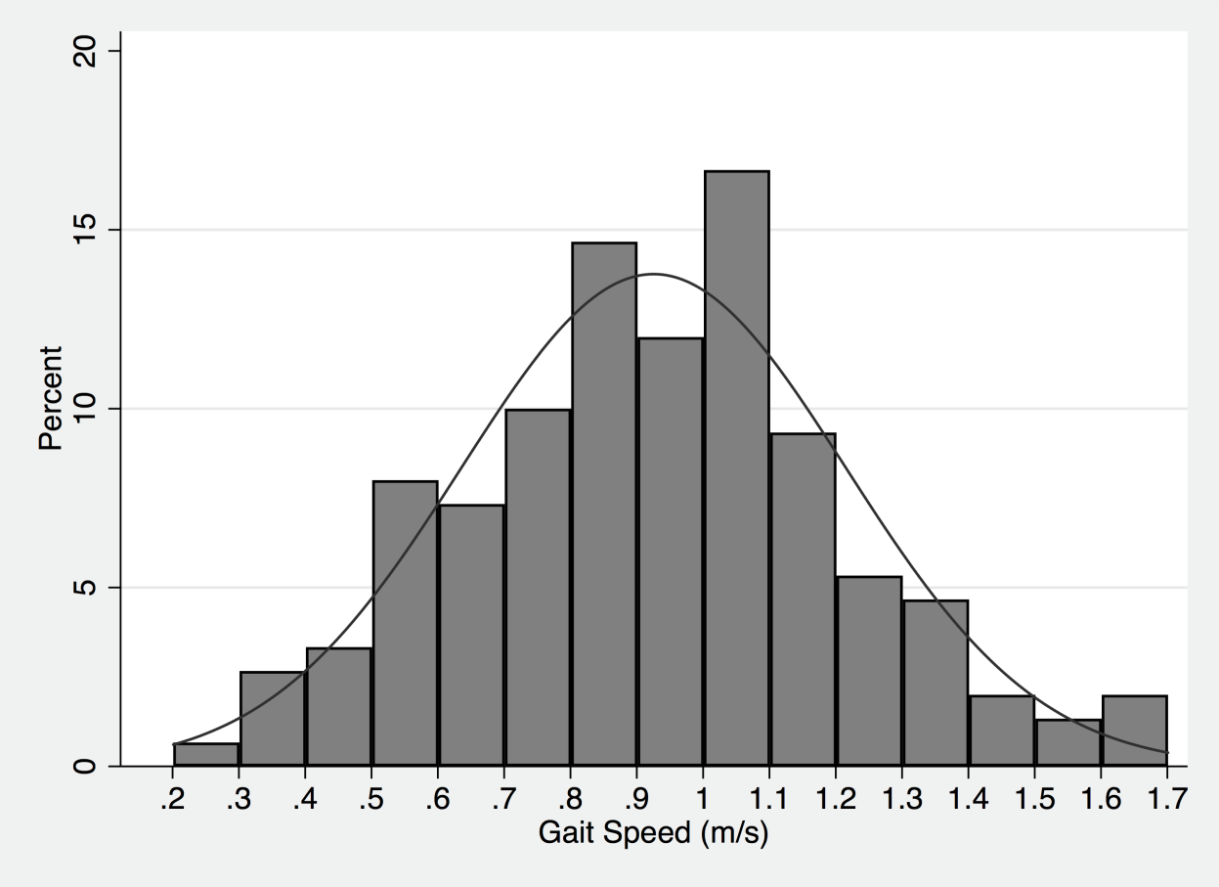

Caption: Gait speed was normally distributed with a mean of 0.93 ± 0.29 meters per second (m/s). The mean grip strength for Canadian men and women aged 60-79 years in the community is approximately 1.2 m/s. The cutoff used to defined slow gait speed in men and women in this study was <0.83 m/s.

Supplementary Figure 3: Prevalence of ADL/IADL Disabilities at Baseline and Follow-Up



Caption: Basic activities of daily living (ADL) of interest were: bathing, dressing, toileting, transferring in and out of bed, getting to the bathroom on time, and feeding oneself. Instrumental activities of daily living (IADL) of interest were: using transportation, using the telephone, shopping, preparing meals, doing housework, taking medicines, and managing finances.