Appendix:
Literature search key words and MeSH terms for Medline in Process, OVID Medline, Embase, PuvMed, CINAHL, and Cochrane Ccentral

1 exp Emergency Service, Hospital/ (62959)
2 Emergency Medical Services/ (37827)
3 (emergency adj2 (care or healthcare or department? or unit or units or room? or treatment?)).tw. (97941)
4 ("accident and emergency" or "accident & emergency" or emergency service?).tw. (9287)
5 (trauma adj2 (centre or centres or center or centers or department? or unit or units)).tw. (13961)
6 (triage adj2 (centre or centres or center or centers or department? or unit or units)).tw. (474)
7 (emergency adj2 visit?).tw. (8311)
8 (urgent adj2 (care or healthcare or health care)).tw. (1808)
9 ((semiurgent or semi-urgent or nonemergen$ or non-emergen$) adj2 (treatment? or care or visit?)).tw. (280)
10 ((emergency or non-emergency or nonemergency or urgent or non-urgent or nonurgent or semi-urgent or semiurgent) adj2 patient?).tw. (10731)
11 triage/ (9688)
12 (intensive adj3 care).tw. (116996)
13 Critical Care/ (46120)
14 (emergency adj2 ward*).tw. (1191)
15 Emergencies/ (38192)
16 or/1-15 (338601)
17 exp Syncope/ (12019)
18 syncop*.tw. (15677)
19 (drop adj2 attack*).tw. (429)
20 or/17-19 (20160)
21 16 and 20 (1284)
22 exp Adult/ or (adult or adults or adulthood or middle age or middle aged or elderly or senior or seniors or man or men or woman or women).tw. (7471127)
23 Adolescent/ or exp Child/ or exp Infant/ or Pediatrics/ or (child or children or childhood or infant or infants or baby or babies or newborn or newborns or neonate or neonatal or neonates or preemie or preemies or infancy or paediatric or pediatric or girl or girls or boy or boys or kid or kids or teen or teens or teenage or teenager or teenagers or youngster or youngsters or youth or youths or adolescent or adolescents or adolescence or preadolescent or preadolescence or pre adolescent or pre adolescence or preschooler or school age or school aged or schoolchildren).tw. (3781737)
24 22 not 23 (5641173)
25 21 and 24 (695)

Appendix Table 1: Summary of outcomes day 31 – day 365
Author | Length of Follow-Up (Months | Mortality  N(%) | Other Outcomes N(%)*
Costantino, 2008 | 12 | 40 (6.0%) | NR
Gomes, 2016 | 12 | 12 (3.1%) | Device insertion 5 (1.3%)
Perez-Rodon, 2014 | 12 | 33 (6.3%) | NR
Quinn, 2008⁺ | 18 | 91 (6.2%) | NR
Reed, 2011 | 12 | 33 (3.2%) | Device insertion 13 (1.25%)
Reed, 2012 | 12 | 33 (9.8%) | NR
Shiyovich, 2008 | 12 | 24 (6.7%) | NR
Silva, 2016 | 18 | 5 (4.6%) | NR
Ungar, 2015 | 12 | 16 (6.0%) | Recurrence of syncope 31 (11.6%)
Numeroso | 12 | 10 (%5.0) | NR
Sandu, 2018 | 12 | 1978.0 (3.82%) | NR

*Other outcomes included: Pacemaker insertion, implantable cardioverter-defibrillator, new arrhythmia, and recurrence of syncope requiring admission
NR= Not recorded
+ Study had follow-up >12 months however 12-month data could be extracted

Appendix Table 2: Summary of outcomes >12 months

NR= Not recorded

Author | Mean Length of Follow-Up (Months) | Morality N(%) | Other Outcomes N (%)
Aggarwal, 2011 | 30 | 58 (16.7%) | NR
Baron-Esquivias, 2017 | 38 | 26 (8.00%) | Recurrence of syncope requiring admission 60 (18.6%)
Del Rosso, 2008 | 24 | 32 (8.83%) | NR
Du Fay De Lavallaz, 2018 | 24 | 227 (15.2%) | NR
Martin, 1997 | 36 | 39 (15.0%) | Arrhythmia 72 (11.5%)
Ruwald, 2013 | 50 | 7761 (21.0%) | NR
Shen, 2004 | 18 | 5 (4.85%) | Recurrence of syncope requiring admission 9 (6.80%); device insertion 12 (11.7%); arrhythmia 9 (6.80%)
Quinn, 2008 | 18 | 112 (7.6%) | NR

Appendix Figure 1: Forest Plot for Meta-analyzed Data Day 31- Day 365
Appendix Figure 1a: Forest Plot for Mortality for Day 31 – Day 365

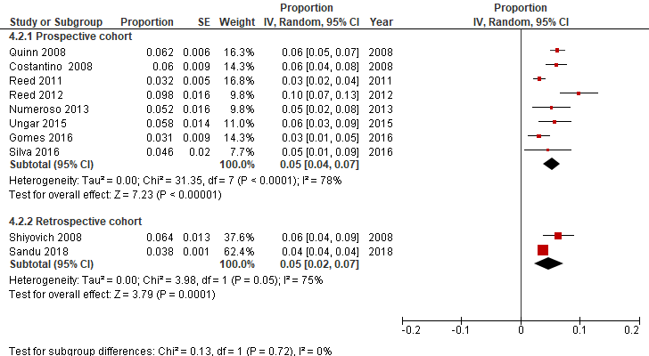

Appendix Figure 1b: Forest Plot for Device Insertion for Day 31 – Day 365
