Web appendix. Figure 3. Box-plot for the bladder width according to success or failure in the procedure for three age groups.

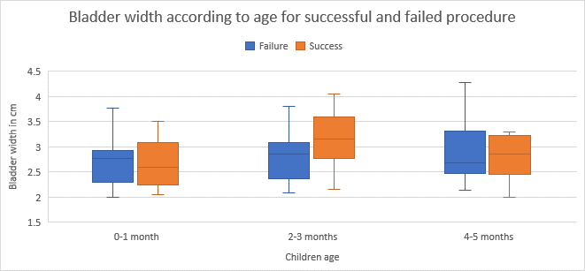

Web appendix Table 3. Predictors of Success
Characteristics | Success n=103(%) | Failure  n=98 (%) | OR | P-value
Age group  - 0-29 days  - 30-59 days  - 60-89 days  - > 89 days | 15 (15)  45 (44)  25 (24)  18 (17) | 10 (10)  23 (23)  32 (33)  33 (34) | 2.75 (1.03-7.36)  3.59 (1.67-7.69)  1.43 (0.66-3.12)  ref | 0.04  0.001  0.37  ref
Sex male | 57 (55) | 47 (48) | 1.35 (0.77-2.34) | 0.30
Last urine void < 1 hour | 62 (60) | 66 (67) | 0.72 (0.41-1.34) | 0.32
Low oral intake | 52 (50) | 58 (59) | 0.65 (0.37-1.14) | 0.14

