Appendix 1: Clinical Opiate Withdrawal Scale

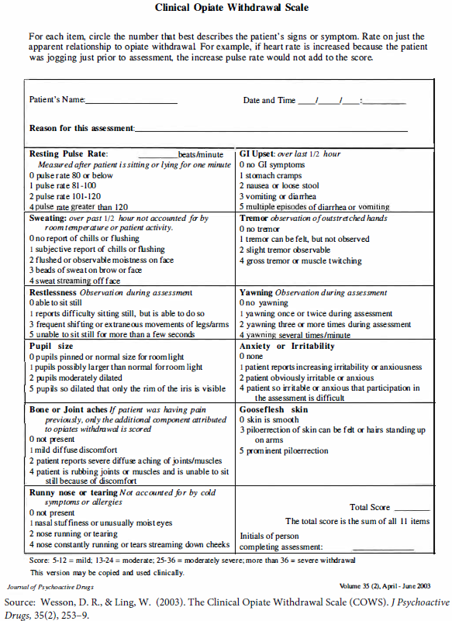
Appendix 2: Treatment algorithm

Patients assessed for eligibility in the emergency department:
Meets DSM-5 criteria for opioid use disorder
In mild opioid withdrawal (Clinical Opiate Withdrawal Scale > 5)
No opioid use in previous 12 hours
Not on methadone
Consents to receiving buprenorphine/naloxone treatment
Initiate buprenorphine/naloxone in the emergency department:
Provide 2-4 mg sublingually
Dose is witnessed by nurse to ensure medication has fully dissolved

Reassess in 1-2 hours using the Clinical Opiate Withdrawal Scale
If still in opioid withdrawal (Clinical Opiate Withdrawal Scale > 5), administer another dose of buprenorphine/naloxone (2-4 mg sublingually)
Maximum dose in emergency department: 8 mg SL

Discharge from emergency department with:
Patient information package on opioid withdrawal symptoms, options for managing opioid withdrawal, contact information for clinics prescribing methadone and buprenorphine/naloxone, and information regarding outpatient case management programs
Patient instructed to go to rapid access addiction clinic the next morning to make an appointment (same day appointments available) and to receive next dose of buprenorphine/naloxone

Information faxed to community-based rapid access addiction clinic (RAAC) before discharge from the emergency department:
Prescription for up to 3 daily observed doses of buprenorphine/naloxone to bridge patient until seen at RAAC
Request for pharmacy to provide take-home naloxone, including instructions for use
Referral to RAAC for assessment and management

Patient attends RAAC appointment

Appendix 3: Chart selection for review

Generated list of all emergency department patients triaged with presenting complaint of substance withdrawal between April 2017 – December 2017 at Lakeridge Health
Charts were reviewed for patients presenting specifically in opioid withdrawal
Charts were reviewed for patients offered education packages on opioid
withdrawal, treated with buprenorphine/naloxone in the emergency department,
and referred to the outpatient RAAC

Charts were reviewed for patients seen at the outpatient RAAC that
were referred from the emergency department
- Follow-up time and status at 6 months post-referral

