Appendix 1
Figure 1: Pre-Trial Questionnaire

Figure 2: Post trial questionnaire

Appendix 2

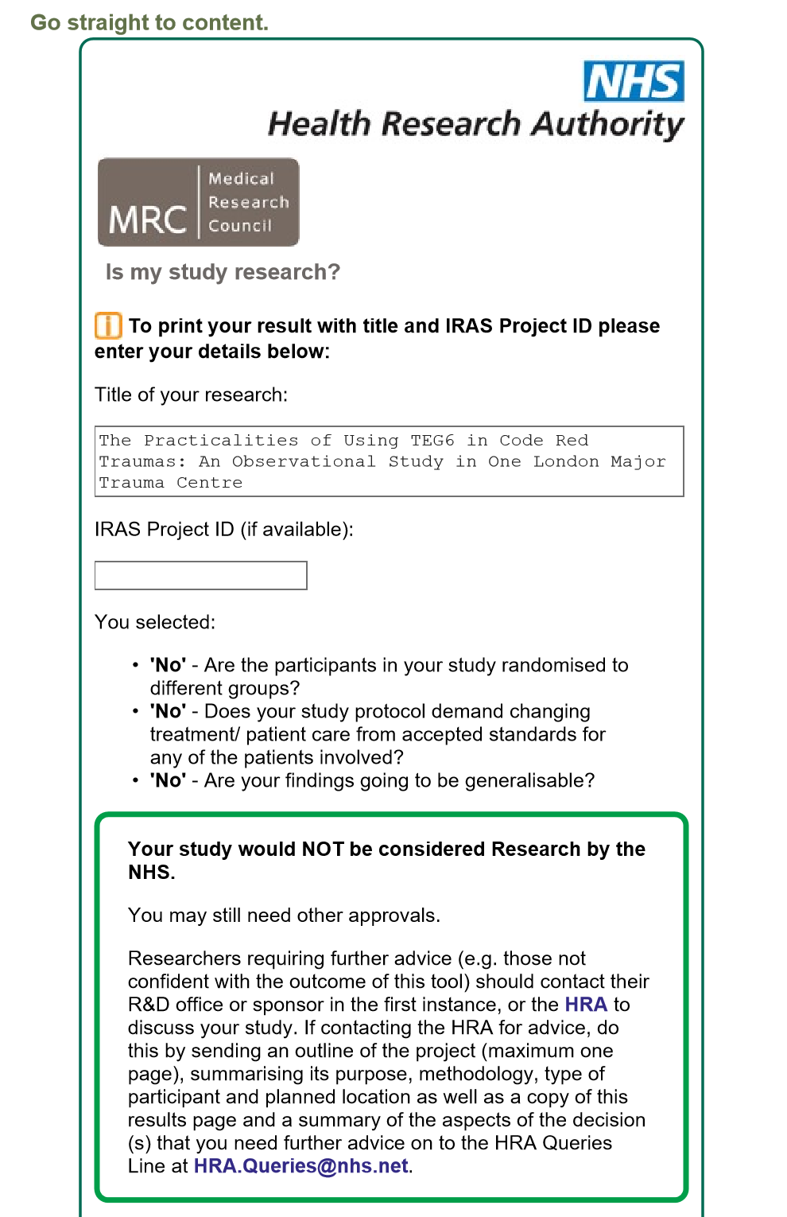

Appendix 3
Table 1: Results of TEG-6 run during the trial period on Code Red Patients
Patient | Sex | Age | Injury Severity Score | Number of TEGS run | TEG results | INR result | Blood components given* | On review of TEG results by consultant haematologist following trial, could blood product administration have been altered at the time of the TEG? | Patient Outcome
1 | F | 80 | 22 | 1 | Normal | 1.0 | 3 PRC/2 FFP | No | Survived
2 | M | 28 | 9 | 1 | Mildly hypercoagulable | 1.1 | Not available | No | Survived
3 | M | 51 | 17 | 1 | Normal | 0.9 | 0 | No | Survived
4 | M | 94 | 29 | 1 | Test failed | 1.0 | 4 PRC/4FFP | No | Deceased
5 | M | 82 | N/A¶ | 1 | Normal | NO RESULTS | 2 PRC | No | Deceased
6 | M | 26 | Awaiting | 1 | Normal | 0.9 | 1 PRC | No | Survived
7 | F | 92 | 34 | 1 | Mildly hypercoagulable | 1.0 | 1 PRC | No | Deceased
8 | F | 86 | 22 | 1 | Mild coagulopathy | 1.1 | 4 PRC/2 FFP | Advise plasma | Deceased
9 | M | 16 | 35 | 1 | Coagulopathic | 1.4 | 4 PRC/4FFP | Advise fibrinogen replacement | Survived
10 | M | 46 | 9 | 1 | Normal | 1.1 (initial result was no result) | 3PRC/3FFP | No | Deceased
11 | M | 33 | 43 | 2 | Coagulopathic | 1.2 | 4 PRC/3FFP/1 Plts/2 cryo | Advise further fibrinogen replacement** | Deceased
12 | M | 61 | 66 | 1 | Coagulopathic | 1.3 | 4PRC/4FFP | Advise fibrinogen replacement | Deceased
PRC = packed red cells; FFP = fresh frozen plasma; cryo = cryoprecipitate; Plts = platelets
*Blood components administered within the emergency department. Some patients went on to have further components.
¶Patient had a road traffic accident secondary to abdominal aortic aneurysm so no severity of trauma score. No blood results formally taken.
**Patient’s blood components were guided by results of first TEG. Second TEG result suggested fibrinogen deficiency.

