SUPPLEMENTAL FIGURES
Supplemental Figure 1: REMINDER Intervention

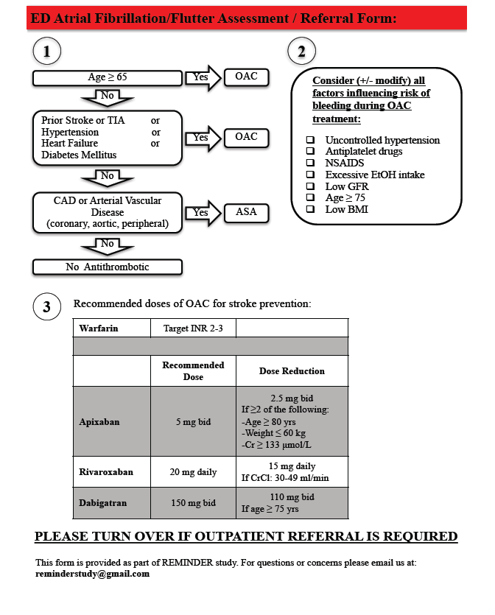

Supplemental Figure 2: REMINDER Intervention Referral Form

Supplemental Table 1: Characteristics of patients with AF/AFL discharged from the Emergency Department, stratified by ED-Intervention Sites vs. ED-Control Sites

 | ED-Intervention  n=1,921 | ED-Control  n=1,600 | P-value
Age ± SD, years | 73 ± 15 | 75 ± 15 | <0.001
Female – No. (%) | 856 (44.5) | 720 (45.0) | 0.8
Heart Failure – No. (%) | 484 (25.2) | 432 (27.0) | 0.2
Hypertension – No. (%) | 904 (47.1) | 819 (51.2) | 0.02
Diabetes – No. (%) | 335 (17.4) | 260 (16.3) | 0.4
Ischemic Stroke – No. (%) | 262 (13.6) | 218 (13.6) | 0.9
CHADS65 (mean ± SD) | 1.9 ± 1.3 | 2.0 ± 1.3 | 0.003
0 – No. (%) | 310 (16.1) | 199 (12.4) | 0.01
1 – No. (%) | 479 (24.9) | 378(23.6)
2 – No. (%) | 570 (29.7) | 519 (32.4)
3 – No. (%) | 333 (17.3) | 301 (18.8)
≥ 4 – No. (%) | 229 (11.9) | 203 (12.7)
Valvular AF – No. (%) | 56 (2.9) | 4 (1.5) | 0.01
AF as primary diagnosis (%) | 699 (36.4) | 543 (33.9) | 0.1
Hemorrhagic Stroke (%) | 21 (1.1) | 20 (1.3) | 0.7

