Appendix 1 – Scenarios

Scenario 1 involved a 25-year-old male patient who was discovered unresponsive by his spouse after an apparent multi-drug overdose. The patient presented in an obtunded state with slow and ineffective respirations and evidence of frank hypoxia (e.g., initial oxygen saturation of 85%). Bag-valve mask ventilation was in progress and was ineffective at achieving ventilation.

Scenario 2 involved a 16-year-old male patient who was discovered unresponsive at the bottom of a residential swimming pool, the victim of an apparent drowning. Bystanders promptly rescued the patient and performed cardiopulmonary resuscitation, achieving a return of spontaneous circulation, thus when the patient was presented to the participants, he was in an unconscious state with ineffective respirations.

In both scenarios, the patient’s vital signs were scripted to deteriorate every three minutes until a patent airway was established (i.e., surgical airway in Scenario 1; successful advanced airway placement in Scenario 2). Failure to establish a patent airway by 12 minutes resulted in cardiac arrest. For both scenarios, the participant was informed that they were providing advanced life support “back up” to a basic life support paramedic crew that was already on scene and had loaded the patient into their ambulance. Thus the participant had two paramedics (played by trained student confederates) to assist with patient care. Where elements of the scenario were difficult to simulate, these details were provided to the participant by the confederates (e.g., “there is cyanosis”) who were in contact with members of the research team via radio headset. All scenarios were audio and video recorded from the moment of patient contact until completion (defined as the point at which a patent airway was achieved or 15-minutes had elapsed; whichever occurred first).

Appendix 2 – Global Rating Scale – Front Page
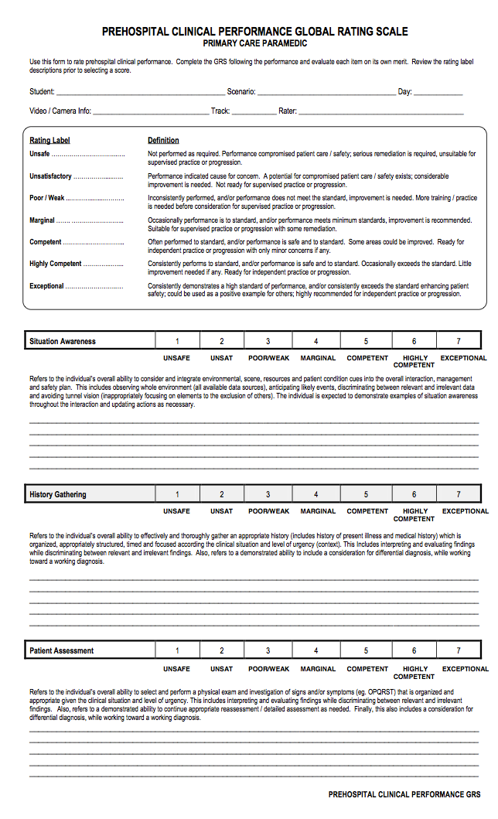

Appendix 2 – Global Rating Scale – Back Page

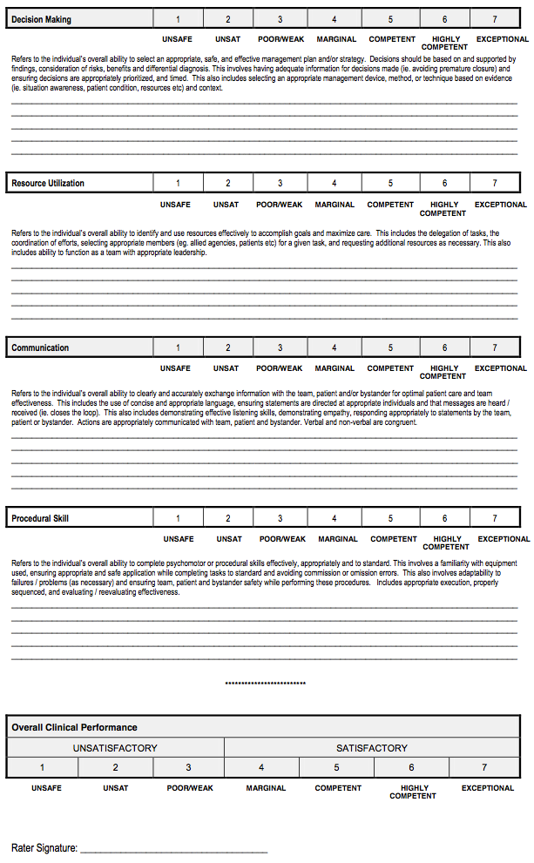

Appendix 3 – Scenario Content Validity Check

As a manipulation check, we evaluated whether the cases we created differed in difficulty and whether we had achieved a reasonable degree of realism to promote internal and external validity. A paired sample t-test revealed significantly lower mean GRS scores for Scenario 1 compared to Scenario 2 (mean (SD) = 4.2 (1.01) v. 4.9 (1.22) respectively; t(29) = 2.9, p = 0.007, d = 0.53). Similarly, more errors were committee in Scenario 1 compared to Scenario 2 (mean (SD) = 5.7 (2.56) v. 2.9 (2.18) respectively; t(29) = 5.7, p < 0.001, d = 1.1). And finally, the time to achieve effective ventilation was longer for Scenario 1 (mean (SD) = 11:55 (3:47) minutes v. 6:58 (3:03); t(29)=6.76, p<.001, d=1.30). These data confirmed that, as expected, the “can’t intubate, can’t ventilate” scenario was more challenging than the scenario in which intubation was possible. To assess the perceived realism of the simulations, we asked each participant to complete a questionnaire rating the realism on a 5-point Likert scale (1 = not at all realistic; 5 = highly realistic). The average score for Scenario 1 was 4.0 (SD = 0.74) and the average score for Scenario 2 was 4.5 (SD = 0.74), leading us to believe that the scenarios conveyed a high degree of physical, conceptual and emotional realism.

