Supplementary file

Table S1. Summary of the EST-SSRs from transcriptome sequences of C. fascicularis
Repeat motifs | Number of repeats |  |  |  |  |  |  | Sum of No. | Percentage (%)
 | 5 | 6 | 7 | 8 | 9 | 10 | 11
di-repeats | 0 | 5208 | 3849 | 4533 | 5251 | 2463 | 433 | 21742 | 71.44
Tri-repeats | 3705 | 2454 | 1511 | 69 | 3 | 4 | 0 | 7754 | 25.48
Tetra-repeats | 634 | 85 | 2 | 3 | 0 | 0 | 1 | 725 | 2.38
Penta-repeats | 67 | 8 | 1 | 6 | 3 | 0 | 0 | 85 | 0.28
Hexa-repeats | 55 | 44 | 17 | 6 | 5 | 2 | 0 | 129 | 0.42

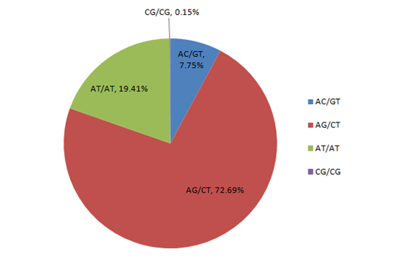
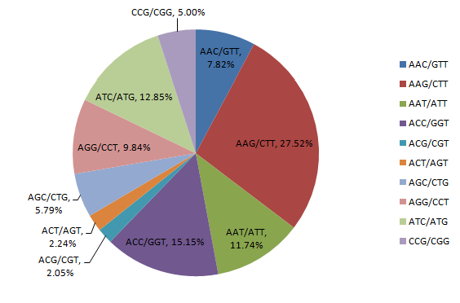
Fig. S1. The percentage of different motif repeats in EST-SSR loci

