Table S1. List of SSR primers used in the study with respective repeat motif and chromosome location
Primers name | Chromosomal Location | Repeated Motif
wmc120 | 1A | (CA)8, or (GA)14, or( GT)8,
wmc312 | 1A | (GA)
wmc619 | 1B | -
wmc128 | 1B | [GT]16 [GA]10
wmc31 | 1B | (GA)11, (GT)19,
wmc339 | 1D | (GA)8
cfd92 | 1D | (CT)21(A)19
gwm642 | 1D | GT)14
wmc407 | 2A | (GA)16
wmc477 | 2B | (GT)16
gwm388 | 2BL | CT)4(CA)11(CA)12
wmc601 | 2D | -
wmc11 | 3A | -
wmc532 | 3A | (GA)5, GA)11
gwm135 | 3B | (GA)20
wmc231 | 3B | (GA)20, (GT)8
gwm102 | 3B | (GA)10,
wmc219 | 4A | CA)57
wmc96 | 4A | (CA)29
wmc313 | 4AL | (CA)18
wmc657 | 4B | -
wmc48 | 4B, 4D | -
wmc327 | 5A | (GT)25
gwm182 | 5D/6B | (CT)18
wmc233 | 5D | (CA)11, (CA)14, (GT)23
wmc163 | 6A | (GT)8
wmc596 | 7A | -
wmc107 | 7A | (GT)1
wmc364 | 7B, 7D | (CA)18

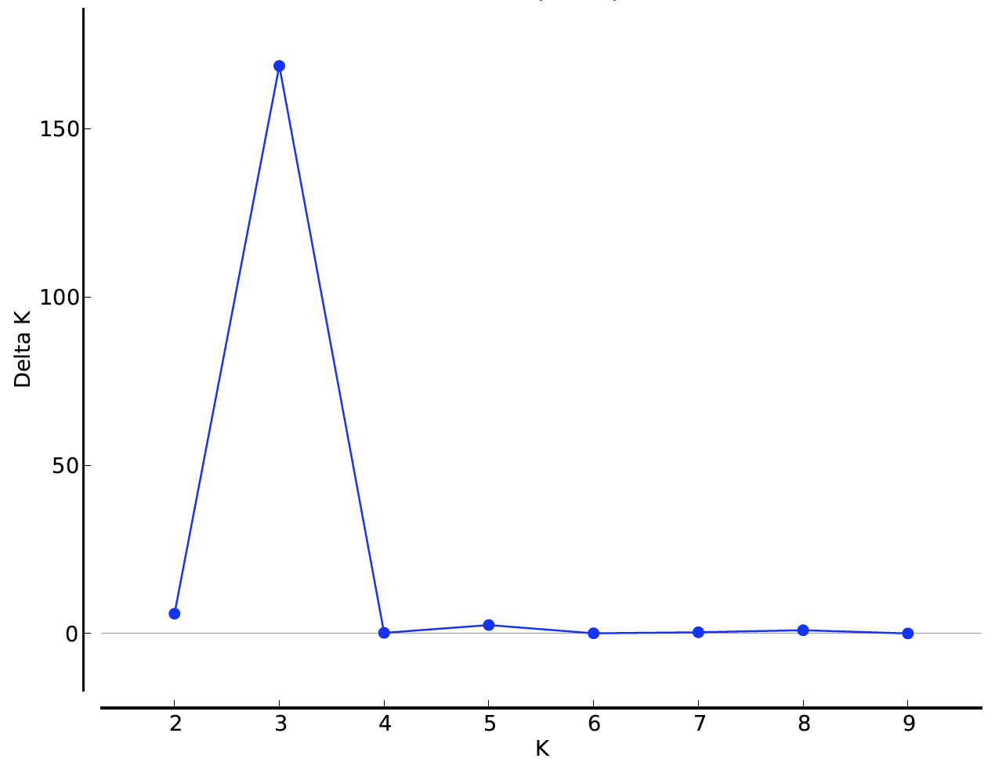
Figure S1. Population genetic structure of the estimated Delta K values for true K. The highest ΔK value was at three according to 29 SSR primers.

