Table S1. Range and mean of different morphological traits in 169 BILs of maize under artificially inoculated and control environment
S. No. | Characters | Inoculated environment (E₁) |  | Control environment (E₂) |  | DI-103  (E₁) | DI-103  (E₂) | Teosinte  (E₁) | Teosinte  (E₂)
 |  | Range | Mean | Range | Mean | Mean | Mean | Mean | Mean
 | DA | 45-67 | 56.85 | 47-68 | 58.88 | 52.5 | 54.5 | 81.5 | 81.5
 | DS | 43-66 | 57.17 | 44-67 | 58.25 | 55.0 | 56.5 | 78.5 | 78.0
 | ASI | -5 – 4 | 2.35 | -4 – 5 | 2.46 | 2.5 | 2.0 | -3.5 | -3.0
 | FLL (cm) | 9.9 - 59.45 | 30.76 | 9.4-60.88 | 33.73 | 29.51 | 30.78 | 26.00 | 23.75
 | FLW (cm) | 1.01- 6.56 | 3.92 | 2.8-7.6 | 4.53 | 4.53 | 4.66 | 3.88 | 3.5
 | PH (cm) | 90.6-248 | 167.39 | 88-229.33 | 164.00 | 97.20 | 97.39 | 241.33 | 242.00
 | E/P | 1.0-4.0 | 2.32 | 1.0-5.5 | 2.13 | 1.16 | 1.16 | 242.33 | 263.50
 | NBE | 3-7.6.0 | 5.62 | 2.6 -7.6 | 5.71 | 4.5 | 4.16 | 6.16 | 5.83

Table S2. List of polymorphic markers used in the investigation, their PIC value, product length and number of alleles
S. No. | Primer Name | No. of allele | Product length (bp) | PIC
1 | phi056 | 2 | 250-270 | 0.78
2 | umc2025 | 3 | 140-180 | 0.79
3 | umc1988 | 6 | 120-300 | 0.47
4 | bnlg615 | 4 | 250-270 | 0.86
5 | umc1245 | 2 | 150-190 | 0.44
6 | dupssr12 | 3 | 140-190 | 0.72
7 | umc1726 | 4 | 110-250 | 0.86
8 | umc1538 | 4 | 150-210 | 0.64
9 | umc1500 | 2 | 150-180 | 0.61
10 | umc1622 | 2 | 80-90 | 0.62
11 | umc1845 | 3 | 150-180 | 0.62
12 | umc1024 | 2 | 180-200 | 0.67
13 | umc1156 | 3 | 110-130 | 0.68
14 | umc1126 | 3 | 150-170 | 0.64
15 | bnlg1721 | 4 | 100-220 | 0.59
16 | bnlg1662 | 2 | 150-190 | 0.63
17 | bnlg1520 | 3 | 180-210 | 0.60
18 | umc2118 | 2 | 130-150 | 0.62
19 | dupssr5 | 4 | 120-250 | 0.58
20 | phi104127 | 2 | 210-240 | 0.60
21 | bnlg1144 | 2 | 150-200 | 0.62
22 | umc2000 | 3 | 180-290 | 0.69
23 | umc1030 | 3 | 100-150 | 0.56
24 | bnlg197 | 3 | 80-120 | 0.29
25 | umc1294 | 3 | 200-300 | 0.51
26 | umc2281 | 3 | 180-200 | 0.61
27 | umc1662 | 2 | 100-120 | 0.62
28 | umc1869 | 3 | 130-250 | 0.74
29 | umc1667 | 3 | 140-170 | 0.63
30 | umc1939 | 4 | 170-280 | 0.64
31 | umc1720 | 3 | 150-190 | 0.58
32 | bnlg1006 | 4 | 190-250 | 0.62
33 | phi10918 | 2 | 180-350 | 0.66
34 | umc1692 | 2 | 110-200 | 0.60
35 | umc1171 | 3 | 150-400 | 0.74
36 | umc2164 | 3 | 120-150 | 0.69
37 | umc2143 | 2 | 150-170 | 0.65
38 | bnlg389 | 2 | 80-100 | 0.65
39 | umc2307 | 3 | 150-350 | 0.68
40 | phi075 | 3 | 220-250 | 0.58
41 | bnlg1600 | 3 | 150-190 | 0.72
42 | y1SSR | 2 | 200-210 | 0.54
43 | bnlg1371 | 2 | 90-150 | 0.65
44 | umc1215 | 2 | 80-90 | 0.62
45 | phi070 | 2 | 90-100 | 0.66
46 | umc1127 | 3 | 180-200 | 0.74
47 | phi089 | 2 | 90-100 | 0.62
48 | umc1546 | 2 | 80-150 | 0.63
49 | umc2392 | 5 | 200-600 | 0.61
50 | umc1428 | 2 | 80-100 | 0.56
51 | umc1393 | 2 | 100-120 | 0.76
52 | phi091 | 2 | 110-130 | 0.56
53 | phi328175 | 4 | 140-300 | 0.58
54 | phi069 | 4 | 200-500 | 0.59
55 | umc1154 | 2 | 150-190 | 0.63
56 | umc2635 | 2 | 80-90 | 0.60
57 | phi420701 | 2 | 300-320 | 0.55
58 | umc1304 | 3 | 150-175 | 0.74
59 | bnlg669 | 4 | 110-250 | 0.62
60 | phi121 | 2 | 90-100 | 0.62
61 | bnlg1176 | 3 | 190-260 | 0.58
62 | bnlg162 | 2 | 250-290 | 0.65
63 | bnlg1065 | 3 | 220-250 | 0.62
64 | umc1673 | 2 | 80-100 | 0.76
65 | umc1279 | 2 | 90-100 | 0.69
66 | phi067 | 2 | 200-210 | 0.67
67 | phi016 | 2 | 150-170 | 0.58
68 | umc2341 | 2 | 140-170 | 0.67
69 | bnlg1375 | 3 | 120-150 | 0.60
70 | umc1152 | 2 | 190-200 | 0.64
71 | phi054 | 2 | 100-110 | 0.65
72 | umc1053 | 3 | 100-150 | 0.67
73 | bnlg1074 | 3 | 190-400 | 0.65
74 | bnlg1250 | 3 | 100-290 | 0.63
75 | phi035 | 2 | 100-150 | 0.68
76 | bnlg1677 | 3 | 180-200 | 0.69
Total | 207
Average | 2.70 |  |  | 0.64

Table S3. Trait, environment and chromosome wise QTLs identified in BILs of maize
S. No. | Traits | Environment | No. of QTLs | Chromosome No.
 |  |  |  | 1 | 2 | 3 | 4 | 5 | 6 | 7 | 8 | 9 | 10
1 | DA | E₁ | 3 |  |  |  | * |  |  |  |  | **
 |  | E₂ | 4 |  |  |  | * |  |  | * |  | **
2 | DS | E₁ | 4 |  |  | * | * |  |  | * |  | *
 |  | E₂ | 3 |  |  |  | * |  |  | * |  | *
3 | ASI | E₁ | 2 |  |  |  |  |  | **
 |  | E₂ | 2 | * | *
4 | FLL (cm) | E₁ | 4 |  |  |  | * | * |  | * |  |  | *
 |  | E₂ | 4 |  |  | * |  | * |  | **
5 | FLW (cm) | E₁ | 2 |  |  |  |  | * | *
 |  | E₂ | 4 |  | * |  |  | * |  | **
6 | PH (cm) | E₁ | 4 |  |  |  |  |  | * |  | ** | *
 |  | E₂ | 9 |  | * | * | ** | * | * |  |  | * | **
7 | E/P | E₁ | 4 |  | ** |  |  | * |  |  | *
 |  | E₂ | 7 | * | * | ** |  |  |  | * |  |  | **
8 | NBE | E₁ | 6 | * |  |  | * |  | * | ** |  |  | *
 |  | E₂ | 4 |  |  |  |  |  |  | *** |  | *
Total |  | E₁ | 29 | 1 | 2 | 1 | 4 | 3 | 5 | 4 | 3 | 4 | 2
 |  | E₂ | 37 | 2 | 4 | 4 | 4 | 3 | 1 | 10 | 0 | 5 | 4
Grand Total |  |  | 66 | 3 | 6 | 5 | 8 | 6 | 6 | 14 | 3 | 9 | 6
*Chromosomal position of QTLs, E₁= Artificially inoculated environment, E₂=Control environment, DA- Days to 50 % anthesis, DS-Days to 50 % silking, ASI- Anthesis- silking interval, FLL-Flag leaf length, FLW-Flag leaf width, PH-Plant height, E/P-Ears per plant, NBE-Node bearing first ear

Table S4. List of Co-localized QTLs for different traits identified using 169 BILs of maize
S. No. | Markers | Bin | Traits
 |  |  | DA | DS | ASI | FLL | FLW | PH | E/P | NBE
1 | umc1622 | 2.00 |  |  | * |  | * |  | *
2 | bnlg1662 | 2.08 |  |  |  | * |  |  | *
3 | dupssr5 | 3.00 |  |  |  |  |  | * |  | *
4 | umc1939 | 4.09 |  |  |  |  |  | * |  | *
5 | umc1720 | 4.10 | * | *
6 | umc2143 | 5.08 |  |  |  |  | * |  | *
7 | bnlg389 | 5.09 |  |  |  | * |  | *
8 | phi075 | 6.00 |  |  | * |  |  | * |  | *
9 | umc1215 | 6.03 |  |  | * |  | *
10 | umc1428 | 7.01 |  |  |  | * |  |  |  | *
11 | umc1393 | 7.02 |  |  |  |  | * |  | *
12 | phi328175 | 7.04 | * | * |  | * | *
13 | umc1279 | 9.00 | * |  |  |  |  | *
14 | umc2341 | 9.05 | * | * |  |  |  |  |  | *
15 | phi054 | 10.03 |  |  |  | * |  | *
16 | umc1053 | 10.04 |  |  |  |  |  | * | *

Table S5. Pearson Correlation Matrix among different traits under E₁
 | DA | DS | ASI | FLL | FLW | PH | E/P | NBE
DA | 1 | 0.839** | -0.250** | 0.16* | 0.63* | -0.023 | 0.432** | 0.094
DS | 0.839** | 1 | -0.016 | 0.02 | -0.05 | -0.09 | 0.324** | -0.121
ASI | -0.250** | -0.016 | 1 | 0.18* | 0.116 | 0.079 | 0.44** | -0.018
FLL | 0.16* | 0.02 | 0.18* | 1 | 0.622** | 0.142* | 0.39** | 0.012
FLW | 0.63* | -0.053 | 0.116 | 0.622** | 1 | 0.115 | -0.002 | 0.216**
PH | -0.023 | -0.09 | 0.079 | 0.142* | 0.115 | 1 | 0.188* | 0.403**
E/P | 0.432** | 0.324** | 0.44** | 0.39** | -0.002 | 0.188* | 1 | 0.054
NBE | -0.094 | -0.121 | -0.018 | -0.012 | 0.216** | 0.403** | 0.054 | 1

Table S6. Pearson Correlation Matrix among different traits under E₂
 | DA | DS | ASI | FLL | FLW | PH | E/P | NBE
DA | 1 | 0.835** | -0.155* | 0.001 | 0.37* | -0.08 | 0.427** | -0.018
DS | 0.835** | 1 | -0.395** | 0.023 | -0.061 | -0.172* | 0.328** | -0.004
ASI | -0.155* | -0.395** | 1 | -0.005 | 0.156* | 0.202** | 0.07 | 0.017
FLL | 0.001 | 0.023 | 0.005 | 1 | 0.655** | 0.151* | 0.084 | 0.167*
FLW | 0.37* | -0.061 | 0.156* | 0.655** | 1 | 0.307** | -0.065 | 0.205**
PH | -0.08 | -0.172* | 0.202** | 0.151* | 0.307** | 1 | 0.212** | 0.254**
E/P | 0.427** | 0.328** | 0.07 | 0.084 | -0.065 | 0.212** | 1 | 0.012
NBE | -0.018 | -0.004 | 0.017 | 0.167* | 0.205** | 0.254** | 0.012 | 1

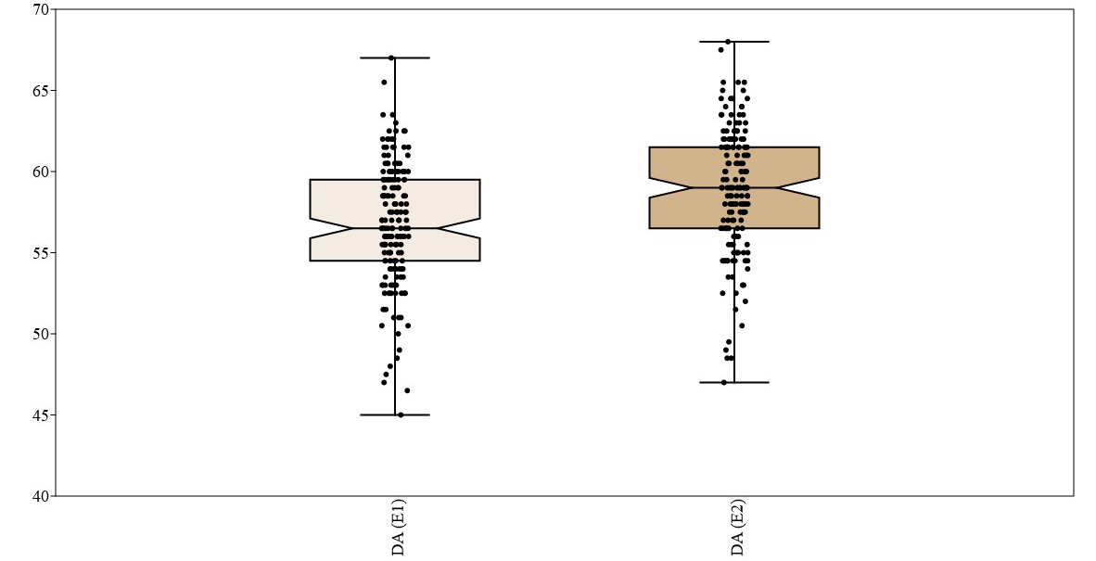
Figure S1.Diversity for days to anthesis in 169 BILs of maize under E₁ and E₂

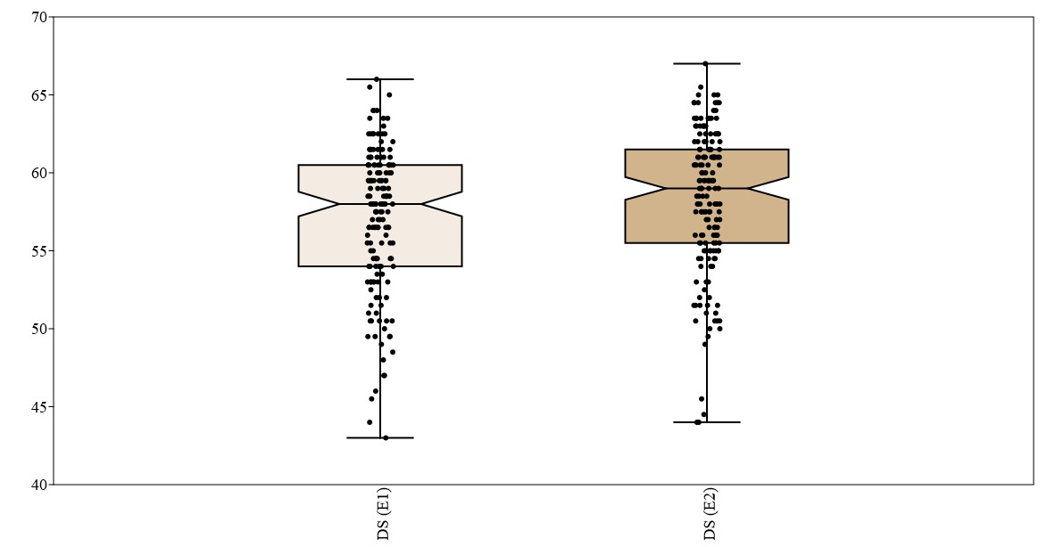
Figure S2.Diversity for days to silking in 169 BILs of maize under E₁ and E₂

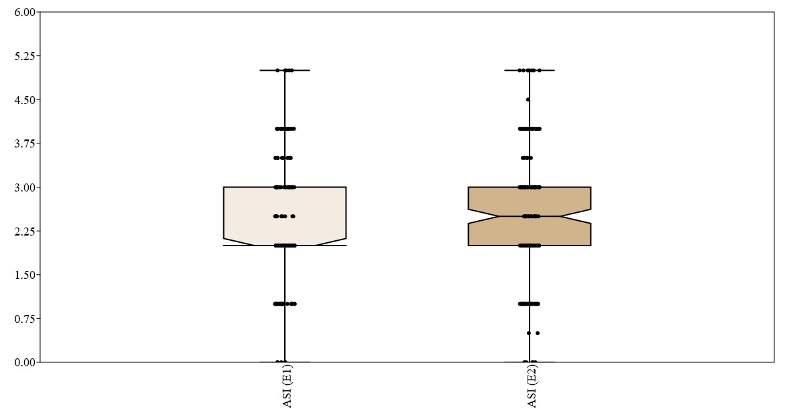
Figure S3.Diversity for anthesis-silking interval in 169 BILs of maize under E₁ and E₂

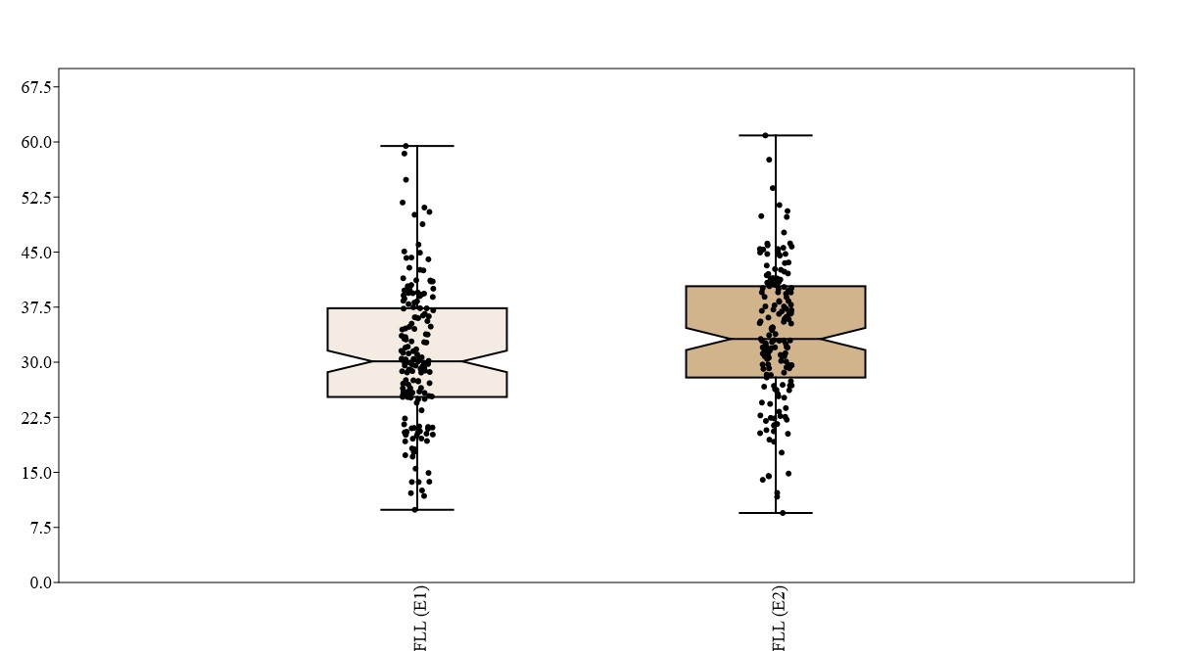
Figure S4.Diversity for flag leaf length in 169 BILs of maize under E₁ and E₂
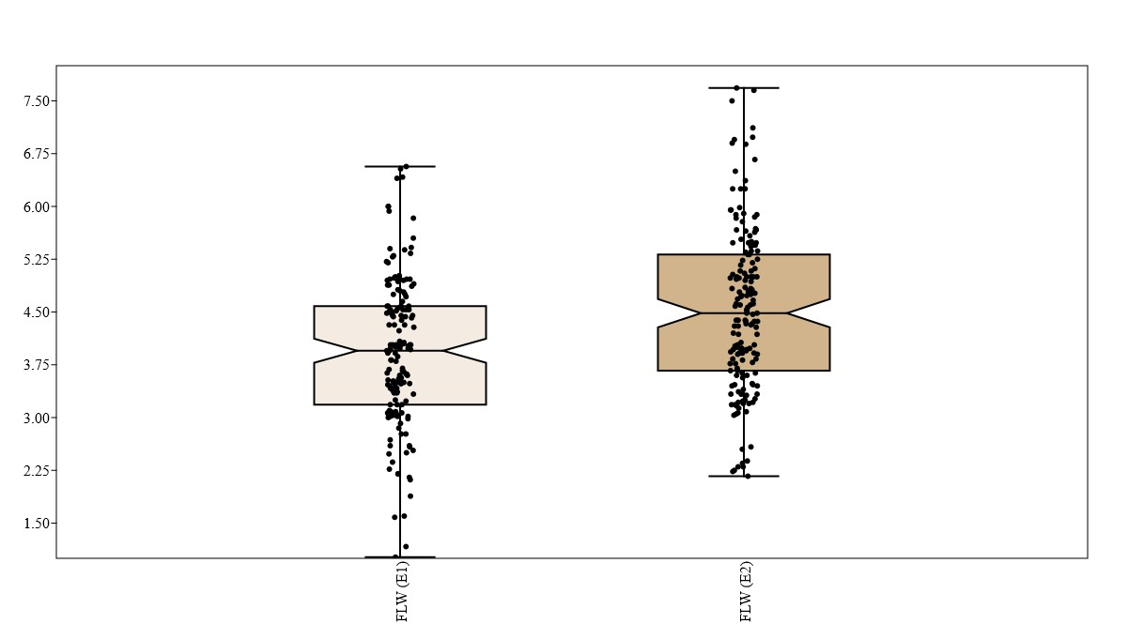
Figure S5.Diversity for flag leaf length in 169 BILs of maize under E₁ and E₂
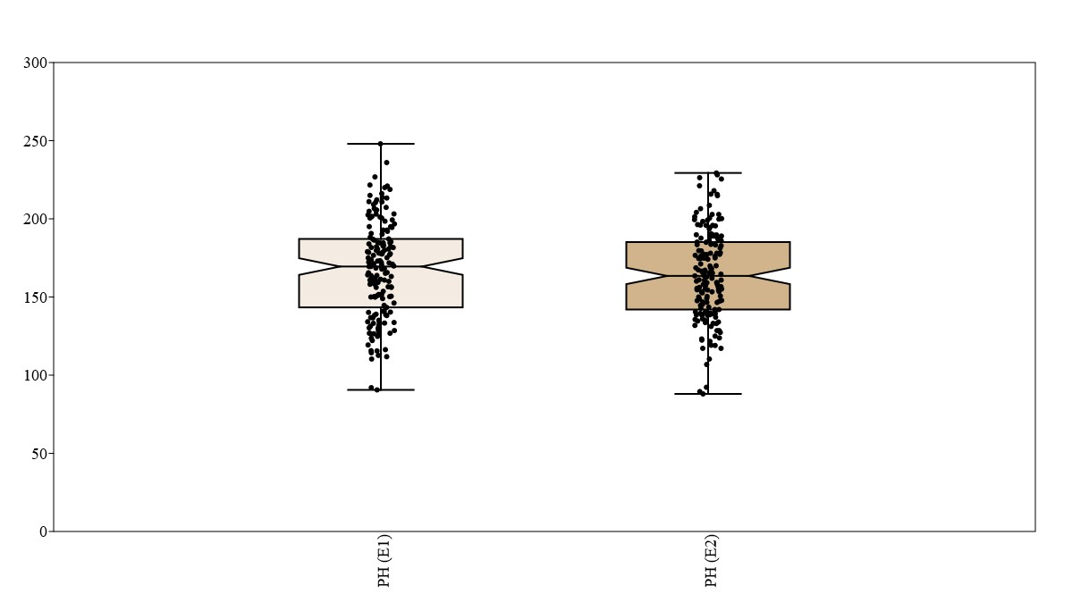
Figure S6.Diversity for plant height in 169 BILs of maize under E₁ and E₂
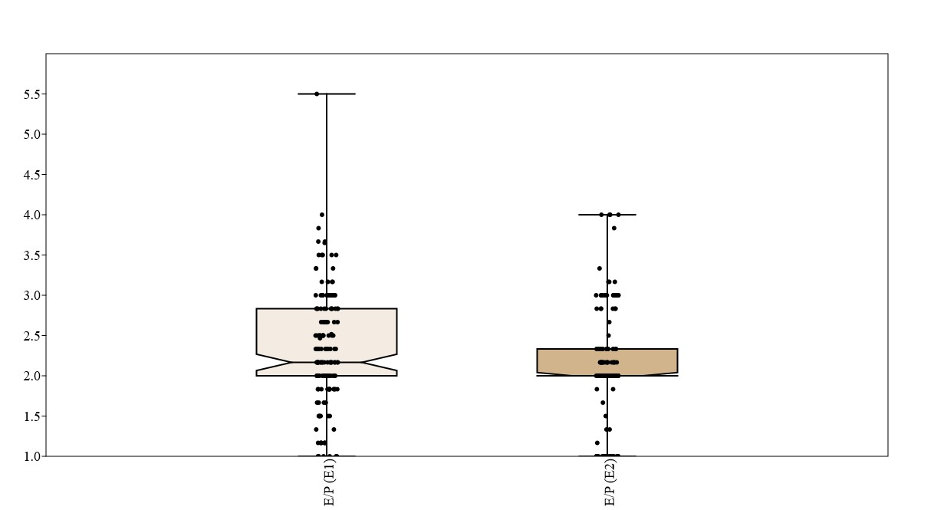

Figure S7.Diversity for ears per palnt in 169 BILs of maize under E₁ and E₂

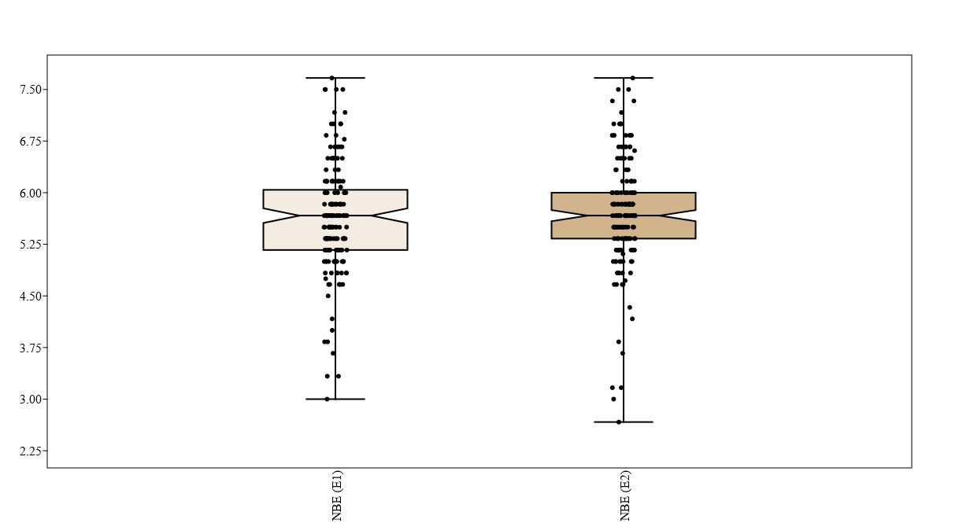
Figure S8.Diversity for node bearing first ear in 169 BILs of maize under E₁ and E₂

