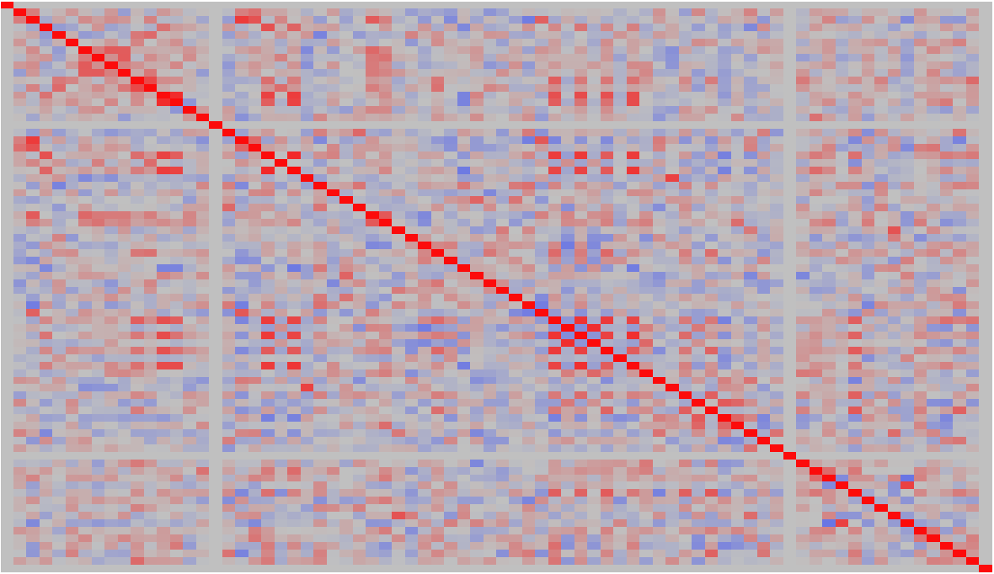
Figure S1. Color map on pairwise correlations for the 76 OIV ampelographic traits recorded on the 36 Greek grapevine cultivars.

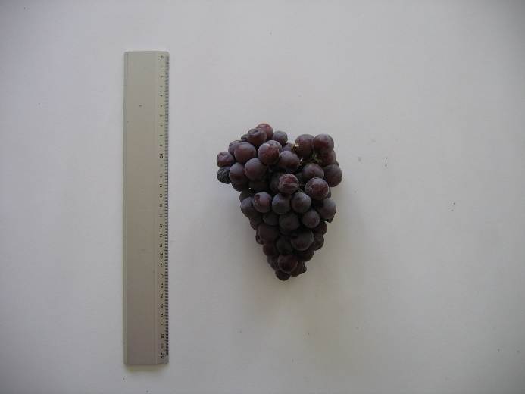
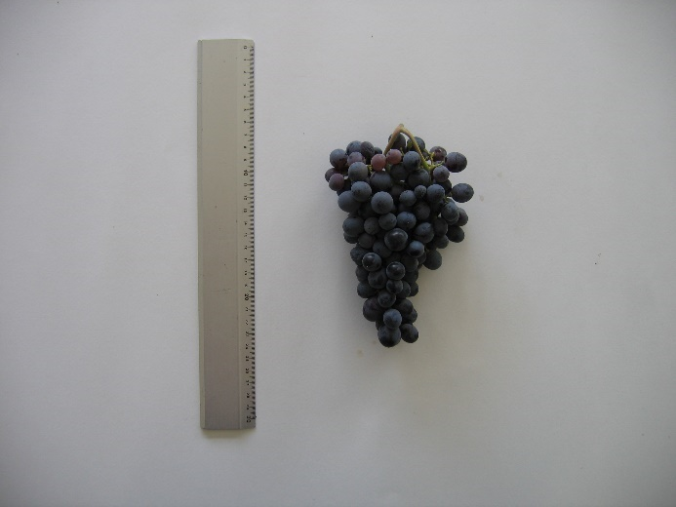
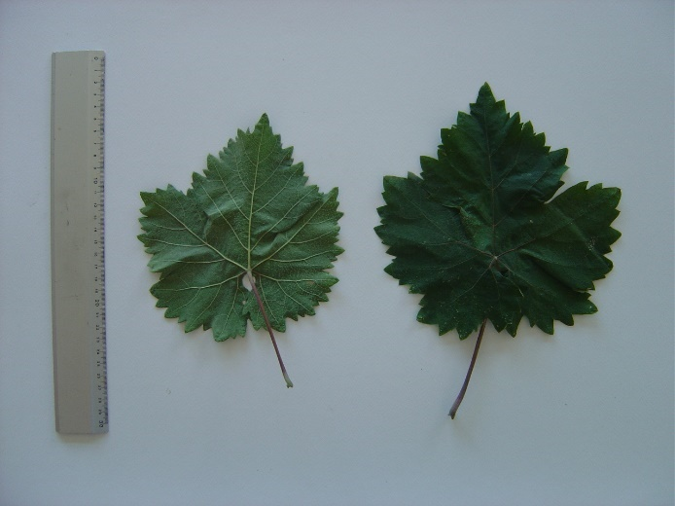
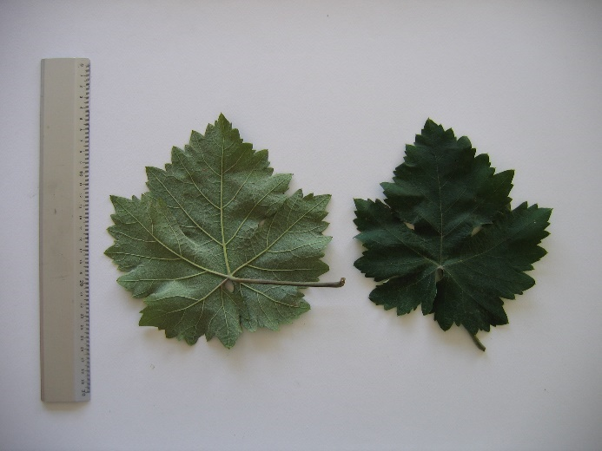
d.
c.
b.
a.
Figure S2. a: Upper and lower side of mature leaf from cultivar “Araklinos”. b: Upper and lower side of mature leaf from cultivar “Mavrotragano”. c: Typical bunch of cultivar “Araklinos”. d: Typical bunch of cultivar “Mavrotragano”.

Table S1. Cultivars (cv), main purpose, color, area of cultivation and number of independent genotypes per cv. analyzed in the framework of the present study [according to Mattheou et al. (2006); Stavrakas (2010); Vlachos (1991)].
No | cv name in English* | cv code | Main purpose | Color | Area of cultivation | Number of analyzed genotypes per cv
1 | Agiorgitiko | 19A | Wine | Colored | Peloponnese | 2
2 | Aidani mavro | 10B | Wine | Colored | Cyclades | 3
3 | Akiki | 47D | Table | Colored | Crete | 2
4 | Araklinos | 10D | Wine | Colored | Cefalonia | 3
5 | Arkadino | 40C | Wine | White | Corfu | 3
6 | Askathari | 31B | Wine | White | Cyclades | 3
7 | Attiki | 53D | Table | Colored | All over Greece | 3
8 | Vilana | 42D | Wine | White | Crete | 2
9 | Votsiki | 37B | Wine | White | Epirus | 3
10 | Glykopati | 23B | Wine | Colored | Ionian islands | 2
11 | Thrapsathiri | 32A | Wine | White | Crete and South Aegean islands | 3
12 | Karvouniaris | 22E | Wine | Colored | South Peloponnese | 3
13 | Cardinal | 54B | Table | Colored | all Greece | 3
14 | Kozanitis | 39E | Wine | White | Ionian islands | 3
15 | Korithi lefko | 45C | Table | White | Ionian islands, Achaia | 3
16 | Korfiatis | 15A | Wine | Colored | Ionian islands | 3
17 | Kotsifali | 12B | Wine | Colored | Crete, Cyclades | 3
18 | Limniona | 16C | Wine | Colored | Thessaly | 3
19 | Malvazia | 30D | Wine | White | Crete, South Peloponnese | 3
20 | Mavro Spetson | 20B | Wine | Colored | Peloponnese, Cyclades | 3
21 | Mavrokorakas | 6B | Wine | Colored | Peloponnese, Ionian islands | 3
22 | Mavrotragano | 8C | Wine | Colored | Santorini | 3
23 | Moschardinia | 37E | Wine | White | Ionian islands | 2
24 | Moschato Amvourgou | 48A | Wine / Table | Colored | all Greece | 3
25 | Mpelenes | 37D | Wine | White | East Aegean islands | 2
26 | Ntempina | 40D | Wine | White | Epirus | 3
27 | Nychato | 45A | Table | Colored | Central and East Macedonia | 3
28 | Ksynomavro | 2A | Wine | Colored | West and Central Macedonia | 3
29 | Pardala | 18C | Wine | Colored | Cyclades, Sterea Ellada | 2
30 | Provatina | 31E | Table | Colored | Zakinthos, Achaia | 3
31 | Rousiko | 31D | Wine | White | Euboea, Cyclades | 2
32 | Savvatiano | 27C | Wine | White | Sterea Ellada, Euboea, Macedonia, Cyclades | 2
33 | Sefka | 17B | Wine | Colored | Macedonia, Thrace | 3
34 | Skylopnichtis kokkinos | 23D | Wine | Colored | Peloponnese, Sterea Ellada | 2
35 | Soultanina | 45E | Table | White | Crete, Peloponnese, Macedonia | 2
36 | Chimoniatiko | 46E | Table | White | Central Macedonia | 2
* Transliterated from Greek according to ISO 843-1997

Table S2. Ampelographic traits (descriptors) employed in the framework of the present study [according to OIV (2009)].
Characteristic |  | OIV Code number
Young shoot | Aperture (opening) of the shoot tip | 001
 | Distribution of anthocyanin coloration on prostrate hairs of the shoot tip | 002
 | Intensity of anthocyanin coloration on prostrate hairs of the shoot tip | 003
 | Density of prostrate hairs on the shoot tip | 004
 | Density of erect hairs on the shoot tip | 005
Shoot | Attitude (before tying) | 006
 | Color of the dorsal side of internodes | 007
 | Color of the ventral side of internodes | 008
 | Color of the dorsal side of nodes | 009
 | Color of the ventral side of nodes | 010
 | Density of erect hairs on nodes | 011
 | Density of erect hairs on internodes | 012
 | Density of prostrate hairs on nodes | 013
 | Density of prostrate hairs on internodes | 014
 | Intensity of anthocyanin coloration on the bud scales | 015-2
 | Vigor of shoot growth | 351
 | Number of consecutive tendrils | 016
 | Length of tendrils | 017
Young leaf | Color of the upper side of blade | 051
 | Intensity of anthocyanin coloration of six distal leaves | 052
 | Density of prostrate hairs between main veins on lower side of blade | 053
 | Density of erect hairs between main veins on lower side of blade | 054
 | Density of prostrate hairs on main veins on lower side of blade | 055
 | Density of erect hairs on main veins on lower side of blade | 056
Mature leaf | Size of blade | 065
 | Shape of blade | 067
 | Number of lobes | 068
 | Color of the upper side of blade | 069
 | Area of anthocyanin coloration of the main veins on the upper side of the blade | 070
 | Area of anthocyanin coloration of the main veins on the lower side of the blade | 071
 | Goffering of blade | 072
 | Undulation of blade between main or lateral veins | 073
 | Profile of blade in cross section | 074
 | Blistering of upper side of blade | 075
 | Shape of teeth | 076
 | Size of teeth in relation to blade size | 077
 | Length of teeth compared with their width (at the end of the base) | 078
 | Degree of opening/overlapping of petiole sinus | 079
 | Shape of base of petiole sinus | 080
 | Petiole sinus base limited by veins | 081-2
 | Degree of opening/overlapping of upper lateral sinuses | 082
 | Shape of the base of upper lateral sinuses | 083-1
 | Density of prostrate hairs between main veins (on lower side of blade) | 084
 | Density of erect hairs between main veins (on lower side of blade) | 085
 | Density of prostrate hairs on main veins (on lower side of blade) | 086
 | Density of erect hairs on main veins (on lower side of blade) | 087
 | Prostrate hairs on main veins (on upper side of blade) | 088
 | Erect hairs on main veins (on upper side of blade) | 089
 | Density of prostrate hairs on petiole | 090
 | Density of erect hairs on petiole | 091
 | Length of petiole compared to length of middle vein | 093
Woody shoot | Cross section | 101
 | Structure of surface | 102
 | Main color | 103
 | Lenticels | 104
Flower/Inflorescence | Sexual organs | 151
 | Number of inflorescences per shoot | 153
Bunch | Length (peduncle excluded) | 202
 | Density | 204
 | Length of peduncle of primary bunch | 206
 | Lignification of peduncle | 207
Berry | Length | 220
 | Uniformity of size | 222
 | Shape | 223
 | Cross section | 224
 | Color of skin | 225
 | Uniformity of skin color | 226
 | Hilum | 229
 | Intensity of flesh anthocyanin coloration | 231
 | Juiciness of flesh | 232
 | Firmness of flesh | 235
 | Particular flavor | 236
 | Length of pedicel | 238
 | Ease of detachment from pedicel | 240
 | Formation of seeds | 241
 | Length of seeds | 242

