Table S1. List of varieties used by surveyed farmers (N represent the total number of varieties in the municipality)
N° | Varieties | Origin | Botanical race | Percentage of overall use | Percentage of use in municipalities
 |  |  |  |  | Boussouma (N = 18) | Korsimoro (N = 16) | Guibare (N = 12)
1 | Rouko | local | Guinea | 21.2 | 3.4 | 70.2
2 | Fiib-miougou | local | Guinea | 20.0 | 28.7 | 4.3 | 19.4
3 | Pisnou | local | Guinea | 18.2 | 32.2 | 2.1 | 5.6
4 | Pissopoè | local | Guinea | 17.6 | 16.1 | 2.1 | 41.7
5 | Mitindaadé | local | Guinea | 16.5 | 9.2 | 10.6 | 41.7
6 | Kourbouli | local | Guinea | 15.9 | 26.4 | 8.5
7 | ICSV 1049 | improved | Caudatum | 9.4 | 12.6 | 10.6
8 | Baninpèlga | local | Guinea | 5.3 |  | 19.1
9 | Kapèlga | improved | Guinea | 4.7 | 3.4 | 2.1 | 11.1
10 | Bèma | local | Guinea | 4.7 | 3.4 |  | 13.9
11 | Sariaso 15 | improved | Caudatum | 4.1 | 2.3 | 10.6
12 | Pèlgo | local | Guinea | 4.1 | 2.3 | 10.6
13 | Sariaso 11 | improved | Caudatum | 3.5 | 4.6 | 2.1 | 2.8
14 | Kazinga | local | Guinea | 2.9 | 1.1 | 2.1 | 8.3
15 | Kendpèlga | local | Guinea | 2.4 |  |  | 11.1
16 | Gambré | local | Guinea | 1.8 | 3.4
17 | Makièmna | local | Guinea | 1.8 | 3.4
18 | Nawa-tenga | local | Guinea | 1.8 | 3.4
19 | Soaasa | local | Guinea | 1.8 | 3.4
20 | Zoé-wongo | local | Guinea | 1.8 |  | 6.4
21 | Sariaso 18 | improved | Guinea | 1.2 | 1.1 | 2.1
22 | Guéteb-lagsda | local | Guinea | 1.2 |  |  | 5.6
23 | Sariaso 14 | improved | Caudatum | 0.6 |  | 2.1
24 | Rawumma | local | Guinea | 0.6 |  |  | 2.8
25 | Gnouga | local | Guinea | 0.6 |  |  | 2.8

Table S2. List of evaluated varieties and their main characteristics.
Values represent two years means
Cluster | Varieties | Varieties code (Figure 3) | Origin | Botanical race | Cycle sowing-heading (days) | Plant height (cm) | Relative chlorophyll (%) | Root’s depth  (cm) | Root’s biomass  (g) | Straw yield (kg.ha-1) | Grain yield (kg.ha-1)
G1 | BF 88-2/31-3 | v05 | new improved lines | Caudatum | 66 | 107.3 | 51.4 | 60.5 | 0.44 | 4581.8 | 1914.8
G1 | ICSV 1049 | v11 | improved | Caudatum | 74 | 141.0 | 52.4 | 62.6 | 0.41 | 4690.6 | 1623.6
G1 | Kazarga | v13 | local | Guinea-caudatum | 73 | 228.3 | 59.1 | 53.1 | 0.34 | 4939.6 | 1010.3
G1 | Sariaso 14 | v45 | improved | Caudatum | 72 | 147.9 | 52.1 | 57.6 | 0.49 | 4846.9 | 1886.0
G1 | Sariaso 15 | v46 | improved | Caudatum | 69 | 162.1 | 46.5 | 52.1 | 0.30 | 4361.5 | 1823.7
G1 | Sariaso 16 | v47 | improved | Caudatum | 70 | 167.9 | 47.2 | 66.4 | 0.49 | 4225.0 | 1697.7
G2 | Baniaringa | v02 | local | Guinea | 60 | 217.1 | 65.0 | 52.7 | 0.35 | 3829.2 | 1327.9
G2 | BF 09-21/1-1-1 | v04 | new improved lines | Guinea-caudatum | 64 | 187.9 | 60.4 | 50.3 | 0.35 | 4656.8 | 1194.8
G2 | CSM 63-E | v06 | improved | Guinea | 62 | 235.8 | 66.6 | 69.3 | 0.58 | 3971.4 | 1839.1
G2 | Fibsablega | v07 | local | Guinea | 65 | 240.4 | 63.5 | 48.9 | 0.28 | 4415.6 | 1661.4
G2 | Fiib-miougou | v08 | local | Guinea | 69 | 248.1 | 62.0 | 57.4 | 0.49 | 3941.7 | 1574.8
G2 | Gambre | v09 | local | Guinea | 72 | 255.6 | 58.0 | 56.4 | 0.48 | 4065.6 | 1244.8
G2 | Gueteb-lagsda | v10 | local | Guinea | 66 | 235.1 | 61.0 | 60.3 | 0.52 | 4129.7 | 1522.2
G2 | Kapelga | v12 | improved | Guinea | 60 | 236.9 | 56.5 | 50.1 | 0.26 | 4893.8 | 1620.2
G2 | Kazinga | v14 | local | Guinea | 65 | 223.5 | 67.5 | 61.0 | 0.54 | 3761.5 | 1785.9
G2 | Mitindaade | v15 | local | Guinea | 62 | 221.3 | 68.3 | 56.6 | 0.61 | 4156.3 | 1985.2
G2 | Pissopoe | v18 | local | Guinea | 67 | 217.8 | 66.9 | 59.3 | 0.53 | 3675.5 | 1527.5
G2 | PSE07 G1/5-1-1-1 | v19 | new improved lines | Guinea | 71 | 229.4 | 64.1 | 51.8 | 0.33 | 4229.2 | 1473.3
G2 | PSE07 S1/1-1Z-1 | v20 | new improved lines | Guinea | 68 | 291.9 | 62.7 | 60.0 | 0.31 | 4996.9 | 2085.9
G2 | PSE07 S1/31-1Z-2 | v22 | new improved lines | Guinea | 68 | 225.6 | 61.2 | 58.3 | 0.50 | 4589.6 | 1367.0
G2 | PSE08 G1/21-1G-1 | v24 | new improved lines | Guinea | 67 | 209.8 | 67.3 | 58.7 | 0.45 | 4285.4 | 1584.2
G2 | PSE08 Silo/27-1-1 | v29 | new improved lines | Guinea | 64 | 255.6 | 66.1 | 55.6 | 0.53 | 4152.6 | 1761.4
G2 | PSE08 Silo/28-1-1 | v30 | new improved lines | Guinea | 65 | 254.2 | 54.4 | 56.6 | 0.31 | 4254.2 | 1933.4
G2 | PSE09 G1/10-1-1 | v33 | new improved lines | Guinea | 63 | 225.6 | 65.1 | 56.3 | 0.38 | 4159.9 | 1768.4
G2 | PSE09 G1/20-1-1 | v37 | new improved lines | Guinea | 65 | 230.0 | 64.3 | 47.4 | 0.32 | 4219.3 | 1821.1
G2 | PSE09 G1/20-1-2 | v38 | new improved lines | Guinea | 61 | 234.0 | 61.2 | 61.9 | 0.36 | 3716.7 | 1596.6
G2 | PSE09 G1/2-1-1 | v39 | new improved lines | Guinea | 65 | 184.6 | 63.9 | 67.2 | 0.67 | 3291.1 | 1408.1
G2 | PSE09 Z3/33-1-1 | v40 | new improved lines | Guinea | 70 | 201.7 | 60.0 | 59.5 | 0.63 | 3888.5 | 1204.4
G2 | PSE09 Z3/53-2-1-2 | v41 | new improved lines | Guinea | 65 | 228.8 | 63.1 | 59.1 | 0.45 | 4683.9 | 2041.3
G2 | Rouko 2 | v43 | local | Guinea | 66 | 231.9 | 57.3 | 58.9 | 0.47 | 4377.6 | 1745.9
G2 | Sariaso 18 | v48 | improved | Guinea | 66 | 202.9 | 66.9 | 58.4 | 0.53 | 4132.8 | 1736.3
G3 | Asseta | v01 | local | Guinea | 63 | 243.8 | 65.9 | 66.0 | 1.33 | 4672.9 | 1851.6
G3 | Baninpelga | v03 | local | Guinea | 67 | 252.9 | 65.2 | 60.7 | 0.73 | 4543.8 | 1867.4
G3 | Naba-koaba | v16 | local | Guinea | 66 | 276.3 | 61.8 | 71.2 | 0.60 | 4617.2 | 1705.9
G3 | Pisnou | v17 | local | Guinea | 65 | 275.6 | 64.0 | 76.8 | 0.60 | 4911.5 | 1961.1
G3 | PSE07 S1/13-2Z-1-1 | v21 | new improved lines | Guinea | 70 | 253.8 | 62.9 | 60.0 | 0.48 | 4586.5 | 1533.7
G3 | PSE08 G1/17-1-2-1 | v23 | new improved lines | Guinea | 66 | 223.2 | 62.8 | 63.3 | 0.61 | 4965.6 | 1807.1
G3 | PSE08 G1/36-1-2-2-1 | v25 | new improved lines | Guinea | 66 | 276.7 | 62.6 | 65.5 | 0.87 | 4678.6 | 2267.8
G3 | PSE08 G1/36-1-2-2-2 | v26 | new improved lines | Guinea | 68 | 283.5 | 63.3 | 62.3 | 0.68 | 5150.5 | 1685.6
G3 | PSE08 G2/15-1G-3-1 | v27 | new improved lines | Guinea | 67 | 209.6 | 60.9 | 65.3 | 0.71 | 4405.7 | 1748.5
G3 | PSE08 G2/46-1G-1 | v28 | new improved lines | Guinea | 68 | 291.5 | 62.6 | 63.6 | 0.48 | 4106.3 | 1970.1
G3 | PSE08 TBOU/3-1-1 | v31 | new improved lines | Guinea | 67 | 268.1 | 62.5 | 71.3 | 0.89 | 4838.5 | 2206.3
G3 | PSE08 Tbou/3-1-2 | v32 | new improved lines | Guinea | 66 | 235.0 | 64.3 | 70.1 | 0.72 | 4799.5 | 2027.8
G3 | PSE09 G1/15-1-1 | v34 | new improved lines | Guinea | 66 | 223.1 | 65.4 | 69.0 | 0.55 | 4279.7 | 1438.5
G3 | PSE09 G1/19-1-1-1 | v35 | new improved lines | Guinea | 63 | 235.2 | 63.0 | 79.5 | 0.70 | 4957.8 | 1860.2
G3 | PSE09 G1/19-1-1-2 | v36 | new improved lines | Guinea | 65 | 237.9 | 66.9 | 61.8 | 0.60 | 4432.8 | 1881.4
G3 | Rouko 1 | v42 | local | Guinea | 63 | 228.1 | 57.8 | 61.1 | 0.64 | 3727.6 | 1495.1
G3 | Sariaso 11 | v44 | improved | Caudatum | 66 | 147.7 | 55.3 | 74.3 | 0.86 | 5340.1 | 1878.6
G3 | Wabenongo | v49 | local | Guinea | 66 | 233.5 | 63.3 | 60.9 | 0.47 | 4212.0 | 1681.8
G3 | Zéo-wongo | v50 | local | Guinea | 67 | 223.8 | 60.4 | 79.1 | 0.75 | 3402.6 | 1422.0
Varieties in bold are the selected ones for a complementary evaluation in intercropping systems.
Table S3. Evaluation two years means scores (1 = bad; 4 = excellent) by variety
Cluster | Varieties | Varieties code (Figure 3) | Origin | Botanical race | Plant heigh | Cycle length | Fodder | Grain productivity | Grain quality | Acceptability | Individual appreciation
G1 | BF 88-2/31-3 | v05 | new improved lines | Caudatum | 2.9 | 3.4 | 3.2 | 3.4 | 3.3 | 3.0 | 2.2
G1 | ICSV 1049 | v11 | improved | Caudatum | 2.5 | 2.4 | 3.1 | 3.0 | 2.8 | 2.5 | 2.1
G1 | Kazarga | v13 | local | Guinea-caudatum | 2.3 | 2.8 | 2.9 | 2.3 | 2.3 | 2.0 | 1.5
G1 | Sariaso 14 | v45 | improved | Caudatum | 2.9 | 2.9 | 3.1 | 3.3 | 2.9 | 2.9 | 2.4
G1 | Sariaso 15 | v46 | improved | Caudatum | 3.0 | 3.8 | 3.4 | 3.5 | 3.5 | 2.9 | 2.6
G1 | Sariaso 16 | v47 | improved | Caudatum | 3.1 | 3.4 | 3.4 | 3.5 | 3.6 | 3.0 | 2.5
G2 | Baniaringa | v02 | local | Guinea | 2.5 | 3.7 | 2.9 | 2.8 | 3.1 | 2.7 | 2.3
G2 | BF 09-21/1-1-1 | v04 | new improved lines | Guinea-caudatum | 2.6 | 2.8 | 2.6 | 2.2 | 2.6 | 1.6 | 1.8
G2 | CSM 63-E | v06 | improved | Guinea | 2.4 | 3.7 | 2.7 | 2.6 | 3.1 | 2.5 | 2.6
G2 | Fibsablega | v07 | local | Guinea | 2.8 | 3.4 | 2.9 | 2.9 | 2.9 | 2.7 | 2.7
G2 | Fiib-miougou | v08 | local | Guinea | 2.8 | 3.5 | 2.8 | 3.2 | 3.3 | 3.4 | 2.7
G2 | Gambre | v09 | local | Guinea | 2.1 | 2.1 | 2.3 | 1.6 | 1.4 | 1.4 | 1.6
G2 | Guéteb-lagsda | v10 | local | Guinea | 2.7 | 3.5 | 3.0 | 3.5 | 3.7 | 3.3 | 3.1
G2 | Kapelga | v12 | improved | Guinea | 2.7 | 2.8 | 2.6 | 2.7 | 2.6 | 2.3 | 1.9
G2 | Kazinga | v14 | local | Guinea | 3.1 | 3.3 | 3.1 | 3.4 | 3.4 | 3.0 | 2.2
G2 | Mitindaade | v15 | local | Guinea | 3.0 | 3.7 | 3.0 | 3.7 | 3.7 | 3.6 | 2.9
G2 | Pissopoe | v18 | local | Guinea | 2.5 | 3.1 | 2.7 | 2.8 | 2.9 | 3.0 | 2.8
G2 | PSE07 G1/5-1-1-1 | v19 | new improved lines | Guinea | 1.9 | 2.3 | 2.6 | 2.4 | 2.6 | 2.2 | 2.2
G2 | PSE07 S1/1-1Z-1 | v20 | new improved lines | Guinea | 2.3 | 2.4 | 2.4 | 2.6 | 2.8 | 2.5 | 2.4
G2 | PSE07 S1/31-1Z-2 | v22 | new improved lines | Guinea | 2.1 | 2.7 | 2.4 | 1.9 | 2.1 | 1.3 | 2.0
G2 | PSE08 G1/21-1G-1 | v24 | new improved lines | Guinea | 3.3 | 3.8 | 3.2 | 3.6 | 3.9 | 3.5 | 3.2
G2 | PSE08 Silo/27-1-1 | v29 | new improved lines | Guinea | 2.7 | 3.4 | 2.8 | 3.1 | 3.1 | 2.6 | 2.6
G2 | PSE08 Silo/28-1-1 | v30 | new improved lines | Guinea | 2.0 | 2.2 | 2.2 | 1.4 | 1.8 | 1.2 | 1.9
G2 | PSE09 G1/10-1-1 | v33 | new improved lines | Guinea | 3.1 | 3.6 | 3.3 | 3.8 | 3.5 | 3.4 | 2.9
G2 | PSE09 G1/20-1-1 | v37 | new improved lines | Guinea | 2.6 | 3.6 | 3.1 | 3.3 | 3.5 | 3.0 | 2.7
G2 | PSE09 G1/20-1-2 | v38 | new improved lines | Guinea | 3.1 | 3.5 | 2.7 | 3.4 | 3.4 | 3.4 | 2.6
G2 | PSE09 G1/2-1-1 | v39 | new improved lines | Guinea | 3.3 | 3.6 | 3.3 | 3.7 | 3.6 | 3.3 | 2.7
G2 | PSE09 Z3/33-1-1 | v40 | new improved lines | Guinea | 2.5 | 2.1 | 2.8 | 1.9 | 2.3 | 1.6 | 1.9
G2 | PSE09 Z3/53-2-1-2 | v41 | new improved lines | Guinea | 2.6 | 2.3 | 3.0 | 2.1 | 2.4 | 2.0 | 2.0
G2 | Rouko 2 | v43 | local | Guinea | 2.4 | 3.2 | 2.6 | 2.9 | 3.3 | 2.7 | 2.6
G2 | Sariaso 18 | v48 | improved | Guinea | 3.2 | 3.8 | 3.3 | 3.7 | 3.7 | 3.5 | 3.1
G3 | Asseta | v01 | local | Guinea | 2.8 | 2.8 | 2.7 | 2.6 | 2.5 | 2.2 | 2.2
G3 | Baninpelga | v03 | local | Guinea | 2.9 | 3.7 | 3.3 | 3.7 | 3.8 | 3.7 | 2.8
G3 | Naba-koaba | v16 | local | Guinea | 2.4 | 3.1 | 2.4 | 3.1 | 3.2 | 3.0 | 2.5
G3 | Pisnou | v17 | local | Guinea | 2.6 | 3.1 | 2.5 | 3.3 | 3.1 | 2.9 | 2.9
G3 | PSE07 S1/13-2Z-1-1 | v21 | new improved lines | Guinea | 2.6 | 3.5 | 2.8 | 3.3 | 3.4 | 3.0 | 2.7
G3 | PSE08 G1/17-1-2-1 | v23 | new improved lines | Guinea | 3.4 | 3.6 | 3.6 | 3.7 | 3.7 | 3.7 | 3.1
G3 | PSE08 G1/36-1-2-2-1 | v25 | new improved lines | Guinea | 2.9 | 3.5 | 3.2 | 3.6 | 3.8 | 3.5 | 3.3
G3 | PSE08 G1/36-1-2-2-2 | v26 | new improved lines | Guinea | 2.4 | 2.7 | 2.8 | 3.1 | 2.9 | 2.6 | 2.7
G3 | PSE08 G2/15-1G-3-1 | v27 | new improved lines | Guinea | 2.6 | 2.7 | 2.8 | 2.4 | 2.5 | 2.1 | 2.3
G3 | PSE08 G2/46-1G-1 | v28 | new improved lines | Guinea | 2.7 | 3.3 | 2.5 | 3.6 | 3.6 | 3.2 | 3.1
G3 | PSE08 TBOU/3-1-1 | v31 | new improved lines | Guinea | 2.0 | 1.6 | 2.1 | 1.4 | 1.3 | 1.3 | 1.3
G3 | PSE08 Tbou/3-1-2 | v32 | new improved lines | Guinea | 2.5 | 2.9 | 2.9 | 3.0 | 3.0 | 2.6 | 2.6
G3 | PSE09 G1/15-1-1 | v34 | new improved lines | Guinea | 2.5 | 2.7 | 2.5 | 2.8 | 2.7 | 2.3 | 2.5
G3 | PSE09 G1/19-1-1-1 | v35 | new improved lines | Guinea | 3.1 | 3.1 | 3.3 | 3.4 | 3.3 | 3.5 | 3.1
G3 | PSE09 G1/19-1-1-2 | v36 | new improved lines | Guinea | 2.7 | 3.5 | 2.8 | 3.2 | 3.3 | 3.0 | 2.6
G3 | Rouko 1 | v42 | local | Guinea | 2.7 | 3.3 | 2.5 | 2.9 | 3.0 | 2.6 | 2.4
G3 | Sariaso 11 | v44 | improved | Caudatum | 3.0 | 3.6 | 3.5 | 3.4 | 3.4 | 3.0 | 2.3
G3 | Wabenongo | v49 | local | Guinea | 2.8 | 2.8 | 2.5 | 2.3 | 2.6 | 1.8 | 2.0
G3 | Zéo-wongo | v50 | local | Guinea | 2.9 | 2.9 | 2.9 | 3.2 | 3.0 | 2.5 | 2.2
Varieties in bold are the selected ones for a complementary evaluation in intercropping systems.

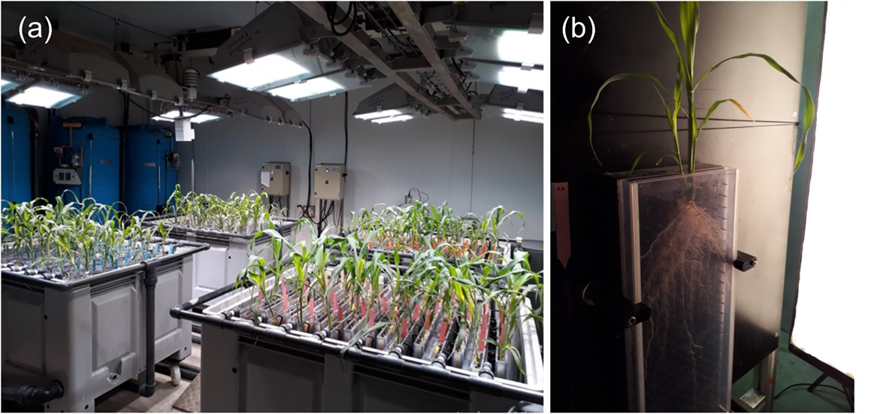
Figure S1: Illustration of (a) rhizoscope’ experimental design and (b) an example of one variety roots system at vegetative stage

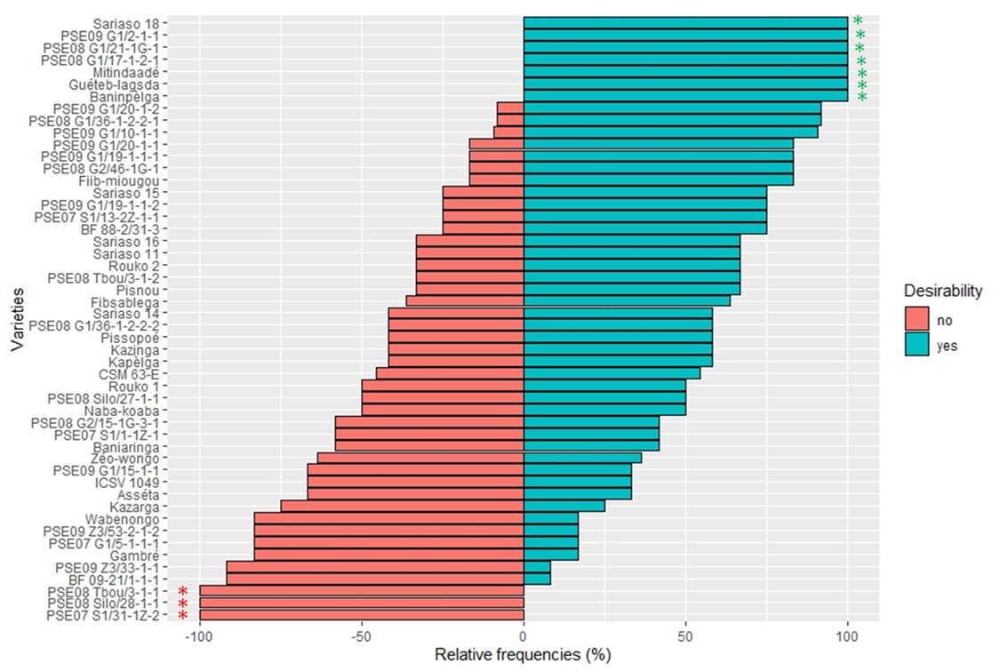
Figure S2: Desirability of varieties evaluated
Green stars indicate unanimously appreciated varieties; the red ones indicate unanimously depreciated varieties.

