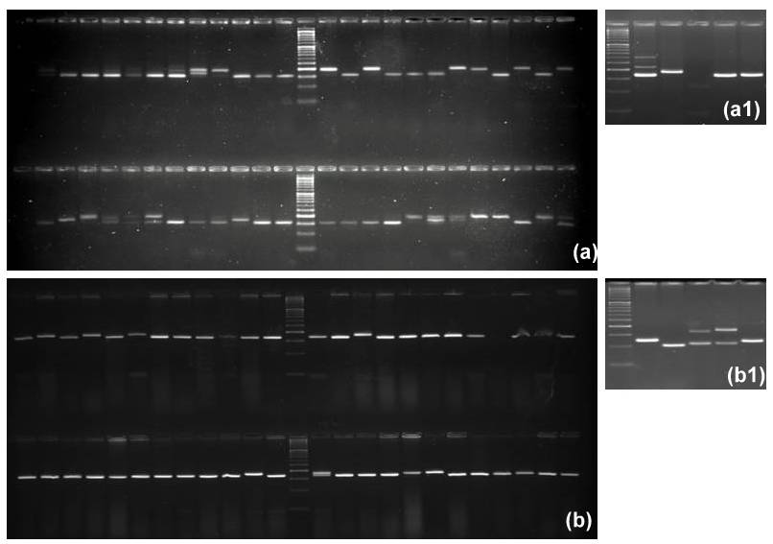

Figure S1. Representative agarose gel images of markers RM 314 (a & a1) and RM 253 ( c & c1) for tested germplasm. Both a & a1, b & b1 represent the banding pattern of 53 germplasm.

