Supplementary data
Table S1: NCBI accession numbers and cultivar sources of ITSs sequences of pearl millet investigated in phylogenetics and polymorphisms analyses. The ITS1 and ITS2 sequences of French accessions were merged as a single sequence for each of the strains UP11/54-93 and UP11/5338 before subjecting to the analysis. Outgroup accessions included Panicum species. Species names appear as available in the NCBI database (Cenchrus americanus and P. americanum are the synonyms of P. glaucum, whereas P. purpureum is the tetraploid relative of pearl millet)

Pearl millet scientific name in NCBI | NCBI Accession No# | Cultivar name | Geographic origin | Aligned sequence length (bp)
C.americanus | KM288868.1 | CZMS-1A | India | 587
C.americanus | KM288869.1 | CZMS-2A | India | 586
C.americanus | KM288870.1 | CZMS-3A | India | 586
C.americanus | KM288871.1 | CZMS-4A | India | 586
C.americanus | KM288872.1 | CZMS-5A | India | 586
C.americanus | KM288873.1 | CZMS-6A | India | 586
C.americanus | KM288874.1 | CZMS-7A | India | 586
C.americanus | KM288875.1 | CZMS-8A | India | 585
C.americanus | KM288876.1 | CZMS-9A | India | 586
C.americanus | KM288877.1 | CZMS-11A | India | 586
C.americanus | KM288878.1 | CZMS-12A | India | 586
C.americanus | KM288879.1 | CZMS-13A | India | 586
C.americanus | KM288880.1 | CZMS-14A | India | 586
C.americanus | KM288881.1 | CZMS-15A | India | 585
C.americanus | KM288886.1 | CZMS-21A | India | 586
C.americanus | KF954526.1 | voucher YNUH20080905 | Korea | 590
C.americanus | HQ600497.1 |  | Korea | 590
P. glaucum | FJ766182.1 |  | Korea | 590
C.americanus | JN115040.1 | voucher SBB-1140 | India | 586
C.americanus x C.purpureus | KJ776738.1 | isolate G | China | 585
P. americanum x P.purpureum | FJ626360.1 | Nanmu 1 | China | 585
P.americanum x P. purpureum | FJ626361.1 | Nanmu 2 | China | 585
P.americanum x P. purpureum | FJ626362.1 | Guimu 1 | China | 585
P. americanum x P. purpureum | FJ626363.1 | Taiwan Sweetgrass | China | 585
P. americanum x P. purpureum | FJ626364.1 | Huangzhucao | China | 586
P. americanum x P. purpureum | FJ626365.1 | Sugarcane | China | 585
P. americanum x P. purpureum | FJ626366.1 | Minmu 6 | China | 586
P. americanum X P. purpureum | FJ626359.1 | Tainong 2 | China | 585
P. americanum X P. purpureum | FJ626352.1 | NA | China | 585
P. glaucum ITS1  P. glaucum ITS2 | AY628130.1 AY628115.1 | strain UP11/54-93 | France | 583
P. glaucum ITS1  P. glaucum ITS2 | AY628131.1 AY628116.1 | strain UP11/5338 | France | 581
Panicum racemosum | KP878907.1 | Out group |  | 586
Panicum pauciflorum | KP878920.1 | Out group |  | 587
Panicum australiense | KP878914.1 | Out group |  | 587

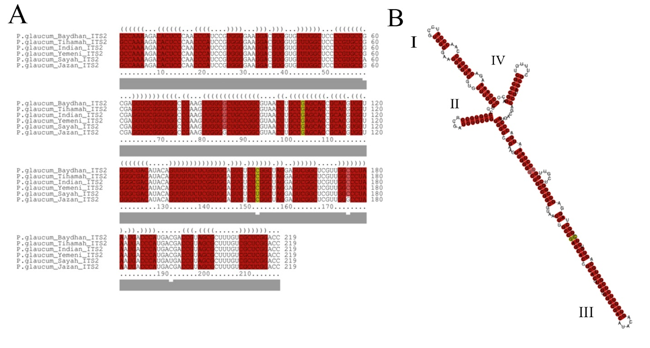
Figure S1: Sequence alignment and structural features for ITS2 sequences as predicted by LocaRNA-P. A. Column alignment of ITS2 sequences of the six pearl millet cultivars. Consensus secondary structure are shown at the first line of alignment using dot-bracket notation. Open parentheses stand for the base pairing with a base ahead of it. Closed parentheses stand for the base pairing with a base behind it. Unpaired bases represented by dots. Compatible base pairs are coloured with red for C-G, and yellow for G-C. The hue shows sequence conservation of the base pair in which the saturation decreases with the number of incompatible base pairs. B. Consensus secondary structure for ITS2 of the six sequences.
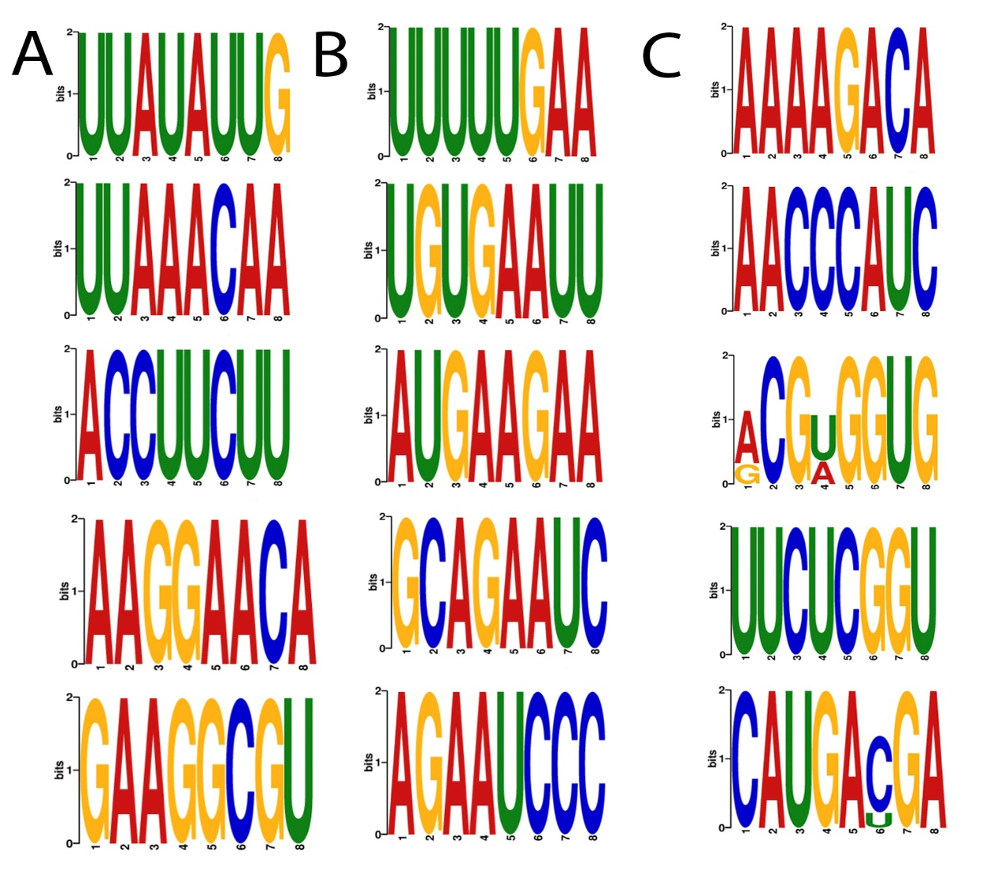
Figure S2: ITS1, 5.8S, and ITS2 motifs of the six local pearl millets predicted by MEME software. A. The predicted conserved motifs in ITS1 sequences. B. The predicted conserved motifs in 5.8S sequences. C. The predicted conserved motifs in ITS2 sequences.

Table S2: Genetic distance within and between pearl millet groups based on sequences of ITS1, 5.8S and ITS2 region. Saudi accessions were obtained by this study and the other five groups of accessions were imported from NCBI GenBank, in addition to outgroup of Panicum accessions. The data was calculated by DNASP software.
Phylogenetics analysis groups | N of accessions | Aligned sequence length | Mean distance within groups | Mean distance between Saudis accessions and other groups
Saudis Accessions | 6 | 586- 587 bp | 0.0023 | -
Indian Accessions | 16 | 585- 587 bp | 0.005 | 0.00377
Korean Accessions | 3 | 590 bp | 0.0045 | 0.11480
Chinese Accessions | 10 | 585-586 bp | 0.0143 | 0.04031
French Accessions | 2 | 581-583 bp | 0.0017 | 0.00548
Out group (Panicum sp.) | 3 | 586-587 bp | 0.0603 | 0.15848

