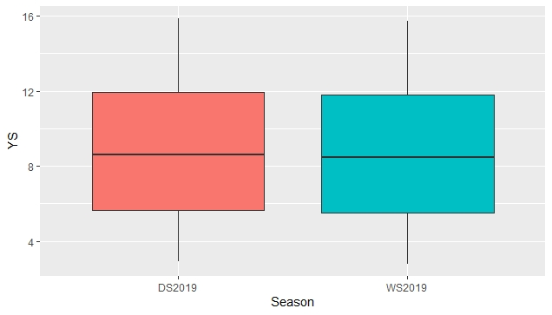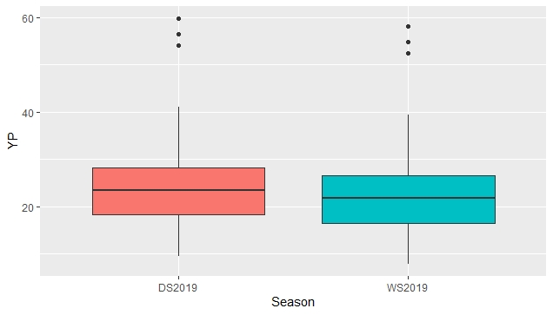
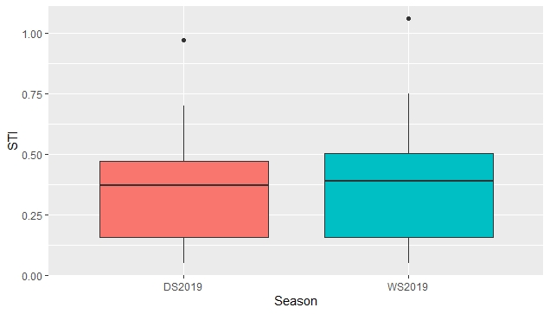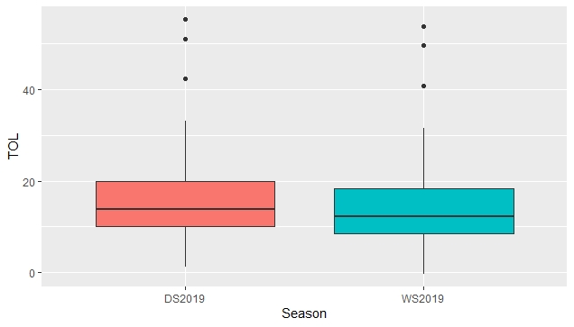
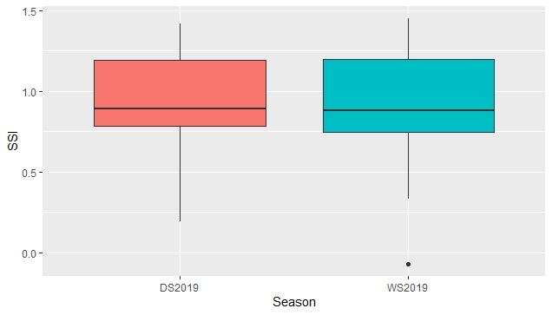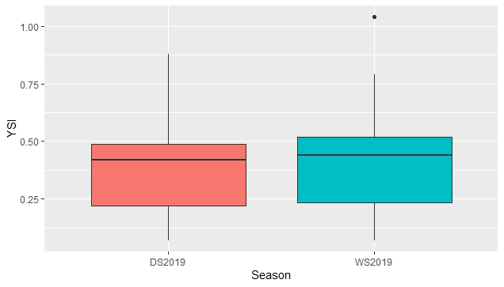
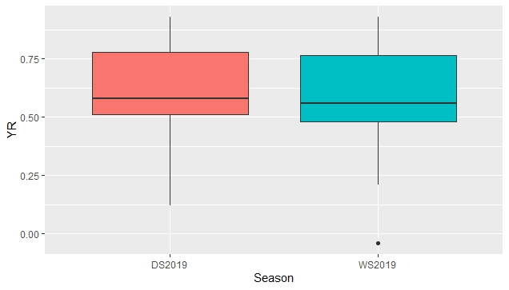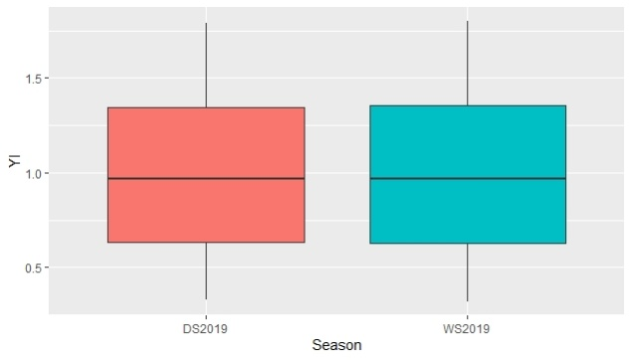

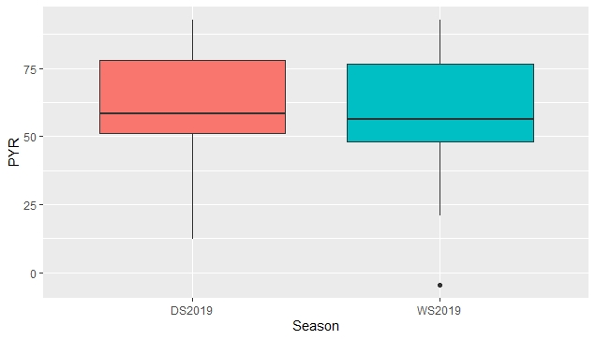
Figure S1. Box-plots depicting the variation of the data from the nine phosphorus stress tolerance indices of introgression lines evaluated for two growing seasons. The vertical lines represent the variation in the population. Dots represent the outliers (Note: Y_{S} = Yield under low soil P condition, Y_{P} = Yield under normal condition, STI = Stress Tolerance Index, TOL = Tolerance Index, SSI = Stress Susceptibility Index, YSI = Yield Stability Index, YR = Yield Reduction Ratio, YI = Yield Index, PYR = Per cent Yield Reduction)
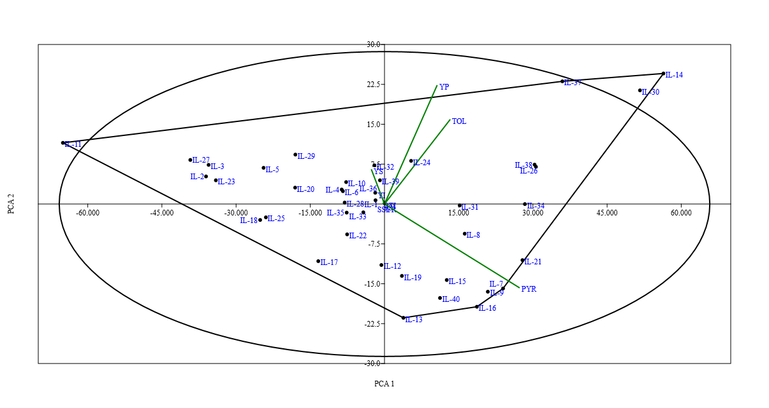
Figure S2. Biplot drawn based on the first and second components obtained from principal component analysis using the grain yield under non-stress (Yp) and stress (Ys) conditions, and low P tolerance indices in introgression lines of O. rufipogon during during wet season 2019
Note: Y_{S} = Yield under low soil P condition, Y_{P} = Yield under normal, STI = Stress Tolerance Index, TOL = Tolerance Index, SSI = Stress Susceptibility Index, YSI = Yield Stability Index, YR = Yield Reduction Ratio, YI = Yield Index, PYR = Per cent Yield Reduction)

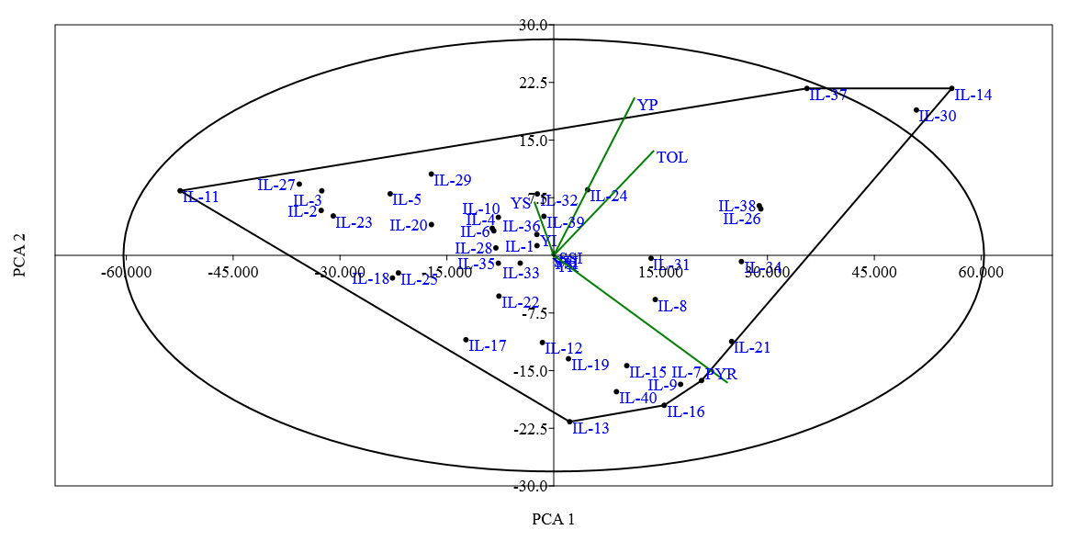

Figure S3. Biplot drawn based on the first and second components obtained from principal component analysis using the grain yield under non-stress (Yp) and stress (Ys) conditions, and low P tolerance indices in introgression lines of O. rufipogon during during dry season 2019.
(Note: Y_{S} = Yield under low soil P condition, Y_{P} = Yield under normal condition, STI = Stress Tolerance Index, TOL = Tolerance Index, SSI = Stress Susceptibility Index, YSI = Yield Stability Index, YR = Yield Reduction Ratio, YI = Yield Index, PYR = Per cent Yield Reduction)

