Table S1. The SSR profiles from the whole genome library database of nipa (Nypa fruticans Wurmb.) using next-generation sequencing.

PARAMETER | COUNT
Total number of sequences examines | 171,845
Total size of examined sequences (bp) | 388,680,787
Total number of identified SSRs | 261,839
Number of SSR containing sequences | 96,424
Number of sequences containing more than 1 SSR | 55.412
Number of SSRs present in compound formation | 65,127

Table S2. Genetic diversity indices of nipa (Nypa fruticans Wurmb.) populations in the Indo-West Pacific Region from 37 samples using microsatellite loci.
Geographic | Genetic Diversity Indices
Location^{z} | N | N_{a} | N_{e} | I | H_{o} | H_{e} | F | %P
PH-NW | 5 | 2.389 | 1.994 | 0.668 | 0.367 | 0.404 | 0.103 | 88.89
PH-SE | 6 | 2.222 | 1.720 | 0.587 | 0.296 | 0.370 | 0.205 | 88.89
ML-NO | 7 | 1.889 | 1.551 | 0.447 | 0.103 | 0.293 | 0.642 | 66.67
ML-SO | 13 | 2.889 | 1.942 | 0.730 | 0.209 | 0.432 | 0.532 | 100.00
SL-SW | 6 | 1.167 | 1.167 | 0.116 | 0.000 | 0.083 | 1.000 | 16.67
Total | 37
Mean |  | 2.111 | 1.675 | 0.510 | 0.195 | 0.316 | 0.388 | 72.22
SE |  | 0.107 | 0.070 | 0.042 | 0.029 | 0.025 | 0.061 | 14.91
^{z}PH-NW = Philippines-northwest; PH-SE = Philippines-southeast; ML-NO = Mainland Southeast Asia-north; ML-SO = Mainland Southeast Asia-south; SL-SW = Sri Lanka- southwest; N = sample size; N_{a} = number of different alleles; N_{e} = number of effective alleles; I = Shannon’s Information Index; H_{o} = observed heterozygosity; H_{e} = expected heterozygosity; F = fixation index; %P = percent polymorphic loci; SE = standard error

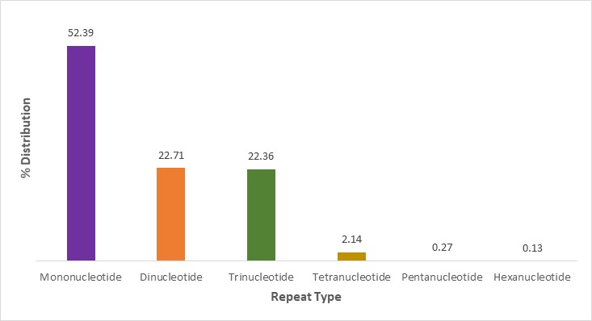
Fig. S1. Percent distribution of repeat types from the whole genome sequences of nipa (Nypa fruticans Wurmb.)

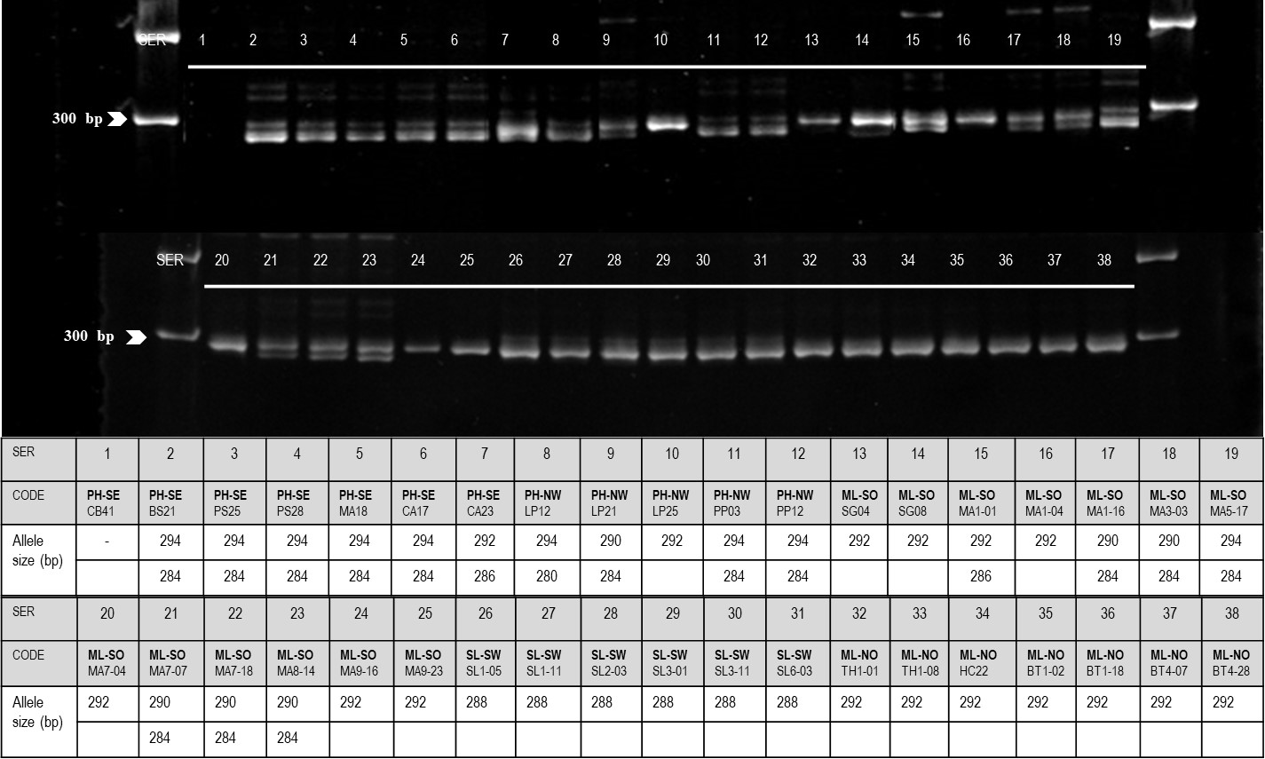
Fig. S2. Results of polyacrylamide gel electrophoresis and the corresponding allele size (bp) of each sample from Indo-West Pacific Region for Nfr58 primer set (Note: The code indicates geographic location followed by sample name; PH-SE = Philippines-southeast; PH-NW = Philippines-northwest; ML-SO = Mainland Southeast Asia-south; SL-SW = Sri Lanka- southwest; ML-NO = Mainland Southeast Asia-north).

