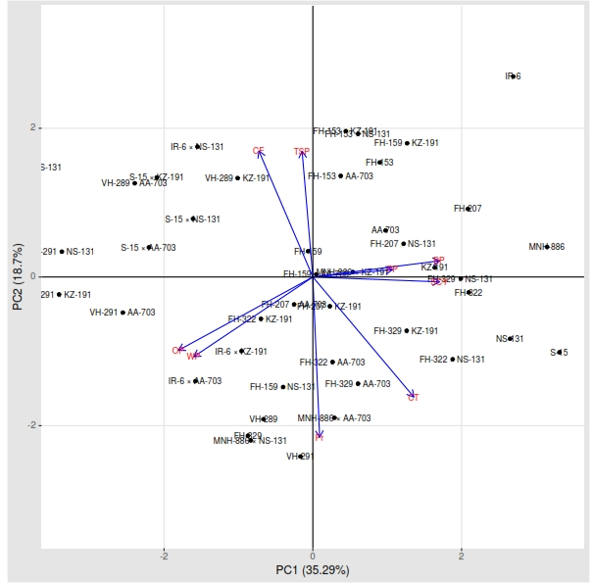
Figure S1. Principal component analysis for studied traits under normal condition
CT – canopy temperature BP – bolls per plant, SCY– seed cotton yield, CF –chlorophyll fluorescence, Pr – proline contents, WP – Water potential, OP – osmotic potential, TSP– total soluble proteins, PP – pressure potential

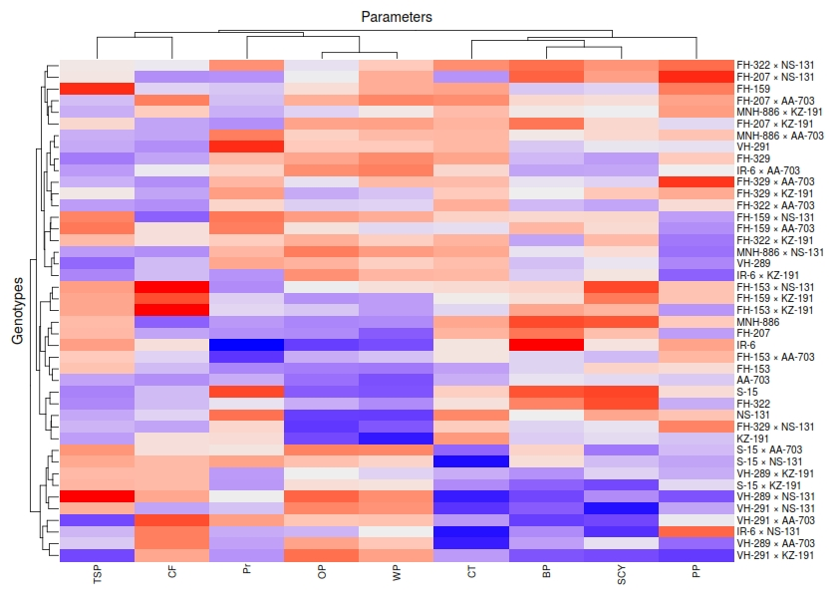
Figure S2. Heat map analysis for studied traits under normal condition
CT – canopy temperature BP – bolls per plant, SCY– seed cotton yield, CF –chlorophyll fluorescence, Pr – proline contents, WP – Water potential, OP – osmotic potential, TSP– total soluble proteins, PP – pressure potential
Note: In the figure, the genotypes on the upper extreme showed the higher mean values for all the traits. Meanwhile red and blue colour shows the higher and lower value respectively of each trait respective to a specific genotype.

Table S1. Mean square values for some physiological and agronomic traits under normal and drought condition.
SOV | DF | CF | CT | WP | OP | PP | Pr | P | BP | SCY
Normal condition
Rep. | 2 | 0.09** | 63.73** | 0.01 | 0.02 | 0.003 | 1.51** | 0.44 | 21.51* | 447.26**
Gen. | 42 | 0.06** | 4.97 | 0.64** | 1.04** | 0.19** | 2.22** | 2.25** | 72.66** | 366.24**
Error | 84 | 0.0037 | 3.5897 | 0.0065 | 0.0722 | 0.0846 | 0.0763 | 0.2679 | 0.1034 | 21.7008
Drought condition
Rep. | 2 | 0.03** | 201.79** | 0.01 | 0.042** | 0.05** | 0.02** | 1.20 | 53.32* | 48.09**
Gen. | 42 | 0.005** | 12.24** | 0.48** | 0.55** | 0.14** | 0.95** | 0.26 | 69.48** | 456.23**
Error | 84 | 0.0005 | 1.5829 | 0.0064 | 0.0046 | 0.0093 | 0.0013 | 0.3696 | 0.0987 | 7.7354
SOV= Sources of variation, DF = degree of freedom, Rep = replications, Gen = Genotypes, CF = chlorophyll fluorescence, CT = canopy temperature, WP = water potential, OP = osmotic potential, PP = pressure potential, P = protein contents, Pr = proline contents, BP = Bolls per plant and SCY = Seed cotton yield

