Supplementary Table 1: The thirteen principal component axes that contributed to the observed variations in the African yam bean accessions from which the principal components biplot analysis was conducted

|  |  |  |  |  |  |  |  |  |  |  |  |  |  |
| --- | --- | --- | --- | --- | --- | --- | --- | --- | --- | --- | --- | --- | --- |
| Axis | 1 | 2 | 3 | 4 | 5 | 6 | 7 | 8 | 9 | 10 | 11 | 12 | 13 |
| TSs-115 | 6.797 | 12.458 | -1.059 | 1.984 | 0.962 | -0.764 | -1.341 | -0.812 | 0.246 | -0.152 | -0.016 | -0.014 | 0.001 |
| TSs-77 | 1.203 | -0.823 | -0.241 | -3.751 | -2.891 | -0.374 | 1.415 | -0.633 | 0.023 | 0.089 | -0.048 | -0.011 | -0.021 |
| TSs-86 | 12.684 | 6.360 | 3.414 | 1.300 | 0.572 | 0.143 | -0.894 | 0.270 | -0.081 | 0.184 | 0.093 | 0.017 | -0.013 |
| TSs-1 | 1.240 | -7.088 | -7.805 | -4.317 | -0.737 | -0.356 | -0.229 | 0.043 | -0.073 | -0.105 | 0.115 | 0.001 | 0.003 |
| TSs-96 | -1.521 | 0.621 | -3.856 | 3.799 | 0.967 | 0.196 | 0.861 | -0.189 | -0.534 | -0.046 | -0.030 | 0.079 | -0.009 |
| TSs-87 | 0.704 | -11.590 | -2.452 | 6.344 | -1.172 | 2.140 | -0.463 | -0.311 | 0.203 | 0.061 | -0.005 | -0.018 | 0.016 |
| TSs-2 | -4.866 | 12.877 | -2.647 | -3.408 | -1.686 | 2.422 | -0.705 | 0.222 | -0.260 | 0.027 | -0.030 | -0.017 | 0.011 |
| TSs-111 | -18.681 | 2.897 | -1.940 | -0.825 | 0.901 | -0.125 | -0.062 | 0.248 | 0.671 | 0.072 | -0.003 | 0.048 | -0.007 |
| Tss-88 | 15.360 | -4.404 | -0.733 | 0.168 | -1.107 | -1.713 | -1.164 | 0.432 | -0.047 | 0.049 | -0.066 | 0.002 | -0.002 |
| TSs-91 | -16.253 | -2.871 | -1.791 | 1.551 | 0.042 | -2.236 | -0.818 | -0.154 | -0.207 | 0.064 | -0.004 | -0.038 | -0.001 |
| TSs-81 | 4.503 | -6.643 | 5.810 | -5.053 | 1.827 | 0.175 | -0.143 | -0.717 | 0.001 | 0.031 | -0.011 | 0.033 | 0.028 |
| TSs-84 | -10.186 | 3.817 | 4.930 | 1.433 | -0.818 | -1.089 | 0.794 | 0.530 | -0.199 | -0.026 | 0.010 | -0.006 | 0.032 |
| TSs-79 | 6.710 | 3.182 | 3.872 | 2.606 | -2.395 | -0.239 | 1.764 | -0.006 | 0.253 | -0.088 | 0.047 | 0.000 | -0.001 |
| TSs-90 | -10.299 | -6.506 | 7.906 | -0.442 | 0.462 | 1.159 | -0.939 | 0.078 | -0.162 | -0.118 | 0.007 | -0.017 | -0.031 |
| TSs-95 | 3.688 | 1.504 | -2.410 | 0.093 | 4.164 | 0.339 | 1.776 | 0.021 | -0.043 | 0.053 | 0.001 | -0.060 | -0.004 |
| TSs-82 | 8.918 | -3.790 | -0.997 | -1.482 | 0.909 | 0.323 | 0.149 | 0.976 | 0.208 | -0.096 | -0.061 | 0.001 | 0.000 |

Supplementary Table 2. Cluster composition of AYB accessions based on morpho-agronomic traits

|  |  |  |  |
| --- | --- | --- | --- |
| Group | Cluster | Number of accessions | Accession code |
| A | A1 | 4 | TSs-1, TSs-84, TSs-79, TSs-86 |
| A2 | 2 | TSs-77, TSs-90 |
| B | B1 | 2 | TSs-115, TSs-96 |
| B2 | 8 | TSs-87, Tss-88, TSs-2, TSs-95, TSs-81, TSs-82, TSs-91, TSs-111 |

C:\Users\Animasaun David\Desktop\AYB\AYB-Graph 2\Slide1.TIF

S. Fig 1: Growth parameters of African yam bean accessions evaluated for variability and genetic diversity at 4-10 weeks after sowing. (a) Stem length (b) Terminal leaf breadth (c) terminal leaf length (d) Number of leaves per plant (d) Number of pry branches (d) Stem girth. All values are means of five replicates and the standard deviation.

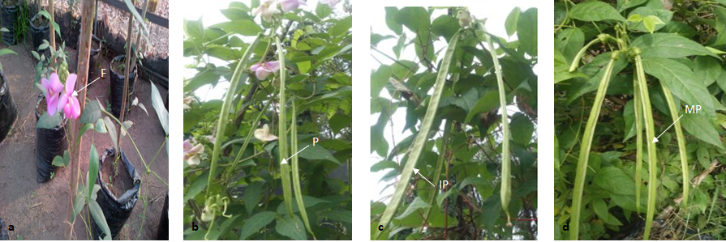

S. Plate 1: (a) Flowering observed in TSs-88 at 53 DAS (b) Pod formation and orientation; P: showing a typical pod (c) IP: Immature pod yet to be filled, and (d) MP; Matured filled pod- of African yam bean accessions

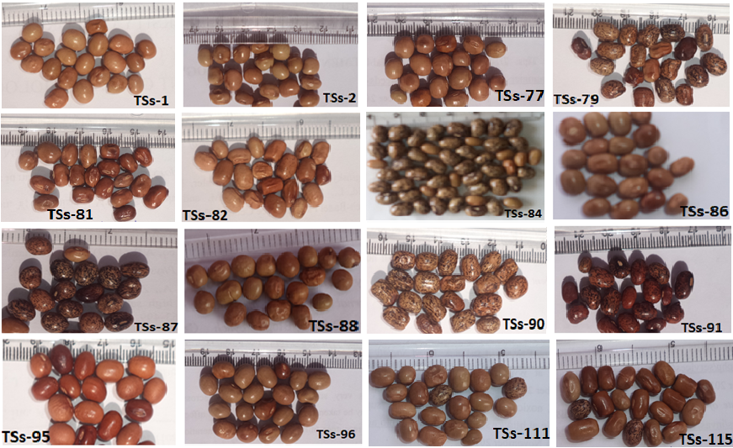

S. Plate 2: The seed phenotypes of the African yam bean accession evaluated for variability and assessment of genetic diversity. The accessions are part of the International Institute of Tropical Agriculture (IITA) African yam beam germplasm collection.



S. Figure 2: Boxplot of the reproductive related traits of the African yam bean accessions evaluated for agronomic trait variability and genetic diversity.

Keys: ND/F: Number of days to flowering; NFC/P: Number of flower cluster per plant; NF/C: Number of flower per cluster; NF/P: Number of flower per plant; NDPF: Number of days to pod formation; NFPD/P: Number of filled pod per plant; PDL: Pod length; PDW: Pod width; NS/P: Number of seed per pod; SL: Seed length; ST: Seed thickness; SD: Seed diameter; and 100-SW: 100 seed weight.



**a**

**b**

Frequency of loci amplification

ISSR markers

Matrix of marker effectiveness

S. Figure 3: (a) The frequency and (b) matrix of the loci amplification showing individual and combined effects of the ISSR markers employed in the assessment of allelic polymorphism and genetic diversity of African yam bean accessions. The blue regions signified poor or null allele amplification while the red regions indicated effective loci and allelic detection and amplification by the markers.

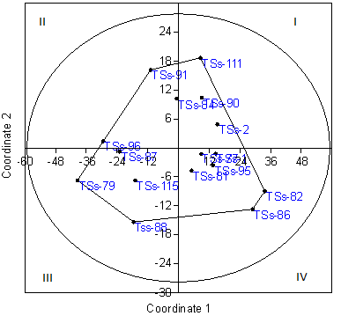

S. Fig. 4: The principal coordinate analysis (PCo1 vs PCo2) of the African yam bean accessions based on the allelic amplification by ISSR markers.