Table S1. List of 75 chickpea genotypes studied for association mapping

Genotype | Pedigree | FW disease reaction | Status
JG62** sensitive check | Local bulk selection | S | Released variety
IPC 2005-45 | DCP92-3 × IPC 71 | R | Advanced breeding line
IPC 2005-37 | L-149 × H-82-2 | MR | Advanced breeding line
IPC 2005-35 | KATILA × BG362 | MR | Advanced breeding line
IPC 2004-8 | IPC94-37 × ICCV96029 | MR | Advanced breeding line
IPC 2005-64 | DCP92-3 × IPC71 | MR | Advanced breeding line
IPC 2005-15 | H-82-2 × X ICCV10 | MR | Advanced breeding line
IPC 2005-34* | ICC4953 × H82-2 | S | Advanced breeding line
IPC 2005-59 | DCP92-3 × IPC71 | MR | Advanced breeding line
IPC 2005-30 | GNG469 × KWR108 | S | Advanced breeding line
IPC 2005-62 | DCP92-3 × T-39-1 | MR | Advanced breeding line
IPC 2005-44 | KPG143-1 × T-39-1 | MR | Advanced breeding line
IPC 2005-54* | PG5 × GNG469 | S | Advanced breeding line
IPC 2005-43** | ICCV10 × PDG84-16 | S | Advanced breeding line
IPC 2005-41(b) | KPG 143-2 × T39-1 | MR | Advanced breeding line
IPC 2005-18 | DCP92-3 × IPC71 × ICC4958 | MR | Advanced breeding line
IPC 2005-27** | GNG469 × KWR108 | S | Advanced breeding line
IPC 2004-3 | Selection from PA079 -9301 | MR | Advanced breeding line
IPCK 2005-46 | H82-94 × H95-67 × HK89131 | MR | Advanced breeding line
IPC 2005-52 | BG362 × BG256 | MR | Advanced breeding line
IPC 2005-24 | DCP92-3 × KTP1 | MR | Advanced breeding line
IPC 2005-19 | DCP92-3 × IPC92-1 | R | Advanced breeding line
IPC 2010-03 | IPCK96-3 × IPCK2004-1 | R | Advanced breeding line
IPC 2007-50 | GNG469 × KWR108 | MR | Advanced breeding line
IPC 2011-76 | CSG892 × FG711 | R | Advanced breeding line
IPC 2011-28 | HC5 × GL23138 | R | Advanced breeding line
IPC 2010-173 | IPC94-132 × BGD 112 | R | Advanced breeding line
IPC 2012-03 | IPC98-12 × BIO25 | MR | Advanced breeding line
IPC 2005-26 | KPG143-2 × T39-1 | MR | Advanced breeding line
IPC 2012-48 | DCP92-3 × BPM | MR | Advanced breeding line
IPC 2008-10 | PDG84-16 × ICC87322 | MR | Advanced breeding line
IPCK 2012-310 | JGK1 × ICC16144 | MR | Advanced breeding line
IPC 2010-185 | Selection from CP-116-15-22 | MR | Advanced breeding line
IPC 2009-153 | DOLLOR × IPCK96-3 | MR | Advanced breeding line
IPC 2010-61 | KWR108 × C. reticulatum | MR | Advanced breeding line
IPC 2012-198 | C214 × K850 | R | Advanced breeding line
IPC 2012-99 | GC98 × ICC14203 | MR | Advanced breeding line
IPC 2007-51 | PDG84-16 × H86-18 | MR | Advanced breeding line
IPC 2010-152 | BG256 × JG16 | MR | Advanced breeding line
IPC 2011-65 | IPC94-94 × IPC2000-4 | MR | Advanced breeding line
IPC 2010-28 | JG315 × ICCV92944 | R | Advanced breeding line
IPC 2010-120 | KWR108 × JG62 | MR | Advanced breeding line
IPC 2010-146 | IPC94-132 × ICCV96029 | MR | Advanced breeding line
IPC 2010-121 | IPC97-7 × IPC95-1 | R | Advanced breeding line
IPCK 2013-209 | Selection from ICARDA28143 line | R | Advanced breeding line
IPC 2007-04 | DCP92-3 × IPC94-19 | R | Advanced breeding line
WR315 tolerant check | Local bulk selection | R | Released variety
IPC 2012-258 | HC5 × PG5 | R | Advanced breeding line
IPC 2007-36 | DCP92-3 × IPC92-1 | R | Advanced breeding line
IPC 2010-78 | CSG8962 × K850 | R | Advanced breeding line
IPC 2011-94 | JG16 × IPC99-18 | R | Advanced breeding line
IPCK 2013-248 | Selection from ICARDA 16116 | R | Advanced breeding line
IPC 2009-66 | Selection from ICARDA LINE | R | Advanced breeding line
IPC 2007-28 | DCP92-3 × SAKI9516 | R | Advanced breeding line
C-104** | Derivative of PB7 × rabat | S | Released variety
IPC 2010-207 | Selection from CP-211-2-3 | MR | Advanced breeding line
IPCK 2012-306 | Selection from ICARDA17/22 line | R | Advanced breeding line
IPC 2011-31 | BG256 × PG5 | R | Advanced breeding line
IPC 2011-45* | Selection from ICARDA 24112 | S | Advanced breeding line
IPC 2011-258* | Selection from ICARDA line | S | Advanced breeding line
IPC 2011-36 | KWR108 × RSG865 | R | Advanced breeding line
IPC 2011-78 | IPC98-12 × FG712 | MR | Advanced breeding line
IPC 2011-248* | Selection from ICARDA line | S | Advanced breeding line
IPC 2011-15** | IPC98-12 × ICC395466 | S | Advanced breeding line
IPC 2011-66 | IPC2002-120× IPC2000-4 | MR | Advanced breeding line
IPC 2016-186 | IPC06-88 × ILWC179 | R | Advanced breeding line
IPC 2016-36 | IPC06-127 × ILWC245 | R | Advanced breeding line
IPC 2016-50 | WR315 × IPCK02 | R | Advanced breeding line
IPC 2016-44 | IPC2008-57 × WR315 | R | Advanced breeding line
IPC 2016-31 | IPC09-50 × BPM | MR | Advanced breeding line
IPC 2016-74 | IPC09-50 × IPC2007-88 | MR | Advanced breeding line
IPC 2016-91 | HC5 × DCP92-3 | R | Advanced breeding line
IPC 2016-69 | KWR108 × JG14 | R | Advanced breeding line
IPC 2016-03 | WR315 × IPCK02 | R | Advanced breeding line
IPC 2016-85 | IPCK02 × ILWC21 | R | Advanced breeding line
R=resistant, MR=moderately resistant, S=susceptible
**=early wilting, *=late wilting

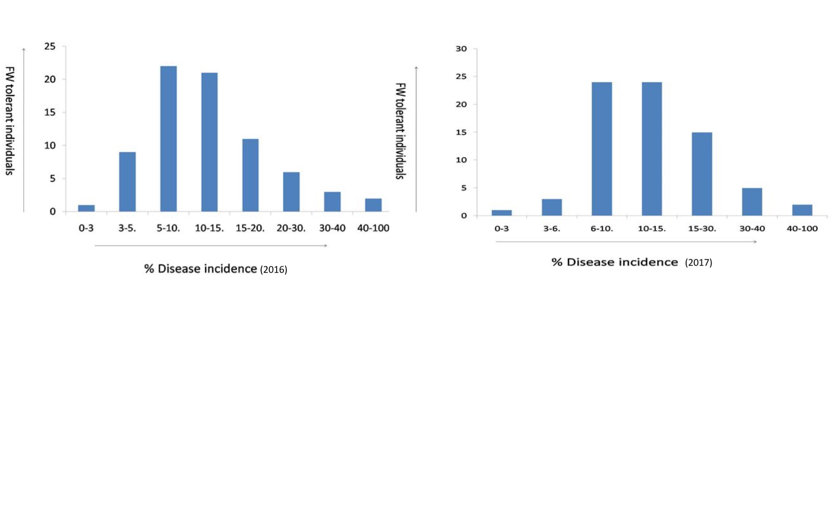
Fig. S1. Frequency distribution of disease incidence in the 75 studied chickpea genotypes in the year 2016 & 2017

 | Table S2. Number of alleles, gene diversity and polymorphism recorded in 75 chickpea genotypes
Marker |  | Allele No. (Na) | Gene Diversity (He) | Heterozygosity | PIC | LG |  | Reference
TA106 |  | 8 | 0.77 | 0.05 | 0.74 | LG6 |  | Winter et al.(2000)
TS35 |  | 3 | 0.55 | 0.07 | 0.46 | LG5 |  | Winter et al.(1999)
NCPGR40 |  | 3 | 0.55 | 0 | 0.48 | LG2 |  | Sethy et al.(2006)
NCPGR129 |  | 4 | 0.44 | 0.15 | 0.38 | LG4 |  | Choudhary et al.(2012)
TA2 |  | 4 | 0.73 | 0.08 | 0.68 | LG4 |  | Winter et al. (1999)
CESSR172 |  | 3 | 0.46 | 0.01 | 0.39 | LG2 |  | Choudhary et al.(2012)
ICCM0124 |  | 4 | 0.56 | 0.24 | 0.5 | LG3 |  | Nayak et al.(2010)
NCPGR274 |  | 3 | 0.64 | 0.07 | 0.57 | LG3 |  | Choudhary et al.(2012)
NCPGR255 |  | 6 | 0.8 | 0.95 | 0.77 | LG7 |  | Choudhary et al.(2012)
NCPGR278 |  | 3 | 0.54 | 0.11 | 0.48 | LG7 |  | Choudhary et al.(2012)
GAA44 |  | 2 | 0.48 | 0.09 | 0.37 | LG7 |  | Winter et al.(2000)
NCPGR249 |  | 2 | 0.19 | 0 | 0.17 | LG1 |  | Choudhary et al.(2012)
H2L102 |  | 5 | 0.74 | 0.03 | 0.7 | LG5 |  | Choudhary et al.(2012)
STMS12 |  | 2 | 0.49 | 0 | 0.37 | LG1 |  | Lichtenzveig et al. (2005)
NCPGR217 |  | 2 | 0.49 | 0 | 0.37 | LG5 |  | Gaur et al.(2011)
NCPGR232 |  | 4 | 0.67 | 0.01 | 0.61 | LG5 |  | Choudhary et al.(2012)
NCPGR238 |  | 4 | 0.65 | 0.01 | 0.58 | LG6 |  | Gaur et al.(2011)
NCPGR46 |  | 2 | 0.49 | 0 | 0.37 | LG6 |  | Sethy et al.(2006)
CESSR88 |  | 2 | 0.41 | 0 | 0.33 | LG3 |  | Choudhary et al.(2012)
ICCeM036 |  | 5 | 0.76 | 0.19 | 0.72 | LG6 |  | Gujaria et al.(2011)
Cak TpSSR2543 |  | 3 | 0.57 | 0.11 | 0.51 | - |  | -
NCPGR149 |  | 6 | 0.77 | 0.39 | 0.73 | - |  | -
NCPGR231 |  | 4 | 0.71 | 0.09 | 0.66 | LG4 |  | Gaur et al.(2011)
NCPGR234 |  | 5 | 0.71 | 0.03 | 0.66 | - |  | Gaur et al.(2011)
NCPGR136 |  | 5 | 0.76 | 0.2 | 0.73 | LG1 |  | Gaur et al.(2011)
STMS10 |  | 4 | 0.65 | 0.01 | 0.59 | LG3 |  | Winter et al. (1999)
GA105 |  | 2 | 0.44 | 0.03 | 0.35 | LG3 |  | Winter et al.(2000)
ICCeM018 |  | 2 | 0.49 | 0.07 | 0.37 | LG3 |  | Winter et al. (2000)
TR19 |  | 6 | 0.72 | 0.16 | 0.67 | LG2 |  | Winter et al. (2000)
TS54 |  | 6 | 0.78 | 0.23 | 0.74 | LG4 |  | Winter et al. (2000)
NCPGR76 |  | 2 | 0.5 | 0 | 0.37 | LG4 |  | Sethy et al. (2006)
CESSR164 |  | 3 | 0.6 | 0.01 | 0.52 | LG4 |  | Choudhary et al.(2012)
CESSR114 |  | 2 | 0.47 | 0 | 0.36 | LG4 |  | Choudhary et al.(2012)
TAAS |  | 7 | 0.77 | 0.21 | 0.74 | LG5 |  | Winter et al.(2000)
NCPGR139 |  | 6 | 0.73 | 0.15 | 0.68 | LG6 |  | Choudhary et al.(2012)
TA176 |  | 7 | 0.72 | 0.24 | 0.69 | LG6 |  | Winter et al. (1999)
NCPGR199 |  | 3 | 0.48 | 0.21 | 0.38 | LG4 |  | Gaur et al.(2011)
NCPGR200 |  | 3 | 0.6 | 0.09 | 0.54 | LG6 |  | Choudhary et al.(2012)
TA80 |  | 6 | 0.76 | 0.37 | 0.73 | LG6 |  | Winter et al.(2000)
GA102 |  | 3 | 0.57 | 0 | 0.49 | LG7 |  | -
H4F07 |  | 4 | 0.69 | 0.25 | 0.63 | LG5 |  | Gujaria et al.(2011)
CESSR432 |  | 2 | 0.39 | 0 | 0.31 | LG5 |  | Choudhary et al.(2012)
NCPGR56 |  | 3 | 0.63 | 0 | 0.56 | LG5 |  | Sethy et al. (2006)
GA9 |  | 4 | 0.58 | 0.04 | 0.51 | LG6 |  | Winter et al.(2000)
H5A04 |  | 3 | 0.63 | 0.05 | 0.56 | LG6 |  | Lichtenzveig et al. (2005)
NCPGR177 |  | 2 | 0.47 | 0.05 | 0.36 | LG6 |  | Choudhary et al.(2012)
STMS2 |  | 4 | 0.56 | 0.05 | 0.47 | LG4 |  | Winter et al.(1999)
GA21 |  | 4 | 0.67 | 0.01 | 0.61 | - |  | Winter et al. (1999)
CESSR142 |  | 3 | 0.49 | 0.01 | 0.38 | LG3 |  | Choudhary et al.(2012)
GAA47 |  | 2 | 0.49 | 0.01 | 0.37 | LG4 |  | Winter et al. (1999)
TAASH |  | 5 | 0.72 | 0.03 | 0.68 | LG5 |  | Winter et al. (1999)
STMS22 |  | 3 | 0.55 | 0.11 | 0.49 | LG5 |  | Lichtenzveig et al. (2005)
NCPGR91 |  | 4 | 0.73 | 0.09 | 0.68 | LG4 |  | Sethy et al. (2006)
ICCM0196 |  | 4 | 0.73 | 0.07 | 0.68 | LG7 |  | Lichtenzveig et al. (2005)
NCPGR171 |  | 2 | 0.37 | 0.01 | 0.3 | LG3 |  | Choudhary et al.(2012)
CESSR53 |  | 3 | 0.42 | 0.07 | 0.35 | LG3 |  | Choudhary et al.(2012)
NCPGR123 |  | 3 | 0.5 | 0.13 | 0.44 | LG6 |  | Choudhary et al.(2012)
ICCM0065b |  | 3 | 0.56 | 0.07 | 0.47 | LG4 |  | Lichtenzveig et al. (2005)
TS72 |  | 2 | 0.46 | 0.01 | 0.35 | LG4 |  | Winter et al. (1999)
NCPGR187 |  | 2 | 0.49 | 0 | 0.37 | LG6 |  | Choudhary et al.(2012)
NCPGR180 |  | 3 | 0.56 | 0 | 0.48 | LG3 |  | Choudhary et al.(2012)
ICCeM028 |  | 3 | 0.55 | 0.07 | 0.46 | LG3 |  | Gujaria et al.(2011)
NCPGR43 |  | 3 | 0.65 | 0.05 | 0.58 | LG3 |  | Sethy et al. (2006)
STMS4 |  | 4 | 0.74 | 0.19 | 0.69 | LG3 |  | Winter et al. (1999)
ICCM034 |  | 2 | 0.3 | 0 | 0.26 | LG7 |  | Lichtenzveig et al. (2005)
NCPGR145 |  | 2 | 0.48 | 0.08 | 0.36 | LG5 |  | Choudhary et al.(2012)
TA34 |  | 3 | 0.59 | 0.01 | 0.51 | LG1 |  | Winter et al.(1999)
TR26 |  | 4 | 0.6 | 0.08 | 0.54 | LG1 |  | Winter et al.(1999)
NCPGR33 |  | 3 | 0.57 | 0 | 0.5 | LG1 |  | Sethy et al.(2006)
CESSR433 |  | 4 | 0.67 | 0.05 | 0.61 | LG1 |  | Choudhary et al.(2012)
TA14 |  | 3 | 0.57 | 0.11 | 0.5 | LG4 |  | Winter et al.(1999)
NCPGR254 |  | 3 | 0.65 | 0 | 0.57 | LG5 |  | Choudhary et al.(2012)
H2B19 |  | 5 | 0.72 | 0.21 | 0.67 | LG7 |  | Choudhary et al.(2012)
ICCM0284 |  | 4 | 0.65 | 0.08 | 0.58 | LG6 |  | Nayak et al. (2010)
NCPGR220 |  | 3 | 0.66 | 0.01 | 0.59 | LG3 |  | Choudhary et al.(2012)
Mean |  | 3.56 | 0.59 | 0.09 | 0.52

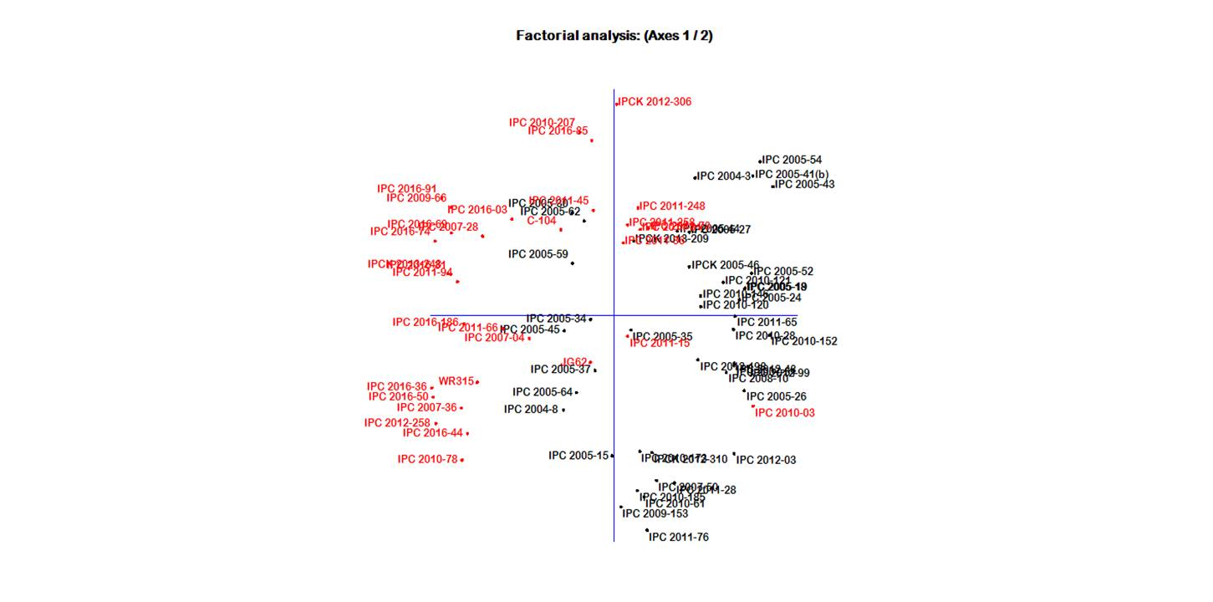

Fig. S3. Factorial analysis of the 75 chickpea genotypes for FW resistance

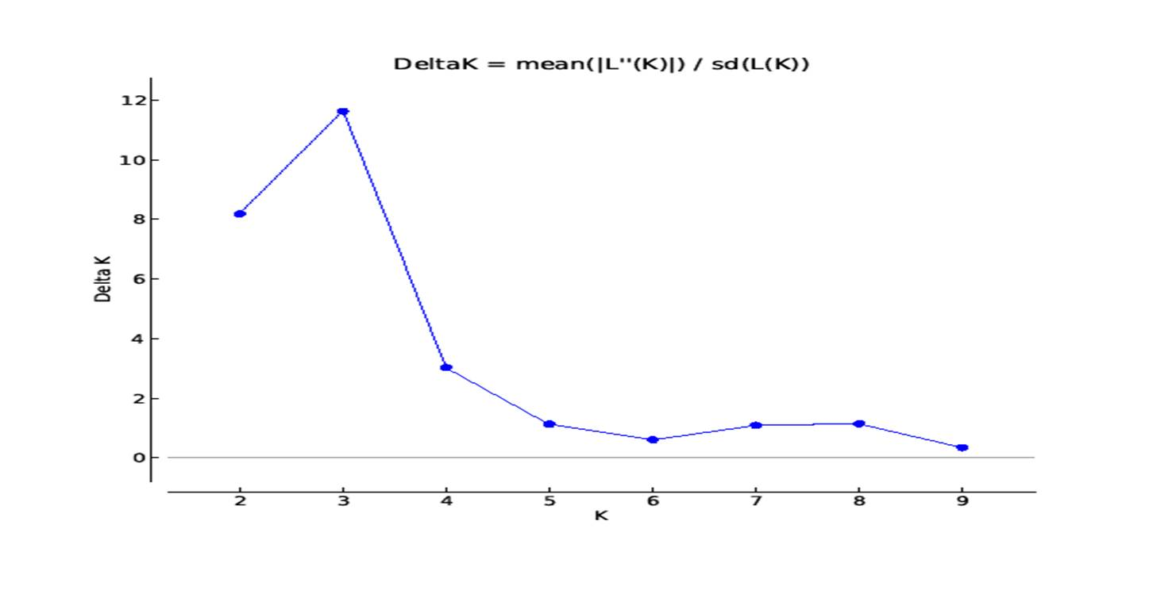
Fig.S4. Relationship between K and ΔΚ based on STRUCTURE analysis of 75 chickpea genotypes based on SSR marker

