Table S1. Morphological traits evaluated in nine chili peppers landraces from Yucatan Peninsula.
Variables | Score and Measurement technics
Quantitative
Cotyledonous leaf length (cm) | Measured in fully developed cotyledons
Cotyledonous leaf width (cm) | Measured in fully developed cotyledons, at the widest point
Stem height (cm) | Measured when the first fruit begins to mature in 50% of the plants
Stem width (cm) | Measured after the first harvest, at the widest point
Stem length (cm) | Measured until the first bifurcation, immediately after the first harvest
Leaf length (cm) | Measured from the apex to the base of the leaf
Leaf width (cm) | Measured at the widest part of the leaf
Anther length (mm) | Measured immediately after anthesis
Filament length (mm) | Measured immediately after anthesis
Fruit length (cm) | Measured in mature fruits of the second harvest, from the union of the fruit with the pedicel to the fruit apex
Fruit width (cm) | Measured in mature fruits of the second harvest, at the widest point
Fruit weight (g) | Grams
Fruit pedicel length (cm) | Measured from the point of union of the pedicel with the fruit to the end of the pedicel
Fruit wall thickness (mm) | Measured in ripe fruit of the second harvest, at the widest point of the pericarp
Seed diameter (mm) | Measured at the widest point of the seed
Qualitative

Hypocotyl color | Ordinal: 1 = white; 2 = green; 3 = purple
Hypocotyl pubescence | Ordinal: 3 = scarce; 5 = intermediate; 7 = dense
Cotyledon shape | Ordinal: 1 = deltoid; 2 = oval; 3 = lanceolate; 4 = elongated-deltoid
Stem color | Ordinal: 1 = green; 2 = green with purple stripes; 3 = purple; 4 = other
Nodal anthocyanin | Ordinal: 1 = green; 3 = light purple; 5 = purple; 7 = dark purple
Stem shape | Ordinal: 1 = cylindrical; 2 = angular; 3 = flattened
Stem pubescence | Ordinal: 3 = scarce; 5 = intermediate; 7 = dense
Growth habit | Ordinal: 3 = prostrate; 5 = intermediate; 7 = erect; 9 = other
Branching density | Ordinal: 3 = scarce; 5 = intermediate; 7 = dense
Tillering | Ordinal: 3 = scarce; 5 = intermediate; 7 = dense
Leaf density | Ordinal: 3 = scarce; 5 = intermediate; 7 = dense
Leaf color | Ordinal: 1 = yellow; 2 = light green; 3 = green; 4 = dark green; 5 = light purple; 6 = purple; 7 = variegated
Leaf shape | Ordinal: 1 = deltoid; 2 = oval; 3 = lanceolate
Leaf blade margin | Ordinal: 1 = integer; 2 = wavy; 3 = ciliate
Leaf pubescence | Ordinal: 3 = scarce; 5 = intermediate; 7 = dense
Number of flowers per axil | Ordinal: 1 = one; 2 = two; 3 = three or more; 4 = many flowers in clusters, but each one in an individual axil; 5 = other

Table S1 continued
Variables | Score and Measurement technics
Flower position | Ordinal: 3 = pending; 5 = intermediate; 7 = erect
Corolla color | Ordinal: 1 = white; 2 = light yellow; 3 = yellow; 4 = yellow-green; 5 = purple with purple base; 6 = white with purple base; 7 = white with purple margin; 8 = purple
Corolla spot color | Ordinal: 1 = white; 2 = yellow; 3 = yellow-green; 4 = green; 5 = purple; 6 = other
Corolla length | Coded: 1 = <1.5; 2 = 1.5-2.5; 3 = >2.5
Anther color | Ordinal: 1 = white; 2 = yellow; 3 = pale blue; 4 = blue; 5 = purple; 6 = other
Filament color | Ordinal: 1 = white; 2 = yellow; 3 = green; 4 = blue; 5 = light purple; 6 = purple; 7 = other
Stigma exertion | Ordinal: 3 = inserted; 5 = at the same level; 7 = exerted
Calyx margin | Ordinal: 1 = integral (smooth); 2 = intermediate; 3 = toothed; 4 = other
Fruit set | Ordinal: 3 = low; 5 = intermediate; 7 = high
Fruit color at the intermediate stage | Ordinal: 1 = white; 2 = yellow; 3 = green; 4 = orange; 5 = purple; 6 = dark purple; 7 = other
Fruit color at the mature stage | Ordinal: 1 = white; 2 = lemon-yellow; 3 = pale yellow-orange; 4 = yellow-orange; 5 = pale orange; 6 = orange; 7 = light red; 8 = red; 9 = dark red; 10 = purple; 11 = brown; 12 = black; 13 = other
Fruit shape | Ordinal: 1 = elongated; 2 = almost round; 3 = triangular; 4 = campanulate; 5 = blocky bell-shaped; 6 = other
Fruit shape at pedicel attachment | Ordinal: 1 = acute; 2 = obtuse; 3 = truncated; 4 = rounded; 5 = lobed
Fruit shape at blossom end | Ordinal: 1 = peak ; 2 = dull; 3 = sunken ; 4 = sunken and peak ; 5 = other
Fruit blossom end appendage | Ordinal: 0 = absent; 1 = present
Transverse fruit corrugation | Ordinal: 3 = slightly corrugated; 5 = intermediate; 7 = very corrugated
Number of locules | Numeric
Fruit surface | Ordinal: 1 = smooth; 2 = semi rough; 3 = rough
Pedicel attachment to fruit | Ordinal: 3 = deciduous; 5 = intermediate; 7 = persistent
Pedicel attachment to stem | Ordinal: 3 = deciduous; 5 = intermediate; 7 = persistent
Seed color | Ordinal: 1 = dark yellow; 2 = brown; 3 = black; 4 = other
Seed surface | Ordinal: 1 = smooth; 2 = rough; 3 = wrinkled
Seed size | Ordinal: 3 = small; 5 = intermediate; 7 = large
Number of seeds per fruit | Numeric

Table S2. Results of principal component analysis (PCA), obtained with qualitative data of nine landraces of Capsicum spp., cultivated in the Yucatan Peninsula.
Variable | Main components
 | PC1 |  |  | PC2 |  |  | PC3 |  | PC4
Eigenvalue | 13.07 |  |  | 7.15 |  |  | 5.35 |  | 4.58
Proportion of variance explained (%) | 33.51 |  |  | 18.34 |  |  | 13.73 |  | 11.76
Proportion of cumulative variance (%) | 33.51 |  |  | 51.85 |  |  | 65.59 |  | 77.35
Variables evaluated |  |  | Correlation values
Hypocotyl color | 0.226 |  |  | 0.529 |  |  | 0.488 |  | -0.206
Hypocotyl pubescence | -0.820 |  |  | -0.024 |  |  | -0.316 |  | 0.169
Cotyledon shape | 0.399 |  |  | -0.367 |  |  | 0.367 |  | -0.664
Stem color | 0.430 |  |  | -0.019 |  |  | -0.297 |  | -0.203
Nodal anthocyanin | 0.781 |  |  | 0.101 |  |  | -0.466 |  | -0.027
Stem shape | 0.332 |  |  | -0.880 |  |  | 0.283 |  | -0.078
Stem pubescence | 0.159 |  |  | -0.007 |  |  | 0.542 |  | -0.285
Growth habit | 0.322 |  |  | -0.880 |  |  | 0.283 |  | -0.078
Branching density | -0.627 |  |  | -0.607 |  |  | 0.415 |  | 0.229
Tillering | -0.703 |  |  | -0.570 |  |  | -0.088 |  | 0.294
Leaf density | -0.607 |  |  | -0.504 |  |  | 0.547 |  | -0.088
Leaf color | 0.500 |  |  | -0.367 |  |  | -0.230 |  | 0.653
Leaf shape | 0.344 |  |  | -0.170 |  |  | -0.172 |  | 0.650
Leaf blade margin | -0.870 |  |  | 0.283 |  |  | -0.077 |  | -0.328
Leaf pubescence | -0.456 |  |  | 0.128 |  |  | 0.660 |  | 0.051
Number of flowers per axil | -0.322 |  |  | 0.880 |  |  | -0.283 |  | 0.078
Flower position | -0.595 |  |  | 0.047 |  |  | -0.466 |  | 0.129
Corolla color | -0.641 |  |  | 0.718 |  |  | -0.224 |  | -0.110
Corolla spot color | -0.878 |  |  | 0.096 |  |  | -0.015 |  | -0.379
Corolla length | 0.581 |  |  | 0.142 |  |  | 0.532 |  | -0.083
Anther color | 0.205 |  |  | 0.395 |  |  | 0.203 |  | -0.800
Filament color | -0.880 |  |  | 0.176 |  |  | -0.042 |  | -0.360
Stigma exertion | -0.331 |  |  | 0.136 |  |  | 0.534 |  | 0.239
Calyx margin | 0.376 |  |  | 0.397 |  |  | -0.334 |  | -0.132
Fruit set | 0.624 |  |  | 0.026 |  |  | -0.662 |  | -0.100
Fruit color at the mature stage | -0.315 |  |  | -0.181 |  |  | 0.703 |  | 0.193
Fruit shape | -0.404 |  |  | 0.249 |  |  | 0.140 |  | 0.778
Fruit shape at pedicel attachment |  | 0.669 |  |  | 0.477 | 0.168 |  | 0.346
Fruit shape at blossom end |  | -0.482 |  |  | 0.336 | 0.145 |  | 0.585
Fruit blossom end appendage |  | 0.282 |  |  | 0.239 | 0.554 |  | 0.363
Fruit cross-sectional corrugation |  | -0.031 |  |  | 0.846 | 0.205 |  | 0.333
Number of locules |  | 0.325 |  |  | 0.572 | 0.652 |  | 0.263
Fruit surface |  | -0.036 |  |  | 0.513 | 0.186 |  | 0.147
Pedicel attachment to fruit |  | 0.850 |  |  | 0.371 | 0.133 |  | -0.006
Pedicel attachment to stem |  | 0.560 |  |  | -0.180 | -0.138 |  | -0.175
Seed color |  | 0.931 |  |  | -0.223 | 0.114 |  | 0.200
Seed surface |  | -0.725 |  |  | 0.264 | 0.270 |  | -0.491
Seed size |  | 0.850 |  |  | 0.344 | 0.319 |  | -0.108
Number of seeds per fruit |  | 0.926 |  |  | 0.282 | 0.121 |  | -0.185

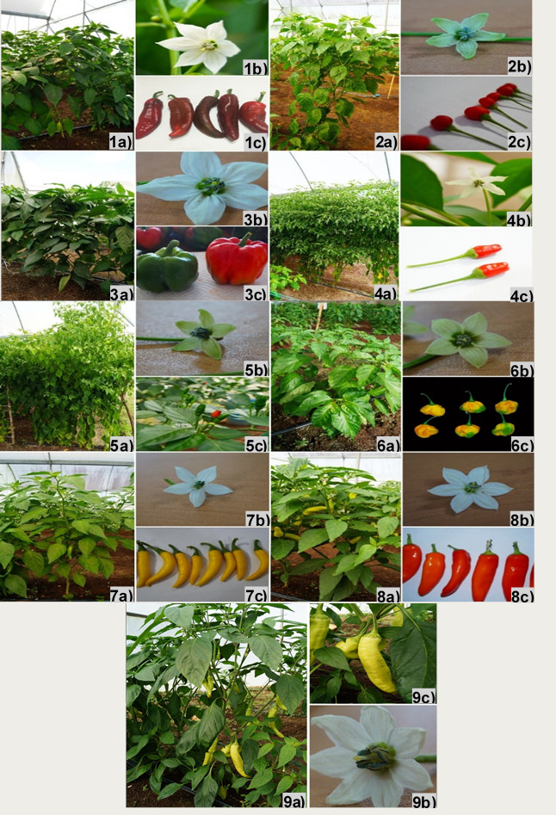

Figure S1. Morphological traits of chili pepper landraces cultivated in Yucatan Peninsula, Mexico. 1) Bobo landrace; 2) Bolita landrace; 3) Dulce landrace; 4) Maax landrace; 5) Pico paloma landrace; 6) Rosita landrace; 7) Verde landrace; 8) Xcat’ik1 landrace; 9) Xcat’ik2 landrace. In all cases plant, flower, and fruit are a, b, and c, respectively.

