Evaluation of Triticum durum - Aegilops tauschii derived primary synthetics as potential sources of heat stress tolerance for wheat improvement
Amandeep Kaur^{1*}, Parveen Chhuneja¹, Puja Srivastava², Kuldeep Singh^{1,3} and Satinder Kaur¹
- School of Agricultural Biotechnology, Punjab Agricultural University, Ludhiana, India
- Department of Plant Breeding and Genetics, Punjab Agricultural University, Ludhiana, India
- Present address: National Bureau of Plant Genetic Resources, Pusa Road, New Delhi, India
*Corresponding author email: aman-coasab@pau.edu
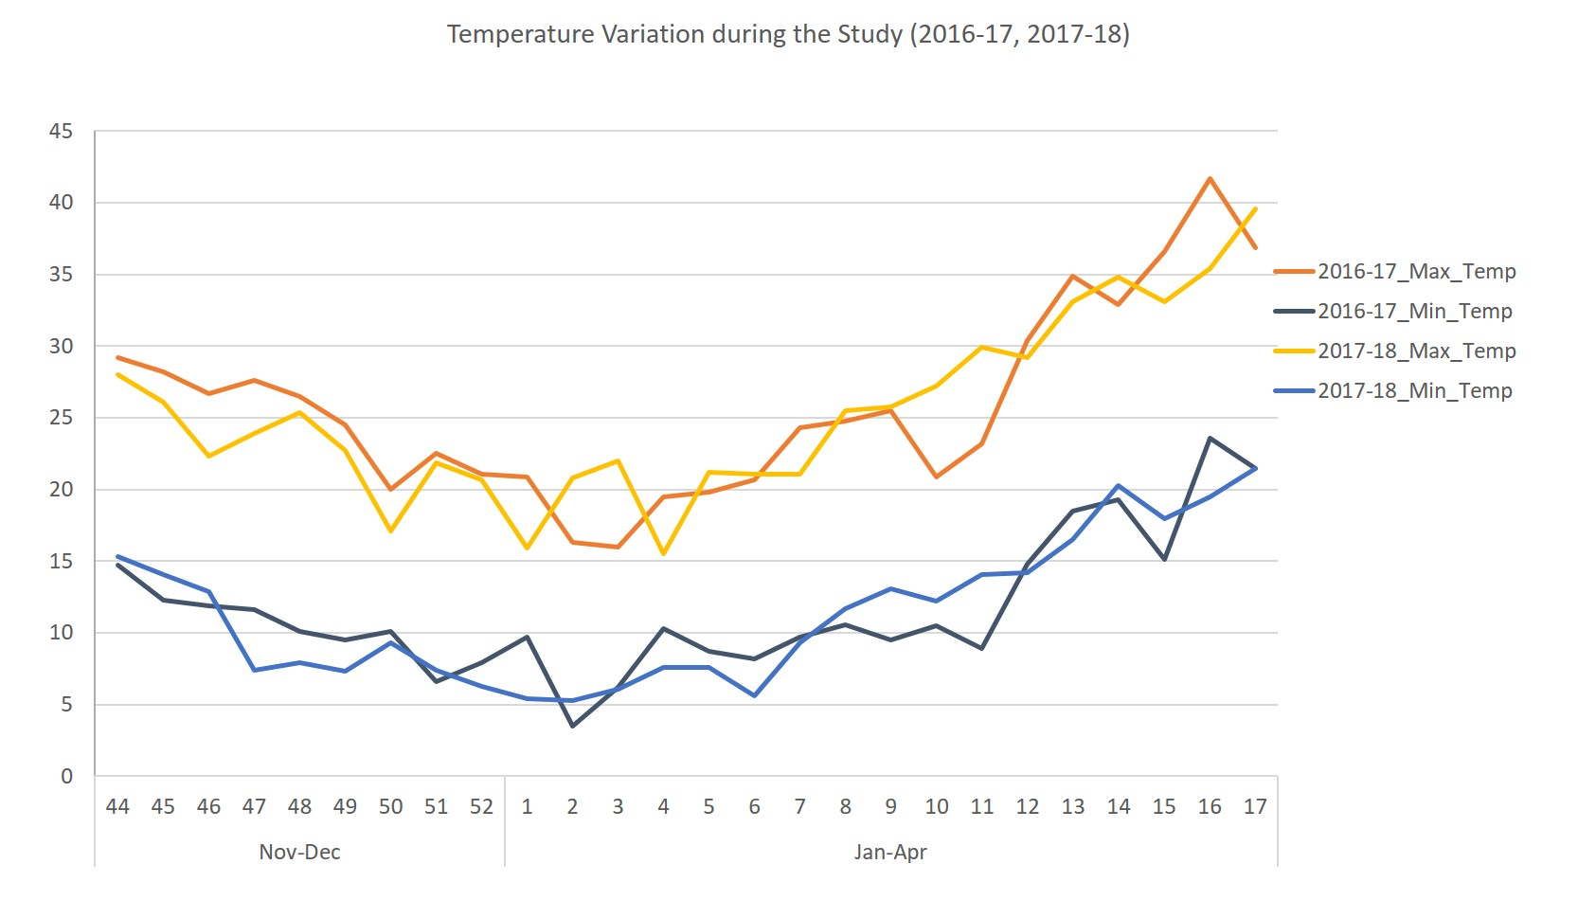
Figure S1: Temperature variation over two growing seasons in the present study

