Table S1. Information on SSR primers and their amplification results
Primers | Sequences (5’→3’) | repeat motifs | fragment size /bp | annealing temperature /℃
CUJRA123 | F-TTGGTCTCTTCTTTCCTCTATG | (AC)₁₂ | 198–212 | 53
 | R-TCGAACGTACAATAACGTACAG
CUJRA124 | F-CGTTGCCTGAACAAGTAAGAT | (GT)₁₃ | 165–184 | 58
 | R-GAAGGAGGCTAACTCCCTATG
CUJRA206 | F-GCCGAGAGAGGAAGAGAGACT | (AC)₁₆ | 200–212 | 60
 | R-CGACTACAGGGACCAATCAAC
CUJRB012 | F-ACTCATCAAGATCCCCGACTAC | (AG)₁₅ | 96–118 | 56
 | R-CCACATCGTCTGGGTTCAT
CUJRB103 | F-CATGCTATGGACTACCTCCTC | (TC)₁₇ | 144–174 | 58
 | R-AAGAGAGACGAACGAAGAGTG
CUJRB218 | F-CTAGCGTCGAAGAAGAAGATG | (GA)₁₃ | 168–174 | 58
 | R-TTGTTTCTCCTCTGTCATGTTT
CUJRB220 | F-AGCATGTATAGGCCAATGATG | (TC)₂₅ | 147–196 | 60
 | R-TCGTTCTATCTACAAGCACTCG
CUJRB305 | F-GCTGCTTTATTAGCCATGATC | (GA)₁₉ | 133–179 | 56
 | R-GGTTCAATGTGCAACAAGAG
CUJRB307 | F-CTGGGCTGAAGGAGAATC | (GA)₂₃ | 146–181 | 60
 | R-TTGGATGTCTGCTTTTTTAGAG
CUJRB317 | F-TGCCCACTAACCCTAACC | (TC)₁₇ | 131–151 | 53
 | R-GAGAAAAAGAATGGCTGTATTG
CUJRC310 | F-GCTGTTAGTGGAATCCCAACT | (TTG)₇ | 162–172 | 60
 | R-TAAACGTGATCGAAGTGAAATG
CUJRD204 | F-CAGCCAATCTTCTTCTGCTTC | (CTC)₄ | 172–174 | 60
 | R-GAGACCTACGACCACGATCAC
JH2753 | F-CAGTTTTGGCCAGCTGCAAT | (GCT)₆ | 188–212 | 55
 | R-TGTGCCCATGCTAAGACTGG
ZMZ11 | F-CCAGAACCAGGAGCCAGCAA | (CTG)₇ | 162–175 | 55
 | R-GACCATCGGCCCGAAAGTAA
JRE-46 | F-GCCTCTCCTCGTGCTCATTT | (GAA)₁₈ | 190–220 | 60
 | R-ACTCGCTACTTTTCAGGCCC
JSI-15 | F-ATGAGAGCCAGCCAACAGAC | (TC)₆ | 180–200 | 60
 | R-CGAGCGAGCAAGAGAGAGAG
JSI-63 | F-TCCGGACAACTCCTCATCCT | (GATCG)₅ | 203–208 | 60
 | R-CTCTCCGCCGAGTCATGTAC
JSI-71 | F-AGCTAGCTCTCAAACAACAAGC | (GCAGTA)₈ | 135–155 | 60
 | R-ACAAACATGGCAACCTTCGTG
JSI-73 | F-AGCTCAACGGTCAAGGAAGG | (TGCTCG)₅ | 160–175 | 60
 | R-GGAGAGAGAGAGCTCGGCTA
 | R-GGTTCTTCCGCAGTTGGTCT
JUG-13 | F-GAAGAGACTCCGTTGCCACA | (GGA)₅ | 240–250 | 60
 | R-ACTCCGTCGTTTCCCTGAAC

Table S2. Diversity of 20 SSR loci in all tested collections of iron walnut in Yunnan
Loci | N | H_{o} | H_{e} | I | PIC | N_{m} | F_{IT} | F_{IS} | F_{ST}
CUJRA123 | 13 | 0.42 | 0.69 | 1.37 | 0.67 | 4.03 | 0.40 | 0.40 | 0.06
CUJRA124 | 21 | 0.27 | 0.43 | 1.04 | 0.49 | 4.90 | 0.37 | 0.38 | 0.05
CUJRA206 | 18 | 0.25 | 0.60 | 1.44 | 0.70 | 2.51 | 0.54 | 0.59 | 0.09
CUJRB012 | 19 | 0.50 | 0.56 | 1.28 | 0.64 | 3.63 | 0.08 | 0.11 | 0.06
CUJRB103a | 23 | 0.40 | 0.58 | 1.33 | 0.61 | 5.12 | 0.33 | 0.32 | 0.05
CUJRB218 | 20 | 0.67 | 0.74 | 1.63 | 0.74 | 6.56 | 0.09 | 0.09 | 0.04
CUJRB220 | 25 | 0.63 | 0.78 | 1.78 | 0.78 | 8.58 | 0.19 | 0.19 | 0.03
CUJRB305 | 24 | 0.22 | 0.36 | 0.72 | 0.36 | 7.61 | 0.35 | 0.38 | 0.03
CUJRB307 | 27 | 0.62 | 0.78 | 1.86 | 0.79 | 8.13 | 0.21 | 0.20 | 0.03
CUJRB317 | 17 | 0.62 | 0.69 | 1.53 | 0.72 | 4.13 | 0.13 | 0.11 | 0.06
CUJRC310 | 8 | 0.35 | 0.55 | 0.95 | 0.55 | 2.42 | 0.37 | 0.36 | 0.09
CUJRD204 | 14 | 0.30 | 0.48 | 0.75 | 0.41 | 3.24 | 0.35 | 0.37 | 0.07
JH2753 | 13 | 0.49 | 0.56 | 0.94 | 0.51 | 8.15 | 0.11 | 0.13 | 0.03
ZMZ11 | 11 | 0.55 | 0.55 | 0.92 | 0.48 | 6.77 | -0.01 | -0.01 | 0.04
JUG13 | 17 | 0.18 | 0.26 | 0.55 | 0.22 | 6.66 | 0.30 | 0.29 | 0.04
JRE46 | 24 | 0.38 | 0.68 | 1.48 | 0.69 | 8.28 | 0.44 | 0.44 | 0.03
JSI15 | 14 | 0.58 | 0.53 | 0.99 | 0.51 | 11.34 | -0.11 | -0.09 | 0.02
JSI63 | 11 | 0.75 | 0.54 | 0.85 | 0.45 | 19.72 | -0.42 | -0.41 | 0.01
JSI71 | 25 | 0.71 | 0.78 | 1.80 | 0.79 | 5.95 | 0.08 | 0.09 | 0.04
JSI73 | 7 | 0.25 | 0.29 | 0.59 | 0.32 | 6.27 | 0.11 | 0.12 | 0.04
Average | 17.55 | 0.46 | 0.57 | 1.19 | 0.57 | 6.70 | 0.19 | 0.20 | 0.05
Total | 351
N, number of alleles per SSR locus; H_{o}, obseved heterozygosity; H_{e}, expected heterozygosity; I, Shannon’s information index; PIC, polymorphic information content; N_{m}, gene flow; F_{IT}: total population inbreeding coefficient; F_{IS}, within-population inbreeding coefficient; F_{ST}, among-population genetic differentiation coefficient

Table S3. Analysis of molecular variance of 14 iron walnut populations
Source of variation | df | Sum of square | Variance components | Percentage of variance (%) | P-value
Among populations | 13 | 984.61 | 0.79 | 5.15 | 0.001
Within populations | 1108 | 16188.91 | 14.61 | 94.85 | 0.001
Total | 1121 | 17173.52 | 15.41 | 100

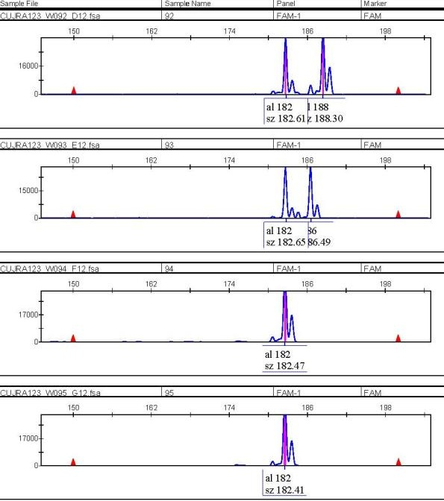
Fig. S1 Capillary electrophoresis spectral diagram of primer CUJRA123 amplified from samples W092 to W095

