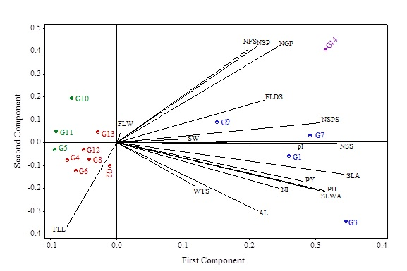

Figure S1. Bi-plot based on first and second principal components for 14 bread wheat cultivars (G1: Alvand, G2: Chamran, G3: Omid, G4: Shirudi, G5: Mihan, G6: Pishtaz, G7: Backcross, G8: Arg, G9: Roshan, G10: Gaspard, G11: Verinak, G12: Atila, G13: Niknejad and G14: Darab2) under normal conditions. (PH: Plant height, NI: The number of internode, NSP: Number of stems per plant, NFS: Number of fertilized stems, FLL: Flag leaf length, FLW: Flag leaf width, FLDS: Flag leaf distance to spike, PL: Peduncle length, NSPS: Number of spikes per spike, SLA: Spike length without awn, SLWA: Spike length with awn, AL: Awn length, SW: Shoot Width, NSS: Number of seeds per spike, NGP: Number of grains per plant, WTS: the weight of one thousand seeds and PY: Plant yield)

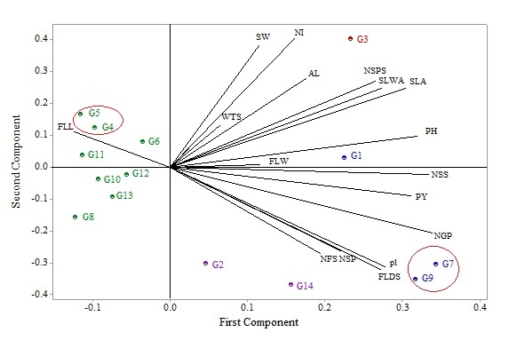

Figure S2. Bi-plot based on first and second principal components for 14 bread wheat cultivars (G1: Alvand, G2: Chamran, G3: Omid, G4: Shirudi, G5: Mihan, G6: Pishtaz, G7: Backcross, G8: Arg, G9: Roshan, G10: Gaspard, G11: Verinak, G12: Atila, G13: Niknejad and G14: Darab2) under moderate salinity level. (PH: Plant height, NI: The number of internode, NSP: Number of stems per plant, NFS: Number of fertilized stems, FLL: Flag leaf length, FLW: Flag leaf width, FLDS: Flag leaf distance to spike, PL: Peduncle length, NSPS: Number of spikes per spike, SLA: Spike length without awn, SLWA: Spike length with awn, AL: Awn length, SW: Shoot Width, NSS: Number of seeds per spike, NGP: Number of grains per plant, WTS: the weight of one thousand seeds and PY: Plant yield)

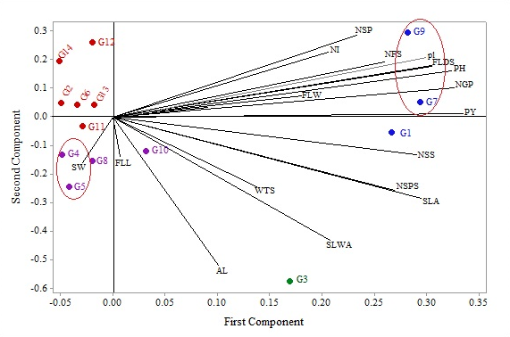

Figure S3. Bi-plot based on first and second principal components for 14 bread wheat cultivars (G1: Alvand, G2: Chamran, G3: Omid, G4: Shirudi, G5: Mihan, G6: Pishtaz, G7: Backcross, G8: Arg, G9: Roshan, G10: Gaspard, G11: Verinak, G12: Atila, G13: Niknejad and G14: Darab2) under high salinity level. (PH: Plant height, NI: The number of internode, NSP: Number of stems per plant, NFS: Number of fertilized stems, FLL: Flag leaf length, FLW: Flag leaf width, FLDS: Flag leaf distance to spike, PL: Peduncle length, NSPS: Number of spikes per spike, SLA: Spike length without awn, SLWA: Spike length with awn, AL: Awn length, SW: Shoot Width, NSS: Number of seeds per spike, NGP: Number of grains per plant, WTS: the weight of one thousand seeds and PY: Plant yield)

Figure S4. Dendrogram of cluster analysis of 14 wheat cultivars (G1: Alvand, G2: Chamran, G3: Omid, G4: Shirudi, G5: Mihan, G6: Pishtaz, G7: Backcross, G8: Arg, G9: Roshan, G10: Gaspard, G11: Verinak, G12: Atila, G13: Niknejad and G14: Darab2) under normal conditions.

Figure S5. Dendrogram of cluster analysis of 14 wheat cultivars (G1: Alvand, G2: Chamran, G3: Omid, G4: Shirudi, G5: Mihan, G6: Pishtaz, G7: Backcross, G8: Arg, G9: Roshan, G10: Gaspard, G11: Verinak, G12: Atila, G13: Niknejad and G14: Darab2) under moderate salinity level.

Figure S6. Dendrogram of cluster analysis of 14 wheat cultivars (G1: Alvand, G2: Chamran, G3: Omid, G4: Shirudi, G5: Mihan, G6: Pishtaz, G7: Backcross, G8: Arg, G9: Roshan, G10: Gaspard, G11: Verinak, G12: Atila, G13: Niknejad and G14: Darab2) under high salinity level.

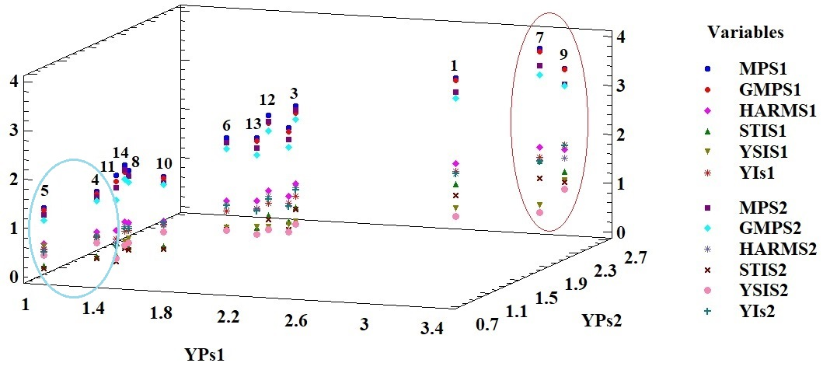
Figure S7. Multiple plot of plant yield under salinity stress (S1: moderate and S2: high salinity stresses) and 6 indices (MP, GMP, HARM, STI, YSI and YI based on both salinity stresses (S1 and S2)) for 14 wheat cultivars (1: Alvand, 2: Chamran, 3: Omid, 4: Shirudi, 5: Mihan, 6: Pishtaz, 7: Backcross, 8: Arg, 9: Roshan, 10: Gaspard, 11: Verinak, 12: Atila, 13: Niknejad and 14: Darab2).

Table S1. Names and origin of 14 bread wheat cultivars that were used in this experiment during 2018-2019.
Origin | Genotype
Iran | Alvabd
India | Arg
CIMMYT | Atila
Iran | Backcross
CIMMYT | Chamran
CIMMYT | Darab 2
France | Gaspard
Iran | Mihan
ICARDA | Niknejad
Iran | Omid
Iran | Pishtaz
Iran | Roshan
Iran | Shirudi
CIMMYT | Verinak

Table S2. Analysis of variance (Mean Squares) for some traits of bread wheat at normal condition and two levels of salinity stress
Trait | Df | PH | NI | NSP | NFS | FLL | FLW | FLDS | PL | NSPS
Replication (Rep) | 2 | 32.88 | 0.45 | 0.11 | 0.02 | 2.57 | 0.05* | 6.90 | 4.31 | 5.99
Salinity | 2 | 1976** | 5.09** | 42.60** | 26.72** | 162.8** | 1.41** | 154.6** | 353.2** | 84.18**
Rep×Salinity | 4 | 10.35 | 0.30 | 0.38 | 0.58 | 4.81 | 0.001 | 3.22 | 2.73 | 0.98
Cultivar | 13 | 1553** | 0.90** | 14.54** | 9.15** | 56.06** | 0.29** | 113.7** | 176.5** | 34.17**
Cultivar×Salinity | 26 | 127.1** | 0.31** | 5.86** | 2.43** | 6.48** | 0.05 | 6.73** | 12.10** | 3.27**
Error | 78 | 13.73 | 0.10 | 0.37 | 0.23 | 2.23 | 0.07 | 1.64 | 6.18 | 1.49

Table S3. Continued
Trait | Df | SLA | SLWA | AL | SW | NSS | NGP | WTS | PY
Replication (Rep) | 2 | 1.40 | 5.66 | 0.94 | 0.05 | 64.10 | 40.42 | 0.46 | 0.04
Salinity | 2 | 44.25** | 80.99** | 35.28** | 0.25** | 608.15 | 17440** | 1545** | 25.20**
Rep×Salinity | 4 | 2.08 | 3.71 | 0.17 | 0.01 | 32.67 | 101.20 | 0.78 | 0.07
Cultivar | 13 | 15.19** | 74.99** | 32.00** | 0.02** | 393.00 | 13678** | 12.41** | 4.16**
Cultivar×Salinity | 26 | 0.86** | 2.89** | 1.22** | 0.01** | 20.07 | 3729** | 14.18** | 0.24**
 | 78 | 0.36 | 0.98 | 0.18 | 0.001 | 13.03 | 138.04 | 0.60 | 0.11
- PH: Plant height, NI: The number of internode, NSP: Number of stems per plant, NFS: Number of fertilized stems, FLL: Flag leaf length, FLW: Flag leaf width, FLDS: Flag leaf distance to spike, PL: Peduncle length, NSPS: Number of spikes per spike, SLA: Spike length without awn, SLWA: Spike length with awn, AL: Awn length, SW: Shoot Width, NSS: Number of seeds per spike, NGP: Number of grains per plant, WTS: the weight of one thousand seeds and PY: Plant yield
- Df: Degrees of freedom
- *, **: significant at the 5 and 1 % levels of probability, respectively.

Table S3. Mean comparison of different traits in 14 wheat cultivars in normal and salinity stress conditions.
SC |  |  |  | 0 mM
NO. | Cultivar | PH | NI | NSP | NFS | FLL | FLW | FLDS | PL | NSPS
G1 | Alvand | 88.49b | 3.66c | 5.33cd | 4.86c | 16.75c | 1.13ab | 13.69cd | 25.36c | 20.00a
G2 | Chamran | 59.51hi | 3.26defj | 4.80def | 4.60cd | 15.78c | 1.04ab | 12.28de | 24.67c | 16.26d
G3 | Omid | 110.48a | 4.86a | 5.60c | 3.46f | 16.13c | 1.02ab | 8.38f | 29.14b | 17.86c
G4 | Shirudi | 44.76m | 3.20efg | 5.06cde | 5.00c | 17.99b | 1.14ab | 6.01hg | 18.3e | 12.33i
G5 | Mihan | 45.96l | 3.40de | 4.73def | 2.80g | 14.70d | 1.38ab | 3.46i | 15.20f | 15.20e
G6 | Pishtaz | 56.76j | 3.33def | 4.93de | 3.73ef | 17.8b | 1.07ab | 6.58g | 20.96d | 14.66ef
G7 | Backcross | 78.66d | 4.33b | 7.80b | 6.73b | 9.29fg | 1.64a | 13.4cd | 28.18b | 19.33ab
G8 | Arg | 70.33e | 3.13fg | 4.46ef | 4.53cd | 19.51a | 1.16ab | 15.55b | 29.05b | 13.13h
G9 | Roshan | 81.88c | 4.20b | 4.86def | 3.53f | 10.19f | 1.08ab | 17.91a | 33.97a | 17.73c
G10 | Gaspard | 61.80g | 3.46cd | 4.80def | 3.33f | 11.80e | 1.5a | 8.08f | 20.54d | 14.00gf
G11 | Verinak | 51.12k | 3.66c | 3.80g | 3.53f | 11.38e | 0.94ab | 4.94h | 15.97f | 16.66d
G12 | Atila | 59.36i | 3.06g | 4.20fg | 3.60f | 8.93g | 0.70b | 8.08f | 20.52d | 15.13e
G13 | Niknejad | 60.56h | 3.13fg | 4.40efg | 4.13de | 10.02f | 0.62b | 10.9e | 24.98c | 13.93g
G14 | Darab2 | 66.51f | 3.33def | 14.26a | 9.73a | 8.40g | 0.96ab | 14.76bc | 26.10c | 18.73b
SC |  |  |  | 75mM
NO. | Cultivar | PH | NI | NSP | NFS | FLL | FLW | FLDS | PL | NSPS
G1 | Alvand | 74.61b | 3.66abc | 4.20b | 3.53bc | 12.0abcde | 0.86bc | 12.80ab | 23.5bc | 18.40a
G2 | Chamran | 54.09cde | 3.26bc | 4.60b | 3.86b | 15.16a | 0.95b | 10.16bcd | 22.23bcd | 15.20bc
G3 | Omid | 85.70a | 4.33a | 4.26b | 3.13bc | 11.32abcde | 0.99b | 6.74def | 20.06bcd | 16.93ab
G4 | Shirudi | 42.52f | 2.93c | 4.06b | 3.86b | 13.34ab | 0.88bc | 5.94efg | 18.13cd | 13.80bc
G5 | Mihan | 45.51ef | 3.46bc | 3.93b | 2.60c | 12.44abcd | 1.00b | 2.74g | 14.88d | 14.93bc
G6 | Pishtaz | 53.18cde | 3.93ab | 4.13b | 3.06bc | 13.07abc | 0.99b | 5.17efg | 17.00cd | 14.40bc
G7 | Backcross | 75.38b | 3.60bc | 6.53a | 5.66a | 9.10cde | 1.25a | 11.20bc | 26.02ab | 18.53a
G8 | Arg | 60.57cd | 3.13c | 4.00b | 3.26bc | 12.52abcd | 0.94b | 8.18cde | 21.13bcd | 12.93c
G9 | Roshan | 74.27b | 3.40bc | 4.86b | 3.40bc | 10.60bcde | 1.06ab | 14.89a | 32.12a | 14.53bc
G10 | Gaspard | 61.40c | 3.33bc | 4.73b | 3.20bc | 10.48bcde | 1.24a | 7.98cde | 17.38cd | 13.80bc
G11 | Verinak | 50.90def | 3.46bc | 3.66b | 3.40bc | 9.92bcde | 0.84bc | 3.80fg | 16.74cd | 15.26bc
G12 | Atila | 57.09cd | 3.06c | 4.13b | 3.53bc | 8.74de | 0.68cd | 7.06def | 20.12bcd | 14.66bc
G13 | Niknejad | 55.36cd | 3.66abc | 4.33b | 4.0b | 8.76de | 0.60d | 6.053efg | 18.74bcd | 13.26c
G14 | Darab2 | 61.36c | 3.26bc | 7.46a | 5.93a | 8.26e | 0.91bc | 11.31bc | 24.18bc | 13.40c
SC |  |  |  |  | 150mM
No. | Cultivar | PH | NI | NSP | NFS | FLL | FLW | FLDS | PL | NSPS
G1 | Alvand | 70.23a | 3.20abc | 3.93b | 3.33bc | 11.53ab | 0.733abcd | 11.72ab | 21.37c | 16.86a
G2 | Chamran | 53.42bcd | 3.00abcd | 3.93b | 3.46b | 12.39a | 0.740abcd | 8.30c | 18.6d | 13.66bcd
G3 | Omid | 57.02bc | 2.73abcd | 3.20bc | 2.60bcdef | 9.49bcd | 0.853a | 6.20de | 18.51d | 15.53ab
G4 | Shirudi | 37.03h | 2.50d | 3.13bc | 2.40def | 10.07abcd | 0.58cd | 4.57f | 15.97e | 11.20ef
G5 | Mihan | 42.90fgh | 3.13abcd | 3.53bc | 2.53cdef | 11.74ab | 0.95a | 1.91g | 12.2f | 13.33cd
G6 | Pishtaz | 49.21def | 3.00abcd | 3.93b | 3.00bcde | 11.46ab | 0.52d | 4.96ef | 15.71e | 12.60cde
G7 | Backcross | 68.39a | 3.26ab | 5.60a | 5.06a | 7.51de | 0.79abc | 10.66b | 24.21b | 17.13a
G8 | Arg | 58.62b | 3.00abcd | 3.93b | 3.133bcd | 10.90abc | 0.82ab | 6.61d | 19.33cd | 10.86ef
G9 | Roshan | 73.60a | 3.20abc | 3.86b | 3.00bcde | 8.72cd | 0.92a | 12.40a | 27.67a | 13.60bcd
G10 | Gaspard | 46.1efg | 2.20ef | 4.00b | 2.20ef | 8.76cd | 0.87a | 6.32de | 15.53e | 11.73def
G11 | Verinak | 41.72gh | 2.80abcd | 2.26c | 2.00f | 9.92abcd | 0.78abc | 1.90g | 15.36e | 14.60bc
G12 | Atila | 48.73def | 2.53cd | 2.86cb | 2.66bcdef | 7.74de | 0.57cd | 5.40def | 17.0de | 12.13de
G13 | Niknejad | 51.14cde | 3.40a | 3.73cb | 3.46b | 8.22cd | 0.58cd | 4.14f | 15.50e | 12.46de
G14 | Darab2 | 46.40efg | 2.53cd | 2.93cb | 2.40def | 5.50e | 0.61bcd | 5.42def | 14.69e | 10.00f

Table S2. Continued
SC |  |  |  | 0mM
NO. | Cultivar | SLA | SLWA | AL | SW | NSS | NGP | WTS | PY
G1 | Alvand | 10.81a | 16.84b | 6.30b | 0.32cd | 41.13a | 143.20c | 27.77fg | 3.98b
G2 | Chamran | 8.46d | 12.09e | 4.80b | 0.26ef | 33.13d | 99.40ef | 32.19bc | 3.20ced
G3 | Omid | 11.10a | 18.63a | 8.64a | 0.46a | 43.13a | 107.13de | 35.45a | 3.79b
G4 | Shirudi | 6.97f | 10.92f | 4.97d | 0.27ef | 23.40f | 87.53fg | 31.58bcd | 2.76efg
G5 | Mihan | 7.08ef | 10.26f | 3.02f | 0.44ab | 23.53f | 57.73i | 30.41bcde | 1.75h
G6 | Pishtaz | 7.12ef | 13.04de | 4.75d | 0.33c | 26.46e | 101.93e | 30.31cde | 3.08def
G7 | Backcross | 10.28b | 15.32c | 4.91d | 0.36c | 35.60c | 157.86b | 29.34ef | 4.62a
G8 | Arg | 8.48d | 10.85f | 4.01e | 0.24ef | 17.26g | 78.86gh | 31.93bc | 2.51g
G9 | Roshan | 9.44c | 10.74f | 1.30h | 0.24f | 36.00c | 159.76b | 27.01gh | 3.29cd
G10 | Gaspard | 7.03f | 7.67g | 0.43i | 0.40b | 28.13e | 78.66gh | 25.61h | 2.01h
G11 | Verinak | 7.54ef | 10.02f | 2.36g | 0.32cd | 21.53f | 69.80hi | 27.59fg | 1.92h
G12 | Atila | 7.62e | 13.11de | 5.67c | 0.28de | 28.86e | 116.86d | 31.47bcd | 3.67bc
G13 | Niknejad | 7.24ef | 12.42e | 5.00d | 0.24f | 27.73e | 102.26e | 29.57def | 3.02def
G14 | Darab2 | 8.90d | 14.14d | 4.81d | 0.42b | 38.73b | 344.93a | 32.41b | 2.65fg
SC |  |  |  | 75mM
NO. | Cultivar | SLA | SLWA | AL | SW | NSS | NGP | WTS | PY
G1 | Alvand | 8.513bc | 12.62bc | 4.88b | 0.28abcd | 39.66a | 126.53b | 22.04bc | 2.79a
G2 | Chamran | 6.38d | 11.84cde | 4.17bcd | 0.24bcd | 30.00abcd | 88.20cd | 23.534a | 2.07b
G3 | Omid | 10.09a | 18.23a | 7.92a | 0.34ab | 30.13abcd | 94.40c | 21.24de | 2.00bc
G4 | Shirudi | 6.14d | 9.36efg | 3.42cd | 0.24bcd | 20.93de | 62.00e | 21.11def | 1.31cde
G5 | Mihan | 6.90cd | 9.60ef | 3.16d | 0.32abc | 22.06de | 47.53e | 21.22de | 1.00e
G6 | Pishtaz | 6.92cd | 9.54ef | 2.04e | 0.28abcd | 26.00bcde | 85.33cd | 20.26g | 1.73bcde
G7 | Backcross | 9.65ab | 14.51b | 3.82bcd | 0.35a | 35.00abc | 155.53a | 20.42fg | 3.17a
G8 | Arg | 6.38d | 7.00g | 0.75fg | 0.23cd | 16.53e | 66.60de | 19.98g | 1.32bcde
G9 | Roshan | 8.48bc | 9.88def | 1.04efg | 0.21d | 35.33ab | 140.23ab | 22.41b | 3.24a
G10 | Gaspard | 7.22cd | 7.51fg | 0.34g | 0.30abcd | 20.13de | 66.53de | 22.29b | 1.48bcde
G11 | Verinak | 6.96cd | 9.35efg | 1.46ef | 0.30abcd | 20.20de | 58.87cd | 20.48fg | 1.20de
G12 | Atila | 7.16cd | 12.46bc | 4.67b | 0.26abcd | 26.73bcde | 93.40c | 21.40cd | 1.91bcd
G13 | Niknejad | 6.60d | 12.18bcd | 4.48bc | 0.23cd | 24.40cde | 93.40b | 20.64efg | 1.92bcd
G14 | Darab2 | 6.52d | 13.20bc | 4.63b | 0.28abcd | 30.20abcd | 141.33ab | 18.79h | 1.37bcde
SC |  |  |  | 150mM
NO. | Cultivar | SLA | SLWA | AL | SW | NSS | NGP | WTS | PY
G1 | Alvand | 8.22b | 11.52c | 4.14b | 0.17bcde | 36.66a | 112.40ab | 19.72ab | 2.2137ab
G2 | Chamran | 5.76cd | 11.37c | 3.30c | 0.18abcde | 25.93bcd | 85.60cd | 18.62bc | 1.59cde
G3 | Omid | 9.32a | 17.60a | 6.38a | 0.16bcde | 25.60bcd | 90.53bc | 20.40a | 1.84bc
G4 | Shirudi | 5.70cd | 8.53d | 2.71d | 0.18abcde | 17.66g | 58.93efg | 18.98bc | 1.12def
G5 | Mihan | 5.34de | 8.20d | 2.74d | 0.18bcde | 19.00fg | 39.27g | 18.40c | 0.72f
G6 | Pishtaz | 5.96cd | 8.23d | 1.56f | 0.18bcde | 24.33cde | 80.93cde | 19.02bc | 1.54cde
G7 | Backcross | 8.02b | 13.88b | 2.30de | 0.22abc | 28.26bc | 131.47a | 18.73bc | 2.46a
G8 | Arg | 5.24de | 6.31e | 0.65gh | 0.14cde | 13.00h | 62.47defg | 18.12c | 1.132def
G9 | Roshan | 7.85b | 8.08d | 0.78g | 0.12de | 29.26b | 131.17a | 20.93a | 2.63a
G10 | Gaspard | 5.85cd | 6.20e | 0.14h | 0.26a | 16.73gh | 60.73defg | 20.60a | 1.25cdef
G11 | Verinak | 5.54cde | 7.74d | 0.95g | 0.24ab | 17.80g | 52.67fg | 18.75bc | 0.98ef
G12 | Atila | 6.30c | 10.92c | 4.02b | 0.19abcd | 22.66def | 80.33cde | 20.93a | 1.68bcd
G13 | Niknejad | 5.54cde | 10.16c | 3.72bc | 0.14cde | 20.06efg | 91.53bc | 16.37d | 1.49cde
G14 | Darab2 | 4.71e | 8.45d | 1.97ef | 0.10e | 21.33defg | 72.27cdef | 11.87e | 0.86f
- Means followed by similar letter in each column are not significantly different at 5% level based on Duncan test.
- SC: Salinity Concentration
- PH: Plant height, NI: The number of internode, NSP: Number of stems per plant, NFS: Number of fertilized stems, FLL: Flag leaf length, FLW: Flag leaf width, FLDS: Flag leaf distance to spike, PL: Peduncle length, NSPS: Number of spikes per spike, SLA: Spike length without awn, SLWA: Spike length with awn, AL: Awn length, SW: Shoot Width, NSS: Number of seeds per spike, NGP: Number of grains per plant, WTS: the weight of one thousand seeds and PY: Plant yield

Table S4. Correlation coefficients between studied indices based on two salinity stresses conditions and plant yield (PY) at three conditions (N: normal, S1: moderate salinity stress and S2: high salinity stress)
 | YP_{N} | YP_{S1} | YP_{S2} | MP_{S1} | MP_{S2} | GMP_{S1} | GMP_{S2} | HARM_{S1} | HARM_{S2} | STI_{S1} | STI_{S2} | YSI_{S1} | YSI_{S2} | YI_{S1} | YI_{S2}
YP_{N} | 1
YP_{S1} | 0.80** | 1
YP_{S2} | 0.81** | 0.97** | 1
MP_{S1} | 0.96** | 0.94** | 0.93** | 1
MP_{S2} | 0.97** | 0.91** | 0.93** | 0.99** | 1
GMP_{S1} | 0.94** | 0.96** | 0.95** | 0.99** | 0.99** | 1
GMP_{S2} | 0.94** | 0.94** | 0.96** | 0.99** | 0.99** | 0.99** | 1
HARM_{S1} | 0.92** | 0.97** | 0.95** | 0.99** | 0.98** | 0.99** | 0.98** | 1
HARM_{S2} | 0.91** | 0.95** | 0.98** | 0.98** | 0.98** | 0.98** | 0.99** | 0.98** | 1
STI_{S1} | 0.85** | 0.93** | 0.91** | 0.93** | 0.91** | 0.94** | 0.92** | 0.94** | 0.92** | 1
STI_{S2} | 0.86** | 0.91** | 0.92** | 0.93** | 0.92** | 0.93** | 0.93** | 0.93** | 0.93** | 0.99** | 1
YSI_{S1} | 0.11^{ns} | 0.67** | 0.63** | 0.39* | 0.33^{ns} | 0.44* | 0.41* | 0.49** | 0.47** | 0.49** | 0.45* | 1
YSI_{S2} | 0.12^{ns} | 0.61** | 0.66** | 0.36^{ns} | 0.35^{ns} | 0.41* | 0.44* | 0.45* | 0.51** | 0.43* | 0.45* | 0.91** | 1
YI_{S1} | 0.77** | 0.99** | 0.96** | 0.92** | 0.89** | 0.93** | 0.91** | 0.95** | 0.93** | 0.96** | 0.94** | 0.69** | 0.62** | 1
YI_{S2} | 0.78** | 0.96** | 0.99** | 0.91** | 0.90** | 0.92** | 0.93** | 0.93** | 0.95** | 0.94** | 0.95** | 0.64** | 0.67** | 0.97** | 1
*, **: significant at the 5 and 1 % levels of probability, respectively. ns: non-significant

