Supplementary Material

QTL mapping for stripe rust and powdery mildew resistance in Triticum durum- Aegilops speltoides backcross introgression lines
Guriqbal Singh Dhillon^{1,2}, Satinder Kaur¹, Niranjan Das², Rohtas Singh¹, Jesse Poland³, Jaspal Kaur⁴, Parveen Chhuneja^{1*}

- School of Agricultural Biotechnology, Punjab Agricultural University, Ludhiana, India
- Department of Biotechnology, Thapar Institute of Engineering and Technology, Patiala, India
- Wheat Genetics Resource Centre, Kansas State University, USA
- Department of Plant Breeding and Genetics, Punjab Agricultural University, Ludhiana, India
*Corresponding author email: pchhuneja@pau.edu
Mobile No.: +919888885557
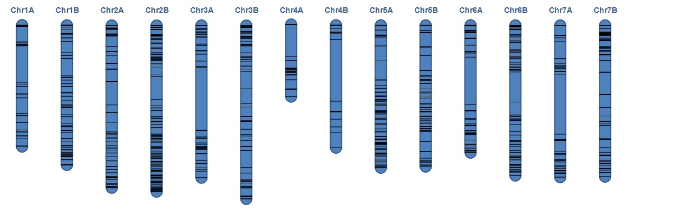
Figure S1: Coverage of filtered 1095 SNPs used for mapping QTLs for various diseases along A and B genome chromosomes. The black lines represent physical positions of the SNPs according to wheat RefSeqv1.0 on blue background of recurrent parent PDW274.

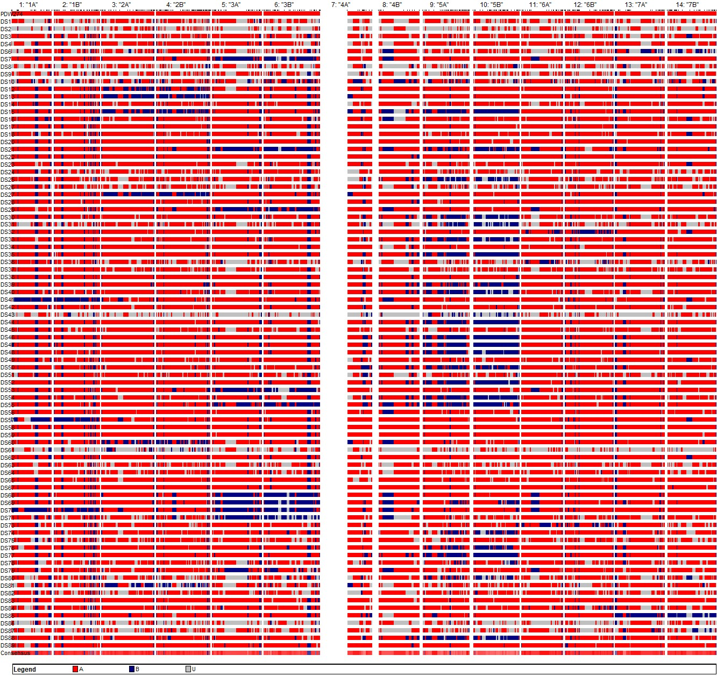
Figure S2: Introgression profile of 89 lines with recurrent parent PDW274 (on top) is given with red colour represents the segment from PDW274 and blue represent the introgression of Ae. speltoides in the DS-BILs

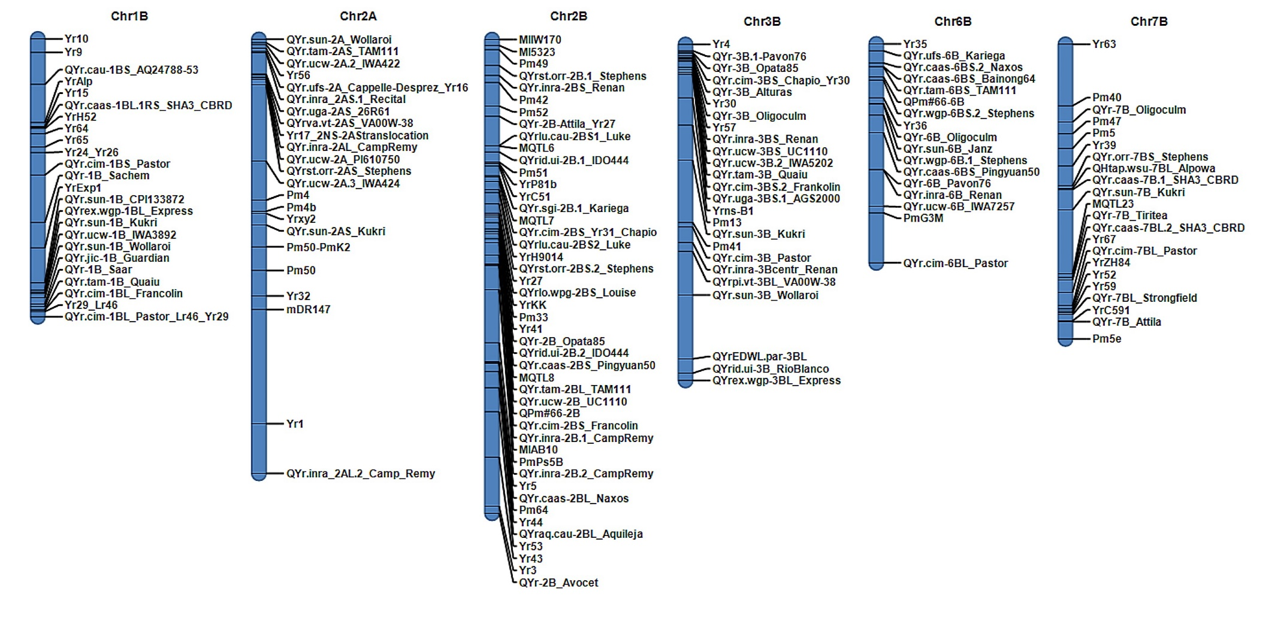
Figure S3: Summary of the designated genes, preliminary reported genes and QTLs on chromosomes harbouring QTL in the present study. The mapped genes/QTL, their linkage positions were retrieved from www.wheat.pw.usda.gov as has been reported by Maccaferri et al. (2015) for stripe rust and Ben-David et al. (2014) for powder mildew along with other powder mildew genes reported and chromosome maps were generated in IciMapping V4.1.0.0

Table S1: Postulation of genes present in the survey sequence of wheat genome refseqV1.0
QTL | Trait | SNP marker | Distance  from SNP | Chr | Reference gene Gene ID | Function
QYrAs.pau-1B | ASR Pst field pathotypes | S1B_626229235 | +4.598 | chr1B | TraesCS1B01G393400.1 | RING/U-box superfamily protein(Zinc finger)*
 |  |  | -1.251 | chr1B | TraesCS1B01G393500.1 | Serine/threonine-protein phosphatase
 |  |  | -14.764 | chr1B | TraesCS1B01G393600.1 | Disease resistance protein (NBS-LRR class) family*
 |  |  | -21.334 | chr1B | TraesCS1B01G393700.1 | Reticulon-like protein
QYrAs.pau-2A.1 | ASR Pst field pathotypes | S2A_16016633 | 0 | chr2A | TraesCS2A01G038100.1 | L-gulonolactone oxidase*
 |  |  | -8.225 | chr2A | TraesCS2A01G038200.1 | Vascular endothelial growth factor receptor 3
 |  |  | -49.03 | chr2A | TraesCS2A01G038300.1 | Beta-glucosidase
QPmAS.pau-2A.1 | ASR Bg field pathotypes | S2A_43146710 | +13.059 | chr2A | TraesCS2A01G090000.1 | 26S protease regulatory subunit*
 |  |  | +1.31 | chr2A | TraesCS2A01G090100.1 | Leucine-rich repeat receptor-like protein kinase*
 |  |  | -33.072 | chr2A | TraesCS2A01G090200.1 | Zinc-finger protein*
QYrTd.pau-2A.2 | ASR Pst 78S84 | S2A_766158316 | +6.454 | chr2A | TraesCS2A01G567300.1 | Auxin response factor*
 |  |  | 0 | chr2A | TraesCS2A01G567400.1 | CAA30371.1 protein
QPmAS.pau-2A.2 | ASR Bg field pathotypes | S2A_771507864 | +21.662 | chr2A | TraesCS2A01G577300.1 | Protein kinase family protein, putative, expressed*
 |  |  | +2.653 | chr2A | TraesCS2A01G577400.1 | Kinase family protein*
 |  |  | 0 | chr2A | TraesCS2A01G577500.1 | Pentatricopeptide repeat-containing family protein
 |  |  | -4.614 | chr2A | TraesCS2A01G577600.1 | 3-isopropylmalate dehydrogenase
 |  |  | -7.998 | chr2A | TraesCS2A01G577700.1 | UPF0235 protein
 |  |  | -30.782 | chr2A | TraesCS2A01G577800.1 | Cytochrome P450 family protein, expressed
 |  |  | -39.245 | chr2A | TraesCS2A01G577900.1 | Glutathione S-transferase*
QYrAs.pau-2B | ASR Pst field pathotypes | S2B_27896451 | +8.029 | chr2B | TraesCS2B01G057200.1 | ELMO domain-containing protein, putative
 |  |  | 0 | chr2B | TraesCS2B01G057300.1 | Zinc finger family protein*
QPmAS.pau-2B | ASR Bg field pathotypes | S2B_791958961 | +1.911 | chr2B | TraesCS2B01G612700.1 | Dihydroflavonol-4-reductase
QYrTd.pau-3B | ASR Pst 78S84 | S3B_743818730 | +5.51 | chr3B | TraesCS3B01G499200.1 | Glutathione S-transferase*
QPmAs.pau-3B | ASR Bg field pathotypes | S3B_775092221 | -145.056 | chr3B | TraesCS3B01G535100.1 | GRAS family transcription factor containing protein
 |  |  | +83.639 | chr3B | TraesCS3B01G535200.1 | F-box protein
 |  |  | +352.758 | chr3B | TraesCS3B01G535300.1 | Glutathione S-transferase*
 |  |  | +383.528 | chr3B | TraesCS3B01G535400.1 | Peroxiredoxin
 |  |  | +388.745 | chr3B | TraesCS3B01G535500.1 | Protein ENHANCED DISEASE RESISTANCE 2*
 |  |  | +444.521 | chr3B | TraesCS3B01G535600.1 | F-box SKIP23-like protein
 |  |  | +469.715 | chr3B | TraesCS3B01G535700.1 | Glutathione S-transferase*
QPmAS.pau-6B | ASR Bg field pathotypes | S6B_26793381 | +24.086 | chr6B | TraesCS6B01G044800.1 | receptor kinase 1*
 |  |  | 0 | chr6B | TraesCS6B01G044900.1 | Mitochondrial transcription termination factor-like*
 |  |  | -47.402 | chr6B | TraesCS6B01G045000.1 | Mitochondrial transcription termination factor-like*
QYrAs.pau-7B | ASR Pst field pathotypes | S7B_708445814 | +29.704 | chr7B | TraesCS7B01G443600.1 | RING/U-box superfamily protein (Zinc finger) *
 |  |  | -30.142 | chr7B | TraesCS7B01G443700.1 | Coatomer subunit beta'-1

* represent genes/ functions which have been well reported to be a part of plant-pathogen interaction or plant-pathogenesis
In column distance from SNP represent the distance of start site of the gene to SNP linked with QTL, where + sign represents the gene was found downstream of the SNP and – sign gene was found upstream, 0 represent the SNP was present inside the gene, and all distances are in kilobase

