Dissection of quantitative trait loci for root characters and day length sensitivity in SynOpDH wheat (Triticum aestivum L.) bi-parental mapping population

Supplementary Files

Figure Legends

Figure S1: Histograms of the phenotypic values in bread wheat for total root biomass (RM), shallow root weight (SRW), deep root weight (DRW), shoot biomass (SM), grain yield (GY), number of fertile tillers (FT), number of tillers (NT), harvest index 1 (HI1), plant height (PH), days to anthesis (DTA) and root length (RL) for 2013 and 2014 experiments. Green and red arrows highlight the group that parents Opata M85 (Op) and Synthetic W7984 (Syn) fall into respectively. Refer to Table 1 for population and parent mean values.

2013 | 2014
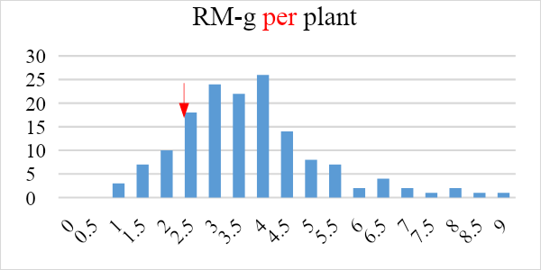  Syn Op | 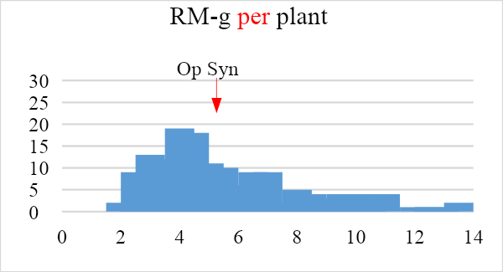
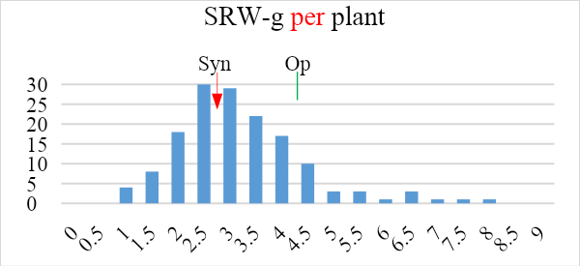 | 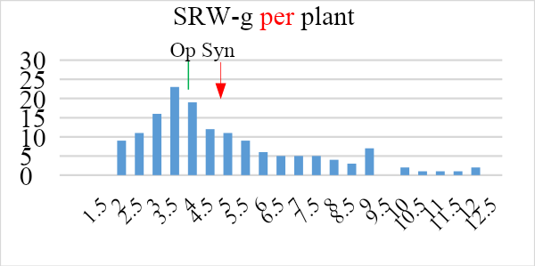
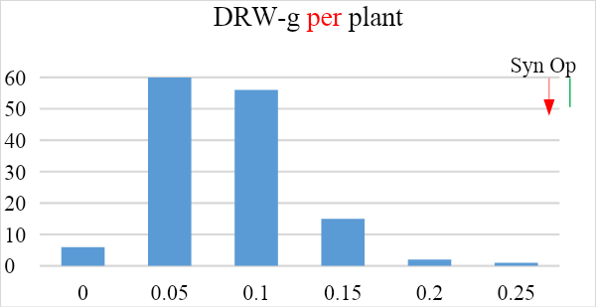 | 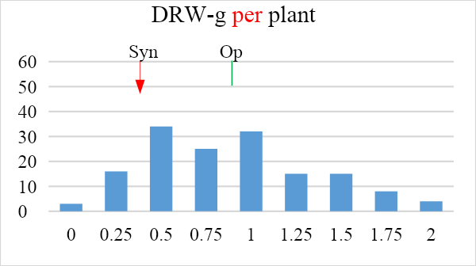
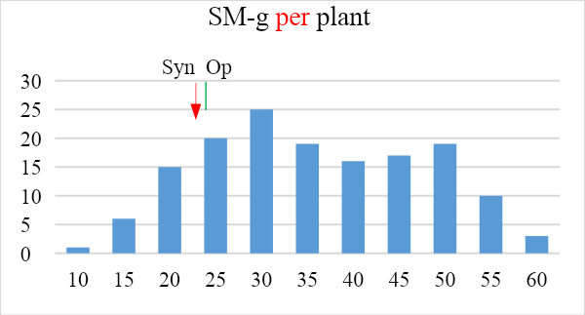 | 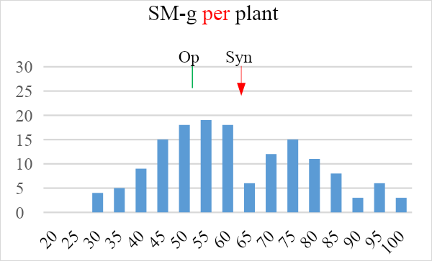
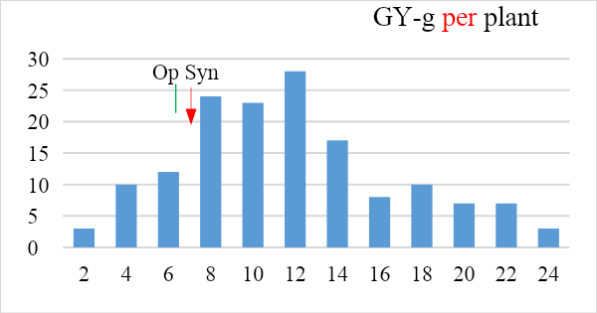 | 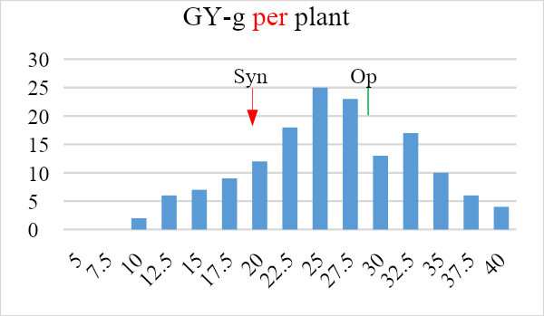
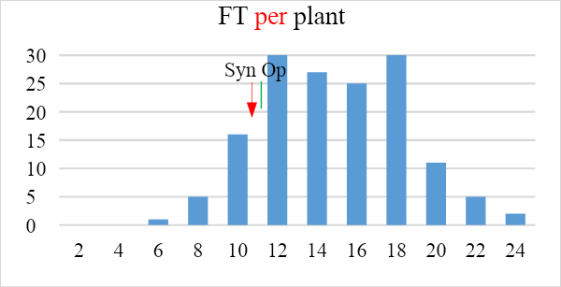 | 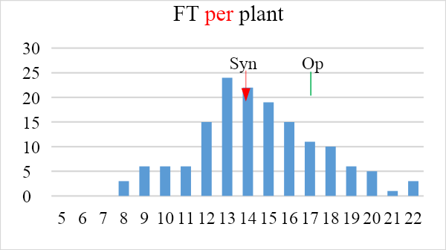
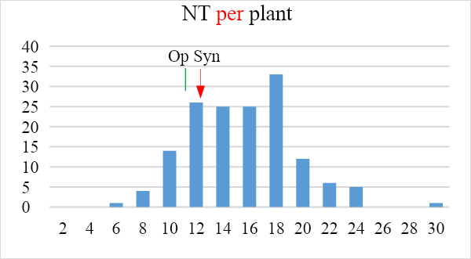 | 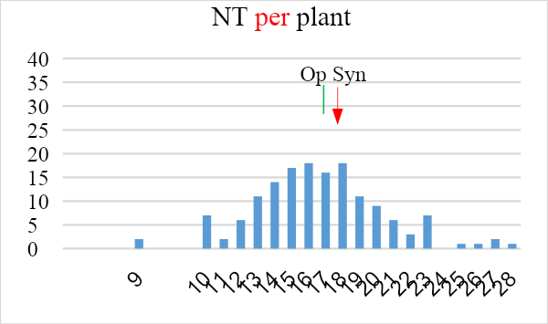
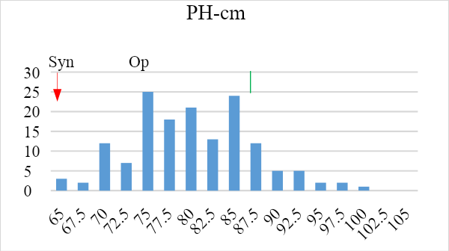 | 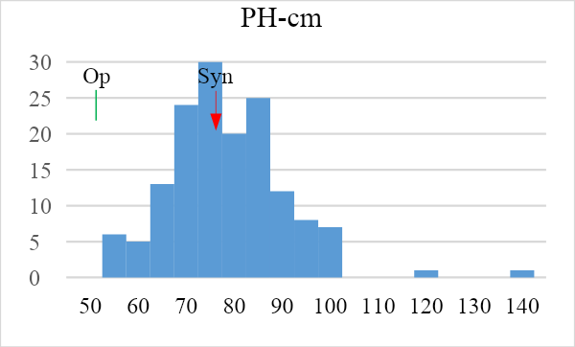
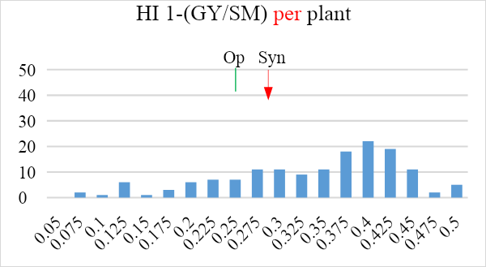 | 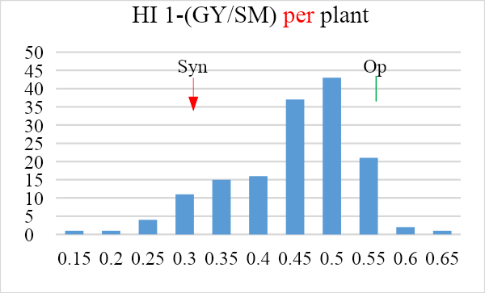
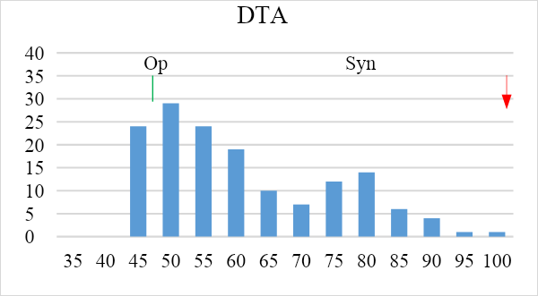 | 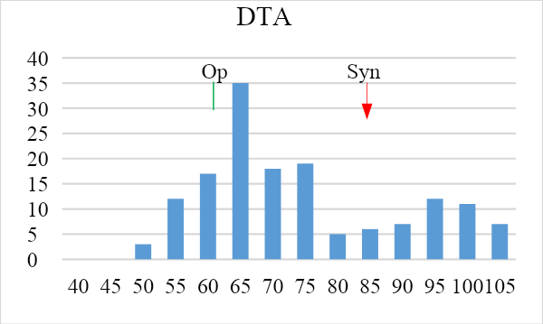
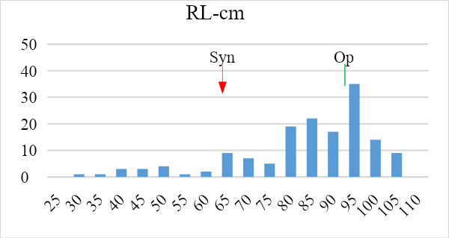 | 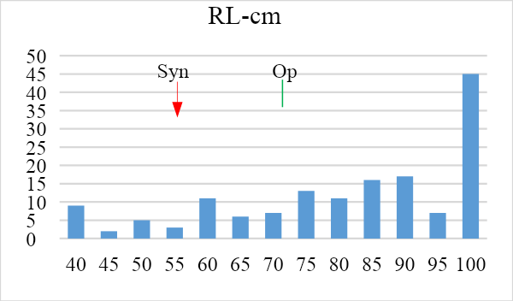

Figure S1: Histograms of the phenotypic values in bread wheat for total root biomass (RM), shallow root weight (SRW), deep root weight (DRW), shoot biomass (SM), grain yield (GY), number of fertile tillers (FT), number of tillers (NT), harvest index 1 (HI1), plant height (PH), days to anthesis (DTA) and root length (RL) for 2013 and 2014 experiments. Green and red arrows highlight the group that parents Opata M85 (Op) and Synthetic W7984 (Syn) fall into respectively. Refer to Table 1 for population and parent mean values.

Supplementary Tables

Table S1: Genotype, Year and Genotype*Year interactions General AOV tables for deep root weight (DRW), total root biomass (RM), shoot biomass (SM), shallow root weight (SRW), days to anthesis (DTA), plant height(PH), harvest index 1 (HI1), root length (RL), number of fertile tillers (FT) and grain yield (GY).
DRW |  |  |  |  |  | PH
Source | DF | SS | MS | F | P | Source | DF | SS | MS | F | P
Genotype | 151 | 126.896 | 0.8404 | 2.67 | 0.0000 | Genotype | 151 | 67702 | 448.35 | 3.33 | 0.0000
Year | 1 | 13.485 | 13.4853 | 42.82 | 0.0000 | Year | 1 | 2039 | 2038.82 | 15.13 | 0.0001
Genotype*Year | 151 | 37.575 | 0.2488 | 0.79 | 0.9608 | Genotype*Year | 151 | 24406 | 161.63 | 1.20 | 0.0717
Error | 607 | 191.150 | 0.3149 |  |  | Error | 608 | 81940 | 134.77
Total | 910 |  |  |  |  | Total | 911 | 176086
Grand Mean | 0.6514 |  |  |  |  | Grand Mean | 77.529
CV | 86.14 |  |  |  |  | CV | 14.97
RM |  |  |  |  |  | HI1
Source | DF | SS | MS | F | P | Source | DF | SS | MS | F | P
Genotype | 151 | 3268.77 | 21.648 | 8.45 | 0.0000 | Genotype | 151 | 5.4359 | 0.03600 | 4.76 | 0.0000
Year | 1 | 877.16 | 877.159 | 342.21 | 0.0000 | Year | 1 | 2.2214 | 2.22138 | 293.65 | 0.0000
Genotype*Year | 151 | 896.93 | 5.940 | 2.32 | 0.0000 | Genotype*Year | 151 | 2.2752 | 0.01507 | 1.99 | 0.0000
Error | 608 | 1558.45 | 2.563 |  |  | Error | 608 | 4.5994 | 0.00756
Total | 911 | 6601.32 |  |  |  | Total | 911 | 14.5319
Grand Mean | 4.4546 |  |  |  |  | Grand Mean | 0.3740
CV | 35.94 |  |  |  |  | CV | 23.26
SM |  |  |  |  |  | RL
Source | DF | SS | MS | F | P | Source | DF | SS | MS | F | P
Genotype | 151 | 175441 | 1162 | 13.75 | 0.0000 | Genotype | 151 | 225915 | 1496.13 | 4.20 | 0.0000
Year | 1 | 154398 | 154398 | 1827.64 | 0.0000 | Year | 1 | 1539 | 1539.01 | 4.32 | 0.0381
Genotype*Year | 151 | 21849 | 145 | 1.71 | 0.0000 | Genotype*Year | 151 | 68712 | 455.05 | 1.28 | 0.0241
Error | 608 | 51364 | 84 |  |  | Error | 607 | 216215 | 356.20
Total | 911 | 403052 |  |  |  | Total | 910
Grand Mean | 46.495 |  |  |  |  | Grand Mean | 80.094
CV | 19.77 |  |  |  |  | CV | 23.56
SRW |  |  |  |  |  | FT
Source | DF | SS | MS | F | P | Source | DF | SS | MS | F | P
Genotype | 151 | 2384.48 | 15.791 | 9.10 | 0.0000 | Genotype | 151 | 7336.5 | 48.5859 | 5.12 | 0.0000
Year | 1 | 673.28 | 673.277 | 388.00 | 0.0000 | Year | 1 | 0.2 | 0.1579 | 0.02 | 0.8975
Genotype*Year | 151 | 700.16 | 4.637 | 2.67 | 0.0000 | Genotype*Year | 151 | 2436.8 | 16.1380 | 1.70 | 0.0000
Error | 608 | 1055.04 | 1.735 |  |  | Error | 608 | 5774.7 | 9.4978
Total | 911 | 4812.96 |  |  |  | Total | 911 | 15548.1
Grand Mean | 3.8034 |  |  |  |  | Grand Mean | 14.114
CV | 34.63 |  |  |  |  | CV | 21.84
DTA |  |  |  |  |  | GY
Source | DF | SS | MS | F | P | Source | DF | SS | MS | F | P
Genotype | 151 | 178634 | 1183.0 | 51.59 | 0.0000 | Genotype | 151 | 26504.5 | 175.5 | 6.03 | 0.0000
Year | 1 | 37448 | 37447.7 | 1632.99 | 0.0000 | Year | 1 | 44294.2 | 44294.2 | 1520.92 | 0.0000
Genotype*Year | 151 | 13344 | 88.4 | 3.85 | 0.0000 | Genotype*Year | 151 | 6567.1 | 43.5 | 1.49 | 0.0005
Error | 608 | 13943 | 22.9 |  |  | Error | 608 | 17707.0 | 29.1
Total | 911 | 243369 |  |  |  | Total | 911 | 95072.8
Grand Mean | 65.401 |  |  |  |  | Grand Mean | 17.698
CV | 7.32 |  |  |  |  | CV | 30.49

Table S2: QTL associated with, grain yield (GY), shoot biomass (SM), total root biomass (RM), shallow root weight (SRW), deep root weight (DRW), fertile number of tillers (FT), root length (RL), days to anthesis (DTA) and flag leaf width (FLW) in the SynOpDH population with 122 lines (Lines with vernalization requirement are excluded).
Trait | Year | Chromosome | Position | LeftMarker | RightMarker | LODª | PVE(%)^{b} | Additive^{c}
GY | 2013 | 2D | 68.2300 | 579 | 1212 | 6.4743 | 22.0620 | 2.2977
 | 2014 |  | 71.2300 | 745 | 250 | 7.8059 | 23.8856 | 3.2973
SM | 2013 | 2A | 45.0000 | 374 | 262 | 7.9988 | 12.2215 | -4.2352
 | 2014 |  | 46.0000 | 374 | 262 | 5.5280 | 8.9103 | -4.8328
 | 2013 | 2D | 68.2300 | 579 | 1212 | 25.2312 | 54.4679 | 8.8281
 | 2014 |  | 68.2300 | 579 | 1212 | 23.2015 | 53.4729 | 11.6824
RM | 2013 | 2A | 47.0000 | 262 | 10 | 3.4541 | 8.7349 | -0.4018
 | 2014 |  | 45.0000 | 374 | 262 | 6.4722 | 13.2787 | -0.9279
 | 2013 | 2D | 68.2300 | 579 | 1212 | 10.0880 | 29.1641 | 0.7244
 | 2014 |  | 68.2300 | 579 | 1212 | 16.4521 | 40.7664 | 1.6054
SRW | 2013 | 2A | 45.0000 | 374 | 262 | 3.1992 | 8.6137 | -0.3230
 | 2014 |  | 40.0000 | 1017 | 374 | 7.1893 | 15.0230 | -0.8500
 | 2013 | 2D | 71.2300 | 745 | 250 | 8.7053 | 25.6886 | 0.5500
 | 2014 |  | 68.2300 | 579 | 1212 | 16.8759 | 41.1759 | 1.3874
DRW | 2013 | 2D | 68.2300 | 79 | 1212 | 7.2126 | 23.9542 | 0.1732
 | 2014 |  | 71.2300 | 45 | 250 | 7.0987 | 23.5061 | 0.2337
FT | 2013 | 4D | 0.0000 | 838 | 570 | 3.8062 | 9.4812 | -1.1818
 | 2014 |  | 0.0000 | 838 | 570 | 3.7903 | 11.6982 | -1.0396
RL | 2013 | 2D | 68.2300 | 579 | 1212 | 8.3675 | 22.4475 | 7.8546
 | 2014 |  | 65.2300 | 579 | 1212 | 4.6290 | 14.8319 | 7.5856
DTA | 2013 | 2A | 39.0000 | 1017 | 374 | 13.2580 | 23.7258 | -6.5016
 | 2014 |  | 40.0000 | 1017 | 374 | 12.2099 | 24.2725 | -7.1430
 | 2013 | 2D | 68.2300 | 579 | 1212 | 20.8195 | 42.6439 | 8.5657
 | 2014 |  | 68.2300 | 579 | 212 | 18.2941 | 39.8006 | 9.0006
FLW | 2013 | 2D | 71.2300 | 745 | 250 | 4.6911 | 14.8899 | 0.0779
 | 2014 |  | 71.2300 | 745 | 250 | 7.2375 | 20.7909 | 0.1400
Plants were grown in 1 m PVC tubes under well-watered conditions until maturity for two seasons. Peak positions (cM) with the highest LOD score, left and right markers, the logarithm of the odds (LOD) scores, percent phenotypic effects, and additive effects.
ª LOD score of 3.45 was used for the declaration of QTL.
^{b} Phenotypic variation explained by QTL
^{c} Additive effect of QTL
^{d} LOD threshold value of 2.5 was used for the QTL declaration.
Table S3: Phenotype associated chromatin regions (Marker *Trait Associations) of the SynOpDH population that were detected only one year (2013 or 2014) for thousand-grain weight (1000gW), grain yield (GY), harvest index 1 (HI 1), shoot biomass (SM), total root biomass (RM), shallow root weight (SRW), deep root weight (DRW), fertile number of tillers (FT), number of tillers (NT), plant height (PH), root length (RL), days to anthesis (DTA) and flag leaf width (FLW).
Trait Name | Year | Chromosome | Position (cM) | Left Marker | Right Marker | LODª | PVE (%)^{b} | Additive^{c}
1000GW | 2013 | 2D | 68.230 | synopGBS579 | synopGBS1212 | 4.1908 | 11.3699 | -2.8223
 |  | 5D | 222.000 | synopGBS737 | synopGBS576 | 3.0333 | 8.0156 | -2.3689
GY | 2013 | 2A | 43.000 | synopGBS374 | synopGBS262 | 3.0219 | 7.0736 | -1.3578
 | 2014 | 4A | 42.850 | synopGBS1186 | synopGBS1416 | 3.4356 | 8.1081 | -1.9788
HI | 2014 | 2A | 71.000 | synopGBS1475 | synopGBS916 | 3.1259 | 7.9469 | 0.0239
 |  | 2D | 68.230 | synopGBS579 | synopGBS1212 | 5.3637 | 14.0689 | -0.0317
SM | 2013 | 5D | 113.000 | synopGBS1282 | synopGBS656 | 3.4005 | 3.9694 | 2.4099
 | 2014 | 4A | 56.850 | synopGBS525 | synopGBS325 | 3.9367 | 4.0702 | -3.4387
 |  | 7D | 89.480 | synopGBS251 | synopGBS1449 | 2.7692 | 2.8441 | 2.8528
RM | 2013 | 5D | 144.000 | synopGBS1273 | synopGBS613 | 3.3553 | 6.5519 | 0.3898
SRW | 2013 | 5A | 125.000 | synopGBS902 | synopGBS147 | 3.3893 | 6.0144 | -0.3039
 |  | 5D | 142.000 | synopGBS1273 | synopGBS613 | 3.8496 | 6.9980 | 0.3357
DRW | 2013 | 3A | 19.000 | synopGBS706 | synopGBS1260 | 3.0382 | 6.7136 | -0.0961
 |  | 6A | 91.000 | synopGBS1239 | synopGBS1401 | 3.5921 | 8.1762 | -0.1062
 | 2014 | 7D | 89.480 | synopGBS251 | synopGBS1449 | 2.6581 | 5.7383 | 0.1144
FT | 2013 | 1B | 82.960 | synopGBS1482 | synopGBS1086 | 3.4165 | 6.8507 | 0.9444
 |  | 2D | 68.230 | synopGBS579 | synopGBS1212 | 10.3159 | 22.7059 | 1.7173
 | 2014 | 5A | 127.000 | synopGBS147 | synopGBS429 | 2.9280 | 7.3109 | 0.7986
 |  | 7B | 111.370 | synopGBS952 | synopGBS1301 | 3.3965 | 8.5685 | -0.8669
NT | 2013 | 2A | 44.000 | synopGBS374 | synopGBS262 | 2.5128 | 5.8713 | -0.9645
 |  | 2D | 68.230 | synopGBS579 | synopGBS1212 | 9.7382 | 23.4817 | 1.9231
 |  | 4A | 0.000 | synopGBS838 | synopGBS570 | 2.9509 | 6.3075 | -1.0105
 | 2014 | 7B | 111.370 | synopGBS952 | synopGBS1301 | 2.7123 | 8.3323 | -1.0951
PH | 2013 | 2A | 42.000 | synopGBS1017 | synopGBS374 | 3.4211 | 7.5067 | -1.9319
 |  | 2D | 66.230 | synopGBS579 | synopGBS1212 | 2.8781 | 6.7032 | 1.8191
 |  | 4A | 27.850 | synopGBS1339 | synopGBS82 | 3.2091 | 7.0017 | -1.8652
 |  | 5A | 47.000 | synopGBS851 | synopGBS826 | 4.5801 | 10.3250 | 2.2620
 |  | 6D | 81.000 | synopGBS965 | synopGBS1413 | 2.5778 | 5.5599 | 1.6770
 | 2014 | 6B | 86.000 | synopGBS1461 | synopGBS1235 | 2.7812 | 8.3059 | 1.2236
RL | 2013 | 3B | 105.000 | synopGBS753 | synopGBS1241 | 2.9651 | 6.0136 | -3.9662
 |  | 6A | 93.000 | synopGBS1239 | synopGBS1401 | 5.5205 | 12.0558 | -5.6851
 |  | 7D | 32.480 | synopGBS254 | synopGBS773 | 2.5756 | 5.2144 | 3.7107
 | 2014 | 6B | 108.000 | synopGBS900 | synopGBS286 | 2.6452 | 5.8114 | 4.7592
DTA | 2013 | 5A | 69.000 | synopGBS293 | synopGBS1405 | 2.9316 | 3.3273 | -2.5959
 |  | 5B | 66.000 | synopGBS1315 | synopGBS1269 | 3.8163 | 4.3380 | 2.9661
 |  | 5D | 134.000 | synopGBS371 | synopGBS611 | 4.2059 | 4.9476 | 3.2116
FLW | 2013 | 5A | 127.000 | synopGBS147 | synopGBS429 | 6.5515 | 14.8346 | -0.0776
 |  | 2A | 26.000 | SynopGBS399 | SynopGBS855 | 3.1872 | 6.6993 | -0.0524
 | 2014 | 5B | 130.000 | synopGBS1330 | synopGBS127 | 3.3704 | 6.2238 | -0.0784
 |  | 2A | 42.000 | synopGBS1017 | synopGBS374 | 3.8694 | 7.2358 | -0.0848
Plants were grown in 1 m PVC tubes under well-watered conditions until maturity for two seasons. Peak positions with the highest LOD score left and right markers, the logarithm of the odds (LOD) scores, percent phenotypic effects, and additive effects.
ª LOD threshold score of 2.5 was used.
^{b} Phenotypic variation explained by associated loci

^{c} Additive effect of specific loci.

