Table S1: Phenotypic disease severity scale for scoring Mungbean Yellow Mosaic Virus (MYMV) disease (Akhtar et al., 2009)

Phenotype | Description | Score | Reaction
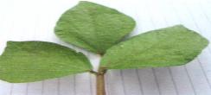 | No visible symptoms on leaves | 1 | Highly resistant
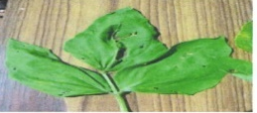 | Small yellow specks with restricted spread covering upto 5 % leaf area | 2 | Resistant
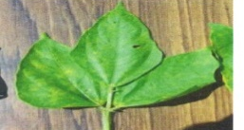 | Yellow mottling covering 5.1 to 15 % leaf area | 3 | Moderate Resistant
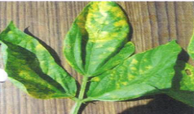 | Yellow mottling and dis-colouration of 15.1 to 30 % leaf area | 4 | Moderate susceptible
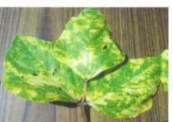 | Pronounced yellow mottling and discoloration of leaves (covering 30.1 to 75 % of area) and pods, reduction in leaf size and stunting of plants | 5 | Susceptible
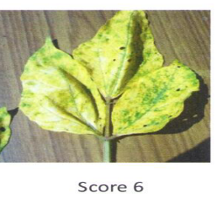 | Severe yellow discoloration covering > 75 % of foliage, stunting of plants and reduction in pod size. | 6 | Highly susceptible

Table S2: Disease severity scores, their corresponding estimates of Per cent Disease Index (PDI) and responses to Mungbean Yellow Mosaic Virus (MYMV) disease
Score | PDI (%) | Response
1 | 0.01-10.00 | Highly resistant
2 | 10.01-25.00 | Resistant
3 | 25.01-40.00 | Moderately Resistant
4 | 40.01-60.00 | Moderately susceptible
5 | 60.01-80.00 | Susceptible
6 | >80.00 | Highly susceptible

Figure S1. Graph indicating increase in number of whiteflies 10 days after planting during crop growth period when plants were infected with Mungbean Yellow Mosaic Virus disease

