Table S1. Fonio varieties cultivated in diversity fields in the six study sites in 2016 and 2017.
 | Variety name | Origin | Description* | Bolimasso | Boumboro | Somo | Finkoloni | N’Goutjina | Siramana | Total # plots
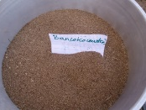 | Bancokocountré | IER | 90-100 day cycle; big grains; red to black in colour | 2016, 2017 | 2016, 2017 | 2016, 2017 | 2016, 2017 | 2016, 2017 | 2016, 2017 | 12
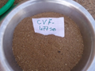 | CVF 477 | IER | 90-100 day cycle | 2016, 2017 | 2016, 2017 | 2016, 2017 | 2016, 2017 | 2016, 2017 | 2016, 2017 | 12
 | CVF 478 | IER |  | 2016 | 2016 |  |  |  |  | 2
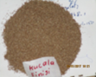 | Fini bléni | Koutiala | 90 day cycle; red colour, adapted to water-logged soil | 2016, 2017 | 2016, 2017 |  | X, X | X, X |  | 4
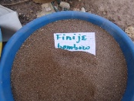 | Fini djè | Boumboro | 85-90 day cycle; small white grains; rapid cooking; adapted to sandy soil, climate resistant at maturity |  | X, X | 2017 | 2016, 2017 | 2016, 2017 | 2016, 2017 | 7
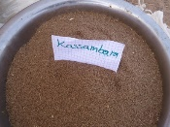 | Kassambara | IER | 90-100 day cycle; big grains, good taste, tends to red color, adapted to sandy soil | 2016, 2017 | 2016, 2017 | 2016, 2017 | 2016, 2017 | 2016, 2017 | 2016, 2017 | 12
 | Niatia | IER | 90-100 day cycle; big grains, good taste, drought tolerant | 2016, 2017 | 2016, 2017 | 2016, 2017 | 2016, 2017 | 2016, 2017 | 2016, 2017 | 12
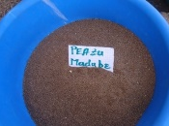 | Péazo Madoubè | Dami | 80-90 day cycle; good in processing | 2016, 2017 | 2016, 2017 | 2017 | 2016, 2017 | 2016, 2017 | 2016, 2017 | 11
 | Pébirou | Bolimasso | 85-90 day cycle; big grains, good taste, black colour; adapted to sandy soil; tolerant to insects and disease | 2016, 2017 | 2016, 2017 | 2017 | 2016, 2017 | 2016, 2017 | 2016, 2017 | 11
 | Péfozo Clément | Sokoro | 85-90 day cycle | 2016, 2017 | 2016, 2017 | 2016, 2017 |  |  |  | 6
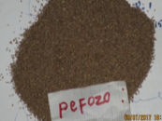 | Pefozo Lamine | Boumboro | 90 day cycle | 2016, 2017 | X, X | 2016 |  |  |  | 3
 | Petjrimè Ouabè | Bolimasso | 80-95 day cycle | 2016, 2017 | 2016, 2017 | 2016 | 2016, 2017 | 2016, 2017 | 2016, 2017 | 11
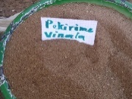 | Petjrimè Vinafo | Sokoro | 90 day cycle |  |  | 2016, 2017 | 2016, 2017 | 2016, 2017 | 2016, 2017 | 8
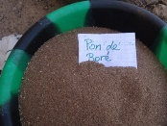 | Pon de Boré | IER | 80-90 day cycle | 2016, 2017 | 2016, 2017 | 2016, 2017 | 2016, 2017 | 2016, 2017 | 2016, 2017 | 12
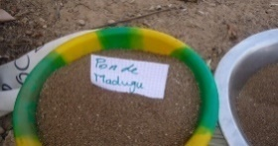 | Pon de Madougou | IER | 80-90 day cycle | 2016, 2017 | 2016, 2017 | 2016, 2017 | 2016, 2017 | 2016, 2017 | 2016, 2017 | 12
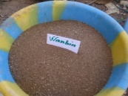 | Wanblen | Boumboro | 80-90 day cycle; good taste, big grains; black color |  | 2016, 2017 | 2017 | 2016, 2017 | 2016, 2017 | 2016, 2017 | 9
Total # varieties |  |  |  | 13 | 13 | 14 | 13 | 12 | 12 | 144
# varieties 2016 |  |  |  | 13 | 13 | 10 | 12 | 12 | 12
# varieties 2017 |  |  |  | 12 | 12 | 12 | 12 | 12 | 12
X indicates varieties that originate from the village but which were not planted in the diversity field
* Variety descriptions are based on information collected by farmers and technicians in the diversity fields, documented in the community biodiversity registers, and shared in focus groups on variety characterization and the community seed fairs.
Table S2. Bambara groundnut varieties cultivated in diversity fields each site 2016/2017.
 | Variety | Origin | Description | Bolimasso | Boumboro | Somo | Finkoloni | N’Goutjina | Siramana | Total # plots
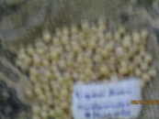 | Alinoro | Djoubasso | 90 day cycle white and black; big grains; good market |  | 2016, 2017 | 2016, 2017 |  |  |  | 4
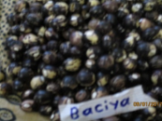 | Batia | Toutou | 90-100 day cycle; black |  | 2016, 2017 |  | 2016, 2017 | 2016 | 2016, 2017 | 7
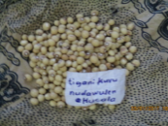 | Bigaré | Koutiala | 90 day cycle ; white seed | 2016, 2017 |  | 2016, 2017 | X, X | X |  | 4
 | Boufigué | Finkoloni | 80 day cycle; medium grains, white, favorite variety in Siramana 2015;good taste |  |  |  | 2016, 2017 | 2016 | 2016, 2017 | 5
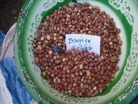 | Bougniga | Kolonto | 90 day cycle, small red grains, good storage, less appreciated |  |  |  | 2016, 2017 | 2016 | 2016, 2017 | 5
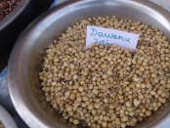 | Dawanu | Somo | 70 day cycle, black and white smaller grain, good taste, used as fresh by boiling, good commercial value | 2016, 2017 | 2017 | X, X | 2016, 2017 | 2016 | 2016, 2017 | 8
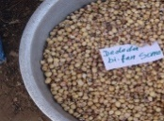 | Dedodabifan | Somo | 80 day cycle ; white color |  |  | X, X | 2016, 2017 | 2016 | 2016, 2017 | 5
 | Fitèrè | Bolimasso | 100 day cycle, mixed colors (red/black), big grain, good taste, good processing; | 2016 | X, X |  | 2016, 2017 | 2016 | 2016, 2017 | 6
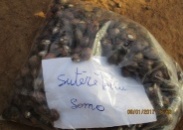 | Fitère burou | Bolimasso | 90 day cycle; black grain | 2016, X |  | 2017 |  |  |  | 2
 | Fitère moumou | Somo |  | 2016 |  |  |  |  |  | 1
 | Noublen | Finkoloni | Red grain | 2016 |  | 2016 | X |  |  | 2
 | Noudafing | Boumboro |  |  | 2016, 2017 | 2017 |  |  |  | 3
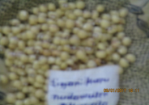 | Noudawulen | Boumboro | 90 day cycle | 2017 | 2016, 2017 | 2017 |  |  |  | 4
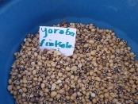 | Noufing | Finkoloni | 90 day cycle | 2016 |  | 2016 | 2016, 2017 | 2016 | 2016, 2017 | 7
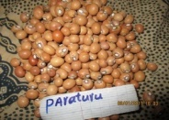 | Paratourou | Boumboro | 90 day cycle |  | 2016, 2017 | 2017 | 2016, 2017 | 2016 | 2016, 2017 | 8
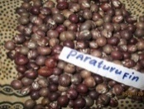 | Paratourou fima | Boumboro | 90-95 day cycle |  | 2016, 2017 |  | 2016, 2017 | 2016 | 2016, 2017 | 7
 | Somo tika | Somo |  |  | 2016 | X |  |  |  | 1
 | Soutere Bolimasso | Bolimasso |  | X, 2017 |  |  |  |  |  | 1
 | Soutere Somo | Somo |  | 2017 |  | X, X |  |  |  | 1
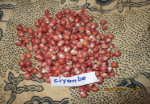 | Tiamba | Boumboro | 95-100 day cycle, good processing, easy harvest |  | 2016, 2017 |  | 2016, 2017 | 2016 | 2016, 2017 | 7
 | Tiandiè | Koutiala |  |  | 2016, 2017 |  | X, X | X |  | 2
 | Tianfin | Boumboro |  |  | 2016 |  |  |  |  | 1
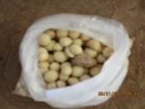 | Tioma foua | Bolimasso | 90 day cycle | 2016, 2017 |  | 2016 | 2016 | 2016 | 2016 | 6
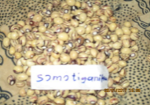 | Tioma moua | Bolimasso | 95 day cycle | X, X |  | 2016, 2017 |  |  |  | 2
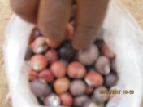 | Tioma poua |  | 90 day cycle |  |  | 2016, 2017 |  |  |  | 2
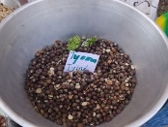 | Tioma tjinè | Bolimasso | 80-90 day cycle | 2016, 2017 |  |  | 2017 |  | 2017 | 4
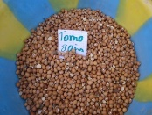 | Tomo | Bolimasso | 80 day cycle | 2016, 2017 |  | 2017 | 2016, 2017 | 2016 | 2016, 2017 | 5
Total # varieties |  |  |  | 13 | 11 | 12 | 13 | 12 | 13 | 113
# varieties 2016 |  |  |  | 10 | 10 | 7 | 12 | 12 | 12
# varieties 2017 |  |  |  | 8 | 9 | 9 | 12 | 0 | 12
X indicates varieties that originate from the village but which were not planted in the diversity field
* Variety descriptions are based on information collected by farmers and technicians in the diversity fields, documented in the community biodiversity registers, and shared in focus groups on variety characterization and the community seed fairs.
Table S3. Evolution of fonio and Bambara groundnut varieties documented in the community biodiversity registers and maintained in community seed banks from 2015 to 2018
Crop | Variety name | 2015† |  |  |  |  |  | 2018†
 |  | Bol | Bom | Som | Fin | NGu | Sir | Bol | Bom | Som | Fin | NGu | Sir
Fonio | Bancokocountré |  |  |  |  |  |  | ✓ | ✓ | ✓ | ✓ | ✓ | ✓
 | CVF 477 |  |  |  |  |  |  | ✓ | ✓ | ✓ | ✓ | ✓ | ✓
 | Finibléni |  |  |  |  |  |  | ✓ | ✓ | ✓
 | Finidjè |  |  |  | ✓ | ✓ |  |  |  |  | ✓ | ✓ | ✓
 | Finifing |  |  |  |  |  | ✓
 | Frac |  |  | ✓
 | Kassambara |  | ✓ |  |  |  |  | ✓ | ✓ | ✓ | ✓ | ✓ | ✓
 | Niatia | ✓ |  |  |  |  |  | ✓ | ✓ | ✓ | ✓ | ✓ | ✓
 | Péazo Madoubè |  | ✓ |  |  |  |  | ✓ | ✓ | ✓
 | Pébirou | ✓ |  |  |  |  |  | ✓ | ✓ | ✓ | ✓ | ✓ | ✓
 | Pefonou | ✓
 | Péfozo Clément |  |  |  |  |  |  | ✓ | ✓ | ✓
 | Petjrimè Ouabè | ✓ |  |  |  |  |  | ✓ | ✓ | ✓ | ✓ | ✓ | ✓
 | Petjrimè Vinafo |  |  |  |  |  |  |  |  |  | ✓ | ✓ | ✓
 | Pon de Boré |  |  | ✓ |  |  |  | ✓ | ✓ | ✓ | ✓ | ✓ | ✓
 | Pon de Madougou |  |  |  |  |  |  | ✓ | ✓ | ✓ | ✓ | ✓ | ✓
 | Wanblen |  | ✓ |  |  |  |  | ✓ | ✓ | ✓ | ✓ | ✓ | ✓
 | Total # varieties | 4 | 3 | 2 | 1 | 1 | 1 | 12 | 12 | 12 | 12 | 12 | 12
Bambara groundnut | Alinoro |  | ✓
 | Batia |  | ✓ |  |  |  |  | ✓ | ✓ | ✓ | ✓ | ✓ | ✓
 | Boufigué |  |  |  | ✓ | ✓ | ✓ | ✓ | ✓ | ✓ | ✓ | ✓ | ✓
 | Bougnégué |  |  |  |  |  | ✓
 | Bougniga |  |  |  | ✓ | ✓ | ✓ | ✓ | ✓ | ✓ | ✓ | ✓ | ✓
 | Bougoua |  |  |  | ✓
 | Dawanou | ✓ |  |  |  |  |  | ✓ | ✓ | ✓ | ✓ | ✓ | ✓
 | Dedodabifan |  |  |  |  |  |  | ✓ | ✓ | ✓ | ✓ | ✓ | ✓
 | Fitèrè | ✓ |  |  |  |  |  | ✓ | ✓ | ✓ | ✓ | ✓ | ✓
 | Fitèrè Bouyiga |  |  |  |  |  |  |  | ✓
 | Kiyanpi |  | ✓
 | Loma poro |  |  | ✓
 | Paratourou |  |  |  |  |  |  | ✓ | ✓ | ✓ | ✓ | ✓ | ✓
 | Paratourou Fima |  |  |  |  |  |  | ✓ | ✓ | ✓ | ✓ | ✓ | ✓
 | Sutèrè |  |  | ✓
 | Tiamba |  | ✓ |  |  |  |  | ✓ | ✓ | ✓ | ✓ | ✓ | ✓
 | Tiandiè |  | ✓
 | Tioma Foua | ✓
 | Tioma tjinè | ✓ |  |  |  |  |  | ✓ | ✓ | ✓ | ✓ | ✓ | ✓
 | Tioma tobo |  |  | ✓
 | Tomo | ✓ |  |  |  |  |  | ✓ | ✓ | ✓ | ✓ | ✓ | ✓
 | Yoroba |  |  |  | ✓ | ✓
 | Total # varieties | 5 | 5 | 3 | 4 | 3 | 3 | 11 | 12 | 11 | 11 | 11 | 11
† Bol=Bolimasso; Bom=Boumboro; Som=Somo; Fin=Finkoloni; NGu=N’Goutjina; Sir=Siramana

Table S4. Post hoc tests on household fonio and Bambara groundnut cultivation frequency, area and yield in 2015 and 2018. Chi-square test results are shown for binomial variables and t-test results are shown for continuous variables.
Contrast | Fonio cultivation (y/n) | Fonio area (Ha) | Fonio yield (kg/Ha) | Bambara groundnut cultivation (y/n) | Bambara groundnut area (Ha) | Bambara groundnut yield (kg/Ha)
Site†
Bol, Som, Bom vs. Fin, NGu, Sir | χ²_{df: 1} = 118.53* | t_{df: 120.55} = 8.5601* | t_{df: 94.151}= 5.0107* | χ²_{df: 1}= 18.613* | t_{df: 271.74}= -4.9386* | t_{df: 268.68} = -0.57288
Bol, Som vs. Bom | χ²_{df: 1}=7.3137* | t_{df: 175.52} = 1.7818^ | t_{df: 136.97}= 0.57308 | χ²_{df: 1}=1.6847 | t_{df: 153.74}= 0.13283 | t_{df: 131.66}= -2.8357*
Bol vs. Som | χ²_{df: 1}=35.913* | t_{df: 78.28} = 7.9175* | t_{df: 100.09}= -0.48955 | χ²_{df: 1}=17.568* | t_{df: 78.489}= 0.14329 | t_{df: 85.854}= -0.90383
Fin, NGu vs. Sir | χ²_{df: 1}=16.147* | t_{df: 5.3565} = 0.94866 | t_{df: 0.4876}= 0.74575 | χ²_{df: 1}=52.332* | t_{df: 17.473}= -0.6111 | t_{df: 42.569}= 2.3972*
Fin vs. NGu† | χ²_{df: 1}=0.59404 | t_{df: 31.146}= -1.9082^ | t_{df: 34.557}= 0.51666 | χ²_{df: 1}=18.486* | t_{df: 70.36}= 3.1056* | t_{df: 56.993}= 1.5242
 | ([Bol>Som]<Bom)>  ([Fin=NGu]>Sir) | ([Bol>Som]=Bom)>  ([Fin=NGu]=Sir) | ([Bol=Som]=Bom)>  ([Fin=NGu]=Sir) | ([Bol>Som]=Bom)>  ([Fin>NGu]>Sir) | ([Bol=Som]=Bom)<  (Fin>NGu]=Sir) | ([Bol=Som]<Bom)=  ([Fin=NGu]>Sir)
Year
2015 vs. 2018 | χ²_{df: 1}=19.757* | t_{df: 236.64}= 3.807* | n/a | χ²_{df: 1}=67.848* | t_{df: 256.34}=2.491* | t_{df: 178.65}= -2.2772
 | 2015<2018 | 2015>2018 |  | 2015<2018 | 2015>2018 | 2015<2018
Site × Year
Bol: 2015 vs. 2018 | χ²_{df: 1}=0.43243 | t_{df: 68.68}= 1.8688^ | n/a | χ²_{df: 1}=3.0988^ | n/a | t_{df: 39.138}= -2.2252*
Som: 2015 vs. 2018 | χ²_{df: 1}=6.8089* | t_{df: 37.98}= -0.80786 | n/a | χ²_{df: 1}=33.351* | n/a | t_{df: 17.484}= 1.2354
Bom: 2015 vs. 2018 | χ²_{df: 1}=0.063241 | t_{df: 52.864}= 0.44438 | n/a | χ²_{df: 1}=11.0* | n/a | t_{df: 54.403}= -0.21871
Fin: 2015 vs. 2018 | χ²_{df: 1}=24.218* | t_{df: 26.881}= 0.82628 | n/a | χ²_{df: 1}=6.0688* | n/a | t_{df: 66.835}= -3.5055*
NGu: 2015 vs. 2018 | χ²_{df: 1}=3.1111^ | t_{df: 16.306}= 2.5084* | n/a | χ²_{df: 1}=38.379* | n/a | t_{df: 3.2284}= -0.10614
Sir: 2015 vs. 2018 | OR§§: 4.701448^ | n/a | n/a | χ²_{df: 1}=0.75 | n/a | t_{df: 6.2882}= -2.6066*
 | 2015<2015 in Som, Fin, marg in Sir | 2015>2018 in NGu marg in Bol |  | 2015<2015 in Som, Bom, Fin, NGu |  | 2015>2018 in Bo, Fin, Sir
† Bol = Bolimasso; Bom=Boumboro; Som=Somo; Fin=Finkoloni; NGu=N’Goutjina; Sir=Siramana
* p-values <0.05; ^ p-value>0.05 and <0.1
§§ Fisher exact test odds ratio applied as an alternative to chi-square because of low sample size
Table S5. Comparison of village-level variety diversity in 2015 and 2018 based on results of the accumulation curves to control for the sample size of households.

Community | Fonio (# varieties) |  | Bambara groundnut (# varieties)
 | 2015† | 2018§ | 2015† | 2018§
Somo | 6.03 ± 1.06 | 4 | 7.35 ± 1.28 | 8
Bolimasso | 9.55 ± 1.18 | 6 | 8.52 ± 0.87 | 11
Boumboro | 5.14 ± 0.77 | 3 | 6.10 ± 0.85 | 8
Finkoloni | 3.56 ± 0.83 | 12 | 3.62 ± 0.79 | 5
N’Goutjina | 4.46 ± 0.56 | 9 | 4.49 ± 0.58 | 6
Siramana | 2.05 ± 0.95 | 4 | 2.13 ± 0.92 | 3
† Estimated number of varieties and standard deviation for 30 households based on accumulation curves
§ Actual number of varieties recorded at community level (N=30)

Figure S1. Rainfall in the study sites over the cropping cycle (June to September) 2016 and 2017.
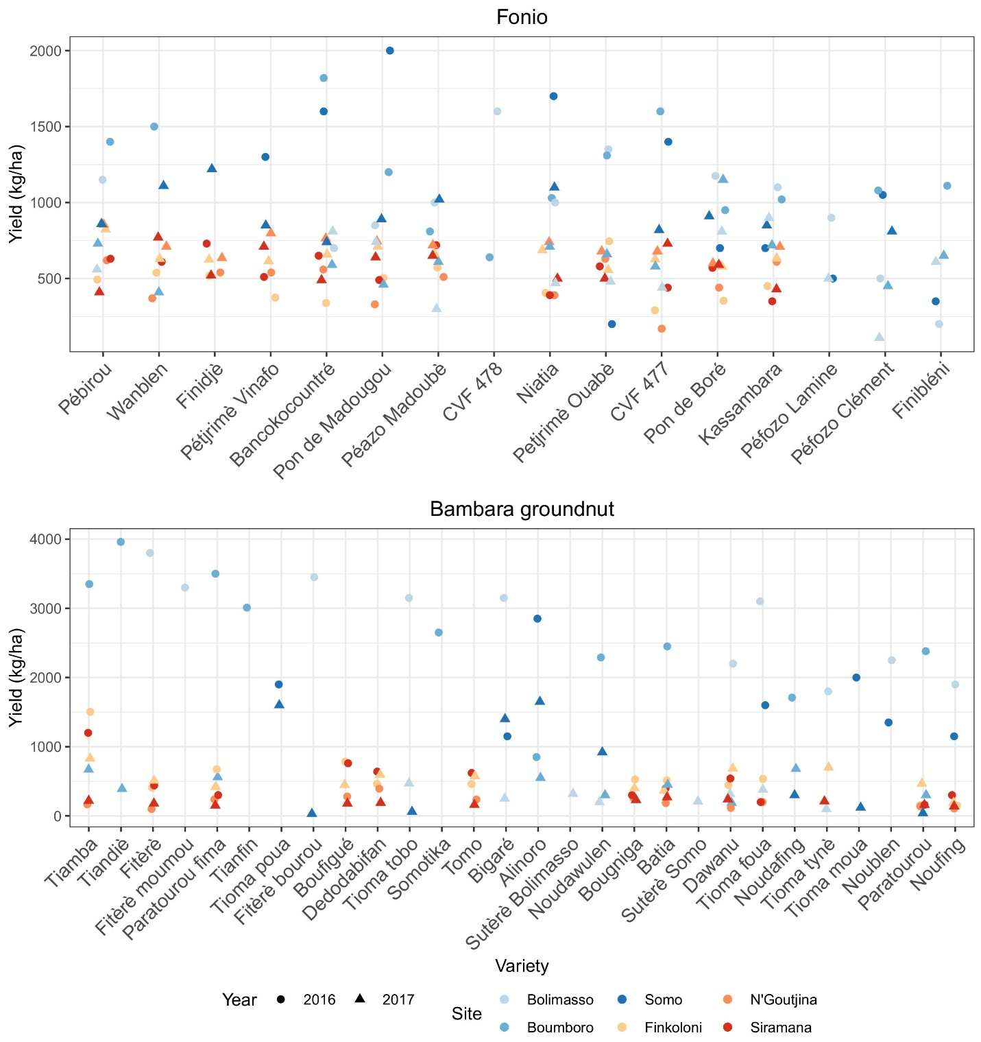

Figure S2. Yield of fonio and Bambara groundnut varieties in the diversity fields by site and year.
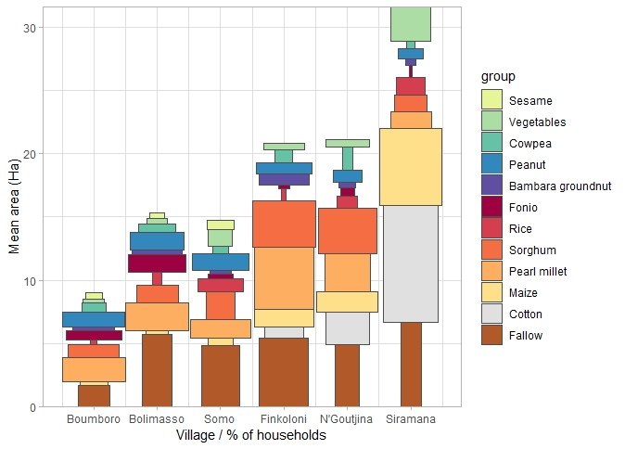

Figure S3. Summary of household cropping systems in the focal villages in 2015. The percent of households growing a specific crop is indicated by the width of the bars and the mean area allocated by growers is indicated by the height of the bars.

