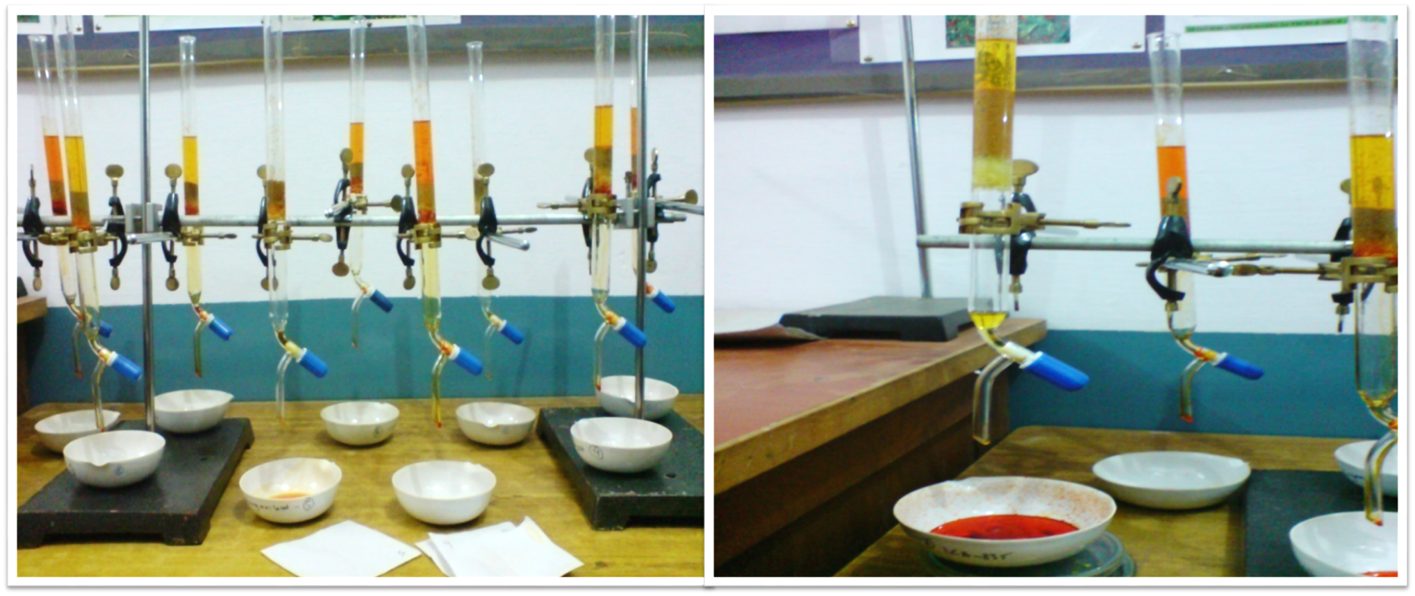
Figure S1. Apparatus used for estimation of oleoresin extraction by gravimetric method

