Table S1. The distribution of alleles for the rice blast resistant genes Pid3, Pigm and Pi54 in 203 Thai landrace rice varieties and in 23 recommended rice varieties
No. | Code | Rice variety | Source | Pid3 | Pigm | Pi54
1 | U 38 | Ngo Phuean | Northern Upland rice | S | R | R
2 | U 39 | Da Ya Li | Northern Upland rice | R | R | S
3 | U 41 | Pue Ko | Northern Upland rice | S | R | S
4 | U 42 | Pue Kaset | Northern Upland rice | R | R | R
5 | U 43 | Niao Saeng Mu Woe | Northern Upland rice | R | R | S
6 | U 44 | Kariang Khao | Northern Upland rice | S | R | S
7 | U 45 | Lueang Hom | Northern Upland rice | R | R | R
8 | U 46 | Cha No Nai | Northern Upland rice | R | S | R
9 | U 48 | Lai San | Northern Upland rice | R | R | R
10 | U 49 | Pi I Mae La | Northern Upland rice | R | R | S
11 | U 50 | Huai Laeng | Northern Upland rice | S | R | R
12 | U 51 | Pi I Su Mae Fang | Northern Upland rice | R | S | R
13 | U 52 | Khao Ko Phae | Northern Upland rice | S | R | R
14 | U 53 | Bue Kho Pho | Northern Upland rice | R | R | S
15 | U 55 | Lueang Liso | Northern Upland rice | S | R | S
16 | U 56 | Khao Daeng | Northern Upland rice | S | S | S
17 | U 57 | Khaoman Mu | Northern Upland rice | S | S | S
18 | U 60 | Ngo Se Ra | Northern Upland rice | S | R | R
19 | U 61 | Niao Klam Hom Saeng Liso | Northern Upland rice | R | R | R
20 | S 71 | Nan Nak | Southern Lowland rice | S | R | S
21 | S 72 | Nang Ma | Southern Lowland rice | S | R | S
22 | S 73 | Niao Nakkharat | Southern Lowland rice | S | R | S
23 | S 74 | Niao Hom | Southern Lowland rice | S | R | S
24 | S 75 | Mae Yaeng | Southern Lowland rice | S | R | S
25 | S 76 | Dok Phuang | Southern Lowland rice | S | R | S
26 | S 77 | Khuen Din | Southern Lowland rice | S | R | S
27 | S 78 | Dok Phikun | Southern Lowland rice | S | R | S
28 | S 79 | Kham Chang | Southern Lowland rice | S | R | S
29 | S 80 | Saibua | Southern Lowland rice | S | S | S
30 | S 81 | Cho Nimit | Southern Lowland rice | S | S | S
31 | S 82 | Rai Sai | Southern Lowland rice | S | R | S
32 | S 83 | Bao Chamuang | Southern Lowland rice | S | R | S
33 | S 84 | Luk Kho | Southern Lowland rice | S | R | S
34 | S 85 | Su Ki Kun Ong | Southern Lowland rice | S | R | S
35 | S 86 | La yod | Southern Lowland rice | S | R | S
36 | S 87 | La Ke Ngo | Southern Lowland rice | S | R | S
37 | S 88 | Nang Thong | Southern Lowland rice | S | X | S
38 | S 89 | Luk Wai | Southern Lowland rice | S | X | S
39 | S 90 | Luk Dam | Southern Lowland rice | S | R | S
40 | S 91 | Chiang Mai | Southern Lowland rice | S | R | S
41 | S 92 | Luk Dang | Southern Lowland rice | S | R | S
42 | S 93 | Beb Nok Bao | Southern Lowland rice | S | R | S
43 | S 94 | Cho | Southern Lowland rice | S | R | S
44 | S 95 | Cho Dang | Southern Lowland rice | S | R | S
45 | S 96 | Ku Ning | Southern Lowland rice | S | R | S
46 | S 97 | Dok Mai Sai | Southern Lowland rice | S | R | S
47 | S 98 | Ruang Thong | Southern Lowland rice | S | R | S
48 | S 99 | Luk Pla | Southern Lowland rice | S | R | S
49 | S 100 | Nang Klai Dang | Southern Lowland rice | S | R | S
50 | S 101 | La Koh | Southern Lowland rice | S | R | S
51 | S 102 | Ku Ning | Southern Lowland rice | S | R | S
52 | S 103 | Mue Chorakhe | Southern Lowland rice | S | R | S
53 | S 104 | Tula Thua | Southern Lowland rice | S | X | S
54 | S 105 | Hom | Southern Lowland rice | S | X | S
55 | S 106 | Kue Sae Dam | Southern Lowland rice | S | R | S
56 | S 107 | Lue Bu Ma So | Southern Lowland rice | S | R | S
57 | S 108 | Nang Rong | Southern Lowland rice | S | R | S
58 | S 109 | I Ku | Southern Lowland rice | S | X | S
59 | S 110 | A Ma | Southern Lowland rice | S | R | S
60 | L 1 | Kao Ruang 17-2-106 | Northeast Lowland rice | S | R | S
61 | L 2 | Ku Mueang | Northeast Lowland rice | S | R | S
62 | L 3 | KDML 41-1-173 | Northeast Lowland rice | S | S | S
63 | L 4 | Kao Tar Hang 55-5-55 | Northeast Lowland rice | S | S | S
64 | L 5 | Kao Yai 33-22-61 | Northeast Lowland rice | S | R | S
65 | L 6 | Kao Pak Mor 74 | Northeast Lowland rice | S | S | S
66 | L 7 | Loot Nee 75-3-2 | Northeast Lowland rice | S | X | S
67 | L 8 | Med Yai 94-4-87 | Northeast Lowland rice | S | X | S
68 | L 9 | Kao Phuang 74-3-38 | Northeast Lowland rice | S | S | S
69 | L 10 | Chao Hang Moo Yai 32-27 | Northeast Lowland rice | S | R | S
70 | L 11 | Chao Hang Moo Yai 32-27 | Northeast Lowland rice | S | R | S
71 | L 12 | Chao Hom 32-18-69 | Northeast Lowland rice | S | R | S
72 | L 13 | Bai Lod 36-10-90 | Northeast Lowland rice | S | R | S
73 | L 14 | Chao Lueang 27-3-19 | Northeast Lowland rice | S | R | S
74 | L 15 | Chao Lueang 27-3-91 | Northeast Lowland rice | S | R | S
75 | L 16 | Chao Pae 31-28-1 (Gs.no 566) | Northeast Lowland rice | S | R | S
76 | L 17 | KDML 109-1-119 (Gs.no 569) | Northeast Lowland rice | S | R | S
77 | L 18 | Bai Lod 36-19-40 (Gs.no 572) | Northeast Lowland rice | S | R | S
78 | L 19 | Bai Lod 36-27-29 (Gs.no 573) | Northeast Lowland rice | S | R | S
79 | L 20 | Ruang Diao 68-10-85 | Northeast Lowland rice | S | R | S
80 | L 21 | Lueang Yai ( | Northeast Lowland rice | S | X | S
81 | L 22 | Lueang Lek 30-1-57 | Northeast Lowland rice | S | X | S
82 | L 23 | Lueang Noon 6-4-102 | Northeast Lowland rice | S | R | S
83 | L 24 | BK 289 | Northeast Lowland rice | S | R | S
84 | L 25 | BK 563 | Northeast Lowland rice | S | R | S
85 | L 26 | Tee 569 | Northeast Lowland rice | S | X | S
86 | L 27 | Kee Tom 222-24-72 | Northeast Lowland rice | S | X | S
87 | L 28 | Kee Tom Yai 35-16-45 | Northeast Lowland rice | S | R | S
88 | L 29 | Kee Tom Khao 222-42-3 | Northeast Lowland rice | R | S | S
89 | L 30 | Kee Tom Khao 222-42-5 | Northeast Lowland rice | S | R | S
90 | L 31 | Han Dong 34-3-95 | Northeast Lowland rice | S | R | S
91 | L 32 | Door Dok Phrao 48-3-123 | Northeast Lowland rice | R | S | S
92 | L 33 | Kee Tom Hom (Gs.no 2720) | Northeast Lowland rice | R | S | S
93 | L 34 | Niao Dam (Gs.no 2723) | Northeast Lowland rice | S | R | S
94 | L 35 | Do Pong Aeo (Gs.no 2725) | Northeast Lowland rice | S | R | S
95 | L 36 | Dok Doo (Gs.no 2872) | Northeast Lowland rice | R | R | S
96 | L 37 | Tong (Gs.no 2942) | Northeast Lowland rice | S | R | S
97 | L 38 | Man Ped (Gs.no 2943) | Northeast Lowland rice | S | R | S
98 | L 39 | Khao (Gs.no 3356) | Northeast Lowland rice | S | R | S
99 | L 40 | Nang Nuan (Gs.no 3357) | Northeast Lowland rice | S | S | S
100 | L 41 | Khao Kroong (Gs.no 3358) | Northeast Lowland rice | S | R | S
101 | L 42 | Niao Daeng (Gs.no 3360) | Northeast Lowland rice | S | R | S
102 | L 43 | Khao (Gs.no 3361) | Northeast Lowland rice | S | R | S
103 | L 44 | Door Khao (Gs.no 3363) | Northeast Lowland rice | S | S | S
104 | L 45 | Lueang Bun Ma (Gs.no 3364) | Northeast Lowland rice | S | R | S
105 | L 46 | Mak Keng (Gs.no 3365) | Northeast Lowland rice | S | R | S
106 | L 47 | Khao Settee | Northeast Lowland rice | S | R | S
107 | L 48 | Niao Nangnuan (Gs.no 3367) | Northeast Lowland rice | S | R | S
108 | L 49 | Door Ang (Gs.no 3368) | Northeast Lowland rice | S | R | S
109 | L 50 | Khao Kam (Gs.no 3369) | Northeast Lowland rice | S | S | S
110 | L 51 | Pong Aeo (Gs.no 3370) | Northeast Lowland rice | S | R | S
111 | L 52 | I Pong (Gs.no 3372) | Northeast Lowland rice | S | S | S
112 | L 53 | Nanh Nuan (Gs.no 3373) | Northeast Lowland rice | S | S | S
113 | L 54 | Mae Hang (Gs.no 3374) | Northeast Lowland rice | S | R | S
114 | L 55 | Pan Thong (Gs.no 3375) | Northeast Lowland rice | S | R | S
115 | L 56 | I Pid (Gs.no 3376) | Northeast Lowland rice | S | R | S
116 | L 57 | Do Sam Duean (Gs.no 3377) | Northeast Lowland rice | S | S | S
117 | L 58 | Khao Pon (Gs.no 3378) | Northeast Lowland rice | S | S | S
118 | L 59 | I Ton (Gs.no 3379) | Northeast Lowland rice | S | R | S
119 | L 60 | Nangnuan (Gs.no 3380) | Northeast Lowland rice | S | R | S
120 | L 61 | Duangchan (Gs.no 3382) | Northeast Lowland rice | S | R | S
121 | L 62 | Pla Khaeng (Gs.no 3384) | Northeast Lowland rice | S | R | S
122 | L 63 | Petnam (Gs.no 3385) | Northeast Lowland rice | S | R | S
123 | L 64 | Phan Lak (Gs.no 3386) | Northeast Lowland rice | S | R | S
124 | L 65 | Khao Hang (Gs.no 3387) | Northeast Lowland rice | S | R | S
125 | L 66 | Sam Duean (Gs.no 3892) | Northeast Lowland rice | S | R | S
126 | L 67 | Pong Aeo 1(Gs.no 3893) | Northeast Lowland rice | S | R | S
127 | L 68 | Pong Aeo 2 (Gs.no 3894) | Northeast Lowland rice | S | X | S
128 | L 69 | Pong Aeo (Gs.no 3895) | Northeast Lowland rice | S | S | S
129 | L 70 | Maprang (Gs.no 3897) | Northeast Lowland rice | S | R | S
130 | L 71 | Nang Kham Phai (Gs.no 4373) | Northeast Lowland rice | S | R | S
131 | L 72 | Khaoyai (Gs.no 4375) | Northeast Lowland rice | S | R | S
132 | L 73 | O Lon (Gs.no 4377) | Northeast Lowland rice | S | S | S
133 | L 74 | Khao Hom (Gs.no 4809) | Northeast Lowland rice | S | R | S
134 | L 75 | Khao Hom (Gs.no 4810) | Northeast Lowland rice | S | X | S
135 | L 76 | Khao Hom (Gs.no 4814) | Northeast Lowland rice | S | R | S
136 | L 77 | Khao Hom (Gs.no 4815) | Northeast Lowland rice | S | X | S
137 | L 78 | Khao Hom (Gs.no 4816) | Northeast Lowland rice | S | X | S
138 | L 79 | Khao Hom (Gs.no 4817) | Northeast Lowland rice | S | X | S
139 | L 80 | Khao Hom (Gs.no 4818) | Northeast Lowland rice | S | R | S
140 | L 81 | Khao Hom (Gs.no 4829) | Northeast Lowland rice | S | R | S
141 | L 82 | Khao Hom (Gs.no 4831) | Northeast Lowland rice | S | S | S
142 | L 83 | Khao Hom (Gs.no 4832) | Northeast Lowland rice | S | R | S
143 | L 84 | Khao Hom (Gs.no 4833) | Northeast Lowland rice | S | R | S
144 | L 85 | Khao Hom (Gs.no 4834) | Northeast Lowland rice | R | R | S
145 | L 86 | Khao Hom (Gs.no 4835) | Northeast Lowland rice | S | R | S
146 | L 87 | Khao Hom (Gs.no 4869) | Northeast Lowland rice | S | R | S
147 | L 88 | Khao Hom (Gs.no 4870) | Northeast Lowland rice | S | R | S
148 | L 89 | Kathi (Gs.no 5565) | Northeast Lowland rice | S | R | S
149 | L 90 | Khao Do (Gs.no 5566) | Northeast Lowland rice | S | R | S
150 | L 91 | Do Lueang (GS.no 5567) | Northeast Lowland rice | S | R | S
151 | L 92 | Chao Khao (Gs.no 5572) | Northeast Lowland rice | S | S | S
152 | L 93 | Khaoyai (Gs.no 5573) | Northeast Lowland rice | S | R | S
153 | L 94 | Lueang (Gs.no 13232) | Northeast Lowland rice | S | S | S
154 | L 95 | Kraduk Suea (Gs.no 13233) | Northeast Lowland rice | S | S | S
155 | L 96 | KDML (Gs.no 18418) | Northeast Lowland rice | S | S | S
156 | L 97 | KDML(Gs.no 18419) | Northeast Lowland rice | S | R | S
157 | L 98 | KDML (Gs.no 18420) | Northeast Lowland rice | S | R | S
158 | L 99 | KDML (Gs.no 19398) | Northeast Lowland rice | S | S | S
159 | E 100 | Phuang Thong | Northeast Floating rice | S | R | S
161 | E 102 | Phuangmalai 35-10-8 | Northeast Floating rice | S | R | S
162 | E 103 | Phot Chalong 31-34-20 | Northeast Floating rice | S | R | S
163 | E 104 | Champa Chin 84-8-16 | Northeast Floating rice | S | R | S
164 | E 105 | Champa Chin 84-8-22 | Northeast Floating rice | S | R | S
165 | E 106 | Sawang Arom 84-4-118 | Northeast Floating rice | S | S | S
166 | E 107 | Khaobao Thi Ning 95-1-180 | Northeast Floating rice | S | R | S
167 | E 108 | Khai Maengda 59-2-73 | Northeast Floating rice | S | R | S
168 | E 109 | Loi Yai 62-40-140 | Northeast Floating rice | S | R | S
169 | E 110 | Met Lek Nak | Northeast Floating rice | S | R | S
170 | E 111 | Phaya Chom | Northeast Floating rice | S | R | S
171 | E 112 | Khiao | Northeast Floating rice | S | R | S
172 | E 113 | Khao Prachin | Northeast Floating rice | S | R | S
173 | E 114 | Chek Kradot | Northeast Floating rice | S | X | S
174 | E 115 | Ruang Diao | Northeast Floating rice | S | R | S
175 | E 116 | Chao Loi | Northeast Floating rice | S | R | S
176 | E 117 | Lueang Kluai | Northeast Floating rice | S | R | S
177 | E 118 | Khunmae | Northeast Floating rice | S | S | S
178 | E 119 | Khao Yai Khli | Northeast Floating rice | S | R | S
179 | E 120 | Khao Samoe | Northeast Floating rice | S | R | S
180 | E 121 | Lueang Phuang Thong | Northeast Floating rice | S | R | S
181 | E 122 | Lueang Anan | Northeast Floating rice | S | R | S
182 | E 123 | Khao Li | Northeast Floating rice | S | R | S
183 | E 124 | Khao Ta Yat | Northeast Floating rice | S | R | S
184 | E 125 | Nang Khiao | Northeast Floating rice | S | R | S
185 | E 126 | Loi Saibua | Northeast Floating rice | S | R | S
186 | E 127 | Nang Khiao | Northeast Floating rice | S | R | S
187 | E 128 | Nang Khiao | Northeast Floating rice | S | R | S
188 | E 129 | Kwian Hak | Northeast Floating rice | S | R | S
189 | E 130 | Khao Pho | Northeast Floating rice | S | R | S
190 | E 131 | Sam Phran | Northeast Floating rice | S | S | S
191 | E 132 | Niao Bai Si | Northeast Floating rice | S | R | S
192 | E 133 | Lueang Bangbai | Northeast Floating rice | S | S | S
193 | E 134 | Khao Nakhon Chai Si | Northeast Floating rice | S | R | S
194 | E 135 | Chao Loi | Northeast Floating rice | S | R | S
195 | E 136 | Khao Loi | Northeast Floating rice | S | R | S
196 | E 137 | Thantawan | Northeast Floating rice | S | R | S
197 | E 138 | Khao Setthi | Northeast Floating rice | S | S | S
198 | E 139 | Sam Ruang | Northeast Floating rice | S | S | S
199 | E 140 | Hom Thung | Northeast Floating rice | S | R | S
200 | E 141 | Hom Thung | Northeast Floating rice | S | R | S
201 | E 142 | Ai Mong | Northeast Floating rice | S | R | S
202 | E 143 | Phuang Nak | Northeast Floating rice | R | R | S
203 | E 144 | Phuang Ngoen | Northeast Floating rice | R | S | S
204 | R 1 | Suphan Buri 60 | Thai Rice Department Recommended rice | R | S | S
205 | R 2 | Chai Nat 1 | Thai Rice Department Recommended rice | S | S | S
206 | R 3 | Suphan Buri 1 | Thai Rice Department Recommended rice | S | S | S
207 | R 4 | San Pa Tong 1 | Thai Rice Department Recommended rice | S | S | S
208 | R 5 | Pathum Thani 1 | Thai Rice Department Recommended rice | S | R | S
209 | R 6 | Niao Ubon 2 | Thai Rice Department Recommended rice | S | R | S
210 | R 7 | Ko Kho 10 | Thai Rice Department Recommended rice | S | R | R
211 | R 8 | Ko Kho 33 | Thai Rice Department Recommended rice | S | R | S
212 | R 9 | Prachin Buri 2 | Thai Rice Department Recommended rice | S | R | R
213 | R 10 | C101A51 | IRRI Recommended rice | S | R | S
214 | R 12 | C101PKT | IRRI Recommended rice | S | S | R
215 | R 13 | C102PKT | IRRI Recommended rice | S | S | R
216 | R 14 | C104PKT | IRRI Recommended rice | S | S | S
217 | R 15 | C101TTP | IRRI Recommended rice | S | R | S
218 | R 16 | C101TTP | IRRI Recommended rice | S | R | S
219 | R 17 | C105TTP 4-1-23 | IRRI Recommended rice | R | S | R
220 | R 18 | CO39 | IRRI Recommended rice | R | S | R
221 | R 19 | AZUCENA | IRRI Recommended rice | R | NA | S
222 | R 20 | IR64 | IRRI Recommended rice | S | R | S
223 | R 21 | CT9933 | IRRI Recommended rice | R | NA | S
224 | R 22 | JHN | RGDU Recommended rice | R | NA | S
225 | C 1 | KDML105 | Thai Rice Department Recommended rice | S | S | S
226 | C 2 | Nipponbare | Japan | R | S | S

Notes:
Pi-d3 R: resistant allele; after PCR amplification with Pi-d3 gene-specific Pi-d3dCAP2 primers then digested with Bam HI giving 178 bp fragment
S: susceptible allele; after PCR amplification with Pi-d3 gene-specific Pi-d3dCAP2 primers then digested with Bam HI giving 153 bp fragment
Pigm R: resistant allele; after PCR amplification with Pigm gene-specific S29742 primers giving 555 bp fragment
S: susceptible allele; after PCR amplification with Pigm gene-specific S29742 primers giving 461 bp fragment
X: new allele; after PCR amplification with Pigm gene-specific S29742 primers giving 900 bp fragment
Pi54 R: resistant allele; after PCR amplification with P54 gene-specific Pi54 MAS primers giving 216 bp fragment
S: susceptible allele; after PCR amplification with P54 gene-specific Pi54 MAS primers giving 359 bp fragment
ns = could not be amplified

Table S2. Rice blast fungus isolates used in this study
I.D. code Rice variety isolated Organ infected Location collected
10301 KDML105 Collar Meung, Sri saket
10551 KDML105 Leaf Nakhon Ratchasima
10576 KDML105 Leaf Kalasin
10760 KDML105 Neck Phrankratai, Kampheangphet
10927 KDML105 Neck Dok Kam Tai, Phayao
10941 KDML105 Neck Hangchat, Lampang
10945 Sunpathong Neck Jomthong, Chiang Mai
10971 KDML105 Neck Waing Sa, Nan
10993 KDML105 Neck Nangrong, Buri Ram
11108 KDML105 Neck Ubon Ratchathani
Bag 3.2 KDML105 Leaf Wang Thong, Phitsanulok
Bag 5.1 1034N.110 Neck Mueang, Khon Kaen
Bag 8.4 KDML105 Leaf Mueang, Ubon Ratchathani
Bag 9.4 KDML105 Neck Mueang, Chiang Rai
Bag 12.5 RD6 Leaf Phon Phisai, Nong Khai
Bag 14.3 KDML105 Leaf Si Chiang Mai, Nong Khai
Bag 16.2 RD6 Leaf Phen, Udon Thani
Bag 17.2 KDML105 Leaf Chatturat, Chaiyaphum
Bag 22.1 RD10 Leaf Tungfon, Udonthani
Bag 29.2 RD6 Leaf Pangkon, Udonthani

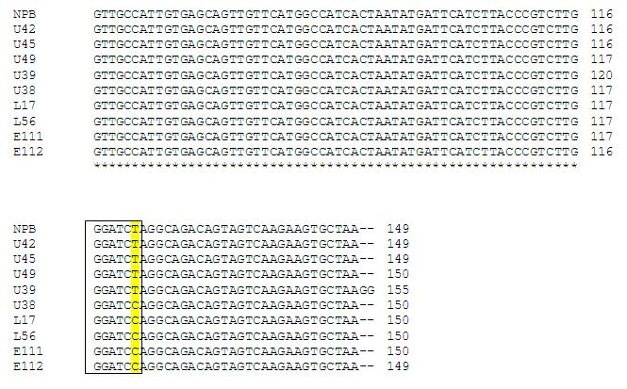
Figure S1. Sequence alignment of the Pid3 gene in ten rice varieties shows the BamHI recognition site. Five rice varieties with the resistant allele are NPB = rice variety Nipponbare, U42 = rice variety Pue Kaset, U45 = rice variety Lueang Hom, U49 = rice variety Pi I Mae La, and U39 = rice variety Da Ya li. Five rice varieties with the susceptible allele are U38 = rice variety Ngo Phuean, L17 = rice variety KDML 109-1-119, L56 = rice variety E Pit, E111 = rice variety Phaya Chom, and E112 = rice variety Khiao.

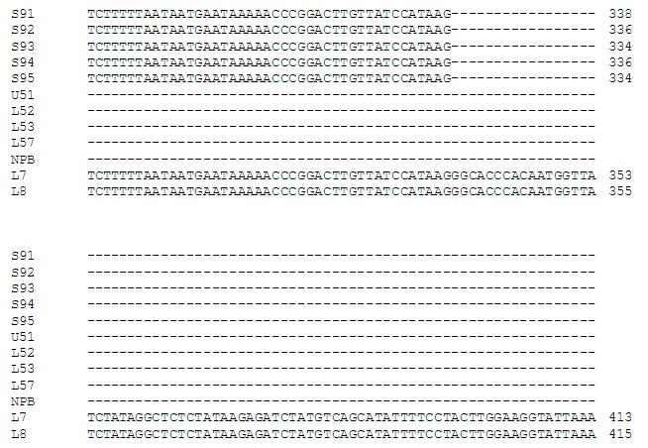
Figure S2. Sequence alignment of the Pigm gene in twelve rice varieties shows the three different alleles. Five rice varieties with the resistant allele are S91 = rice variety Chiang Mai, S92 = rice variety Luk Dang, S93 = rice variety Beb Nok Bao, S94 = rice variety Cho, and S95 = rice variety Cho Dang. Five rice varieties with the susceptible allele are U51 = rice variety Pi I Su Mae Fang, L52 = rice variety I Pong, L53 = rice variety Namh Nuan, L57 = rice variety Do Sam Duean, and NPB = rice variety Nipponbare. Two rice varieties with the novel allele are L7 = rice variety Loot Nee, and L8 = rice variety Med Yai.

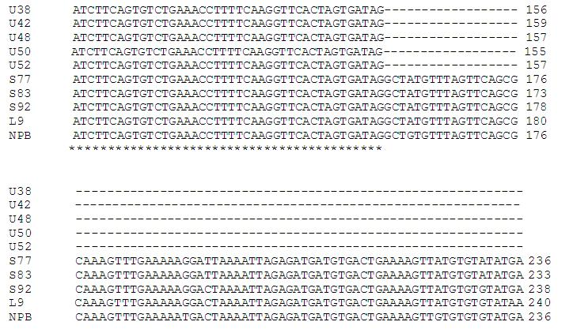
Figure S3. Sequence alignment of the Pi54 gene in ten rice varieties shows the deletion in resistance allele. Five rice varieties with the resistant allele are U38 = rice variety Ngo Phuean, U42 = rice variety Pue Kaset, U48 = rice variety Lai San, U50 = rice variety Huai Laeng, and U52 = rice variety Khao Ko Phae. Five rice varieties with the susceptible allele are S77 = rice variety Khuen Din, S63 = rice variety Bao Chamuang, S92 = rice variety Luk Dang, L9 = rice variety Kao Phuang 74-3-38, and NPB = rice variety Nipponbare.

