Supplementary documents
Table S1. List and type of durum wheat genotypes characterized at two locations over two seasons
Entry | Accession/  variety | Status | Seed source | Region | Collection zone |  |  |  | Locality
G1 | 206551 | FV | EBI | Tigray |  | Southern |  |  |  | Enderta
G2 | 206556 | FV | EBI | Tigray |  | Eastern |  |  |  | Ganta Hafeshum
G3 | 207058 | FV | EBI | Amhara |  | East Gojjam |  |  |  | Enarj Enawga
G4 | 208150 | FV | EBI | Amhara |  | East Gojjam |  |  |  | Enarj Enawga
G5 | 208173 | FV | EBI | Amhara |  | East Gojjam |  |  |  | Enarj Enawga
G6 | 208175 | FV | EBI | Amhara |  | East Gojjam |  |  |  | Enarj Enawga
G7 | 208196 | FV | EBI | Amhara |  | East Gojjam |  |  |  | Enarj Enawga
G8 | 208227 | FV | EBI | Na |  | Na |  |  |  | Na
G9 | 208253 | FV | EBI | Oromia |  | North Shoa |  |  |  | Wara Jarso
G10 | 208304‡ | FV | EBI | Oromia |  | North Shoa |  |  |  | Gerar Jarso
G11 | 208309 | FV | EBI | Oromia |  | North Shoa |  |  |  | Gerar Jarso
G12 | 208315 | FV | EBI | Oromia |  | North Shoa |  |  |  | Gerar Jarso
G13 | 208322 | FV | EBI | Oromia |  | North Shoa |  |  |  | Gerar Jarso
G14 | 208474 | FV | EBI | Oromia | East shoa |  |  |  |  | Lome
G15 | 208482 | FV | EBI | Amhara | East shoa |  |  |  | Minjarna shenokora
G16 | 210825 | FV | EBI | Amhara | East Gojjam |  |  |  | Dejen
G17 | 213310 | FV | EBI | Tigray | Southern |  |  |  | Enderta
G18 | 214357 | FV | EBI | Oromia | North Shoa |  |  |  | Aleltu
G19 | 216796 | FV | EBI | Na | Na |  |  |  | Na
G20 | 222360 | FV | EBI | Amhara |  |  | East Gojjam |  |  |  | Enaraj Enawga
G21 | 226834 | FV | EBI | Amhara |  |  | East Gojjam |  |  |  | Dejen
G22 | 228763 | FV | EBI | Oromia |  |  | West Shoa |  |  |  | Ambo
G23 | 228771 | FV | EBI | Oromia |  |  | West Shoa |  |  |  | Ambo
G24 | 236282 | FV | EBI | Tigray |  |  | Southern |  |  |  | Samre
G25 | 238567 | FV | EBI | Amhara |  |  | North Shoa |  |  |  | Debrebrhan Zuria
G26 | 208336bl | FV | EBI | Oromia |  |  | North Shoa |  |  |  | Mulona Sululta
G27 | 226834B | FV | EBI | Amhara |  |  | East Gojjam |  |  |  | Dejen
G28 | 238137A | FV | EBI | Tigray |  |  | Central |  |  |  | Tahtay Maychew
G29 | 238492B | FV | EBI | Oromia |  |  | East Shoa |  |  |  | Ada’a Chukala
G30 | 8208 | FV | EBI | Amhara |  |  | North Shoa |  |  |  | Matudmezezo Mojana
G31 | 8214 | FV | EBI | Amhara |  |  | North Shoa |  |  |  | Matudmezezo Mojana
G32 | Arendato | IMV | DzARC | - |  |  | - |  |  |  | -
G33 | Asassa | IMV | DzARC | - |  |  | - |  |  |  | -
G34 | Mangudo | IMV | DzARC | - -
G35 | Mukiye | IMV | DzARC | - -
G36 | Robe | IMV | DzARC | - -
‡ FVs selected for superior performance and registered nationally as variety; FV: Farmers variety or landraces; IMV: improved variety, EBI: Ethiopian Biodiversity Institute; DzARC: Debrezeit Agricultural Research Center

Table S2. Matrix of top 10 performer genotypes due to the three way interactions of G × L × Y for selected traits of durum wheat. The rows list of genotypes across various environments while the column presents genotypes performance within an environment.
Trait | Location/year
 | Ayba |  | Melfa |  | Menkere |  | MU
 | 2014 | 2015 | 2014 | 2015 | 2014 | 2015 | 2014 | 2015
DF (early to late; day) | G19, G35, G34,  G26, G29, G36  G4, G7, G16, G18  (79 – 82) | G35, G29, G16 G36, G8, G7  G34,G2,G18 G26  (68 – 71) | G36, G29, G35  G34, G4, G7  G16, G19, G13  G25  (82.3 -73.2) | G14, G31, G29  G34, G26, G16  G32, G36, G8  G7  (69.1 – 72.4) | G36, G4, G35  G34, G29, G32  G7, G18, G2  G16  (68.3-78.1) | G36, G35, G34  G4, G29, G7  G2, G18, G16  G19  (62.2 – 70.8) | G7, G34, G36  G19, G35, G29, G4, G16  G8, G15  (62.3 – 68.5) | G4, G36, G34  G35, G2, G7  G18, G16, G32, G29  (58 – 63)
DM (early to late; day) | G8, G6, G33, G2, G34, G27  G17, G22, G14  G31  (125-129) | G2, G15, G32  G23, G6, G18  G22, G29, G7  G25  (118 – 122) | G6, G15, G34  G13, G35, G10  G2, G14, G12  G7  (121-124) | G4, G32, G6  G9, G33, G15  G10, G25, G30  G2  (105.6 – 111.4) | G10, G32, G9  G2, G6, G31  G22, G1, G30  G11  (116 – 125) | G6, G12, G15  G4, G29, G2  G17, G14, G22  G10  (111.7 – 116.4) | G6, G35, G34  G22, G9, G28  G33, G13, G4  G29  (95.6 – 102.2) | G6, G16, G1  G33, G31, G4  G28, G9, G35  G30  (81.2 – 87.4)
BY (high to low; t ha⁻¹) | G26, G33, G8, G16, G23, G4  G20, G11, G10, G30 | G2, G21, G32  G36, G3, G30  G22, G4, G16  G7  (17.7 -14.6) | G12, G24, G16  G30, G26, G22  G10, G28, G7  G4  (7.03 – 5.71) | G27, G25, G10  G26, G5, G19  G10, G36, G6  G17  (11.7 – 8.45) | G5, G10, G19  G36, G14, G16  G22, G1, G30  G21  (10.9 – 8.6) | G4, G16, G29  G35, G1, G14  G15, G33, G25  G6  (11.1-8.69) | G30, G14, G19, G25, G11, G29, G24, G6, G16  G3  (9.66 – 8.49) | G27, G23, G30, G19, G26, G17, G6, G24, G29, G10  (11.7 – 7.4)
GY (High to low; t ha⁻¹) | G29, G16, G23, G33, G24, G26  G12, G10, G22, G20  (6.38 -5.19) | G22, G21, G7  G30, G12, G31  G10, G16, G14  G25  (6.24 – 4.39) | G33, G26, G30  G21, G24, G22  G28, G4, G10  G27  (2.62 – 2.28) | G27, G10, G25  G13, G17, G26  G22, G16, G6  G30  (4.3 – 3.17) | G10, G7, G5  G19, G36, G11  G13, G22, G30  G14  (3.85 – 3.17) | G15, G16, G30  G6, G36, G12  G34, G21, G10  G29  (3.44 – 2.85) | G11, G26, G4  G8, G30, G19  G13, G21, G10  G28  (3.47 – 2.86) | G27, G25, G23  G13, G30, G10  G19, G22, G6  G15  (3.03 – 2.16)
TGW (large to small: g) | G23, G34, G25, G33, G10, G16  G29, G13, G35, G30  (63.5-51.4) | G30, G22, G34  G10, G13, G1  G12, G2, G28  G5  (66.5 – 56.2) | G23, G9, G10  G34, G14, G25  G30, G3, G33  G21  (54.6 – 48.2) | G23, G25, G27  G33, G14, G10  G21, G30, G24  G19  (56.4 – 49.8) | G23, G14, G13  G5, G3, G30  G11, G10, G25  G8  (54.6 – 46.6) | G34, G11, G25  G27, G14, G21  G35, G8, G13  G30  (62.2 – 49.9) | G23, G25, G30  G14, G13, G11  G34, G20, G3  G19  (50.6 – 39) | G27, G13, G14  G5, G8, G25  G30, G21, G10  G19  (44.8 – 37.8)

Genotypes: G1 – G31 are FVs; G32 – G36 are improved varieties
Genotypes in shade are nationally registered for stable performance and quality grain (data not presented)
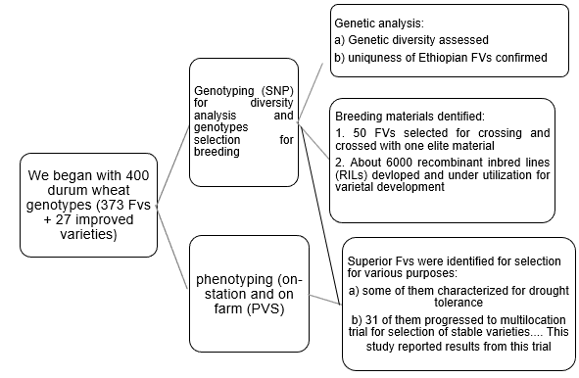
Figure S1. Characterization and selection scheme of durum wheat for identification of useful genotypes

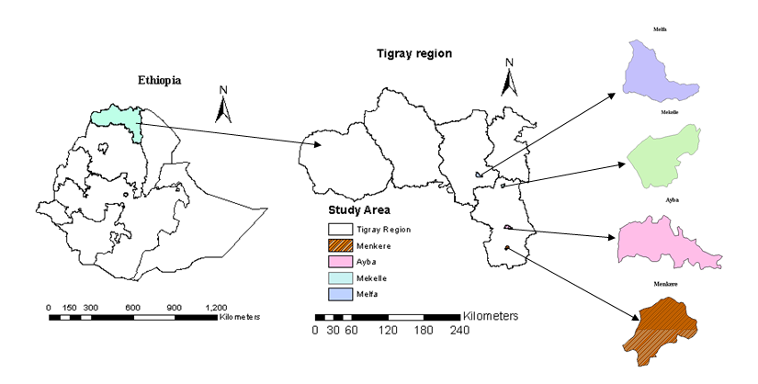

Figure S2. Map showing the point location of the four trial locations in Tigray region, Ethiopia
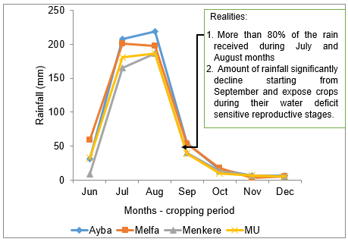
Figure S3. Rainfall amount and distribution trend during the cropping seasons of trial period of the test locations. The sketched value is an average of the two cropping seasons (2015 and 2016).
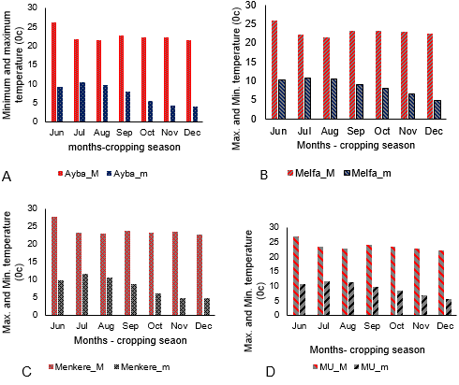
Figure S4. Maximum and minimum temperature (0c) of the test locations for the months of cropping season. Values are average of the two cropping seasons.
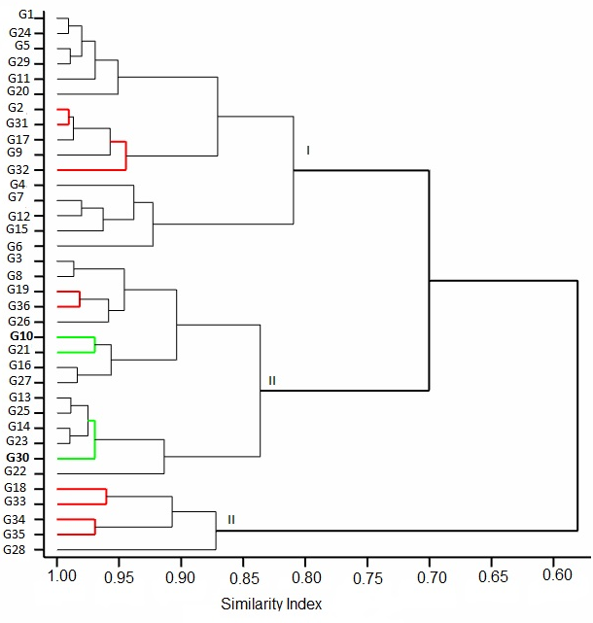

Figure S5. Dendrogram showing the clustering of the genotypes. Nodes designated by green color contained genotypes (G10 and G30) that has shown superior performance and stable performance across locations. Nodes designated by red color contained improved varieties (G32 – G35).

