Supplemental table
Table S1. Clomazone injury (subjectively rated 1, 3, 5, or 7) to 558 sweetpotato accessions grown in the field at Charleston, SC in 2013.

Average injury Number of
from clomazoneª accessions
1 78
2 182
3 236
4 50
5 11
6 1^{b}
7 0
Total 558
______________________________________________________________________________

ªData published at https://data.nal.usda.gov/dataset/data-color-analysis-sweetpotato-leaves-usda-ars-germplasm-collection.
^{b}PI 564142 (= NG7570), which was deleted from the study.

Supplemental figure captions

Fig. S1. Color variation of the adaxial leaf surface of nine sweetpotato plant introductions (PIs) grown in field plots at Charleston, SC, USA, 2012 2014. Top row (left to right): ‘Sulfur’ (PI634402), ‘CN 1489-89’ (PI556941), and ‘CN 1367-2’ (PI556947); middle row: ‘ANG 16’ (PI286619), ‘IB02’ (PI573323), and ‘W-33’ (PI634421); bottom row: ‘Kogane-Sengan’ (PI508508), ‘Promesa’ (PI531161), and ‘Vilca, Romero’ (PI 531126).
Fig. S2. Color coordinates (a* = red-green axis and b* = yellow-blue axis) for the adaxial (a) and abaxial (b) surfaces of late-season, mature purple leaves from 118 sweetpotato plant introductions grown in field plots at Charleston, SC, USA, 2012-2014. The black data points (black circles) represent mean a* and mean b* values for the adaxial and abaxial leaf surfaces.

Fig. S1
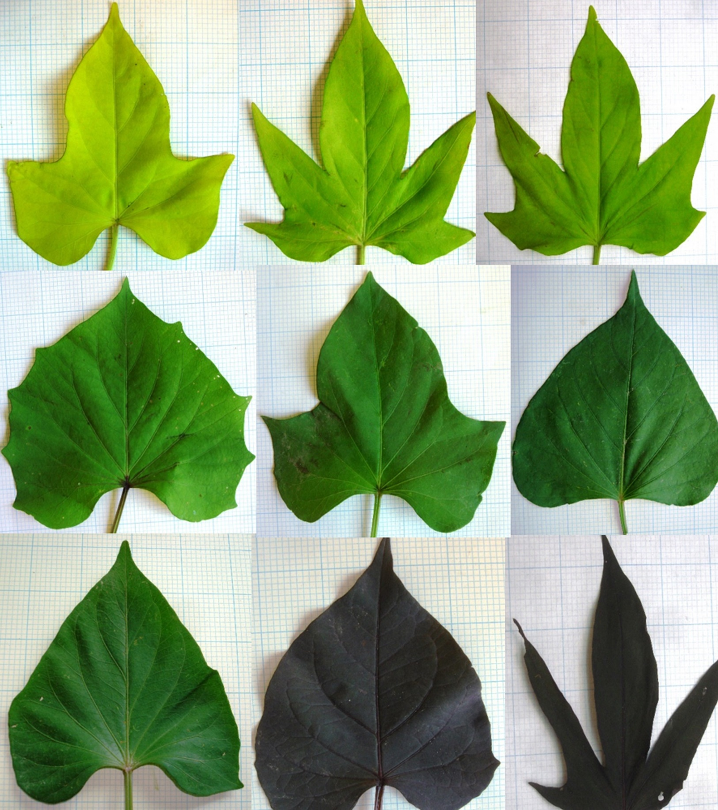

Fig. S2.

a
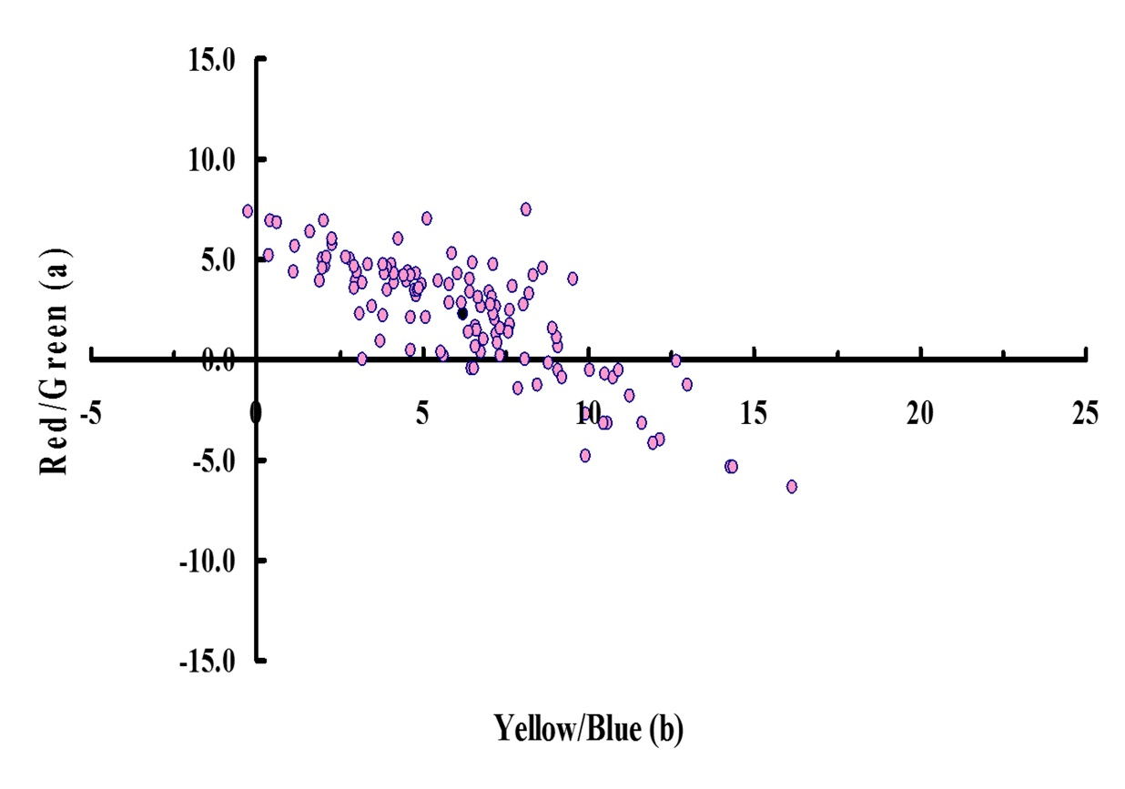

b
