Supplementary Table 1 - The name, the geographical location, level of tolerance (submergence and salinity) of the rice land races used in this study.
Accession number | Cultivar | Village/  District | State | Submergence  Tolerance | Salinity Tolerance
FR13A |  |  |  | HT | -
FL478 |  |  |  | - | T
IR42 |  |  |  | HS | -
IR29 |  |  |  | - | HS
IC145150-B | - | - | - | MT | S
IC203801 | - | Wayanad | Kerala | T | HS
IC203801-1 | - | - | Kerala | HS | MT
IC203815 | - | Kannur | Kerala | HS | MT
IC203817 | - | Wayanad | Kerala | HS | S
IC203817-1 | - | - | Kerala | HS | HS
IC203821 | - | Kannur | Kerala | HS | HS
IC203821-A | - | - | Kerala | HS | T
IC203778 | - | Kannur | Kerala | T | S
IC203778-2 | - | - | Kerala | HS | MT
IC203821-1 | - | Kannur | Kerala | HS | T
IC211147 | - | - | - | HS | S
IC211188 | RDR 294 | Ruddur | AP | HS | S
IC211188-1 |  |  | AP | HS | T
IC211189 | RDR 756 | Ruddur | AP | T | S
IC211197 | RDR -8702 | Ruddur | AP | T | S
IC256282 | - | - | - | HS | S
IC256282-1 | - | - | - | S | S
IC256282-IV | - | - | - | HS | S
IC264718 | Karavala | Alappuzha | Kerala | MT | S
IC264724 | 2001 | Kollam | Kerala | MT | T
IC264727 | Cherumallaran | Kollam | Kerala | S | MT
IC264727-1 | Cherumallaran | Kollam | Kerala | S | S
IC264727-2 | Cherumallaran | Kollam | Kerala | S | S
IC264764 | Chettivirippu | Alappuzha | Kerala | HS | S
IC264764-1 | Chettivirippu | Alappuzha | Kerala | HS | HS
IC264764-2 | Chettivirippu | Alappuzha | Kerala | T | S
IC264727-3 | Cherumallaran | Kollam | Kerala | T | S
IC264766 | Kuruka | Alappuzha | Kerala | T | S
IC264766-1 | Kuruka | Alappuzha | Kerala | HS | S
IC32458gA | Pokkali | Ernakulam | Kerala | MT | S
IC324580 | Pokkali | Ernakulam | Kerala | T | S
IC324582A | Pokkali | Ernakulam | Kerala | T | S
IC324582 | Pokkali | Ernakulam | Kerala | T | S
IC324583 | Pokkali | Ernakulam | Kerala | T | HS
IC324584-A | Pokkali | Ernakulam | Kerala | HS | HS
IC324584 | Pokkali | Ernakulam | Kerala | T | HS
IC324584-A2 | Pokkali | Ernakulam | Kerala | HS | MT
IC324584-1 | Pokkali | Ernakulam | Kerala | T | S
IC324584-2 | Pokkali | Ernakulam | Kerala | T | S
IC324587-A | Pokkali | Ernakulam | Kerala | HS | S
IC324598 | Pokkali | Alleppey | Kerala | HS | S
IC324598-1 | Pokkali | Alleppey | Kerala | HS | S
IC324607 | Pallippuram Pokkali | Alleppey | Kerala | HS | S
IC324607-2 | Pallippuram Pokkali | Alleppey | Kerala | HS | S
IC324608 | Elamkulam Pokkali | Ernakulam | Kerala | HS | S
IC324608-1 | Elamkulam Pokkali | Ernakulam | Kerala | HS | S
IC324610 | Vadanakkudi Pokkali | Ernakulam | Kerala | HS | S
IC324610-1 | Vadanakkudi Pokkali | Ernakulam | Kerala | S | MT
IC413607 | Chettivirippu | Alappuzha | Kerala | HS | S
IC413608 | Pokkali | Alappuzha | Kerala | T | MT
IC413609 | Kuruka | Alappuzha | Kerala | T | S
IC413612 | Kuruka | Alappuzha | Kerala | MT | S
IC413613 | Chettivirippu | Alappuzha | Kerala | MT | S
IC413614 | Virippu | Alappuzha | Kerala | HS | S
IC413616 | Virippu | Alappuzha | Kerala | HS | S
IC413617 | Kuruka | Ernakulam | Kerala | HS | S
IC413629 | Pokkali | Ernakulam | Kerala | T | MT
IC413630 | Pokkali | Ernakulam | Kerala | T | S
IC413631 | Pokkali | Ernakulam | Kerala | HS | S
IC413633 | Pokkali | Ernakulam | Kerala | MT | S
IC413634 | Pokkali | Ernakulam | Kerala | MT | S
IC413636 | Ayyampilly Pokkali | Ernakulam | Kerala | T | S
IC413636-1 | Ayyampilly Pokkali | Ernakulam | Kerala | HS | S
IC413638 | Vytilla-4 | Ernakulam | Kerala | T | S
IC413639 | Ayyampilly Pokkali | Ernakulam | Kerala | T | S
IC413640 | Nedungodu Pokkali | Ernakulam | Kerala | T | MT
IC413643 | D1 (culture) | Ernakulam | Kerala | T | S
IC413644 | Cherayi Pokkali | Ernakulam | Kerala | MT | S
IC413645 | Kuzhippuli Pokkali | Ernakulam | Kerala | T | S
IC413646 | Kuzhippuli Pokkali | Ernakulam | Kerala | T | S
IC536558 | Sulochana | Malappuram | Kerala | T | T
IC536559 | Aivirammeni | Malappuram | Kerala | T | T
IC536604 | Kunjukunju | Malappuram | Kerala | T | T
IC536604-1 | Kunjukunju | Malappuram | Kerala | T | T
IC399100 | Nikunja | SouthParganas | WB | HS | S
IC594019 | Nonabokra | 24Parganas (S) | WB | S | T
IC594004 | Getu | 24Parganas (S) | WB | S | MT
AC-34902 | Canning7 | - | WB | T | T
IC264730 | Orumundukan | Alappuzha | Kerala | HS | MT
IC324589 | Pokkali | Ernakulam | Kerala | T | T
Lunibokra | Lunibokra | - | WB | S | T
Nagarmutha | Nagarmutha | - | WB | HS | S
Pateni-23 | Pateni 23 | - | WB | S | MT
IC594004-1 | Getu | 24Parganas (S) | WB | T | S
Lunibakra | lunibakra | - | WB | HS | T
Lunidhan | Lunidhan | - | WB | HS | S
IC462840 | Leelabati | Dhenkanal | Odisha | HS | S
IC594005 | Rupsal | 24 Parganas (S) | WB | HS | S
Pateni | Pateni | - | WB | HS | S
Patri | Patri | - | WB | HS | S
AC-42461 | Asphal | - | WB | HS | S
IC283126 | Bhaluki | Kendrapara | Odisha | HS | S
AC-42415 | Nagarsali | - | WB | HS | S
Ladu | Ladu | - | WB | HS | S
IC593999 | Marisal | 24 Parganas (S) | WB | HS | S
AC-35710 | Matiya | - | WB | HS | S
Bhunurati | Bhunurati | - | WB | HS | S
Note – HS: highly susceptible; S: susceptible; MT: moderately tolerant; T: tolerant: HT: highly tolerant

Supplementary Table 2 – Physiological response of the genotypes under salinity and submergence condition
Ac. No. | Salinity |  | Submergence
 | SES | SUR% | SES | SUR% | ELOG%
Control (+ve) | 3 | 85 | 1 | 95 | 125
Control (-ve) | 9 | 12 | 9 | 15 | 220
IC145150-B | 7 | 26 | 5 | 55 | 146
IC203801 | 9 | 14 | 3 | 75 | 153
IC203801-1 | 5 | 47 | 9 | 11 | 170
IC203815 | 5 | 45 | 9 | 7 | 155
IC203817 | 7 | 31 | 9 | 12 | 115
IC203817-1 | 9 | 18 | 9 | 9 | 209
IC203821 | 9 | 13 | 9 | 16 | 245
IC203821-A | 3 | 77 | 9 | 18 | 197
IC203778 | 7 | 27 | 3 | 79 | 50
IC203778-2 | 5 | 58 | 9 | 12 | 167
IC203821-1 | 3 | 72 | 9 | 11 | 198
IC211147 | 7 | 24 | 9 | 16 | 190
IC211188 | 7 | 25 | 9 | 17 | 145
IC211188-1 | 3 | 73 | 9 | 19 | 151
IC211189 | 7 | 37 | 3 | 71 | 132
IC211197 | 7 | 22 | 3 | 76 | 118
IC256282 | 7 | 31 | 9 | 16 | 115
IC256282-1 | 7 | 34 | 7 | 29 | 108
IC256282-2 | 7 | 26 | 9 | 12 | 175
IC264718 | 7 | 35 | 5 | 59 | 165
IC264724 | 3 | 73 | 5 | 56 | 145
IC264727 | 5 | 56 | 7 | 37 | 135
IC264727-1 | 7 | 33 | 7 | 32 | 120
IC264727-2 | 7 | 35 | 7 | 34 | 121
IC264764 | 7 | 38 | 9 | 12 | 139
IC264764-1 | 9 | 16 | 9 | 16 | 100
IC264764-2 | 7 | 33 | 3 | 75 | 147
IC264727 | 7 | 40 | 3 | 73 | 155
IC264766 | 7 | 23 | 3 | 75 | 170
IC264766-1 | 7 | 34 | 9 | 16 | 250
IC32458gA | 7 | 26 | 5 | 56 | 119
IC324580 | 7 | 27 | 3 | 76 | 117
IC324582A | 7 | 25 | 3 | 72 | 102
IC324582 | 7 | 26 | 3 | 77 | 117
IC324583 | 9 | 12 | 3 | 76 | 131
IC324584-A | 9 | 17 | 9 | 11 | 159
IC324584 | 9 | 10 | 3 | 75 | 157
IC324584-A-2 | 5 | 54 | 9 | 15 | 190
IC324584-1 | 7 | 36 | 3 | 77 | 126
IC324584-2 | 7 | 34 | 3 | 79 | 123
IC324587-A | 7 | 23 | 9 | 13 | 176
IC324598 | 7 | 39 | 9 | 17 | 146
IC324598-1 | 7 | 32 | 9 | 18 | 149
IC324607 | 7 | 33 | 9 | 16 | 132
IC324607-2 | 7 | 28 | 9 | 15 | 290
IC324608 | 7 | 25 | 9 | 16 | 255
IC324608-1 | 7 | 21 | 9 | 16 | 227
IC324610 | 7 | 39 | 9 | 14 | 290
IC324610-1 | 5 | 55 | 7 | 29 | 168
IC413607 | 7 | 25 | 9 | 17 | 175
IC413608 | 5 | 45 | 3 | 70 | 95
IC413609 | 7 | 38 | 3 | 75 | 100
IC413612 | 7 | 35 | 5 | 55 | 75
IC413613 | 7 | 35 | 5 | 51 | 95
IC413614 | 7 | 31 | 9 | 13 | 210
IC413616 | 7 | 27 | 9 | 11 | 226
IC413617 | 7 | 35 | 9 | 17 | 176
IC413629 | 5 | 59 | 3 | 79 | 250
IC413630 | 7 | 20 | 3 | 75 | 120
IC413631 | 7 | 29 | 9 | 13 | 145
IC413633 | 7 | 39 | 5 | 58 | 140
IC413634 | 7 | 25 | 5 | 48 | 155
IC413636 | 7 | 26 | 3 | 76 | 170
IC413636-1 | 7 | 24 | 9 | 19 | 120
IC413638 | 7 | 36 | 3 | 77 | 222
IC413639 | 7 | 31 | 3 | 73 | 105
IC413640 | 5 | 55 | 3 | 78 | 167
IC413643 | 7 | 27 | 3 | 77 | 110
IC413644 | 7 | 28 | 5 | 51 | 150
IC413645 | 7 | 36 | 3 | 78 | 62
IC413646 | 7 | 35 | 3 | 75 | 95
IC536558 | 3 | 78 | 3 | 70 | 112
IC536559 | 3 | 72 | 3 | 67 | 134
IC536604 | 3 | 77 | 3 | 72 | 126
IC536604-1 | 3 | 79 | 3 | 79 | 111
IC-399100 | 7 | 35 | 9 | 14 | 145
IC-594019 | 3 | 80 | 9 | 15 | 190
IC-594004 | 5 | 45 | 7 | 31 | 156
AC-34902 | 3 | 71 | 3 | 75 | 132
IC264730 | 5 | 45 | 9 | 15 | 128
IC324589 | 3 | 78 | 3 | 79 | 127
LUNIBOKRA | 3 | 78 | 7 | 32 | 165
NAGARMUTHA | 7 | 29 | 9 | 13 | 155
PATENI-23 | 5 | 56 | 7 | 34 | 178
IC594004 | 7 | 39 | 3 | 78 | 119
LUNIBAKRA | 3 | 77 | 9 | 12 | 174
LUNIDHAN | 7 | 25 | 9 | 14 | 320
IC462840 | 7 | 33 | 9 | 16 | 233
IC594005 | 7 | 32 | 9 | 19 | 287
PATENI | 7 | 29 | 9 | 16 | 341
PATRI | 7 | 22 | 9 | 15 | 310
AC42461 | 7 | 27 | 9 | 12 | 220
IC283126 | 7 | 27 | 9 | 11 | 267
AC42415 | 7 | 26 | 9 | 12 | 298
LADU | 7 | 36 | 9 | 16 | 312
IC593999 | 7 | 29 | 9 | 17 | 246
AC35710 | 7 | 25 | 9 | 18 | 205
BHUNURATI | 7 | 25 | 9 | 14 | 210

Supplementary Fig. 1 – Recovery of tolerant/survived plants after (a) salinity and (b) submergence stress.
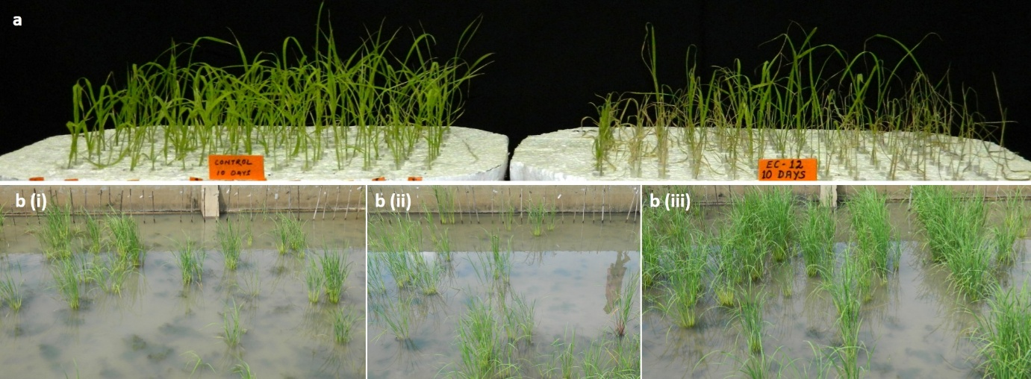

Supplementary Fig. 2 – Gel picture depicting allelic variation among genotypes for Sub1 QTL linked markers
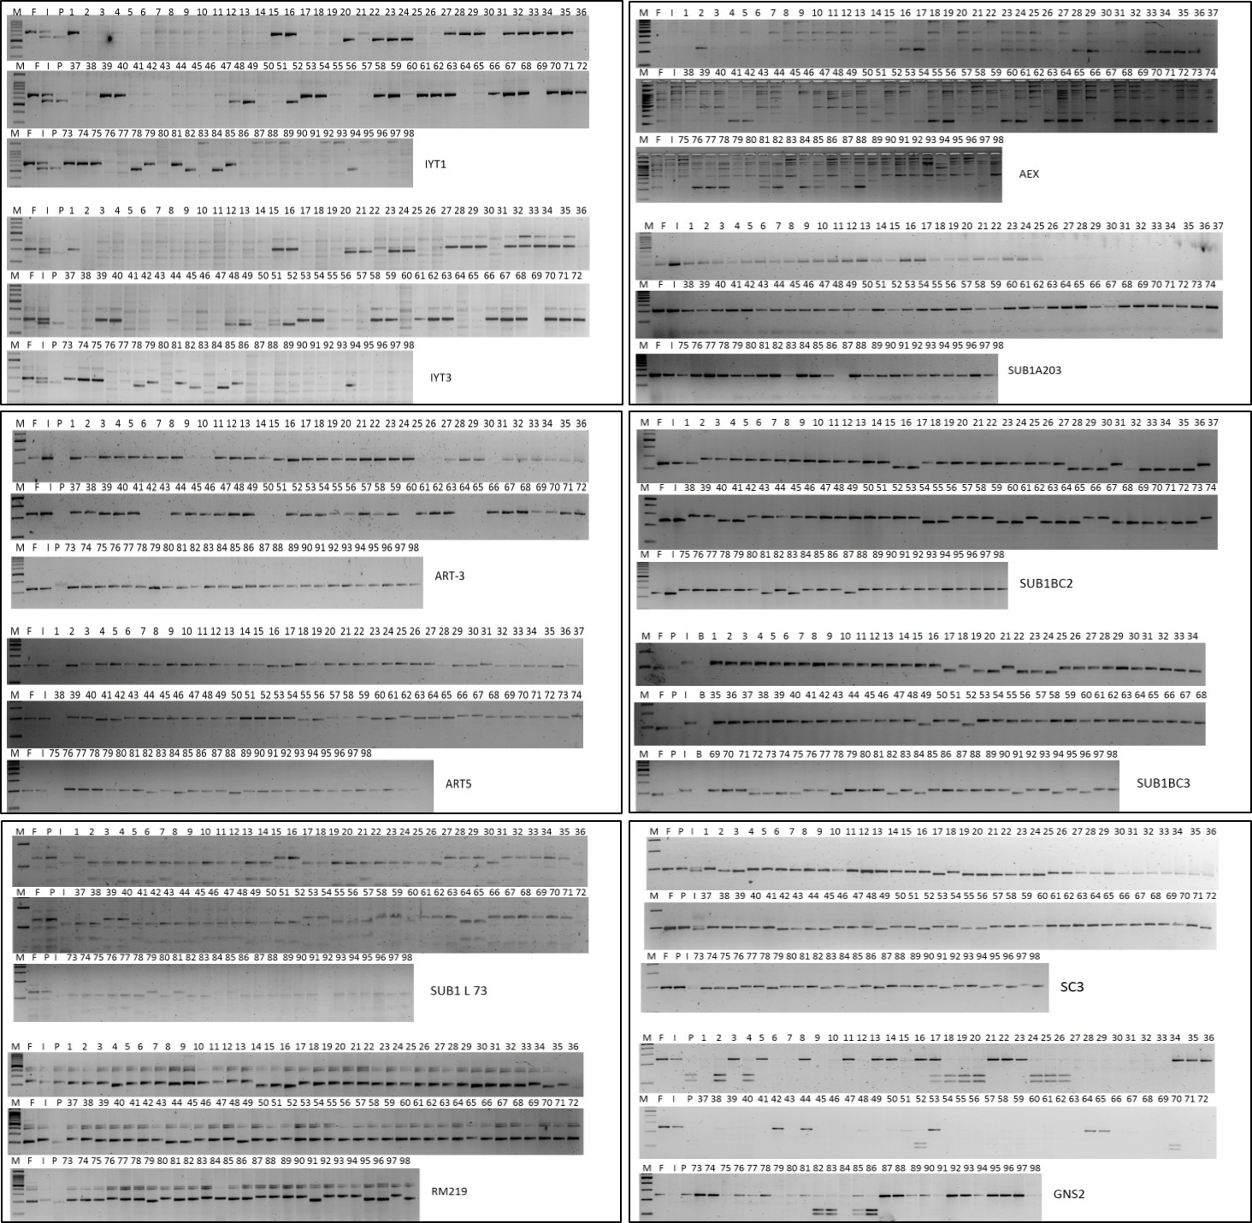

Supplementary Fig. 3 – Gel picture depicting allelic variation among genotypes for Saltol QTL linked markers
