Table S1. Passport information of 41 Grewia tenax accessions collected from western Rajasthan
Sl. No. | Collector No. | Site of collection |  | Habitat | Latitude N˚ | Longitude E˚ | Altitude (ft)
 |  | Village | District
1 | CAZ/JSM/KV/01 | Thayat | Jaisalmer | Scrubland | 26.93969 | 71.02689 | 828
2 | CAZ/JSM/KV/02 | Thayat | Jaisalmer | Scrubland | 26.93652 | 71.02801 | 837
3 | CAZ/JSM/KV/03 | Jaisalmer | Jaisalmer | Scrubland | 26.92238 | 70.97675 | 903
4 | CAZ/JSM/KV/04 | Jaisalmer | Jaisalmer | Scrubland | 26.92285 | 70.97503 | 794
5 | CAZ/JSM/KV/05 | Thayat | Jaisalmer | Scrubland | 26.93062 | 70.99837 | 781
6 | CAZ/JSM/KV/06 | Thayat | Jaisalmer | Scrubland | 26.93308 | 71.03243 | 955
7 | CAZ/JSM/KV/07 | Manapiya | Jaisalmer | Wasteland | 26.90397 | 70.81029 | 715
8 | CAZ/JSM/KV/08 | Manapiya | Jaisalmer | Wasteland | 26.91749 | 70.80644 | 651
9 | CAZ/JSM/KV/09 | Amarsagar | Jaisalmer | Wasteland | 26.93109 | 70.86863 | 814
10 | CAZ/JSM/KV/10 | Devikot | Jaisalmer | Arable | 26.71933 | 71.18450 | 903
11 | CAZ/JSM/KV/11 | Dabla | Jaisalmer | Wasteland | 26.79378 | 71.09223 | 895
12 | CAZ/JSM/KV/12 | Akal | Jaisalmer | Scrubland | 26.83271 | 71.04681 | 771
13 | CAZ/JSM/KV/13 | Akal | Jaisalmer | Scrubland | 26.83239 | 71.04650 | 763
14 | CAZ/JSM/KV/14 | Dhauva | Jaisalmer | Wasteland | 26.86076 | 70.88742 | 840
15 | CAZ/JSM/KV/15 | Dhauva | Jaisalmer | Wasteland | 26.83342 | 70.85849 | 813
16 | CAZ/JSM/KV/16 | Vijaynagar | Jaisalmer | Wasteland | 26.83400 | 70.85966 | 806
17 | CAZ/JSM/KV/17 | Barahmsar | Jaisalmer | Wasteland | 27.03545 | 70.90154 | 503
18 | CAZ/JSM/KV/18 | Hamira | Jaisalmer | Scrubland | 26.96686 | 71.07867 | 729
19 | CAZ/JSM/KV/19 | Hadda | Jaisalmer | Wasteland | 27.07518 | 71.03062 | 490
20 | CAZ/JSM/KV/20 | Jethwai | Jaisalmer | Wasteland | 27.03828 | 70.99362 | 623
21 | CAZ/JSM/KV/21 | Beriganga | Jodhpur | Scrubland | 26.38707 | 73.05728 | 758
22 | CAZ/JSM/KV/22 | Beriganga | Jodhpur | Scrubland | 26.38776 | 73.05475 | 813
23 | CAZ/JSM/KV/23 | Kailana | Jodhpur | Scrubland | 26.32288 | 72.96454 | 954
24 | CAZ/JSM/KV/24 | Kailana | Jodhpur | Scrubland | 26.32202 | 72.96070 | 914
25 | CAZ/JSM/KV/25 | Unda | Jaisalmer | Wasteland | 26.60425 | 71.18914 | 907
26 | CAZ/JSM/KV/26 | Biyad | Barmer | Wasteland | 26.30307 | 71.43618 | 865
27 | CAZ/JSM/KV/27 | Sankra | Jaisalmer | Wasteland | 26.70719 | 71.58356 | 974
28 | CAZ/JSM/KV/28 | Devikot | Jaisalmer | Wasteland | 26.73064 | 71.17355 | 846
29 | CAZ/JSM/KV/29 | Bhopalgargh | Jodhpur | Wasteland | 26.59464 | 73.56725 | 1310
30 | CAZ/JSM/KV/30 | Manapiya | Jaisalmer | Wasteland | 26.90566 | 70.80732 | 710
31 | CAZ/JSM/KV/31 | Pali | Pali | Arable | 25.80255 | 73.29999 | 760
32 | CAZ/JSM/KV/32 | Pali | Pali | Arable | 25.80755 | 73.29079 | 712
33 | CAZ/JSM/KV/33 | Pali | Pali | Arable | 25.80938 | 73.29422 | 734
34 | CAZ/JSM/KV/34 | Pali | Pali | Arable | 25.80115 | 73.29764 | 754
35 | CAZ/JSM/KV/35 | Jadan | Pali | Scrubland | 25.83616 | 73.47212 | 747
36 | CAZ/JSM/KV/36 | Kharra | Pali | Wasteland | 25.87621 | 73.21502 | 705
37 | CAZ/JSM/KV/37 | Kharra | Pali | Wasteland | 25.87612 | 73.21463 | 692
38 | CAZ/JSM/KV/38 | Kairla | Pali | Arable | 25.84689 | 73.19397 | 725
39 | CAZ/JSM/KV/39 | Javdeya | Pali | Arable | 25.82790 | 73.21678 | 700
40 | CAZ/JSM/KV/40 | Khurdai | Pali | Arable | 25.70509 | 73.24200 | 712
41 | CAZ/JSM/KV/41 | Dhayalpura | Pali | Arable | 25.70174 | 73.18622 | 680

Figure S1. The associated vegetation of Grewia tenax at collection sites (‘arrow’- Species observed at more number at sites and ‘red circle’- Species providing protection to G. tenax)
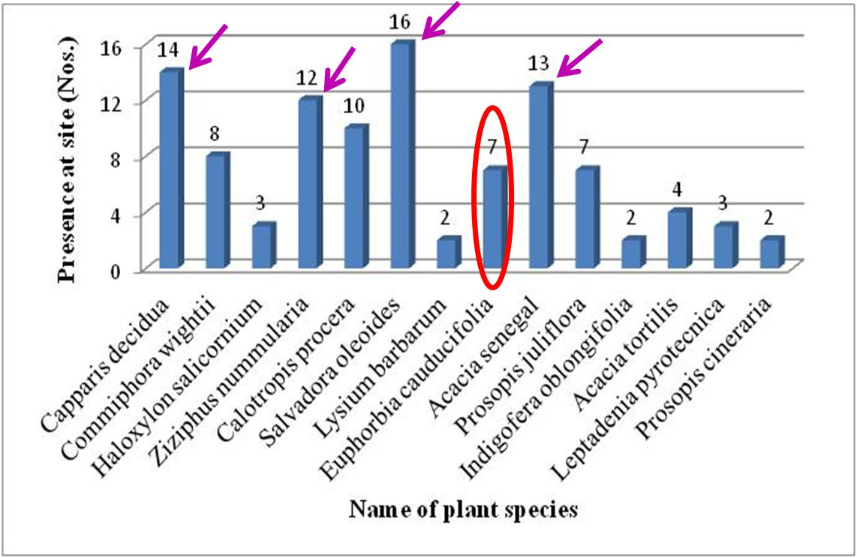
Figure S2. A field views of arid shrub Grewia tenax in Jaisalmer (a) protected and (b) unprotected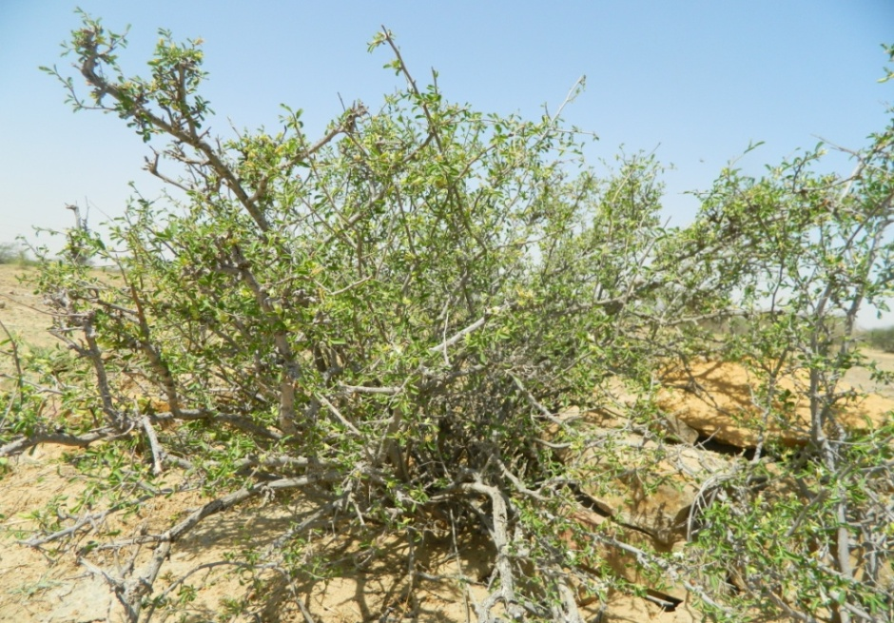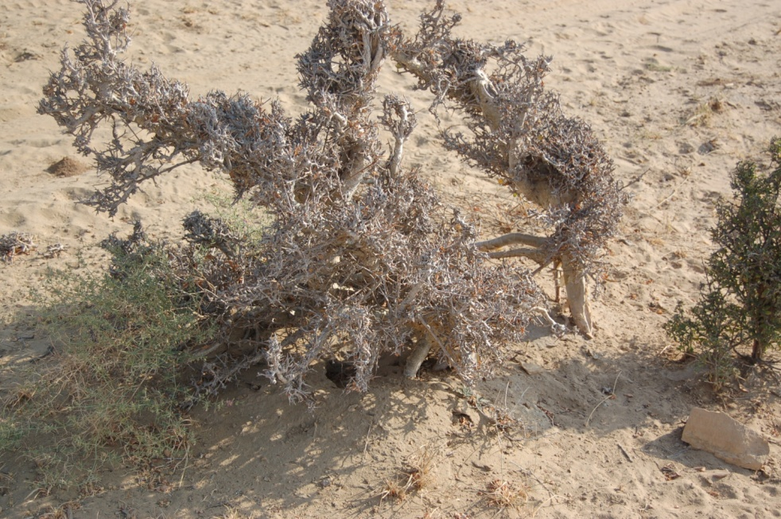
a
b

Figure S3. Grewia tenax’s (a) Stems/ branches as raw material and (b) its use as Chowkney
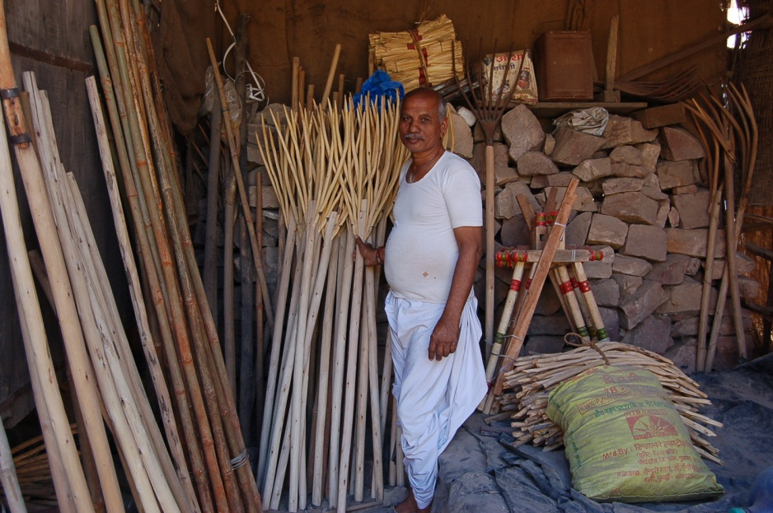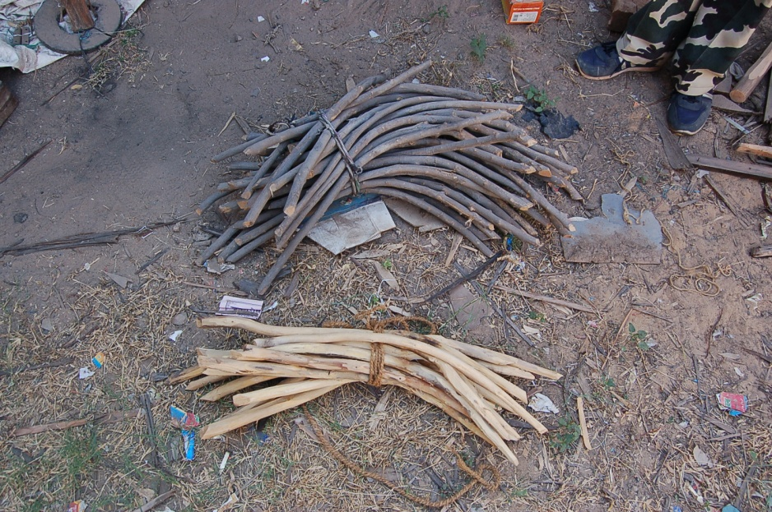
b
a

