Table S1. Analysis of variance of pericarp thickness by kernel type and collection provinces.
Source of  Variation § | df | SS | MS | F | P-value
Endosperm | 2 | 23968.74 | 11984.37 | 76.88 | <0.0001
Province | 8 | 19418.15 | 2427.27 | 15.57 | <0.0001
Endosperm x Province | 14 | 1972.57 | 140.90 | 0.90 | 0.5541
Error | 2389 | 372431.34 | 155.89
Total | 2413 | 417118.82

§ The factor “Endosperm” had 3 levels of normal, segregating and waxy endosperm type. The factor “Province” had a total of 9 levels, which was comprised of 8 different levels for administrative districts(provinces) and 1 level for RDA waxy inbred. However, the level “RDA waxy inbred” was only present in waxy endosperm type, not in normal and segregating endosperm type in the factor “Endosperm”. This made the degrees of freedom for the interaction “Endosperm x Province” 14 instead of 16.

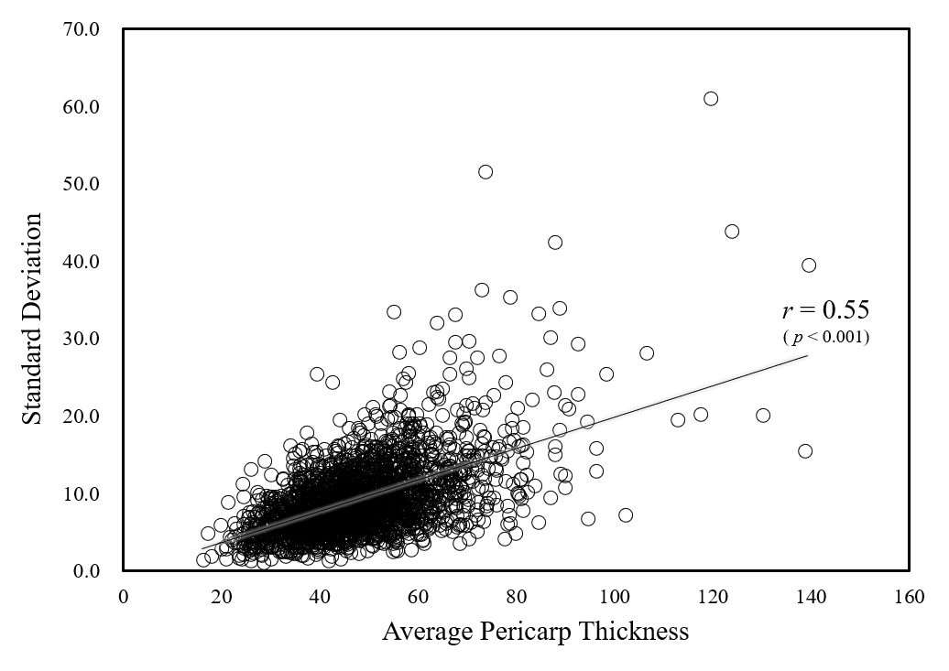
Figure S1. Scatterplot and correlation analysis of 10-sample average and standard deviation for pericarp thickness from 2,414 maize accessions.

