Supplementary Materials
Supplementary Figure S1
Examples of chromosome number observation for F₁ hybrids between T. turgidum and T. monococcum. (a) a cell of AS2231-2/CItr17652 F₁; (b) a cell of AS2305/PI355517 F₁; (c) a cell of AS2637/ CItr13961 F₁; (d) a cell of AS2380/ CItr13963 F_{1.}
Supplementary Figure S2
Examples of chromosome number observation for synthetic amphiploids. (a) Syn-TAM-3 (2n=42); (b) Syn-TAM-24 (2n=42); (c) Syn-TAM-33 (2n=42); (d) Syn-TAM-37 (2n=42).
Supplementary Figure S3
Plant morphology of synthetic amphiploid Syn-TAM-3 (center) and its parents T. turgidum ssp. durum AS2637 (left) and T. monococcum ssp. monococcum CItr13961 (right).
Supplementary Figure S4
Chromosome pairing in pollen mother cells at meiotic metaphase I in amphiploids. (a) Syn-TAM-3 with 21 bivalents; (b) Syn-TAM-24 with 19 bivalents, 1 trivalent and 1 univalent; (c) Syn-TAM-33 with 17 bivalents, 1 trivalent, 1 univalent and 1 pentavalent; (d) Syn-TAM-37 with 19 bivalents, 1 trivalent and 1 univalent. The univalent, trivalent and pentavalent chromosome pairing is indicated by a short arrow, long arrow, and arrowhead, respectively.
Supplementary Table S1
The 156 cross combinations with crossability percentages over 5%.
Supplementary Table S2
The means of crossability percentages for 60 T. turgidum lines from five subspecies with T. monococcum ssp. monococcum.
Supplementary Table S3
The means of crossability percentages for 83 T. monococcum ssp. monococum accessions with T. turgidum lines.
Supplementary Table S4
Selfed seeds of treated F₁ plants of T. turgidum with T. monococcum.
Supplementary Table S5
Stripe rust resistance and Glu-A1^{m}x alleles of amphiploids and their parents.

Figure S1 Examples of chromosome number observation for F₁ hybrids between T. turgidum and T. monococcum. (a) a cell of AS2231-2/CItr17652 F₁; (b) a cell of AS2305/PI355517 F₁; (c) a cell of AS2637/ CItr13961 F₁; (d) a cell of AS2380/ CItr13963 F_{1.}
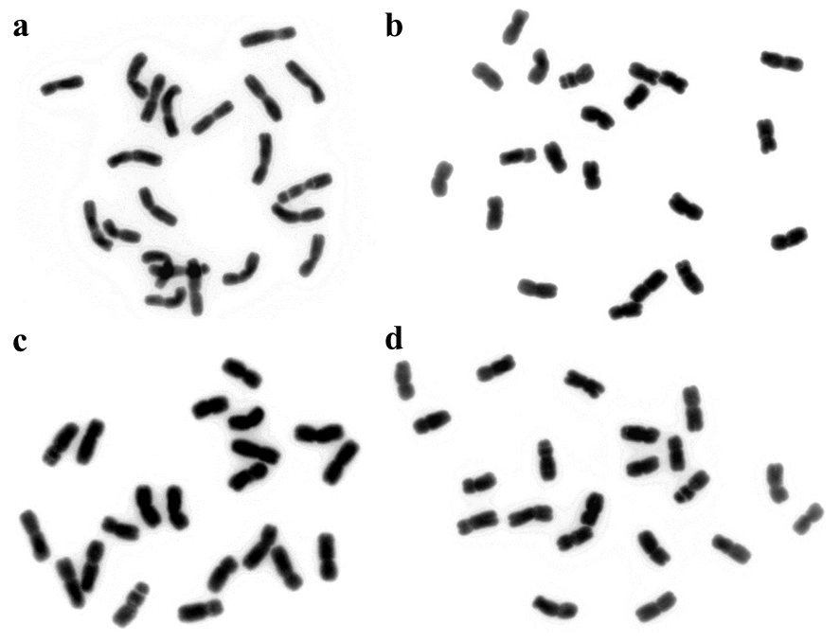

Figure S2 Examples of chromosome number observation for synthetic amphiploids. (a) Syn-TAM-3 (2n=42); (b) Syn-TAM-24 (2n=42); (c) Syn-TAM-33 (2n=42); (d) Syn-TAM-37 (2n=42).
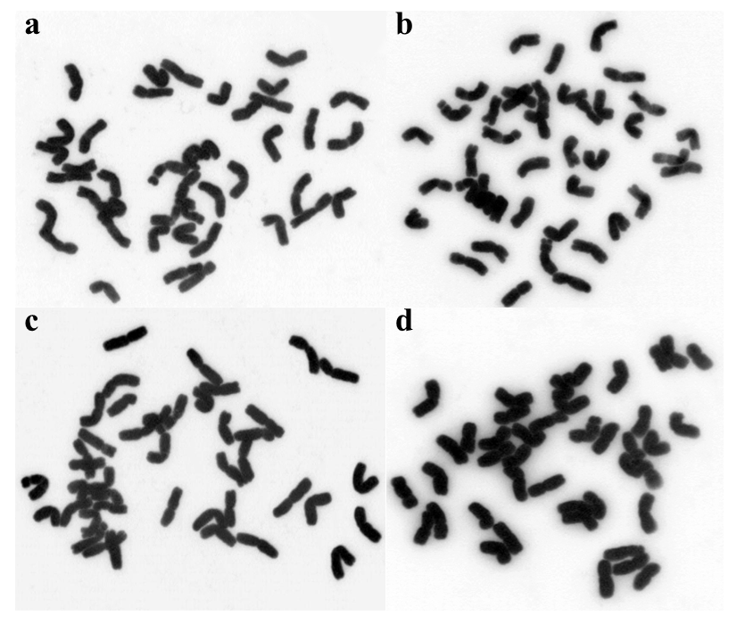

Figure S3 Plant morphology of synthetic amphiploid Syn-TAM-3 (center) and its parents T. turgidum ssp. durum AS2637 (left) and T. monococcum ssp. monococcum CItr13961 (right).
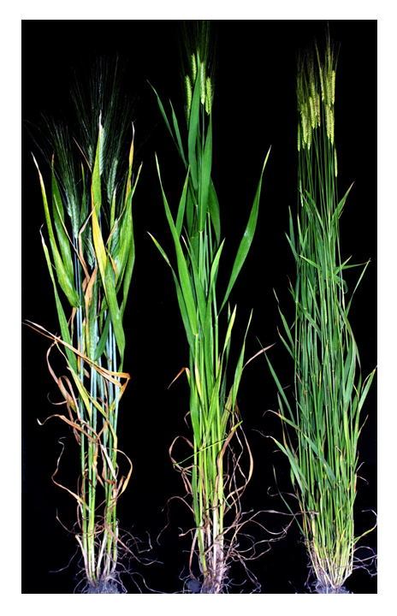

Figure S4 Chromosome pairing in pollen mother cells at meiotic metaphase I in amphiploids. (a) Syn-TAM-3 with 21 bivalents; (b) Syn-TAM-24 with 19 bivalents, 1 trivalent and 1 univalent; (c) Syn-TAM-33 with 17 bivalents, 1 trivalent, 1 univalent and 1 pentavalent; (d) Syn-TAM-37 with 19 bivalents, 1 trivalent and 1 univalent. The univalent, trivalent and pentavalent chromosome pairing is indicated by a short arrow, long arrow, and arrowhead, respectively.
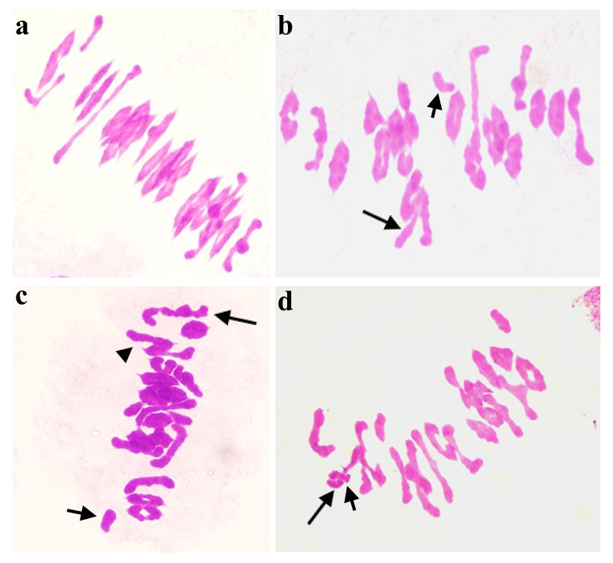

Table S1 The 156 cross combinations with crossability percentages over 5%
ssp. turgidum × T. monococcum (81 combinations)
AS2231-2 × CItr17652 (66.67%); AS2231-2 × PI518452 (33.33%); AS2236-2 × PI330551 (19.23%); AS2239 × CItr13962 (19.15%); AS2239 × CItr17652 (26.32%); AS2239 × PI221416 (32.35%); AS2239 × PI330551 (40.32%); AS2239 × PI355529 (17.65%); AS2239 × PI518452 (5.56%); AS2240 × PI272535 (14.29%); AS2240 × PI290509 (8.33%); AS2255 × CItr13961 (52.38%); AS2285 × CItr17652 (57.14%); AS2285 × PI290509 (20%); AS2291 × CItr13962 (15.85%); AS2291 × CItr17653 (47.14%); AS2291 × PI264935 (10%); AS2291 × PI265008 (22.22%); AS2295 × CItr13961 (30%); AS2295 × CItr13963 (43.96%); AS2295 × PI272535 (22.5%); AS2295 × PI352484 (54.55%); AS2295 × PI352486 (64.29%); AS2295 × PI355517 (45%); AS2295 × PI355543 (27.27%); AS2295 × PI377670 (27.27%); AS2296 × PI10474 (50%); AS2296 × PI266844 (43%); AS2296 × PI355519 (25%); AS2296 × PI427927 (6.25%); AS2298 × PI191096 (42.86%); AS2299 × CItr13963 (11.9%); AS2299 × PI355538 (7.14%); AS2305 × CItr13962 (16.67%); AS2305 × CItr13963 (17.5%); AS2305 × PI355517 (60.71%); AS2305 × PI355519 (14.71%); AS2305 × PI362610 (22.92%); AS2305 × PI428167 (8.33%); AS2305 × PI428173 (12.5%); AS2305 × PI428175 (36.54%); AS2308 × CItr13963 (10%); AS2308 × PI355517 (59.09%); AS2308 × PI560726 (8.33%); AS2308 × PI560727 (27.27%); AS2310 × CItr13961 (47.69%); AS2310 × PI167634 (26.67%); AS2310 × PI355517 (37.5%); AS2310 × PI355519 (39.29%); AS2310 × PI362610 (22.73%); AS2310 × PI428173 (16.67%); AS2310 × PI542473 (35%); AS2312 × PI168805 (13.16%); AS2312 × PI355519 (43.33%); AS2312 × PI362610 (63.64%); AS2313 × PI168805 (83.33%); AS2313 × PI272535 (12.5%); AS2313 × PI355519 (6.58%); AS2326 × CItr13963 (6.82%); AS2326 × PI191096 (56.25%); AS2326 × PI272535 (33.33%); AS2326 × PI355519 (31.03%); AS2326 × PI427959 (31.25%); AS2334 × PI191096 (89.29%); AS2334 × PI355519 (46.71%); AS2334 × PI355521 (29.17%); AS2378 × PI167634 (50%); AS2380 × CItr13961 (33.33%); AS2380 × CItr13963 (63.33%); AS2380 × CItr17653 (60.42%); AS2380 × PI168805 (31.25%); AS2380 × PI237659 (25%); AS2380 × PI295058 (43.75%); AS2380 × PI428161 (55.56%); AS2381 × CItr13961 (18.18%); AS2381 × PI167634 (40%); AS2381 × PI168805 (45.45%); AS2381 × PI190945 (8.33%); AS2381 × PI191381 (33.33%); AS2382 × PI355519 (13.89%); AS2382 × PI427959 (13.89%)
ssp. dicoccon × T. monococcum (59 combinations)
PI113963 × PI192063 (15.38%); PI113963 × PI307984 (10.71%); PI154582 × PI307984 (6.67%); PI191781 × CItr17657 (27.27%); PI191781 × PI190940 (20.21%); PI191781 × PI191098 (25.37%); PI191781 × PI266844 (37.5%); PI191781 × PI272535 ( 9.29%); PI221401 × CItr13961 (13.33%); PI221401 × PI191098 (25%); PI221401 × PI266844 (10%); PI221401 × PI272535 (32.95%); PI221403 × CItr13962 (7.76%); PI221403 × CItr17652 (21.43%); PI221403 × CItr17657 (11.76%); PI221403 × PI190946 (42.11%); PI221403 × PI289599 (18%); PI221403 × PI355543 (21.88%); PI221403 × PI377668 (11.9%); PI221403 × PI377671 (5.26%); PI221403 × PI428154 (6.67%); PI221403 × PI503874 (7.5%); PI221403 × PI584654 (26%); PI306533 × CItr17662 (16.67%); PI306533 × PI10474 (11.36%); PI352331 × PI10474 (13.04%); PI352331 × PI428175 (12.5%); PI352331 × PI584654 (25%); PI352335 × PI272535 (20.59%); PI352358 × PI272535 (25%); PI352359 × CItr17652 (23.68%); PI352359 × CItr17659 (5.88%); PI352359 × CItr17662 (30%); PI352359 × PI167589 (21.88%); PI352359 × PI190942 (10.53%); PI352359 × PI377671 (9.21%); PI352359 × PI560726 (15.38%); PI352369 × PI221416 (20.15%); PI352369 × PI355519 (20%); PI352369 × PI428161 (27.5%); PI355465 × CItr13962 (6.06%); PI355465 × PI266844 (5.56%); PI355465 × PI272535 (23.53%); PI355477 × CItr17658 (11.11%); PI355490 × PI221416 (23.91%); PI355490 × PI355519 (25.51%); PI355497 × PI289599 (15.12%); PI355507 × CItr13963 (19.12%); PI355527 × PI191098 (10.71%); PI355527 × PI584654 (20%); PI377655 × CItr17653 (78.79%); PI377655 × PI377671 (80%); PI377655 × PI560727 (27.27%); PI434998 × PI428158 (20%); PI94666 × PI355543 (6.67%); PI94670 × CItr17662 ( 25%); PI94670 × PI191098 (15.38%); PI94670 × PI503874 (13.64%); PI94675 × PI272535 (10.53%)
ssp. turanicum × T. monococcum (9 combinations)
PI184526 × CItr13962 (11.11%); PI211691 × PI190940 (7.69%); PI211691 × PI355519 (18.09%); PI306665 × CItr13961 (13.33%); PI306665 × PI355519 (46.3%); PI306665 × PI427959 (7.69%); PI306665 × PI428158 (25%); PI352514 × PI221416 (14%); PI352514 × PI518452 (22.73%)
ssp. durum × T. monococcum (5 combinations)
AS2262 × CItr13961 (44.66%); AS904 × PI190942 (44.44%); AS904 × PI191096 (18.33%); AS904 × PI355519 (45%); AS2637 × CItr13961 (26.92%)
ssp. persicum × T. monococcum (2 combinations)
AS2268 × CItr13962 (12.5%); AS2268 × CItr13963 (46.74%)

Table S2 Crossability of 60 T. turgidum lines from five subspecies with T. monococcum ssp. monococcum
T. turgidum ssp. | No. of cross combinations | No. of florets pollinated | No. of kernels | Crossability percentage
persicum | 2 | 140 | 49 | 35.00%
durum | 8 | 514 | 157 | 30.54%
turgidum | 130 | 4844 | 1129 | 23.31%
turanicum | 13 | 504 | 76 | 15.08%
dicoccon | 111 | 4808 | 572 | 11.90%
Total | 264 | 10810 | 1983 | 18.34%

Table S3 The crossability of 83 T. monococcum ssp. monococum accessions with T. turgidum lines
T. monococcum Genotypes | No. of cross combinations | No. of florets pollinated | No. of kernels | Crossability percentage(%)
PI352486 | 1 | 14 | 9 | 64.29%
PI352484 | 1 | 22 | 12 | 54.55%
PI355517 | 4 | 114 | 57 | 50%
CItr17653 | 5 | 250 | 114 | 45.6%
PI190942 | 1 | 18 | 8 | 44.44%
PI190946 | 1 | 38 | 16 | 42.11%
PI191096 | 5 | 176 | 67 | 38.07%
PI428161 | 2 | 58 | 21 | 36.21%
PI542473 | 1 | 20 | 7 | 35%
CItr13961 | 10 | 758 | 262 | 34.56%
PI330551 | 2 | 88 | 30 | 34.09%
PI168805 | 5 | 122 | 41 | 33.61%
PI362610 | 3 | 92 | 30 | 32.61%
CItr13963 | 9 | 686 | 222 | 32.36%
PI355521 | 1 | 24 | 7 | 29.167%
PI355519 | 14 | 892 | 245 | 27.47%
PI428175 | 2 | 84 | 23 | 27.38%
PI560727 | 2 | 88 | 24 | 27.27%
PI377670 | 1 | 22 | 6 | 27.27%
PI167634 | 4 | 122 | 32 | 26.23%
PI 272535 | 1 | 20 | 5 | 25%
PI377671 | 3 | 144 | 33 | 22.92%
PI265008 | 1 | 36 | 8 | 22.22%
CItr17652 | 7 | 294 | 65 | 22.11%
PI167589 | 1 | 32 | 7 | 21.88%
PI191381 | 2 | 56 | 12 | 21.43%
PI221416 | 5 | 330 | 67 | 20.3%
PI355529 | 1 | 68 | 12 | 17.65%
PI295058 | 2 | 40 | 7 | 17.5%
PI190940 | 2 | 120 | 21 | 17.5%
PI191098 | 6 | 304 | 47 | 15.46%
PI290509 | 2 | 54 | 8 | 14.81%
PI272535 | 14 | 596 | 88 | 14.77%
CItr17657 | 3 | 110 | 16 | 14.55%
CItr17662 | 5 | 152 | 22 | 14.47%
PI266844 | 11 | 436 | 63 | 14.45%
PI428158 | 3 | 70 | 10 | 14.29%
PI355543 | 4 | 112 | 15 | 13.39%
PI584654 | 5 | 198 | 26 | 13.13%
PI560726 | 2 | 50 | 6 | 12%
PI377668 | 1 | 42 | 5 | 11.9%
PI10474 | 6 | 204 | 24 | 11.76%
PI190942 | 1 | 38 | 4 | 10.53%
PI264935 | 1 | 20 | 2 | 10%
PI237659 | 2 | 50 | 5 | 10%
CItr13962 | 11 | 712 | 68 | 9.55%
PI518452 | 6 | 254 | 18 | 7.09%
PI289599 | 7 | 318 | 22 | 6.92%
PI428154 | 1 | 30 | 2 | 6.67%
PI427927 | 1 | 32 | 2 | 6.25%
PI192063 | 3 | 64 | 4 | 6.25%
PI190945 | 2 | 98 | 6 | 6.12%
PI428173 | 4 | 120 | 7 | 5.83%
PI307984 | 3 | 92 | 5 | 5.43%
PI503874 | 4 | 116 | 6 | 5.17%
PI428167 | 2 | 40 | 2 | 5%
PI427959 | 1 | 20 | 1 | 5%
PI355538 | 2 | 46 | 2 | 4.35%
CItr17658 | 2 | 46 | 2 | 4.35%
PI289605 | 1 | 24 | 1 | 4.17%
PI427959 | 16 | 486 | 18 | 3.7%
PI190915 | 1 | 28 | 1 | 3.57%
PI272558 | 1 | 32 | 1 | 3.13%
PI277136 | 2 | 48 | 1 | 2.08%
CItr17659 | 3 | 138 | 2 | 1.45%
PI435000 | 4 | 118 | 1 | 0.85%
PI538721 | 3 | 82 | 0 | 0
PI435001 | 2 | 72 | 0 | 0
PI428172 | 1 | 28 | 0 | 0
PI428166 | 1 | 38 | 0 | 0
PI428165 | 1 | 50 | 0 | 0
PI428152 | 1 | 22 | 0 | 0
PI428150 | 1 | 54 | 0 | 0
PI428149 | 2 | 42 | 0 | 0
PI418587 | 1 | 24 | 0 | 0
PI362616 | 1 | 32 | 0 | 0
PI345186 | 1 | 48 | 0 | 0
PI323437 | 1 | 22 | 0 | 0
PI306542 | 1 | 28 | 0 | 0
PI286068 | 1 | 38 | 0 | 0
PI167591 | 2 | 50 | 0 | 0
PI119435 | 1 | 32 | 0 | 0
CItr17654 | 1 | 22 | 0 | 0
Total | 264 | 10810 | 1983 | 18.34

Table S4 Production of selfed seed from colchicine treated T. turgidum × T. monococcum hybrid F₁ plants
Combinations | Germination rate of F₁ seeds (%)ª | No. F₁ Plants colchicine treated | No. S₁ seeds | Germination rate of S₁ seeds (%)^{b}
AS2310 × CItr13961 | 100(18) | 2 | 153 | 100(10)
AS2305 × PI355517 | 100(13) | 2 | 128 | 100(10)
PI221401 × PI191098 | 100(6) | 2 | 104 | 50(10)
AS2295 × PI355517 | 77.8(9) | 2 | 95 | 100(10)
AS2380 × CItr13963 | 100(22) | 2 | 91 | 100(10)
AS904 × PI190942 | 100(8) | 2 | 91 | 80(15)
AS2295 × PI352486 | 90(9) | 2 | 70 | 90(10)
PI355465 × CItr13962 | 100(4) | 2 | 68 | 100(10)
AS2637 × CItr13961 | 100(10) | 2 | 66 | 100(10)
PI154582 × PI307984 | 100(2) | 1 | 65 | 50(10)
AS2305 × CItr13962 | 100(7) | 2 | 58 | 100(10)
AS2305 × PI289605 | 100(1) | 1 | 56 | 100(10)
PI221401 × PI272535 | 100(10) | 4 | 50 | 90(10)
PI377655 × CItr17653 | 80(10) | 2 | 50 | 100(10)
AS2231-2 × CItr17652 | 100(10) | 2 | 48 | 100(10)
PI221403 × PI266844 | 100(1) | 1 | 48 | 100(10)
AS2268 × CItr13962^{c} | 100(6) | 2 | 45 | 100(10)^{c}
AS2305 × PI428175 | 100(9) | 2 | 44 | 100(10)
AS2313 × PI168805 | 90(20) | 2 | 44 | 100(10)
AS2285 × CItr17652 | 100(10) | 2 | 42 | 100(10)
AS2381 × PI190945 | 50(6) | 4 | 40 | 50(10)
AS2305 × PI428167 | 100(2) | 1 | 36 | 70(10)
AS2310 × PI428173 | 100(4) | 2 | 36 | 100(10)
PI184526 × CItr13962 | 83(6) | 2 | 34 | 100(10)
PI221403 × PI190946^{d} | 100(10) | 4 | 33 | 0(10)^{d}
PI352358 × PI272535 | 80(5) | 4 | 33 | 80(10)
PI94670 × PI518452 | 100(1) | 1 | 32 | 70(10)
AS2299 × CItr13963 | 60(5) | 2 | 31 | 100(10)
AS2312 × PI362610 | 100(14) | 2 | 31 | 100(10)
AS2382 × PI355519 | 100(8) | 2 | 29 | 100(10)
PI221401 × CItr13961 | 50(4) | 2 | 29 | 30(10)
AS2231-2 × PI518452 | 100(10) | 2 | 28 | 90(10)
PI221403 × CItr13962 | 100(4) | 2 | 27 | 90(10)
AS2310 × PI362610 | 80(5) | 4 | 24 | 100(10)
PI306533 × CItr17662 | 87.5(8) | 2 | 24 | 90(10)
AS2381 × PI167634^{c} | 87.5(8) | 2 | 23 | 90(10)^{c}
AS2295 × PI377670 | 100(6) | 2 | 22 | 100(10)
AS2380 × CItr17653 | 100(11) | 2 | 22 | 14.29(7)
AS2240 × PI290509^{d} | 100(4) | 2 | 21 | 0(10)^{d}
AS2334 × PI355521 | 100(7) | 5 | 20 | 40(10)
PI113963 × PI307984^{d} | 100(3) | 2 | 17 | 0(10)^{d}
PI352335 × PI272535 | 28.6(7) | 2 | 16 | 50(10)
PI377655 × PI560727 | 60(10) | 2 | 16 | 60(10)
AS2295 × PI272535 | 100(9) | 2 | 15 | 60(10)
AS2382 × PI427959 | 100(3) | 5 | 15 | 80(10)
PI355527 × CItr13962^{c} | 33(3) | 1 | 15 | 50(10)^{c}
AS2291 × CItr13962 | 100(9) | 5 | 14 | 100(10)
AS2268 × CItr13963 | 100(10) | 4 | 13 | 70(10)
AS2299 × PI355538 | 100(2) | 2 | 12 | 80(10)
PI352359 × PI560726 | 100(4) | 2 | 12 | 88.89(9)
PI355477 × PI266844 | 100(1) | 1 | 12 | 100(10)
AS2308 × PI355517^{d} | 100(13) | 2 | 10 | 0(10)^{d}
AS2380 × PI168805 | 100(5) | 2 | 10 | 100(10)
PI113963 × PI192063^{d} | 100(4) | 2 | 10 | 0(10)^{d}
PI352359 × CItr17652 | 100(5) | 4 | 10 | 60(10)
AS2296 × PI10474 | 100(5) | 2 | 9 | 44.44(9)
PI94670 × PI503874 | 100(3) | 1 | 9 | 66.67(9)
AS2291 × PI265008 | 100(7) | 3 | 7 | 100(7)
AS2308 × CItr13963 | 100(5) | 2 | 7 | 85.71(7)
PI191781 × PI191098 | 86(14) | 5 | 6 | 40(6)
PI221403 × PI584654^{d} | 100(13) | 2 | 6 | 0(6)^{d}
PI94670 × PI191098 | 75(4) | 1 | 6 | 66.67(6)
AS2291 × PI427959 | 100(1) | 5 | 5 | 60(5)
AS2239 × PI355529^{c} | 100(12) | 5 | 3 | 33.33(3)^{c}
AS2310 × PI355517 | 88.9(9) | 1 | 3 | 100(3)
AS2255 × CItr13961^{d} | 100(10) | 5 | 2 | 0(2)^{d}
PI221403 × PI428154^{c} | 100(2) | 2 | 2 | 50(2)^{c}
AS2291 × CItr17653 | 100(10) | 5 | 1 | 100(1)
AS2305 × CItr13963^{c} | 100(8) | 3 | 1 | 100(1)^{c}
AS2310 × PI167634^{c} | 100(10) | 4 | 1 | 100(1)^{c}
AS2236-2 × PI330551 | 40(5) | 1 | 0 | -
AS2239 × CItr13962 | 100(13) | 5 | 0 | -
AS2239 × CItr17652 | 70(10) | 2 | 0 | -
AS2239 × PI221416 | 100(5) | 2 | 0 | -
AS2239 × PI330551 | 100(12) | 5 | 0 | -
AS2239 × PI435000 | 100(1) | 1 | 0 | -
AS2239 × PI518452 | 100(2) | 2 | 0 | -
AS2240 × PI272535 | 100(2) | 2 | 0 | -
AS2255 × PI277136 | 100(1) | 1 | 0 | -
AS2262 × CItr13961 | 77.8(9) | 2 | 0 | -
AS2285 × PI290509 | 100(6) | 2 | 0 | -
AS2291 × PI264935 | 100(2) | 2 | 0 | -
AS2295 × CItr13961 | 100(9) | 2 | 0 | -
AS2295 × CItr13963 | 100(10) | 2 | 0 | -
AS2295 × PI352484 | 100(12) | 2 | 0 | -
AS2295 × PI355543 | 100(6) | 2 | 0 | -
AS2296 × PI191096 | 100(1) | 1 | 0 | -
AS2296 × PI266844 | 80(5) | 2 | 0 | -
AS2296 × PI355519 | 100(5) | 2 | 0 | -
AS2298 × PI191096 | 100(5) | 3 | 0 | -
AS2298 × PI355519 | 100(2) | 1 | 0 | -
AS2305 × PI355519 | 100(5) | 4 | 0 | -
AS2305 × PI362610 | 100(11) | 2 | 0 | -
AS2305 × PI428173 | 100(3) | 2 | 0 | -
AS2308 × PI560726 | 100(2) | 2 | 0 | -
AS2308 × PI560727 | 100(6) | 2 | 0 | -
AS2310 × PI355519 | 100(5) | 3 | 0 | -
AS2310 × PI542473 | 100(5) | 2 | 0 | -
AS2312 × PI168805 | 75(4) | 2 | 0 | -
AS2312 × PI355519 | 100(5) | 3 | 0 | -
AS2313 × PI272535 | 100(2) | 3 | 0 | -
AS2313 × PI355519 | 100(5) | 1 | 0 | -
AS2313 × PI427959 | 100(1) | 1 | 0 | -
AS2326 × CItr13963 | 100(3) | 2 | 0 | -
AS2326 × PI168805 | 100(1) | 1 | 0 | -
AS2326 × PI190915 | 100(1) | 1 | 0 | -
AS2326 × PI191096 | 100(5) | 3 | 0 | -
AS2326 × PI272535 | 100(12) | 2 | 0 | -
AS2326 × PI355519 | 40(5) | 3 | 0 | -
AS2326 × PI427959 | 100(5) | 3 | 0 | -
AS2334 × PI191096 | 100(5) | 3 | 0 | -
AS2334 × PI355519 | 94.12(17) | 5 | 0 | -
AS2378 × PI167634 | 70(8) | 2 | 0 | -
AS2380 × CItr13961 | 100(16) | 4 | 0 | -
AS2380 × PI237659 | 80(5) | 2 | 0 | -
AS2380 × PI428161 | 55.6(9) | 2 | 0 | -
AS2381 × CItr13961 | 100(8) | 2 | 0 | -
AS2381 × PI168805 | 100(10) | 2 | 0 | -
AS2381 × PI191381 | 91.67(12) | 3 | 0 | -
AS2382 × CItr13961 | 100(2) | 2 | 0 | -
AS2382 × PI266844 | 100(1) | 1 | 0 | -
AS904 × PI191096 | 50(4) | 2 | 0 | -
AS904 × PI355519 | 100(10) | 3 | 0 | -
PI113963 × CItr17652 | 50(4) | 2 | 0 | -
PI191781 × CItr17657 | 100(12) | 2 | 0 | -
PI191781 × PI190940 | 20(5) | 1 | 0 | -
PI191781 × PI266844 | 100(5) | 3 | 0 | -
PI191781 × PI272535 | 100(13) | 2 | 0 | -
PI211691 × PI190940 | 100(2) | 2 | 0 | -
PI211691 × PI355519 | 25(4) | 1 | 0 | -
PI221401 × PI266844 | 66.67(3) | 2 | 0 | -
PI221403 × CItr17652 | 100(5) | 2 | 0 | -
PI221403 × CItr17657 | 100(4) | 1 | 0 | -
PI221403 × PI272558 | 100(1) | 1 | 0 | -
PI221403 × PI289599 | 100(9) | 2 | 0 | -
PI221403 × PI355543 | 80(5) | 2 | 0 | -
PI221403 × PI377668 | 100(5) | 2 | 0 | -
PI221403 × PI377671 | 100(2) | 1 | 0 | -
PI221403 × PI503874 | 100(3) | 2 | 0 | -
PI306665 × CItr13961 | 50(4) | 2 | 0 | -
PI306665 × PI355519 | 80(5) | 2 | 0 | -
PI306665 × PI428158 | 60(5) | 2 | 0 | -
PI352331 × PI10474 | 66.7(6) | 2 | 0 | -
PI352331 × PI428175 | 100(4) | 2 | 0 | -
PI352331 × PI584654 | 100(5) | 3 | 0 | -
PI352359 × CItr17659 | 50(2) | 2 | 0 | -
PI352359 × CItr17662 | 80(5) | 2 | 0 | -
PI352359 × PI167589 | 100(5) | 2 | 0 | -
PI352359 × PI377671 | 20(5) | 2 | 0 | -
PI352369 × PI221416 | 80(5) | 2 | 0 | -
PI352369 × PI355519 | 100(5) | 2 | 0 | -
PI352369 × PI428161 | 100(5) | 2 | 0 | -
PI352514 × PI518452 | 40(5) | 2 | 0 | -
PI355465 × PI272535 | 40(5) | 2 | 0 | -
PI355477 × CItr17658 | 100(2) | 2 | 0 | -
PI355490 × PI355519 | 20(5) | 1 | 0 | -
PI355507 × CItr13963 | 88.9(9) | 4 | 0 | -
PI355527 × PI191098 | 100(3) | 2 | 0 | -
PI355527 × PI584654 | 100(5) | 2 | 0 | -
PI434998 × PI428158 | 100(4) | 2 | 0 | -
PI94666 × PI355543 | 100(2) | 1 | 0 | -
PI94670 × CItr17662 | 100(5) | 2 | 0 | -
PI94675 × PI272535 | 75(4) | 2 | 0 | -

ª The number of F₁ hybrid seeds of T. turgidum with T. monococcum used for germination are indicated in brackets
^{b} The number of S₁ seeds of synthetic amphiploids used for germination are indicated in brackets
^{c} Selfed S₂ seeds were not obtained from the S₁ plants
^{d} S₁ seeds failed to germinate.

Table S5 Stripe rust resistance and Glu-A1^{m}x alleles of amphiploids and their parents
Amphiploid code | Cross combinations | Seedling stage ITs |  |  |  | Adult stage ITs |  |  |  | Glu-A1^{m}x alleles
 |  | T. turgidum | T. monococcum | amphiploids |  | T. turgidum | T. monococcum | amphiploids |  | T. monococcumª | amphiploids^{b}
Syn-TAM-1 | AS2231-2 × CItr17652 | 4 | 7 | 3 |  | 3 | 2 | 1 |  | Glu-A1^{m}-d | N/A
Syn-TAM-2 | AS2231-2 × PI518452 | 4 | 2 | 2 |  | 3 | 2 | 2 |  | Glu-A1^{m}-d | Glu-A1^{m}-d
Syn-TAM-3 | AS2637 × CItr13961 | 1 | 6 | 3 |  | 2 | 2 | 1 |  | Glu-A1^{m}-c | Glu-A1^{m}-c
Syn-TAM-4 | AS2285 × CItr17652 | 4 | 7 | 3 |  | 6 | 2 | 1 |  | Glu-A1^{m}-d | Glu-A1^{m}-d
Syn-TAM-5 | AS2291 × CItr13962 | 5 | 6 | 3 |  | 6 | 2 | 2 |  | Glu-A1^{m}-d | Glu-A1^{m}-d
Syn-TAM-6 | AS2291 × CItr17653 | 5 | 6 | 3 |  | 6 | 2 | 2 |  | Glu-A1^{m}-d | Glu-A1^{m}-d
Syn-TAM-7 | AS2291 × PI265008 | 5 | 6 | 3 |  | 6 | 1 | 1 |  | Glu-A1^{m}-d | Glu-A1^{m}-d
Syn-TAM-8 | PI94670 × PI503874 | 9 | 4 | 9 |  | 9 | 2 | 9 |  | Glu-A1^{m}-d | Glu-A1^{m}-d
Syn-TAM-9 | PI94670 × PI518452 | 9 | 2 | 9 |  | 9 | 2 | 9 |  | Glu-A1^{m}-d | Glu-A1^{m}-d
Syn-TAM-10 | PI154582 × PI307984 | 6 | 3 | 4 |  | 9 | 2 | 1 |  | Glu-A1^{m}-d | Glu-A1^{m}-d
Syn-TAM-11 | PI191781 × PI191098 | 4 | 3 | 3 |  | 3 | 1 | 1 |  | Glu-A1^{m}-d | Glu-A1^{m}-d
Syn-TAM-12 | PI221401 × CItr13961 | 6 | 6 | 6 |  | 3 | 2 | 3 |  | Glu-A1^{m}-c | Glu-A1^{m}-c
Syn-TAM-13 | PI221401 × PI191098 | 6 | 3 | 3 |  | 3 | 1 | 1 |  | Glu-A1^{m}-d | Glu-A1^{m}-d
Syn-TAM-14 | PI221401 × PI272535 | 6 | 3 | 4 |  | 3 | 1 | 1 |  | Glu-A1^{m}-d | Glu-A1^{m}-d
Syn-TAM-15 | PI221403 × CItr13962 | 6 | 6 | 6 |  | 6 | 2 | 6 |  | Glu-A1^{m}-d | Glu-A1^{m}-d
Syn-TAM-16 | PI221403 × PI266844 | 6 | 4 | 4 |  | 6 | 1 | 4 |  | Glu-A1^{m}-d | Glu-A1^{m}-d
Syn-TAM-17 | PI306533 × CItr17662 | 6 | 7 | 7 |  | 9 | 1 | 3 |  | Glu-A1^{m}-d | Glu-A1^{m}-d
Syn-TAM-18 | PI352335 × PI272535 | 2 | 3 | 2 |  | 2 | 1 | 1 |  | Glu-A1^{m}-d | Glu-A1^{m}-d
Syn-TAM-19 | PI352359 × PI560726 | 9 | 6 | 9 |  | 9 | 2 | 6 |  | Glu-A1^{m}-f | N/A
Syn-TAM-20 | PI355465 × CItr13962 | 2 | 6 | 4 |  | 2 | 2 | 2 |  | Glu-A1^{m}-d | Glu-A1^{m}-d
Syn-TAM-21 | PI355477 × PI266844 | 4 | 4 | 3 |  | 8 | 1 | 1 |  | Glu-A1^{m}-d | Glu-A1^{m}-d
Syn-TAM-22 | PI377655 × CItr17653 | 6 | 6 | 6 |  | 6 | 2 | 1 |  | Glu-A1^{m}-d | Glu-A1^{m}-d
Syn-TAM-23 | PI377655 × PI560727 | 6 | 1 | 9 |  | 6 | 2 | 7 |  | Glu-A1^{m}-f | N/A
Syn-TAM-24 | PI184526 × CItr13962 | 4 | 6 | 4 |  | 2 | 2 | 2 |  | Glu-A1^{m}-d | Glu-A1^{m}-d
Syn-TAM-25 | AS2295 × PI272535 | 2 | 3 | 2 |  | 2 | 1 | 2 |  | Glu-A1^{m}-d | Glu-A1^{m}-d
Syn-TAM-26 | AS2295 × PI352486 | 2 | 2 | 2 |  | 2 | 1 | 1 |  | Glu-A1^{m}-d | N/A
Syn-TAM-27 | AS2295 × PI355517 | 2 | 2 | 1 |  | 2 | 2 | 1 |  | Glu-A1^{m}-b | Glu-A1^{m}-b
Syn-TAM-28 | AS2295 × PI377670 | 2 | 2 | 1 |  | 2 | 1 | 1 |  | Glu-A1^{m}-d | Glu-A1^{m}-d
Syn-TAM-29 | AS2299 × CItr13963 | 4 | 3 | 2 |  | 4 | 2 | 1 |  | Glu-A1^{m}-d | N/A
Syn-TAM-30 | AS2299 × PI355538 | 4 | 3 | 2 |  | 4 | 1 | 1 |  | Glu-A1^{m}-d | Glu-A1^{m}-d
Syn-TAM-31 | AS2305 × CItr13962 | 4 | 7 | 2 |  | 4 | 2 | 1 |  | Glu-A1^{m}-d | N/A
Syn-TAM-32 | AS2305 × PI289605 | 4 | 1 | 2 |  | 4 | 1 | 1 |  | Glu-A1^{m}-e | N/A
Syn-TAM-33 | AS2305 × PI355517 | 4 | 2 | 3 |  | 4 | 2 | 1 |  | Glu-A1^{m}-b | Glu-A1^{m}-b
Syn-TAM-34 | AS2305 × PI428167 | 4 | 1 | 3 |  | 4 | 1 | 1 |  | Glu-A1^{m}-d | N/A
Syn-TAM-35 | AS2305 × PI428175 | 4 | 2 | 1 |  | 4 | 2 | 1 |  | Glu-A1^{m}-c | N/A
Syn-TAM-36 | AS2308 × CItr13963 | 2 | 3 | 3 |  | 2 | 2 | 1 |  | Glu-A1^{m}-d | Glu-A1^{m}-d
Syn-TAM-37 | AS2310 × CItr13961 | 4 | 6 | 2 |  | 4 | 2 | 2 |  | Glu-A1^{m}-c | Glu-A1^{m}-c
Syn-TAM-38 | AS2310 × PI355517 | 4 | 2 | 3 |  | 4 | 2 | 2 |  | Glu-A1^{m}-b | Glu-A1^{m}-b
Syn-TAM-39 | AS2310 × PI362610 | 4 | 2 | 2 |  | 4 | 1 | 2 |  | Glu-A1^{m}-e | N/A
Syn-TAM-40 | AS2310 × PI428173 | 4 | 1 | 4 |  | 4 | 1 | 2 |  | Glu-A1^{m}-c | N/A
Syn-TAM-41 | AS2312 × PI362610 | 4 | 2 | 2 |  | 4 | 1 | 1 |  | Glu-A1^{m}-e | N/A
Syn-TAM-42 | AS2313 × PI168805 | 4 | 3 | 2 |  | 4 | 1 | 2 |  | Glu-A1^{m}-d | Glu-A1^{m}-d
Syn-TAM-43 | AS2380 × CItr13963 | 4 | 3 | 2 |  | 4 | 2 | 2 |  | Glu-A1^{m}-d | Glu-A1^{m}-d
Syn-TAM-44 | AS2380 × CItr17653 | 4 | 6 | 2 |  | 4 | 2 | 2 |  | Glu-A1^{m}-d | Glu-A1^{m}-d
Syn-TAM-45 | AS2380 × PI168805 | 4 | 3 | 3 |  | 4 | 1 | 2 |  | Glu-A1^{m}-d | Glu-A1^{m}-d
Syn-TAM-46 | AS2382 × PI355519 | 4 | 2 | 3 |  | 4 | 1 | 1 |  | Glu-A1^{m}-d | N/A
Syn-TAM-47 | PI94670 × PI191098 | 9 | 3 | 1 |  | 9 | 1 | 2 |  | Glu-A1^{m}-d | Glu-A1^{m}-d
Syn-TAM-48 | PI352359 × CItr17652 | 9 | 7 | 8 |  | 9 | 2 | 6 |  | Glu-A1^{m}-d | Glu-A1^{m}-d
Syn-TAM-49 | AS2296 × PI10474 | 2 | 1 | 2 |  | 2 | 1 | 2 |  | Glu-A1^{m}-d | N/A
Syn-TAM-50 | AS2382 × PI427959 | 4 | 1 | 3 |  | 4 | 1 | 2 |  | Glu-A1^{m}-d | N/A
Syn-TAM-51 | AS2381 × PI190945 | 4 | 3 | 6 |  | 4 | 2 | 2 |  | Glu-A1^{m}-d | N/A
Syn-TAM-52 | AS2268 × CItr13963 | 4 | 3 | 3 |  | 4 | 2 | 2 |  | Glu-A1^{m}-d | N/A
Syn-TAM-53 | AS904 × PI190942 | 9 | 1 | 7 |  | 6 | 2 | 1 |  | Glu-A1^{m}-d | Glu-A1^{m}-d
Syn-TAM-54 | AS2291 × PI427959 | 5 | 1 | 2 |  | 6 | 1 | 2 |  | Glu-A1^{m}-d | N/A
Syn-TAM-55 | PI352358 × PI272535 | 4 | 3 | 3 |  | 6 | 1 | 1 |  | Glu-A1^{m}-d | Glu-A1^{m}-d
Syn-TAM-56 | AS2334 × PI355521 | 4 | 6 | 3 |  | 4 | 2 | 1 |  | Glu-A1^{m}-h | Glu-A1^{m}-h
ªAccording to Li et al. (2016); ^{b}N/A: we failed to differentiate the Glu-A1^{m}x from the Glu-A1x alleles in the amphiploid background.

