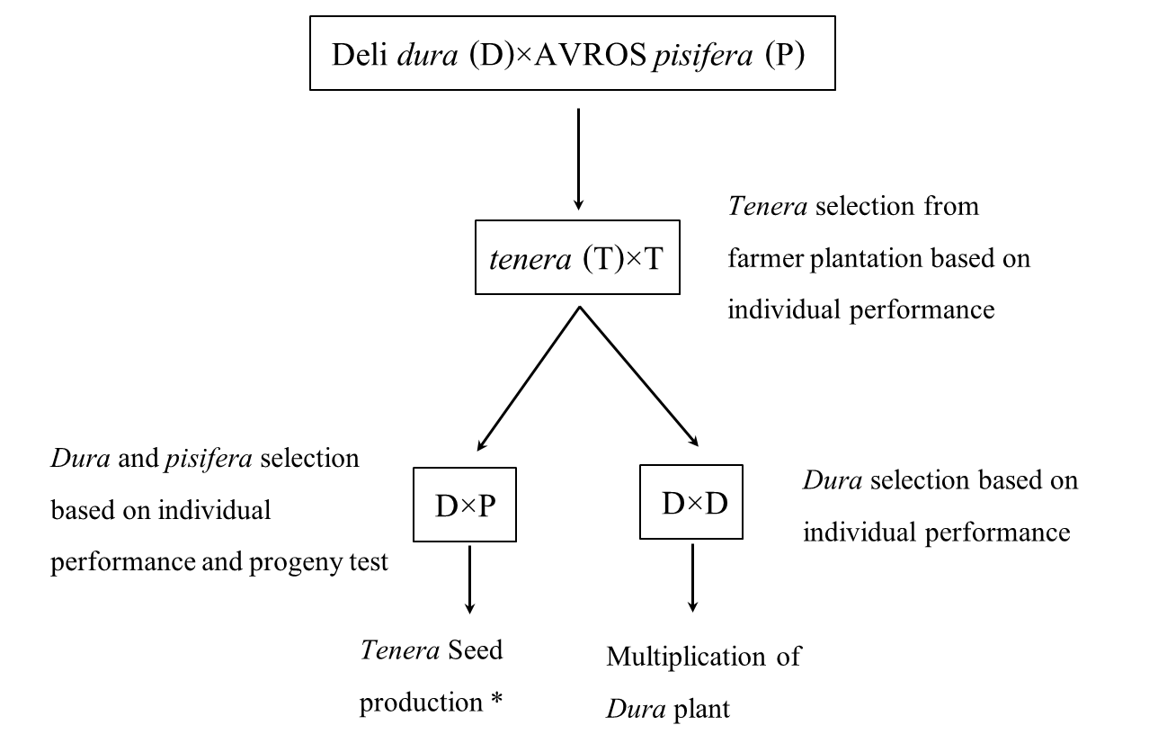

Fig. S1 Oil palm breeding program at Prince of Songkla University, Thailand. Deli dura and AVROS pisifera were genetic backgrounds of tenera hybrids imported from Malaysia during 1980s-1990s to plantation in southern Thailand. A population of 501 palms from either selfed or crossed teneras selected based on individual performance were planted at Khlong Hoy Kong Research Station, Songkhla. The population was a segregation of dura, pisifera and tenera palms. Selected dura plants were selfed for multiplication purpose and crossed with pisifera for tenera seed production. The asterisk indicates where the studied materials were from.
Table S1 Analysis of variance, means and coefficient of variation (CV) for leaf area (LA), plant height (PH), stem diameter (SD), fresh weight (FW), dry weight (DW) and number of leaves per plant (NL), root to shoot ratio (RS), proline content, SPAD value and Fv/Fm for eight DxP genotypes (G) after 3 months of growing under three drought severity (DS): well-watered (WW), moderate stress (MS) and severe stress (SS)
Treatment | Traits
 | LA  (cm²) | PH  (cm) | SD  (cm) | FW  (g) | DW  (g) | RS | NL | Proline  (µmol/g FW) | SPAD | Fv/Fm
Genotype
PSU- 96  PSU- 106  PSU- 128  PSU- 206  PSU- 208  PSU- 210  PSU- 220  PSU- 206/1 | 1111.67bcd  1211.50ab  1083.50 bcd  1005.67 bcd  1330.33a  966.17d  967.67cd  1175.67abc | 12.44  12.39  11.83  13.11  11.89  12.89  12.11  11.56 | 2.81  2.74  3.17  3.10  3.00  3.11  3.18  3.22 | 127.38  125.84  109.81  115.23  141.14  108.17  112.00  125.43 | 29.37ab  28.56ab  25.37b  24.83b  32.81a  22.99b  24.90b  28.40ab | 0.44a  0.30ab  0.32ab  0.32ab  0.27b  0.35ab  0.33ab  0.32ab | 9.67ab  10.56a  9.56ab  10.00ab  8.67b  8.56b  9.11ab  8.44b | 1.62b  1.61b  1.70ab  1.67ab  1.50b  1.67ab  2.05a  1.86ab | 60.14a  57.81ab  53.00b  54.70ab  57.40ab  56.69ab  57.69ab  56.29ab | 0.710  0.744  0.741  0.735  0.731  0.737  0.735  0.715
DS  WW  MS  SS | 1319.25a  1210.06b  790.25c | 13.42a  12.83a  10.58b | 3.34a  3.36a  2.43b | 142.93a  125.88b  93.06c | 277.34a  153.56b  70.64c | 0.32b  0.28b  0.39a | 11.13a  9.17b  7.67c | 1.60c  1.70b  1.83a | 57.04  56.80  56.00 | 0.752a  0.739a  0.701b
F-test  G  DS  G×DS | **  **  ** | ns  **  ns | ns  **  ns | ns  **  ns | **  **  ns | *  **  ns | **  **  * | **  *  * | *  ns  ns | ns  **  ns
CV (%) | 12.59 | 10.04 | 12.25 | 10.04 | 12.78 | 23.54 | 13.39 | 11.54 | 6.49 | 4.33

Note: Means with the same letter in the same column and within the same attribute are not significantly different at a probability level of 0.05 (the Tukey test)
ns represents no significance
* represents significant difference at P ≤ 0.05
** represents significant difference at P ≤ 0.01
Table S2 Means for leaf area (LA), plant height (PH), stem diameter (SD), fresh weight (FW), dry weight (DW), number of leaves per plant (NL), root to shoot ratio (RS), proline content, SPAD value and Fv/Fm for eight DxP progenies after 6 months of growing under three drought severity (DS): well-watered (WW), moderate stress (MS) and severe stress (SS).
Genotypes | LA (cm²) |  |  |  |  |  | PH (cm) |  |  |  |  |  | SD (cm) |  |  |  | FW (g) |  |  |  |  | DW (g)
 | WW |  | MS |  | SS |  | WW |  | MS |  | SS |  | WW |  | MS | SS | WW | MS |  | SS |  | WW | MS |  | SS
PSU-96 | 6207^{c} |  | 4493^{c} |  | 2703^{cd} |  | 30.0^{ab} |  | 23.3 |  | 20.3^{ab} |  | 5.6 |  | 5.0 | 3.8 | 848^{b} | 528^{ab} |  | 281^{ab} |  | 298 | 141^{ab} |  | 75^{ab}
PSU-106 | 10041ª |  | 5255^{b} |  | 2851^{bc} |  | 35.3ª |  | 25.6 |  | 24.5ª |  | 5.7 |  | 5.3 | 3.7 | 1498ª | 617^{ab} |  | 322ª |  | 342 | 158^{ab} |  | 85ª
PSU-128 | 7828^{bc} |  | 5754^{ab} |  | 2643^{cd} |  | 35.3ª |  | 26.6 |  | 21.3^{ab} |  | 5.8 |  | 5.0 | 4.0 | 1061^{ab} | 691ª |  | 289^{bc} |  | 285 | 187ª |  | 67^{ab}
PSU-206 | 7364^{bc} |  | 6282ª |  | 3005^{ab} |  | 29.3^{ab} |  | 24.6 |  | 23.3^{ab} |  | 5.8 |  | 5.1 | 3.7 | 1059^{ab} | 624^{ab} |  | 316^{ab} |  | 309 | 175ª |  | 83ª
PSU-208 | 8333^{ab} |  | 4345^{c} |  | 2791^{cd} |  | 33.0^{ab} |  | 24.3 |  | 22.6^{ab} |  | 6.3 |  | 4.7 | 3.7 | 1131^{ab} | 546^{ab} |  | 257^{bc} |  | 275 | 159^{ab} |  | 66^{ab}
PSU-210 | 7093^{bc} |  | 4143^{c} |  | 2572^{d} |  | 29.6^{ab} |  | 24.6 |  | 22.0^{ab} |  | 7.0 |  | 4.9 | 3.5 | 971^{b} | 446^{b} |  | 231^{c} |  | 248 | 115^{b} |  | 54^{b}
PSU-220 | 6706^{bc} |  | 4406^{c} |  | 3056ª |  | 25.3^{b} |  | 21.6 |  | 20.0^{b} |  | 6.3 |  | 4.5 | 3.9 | 1071^{ab} | 520^{ab} |  | 277^{bc} |  | 211 | 135^{ab} |  | 70^{ab}
PSU-206/1 | 8384^{ab} |  | 4154^{c} |  | 2992^{ab} |  | 28.6^{ab} |  | 25.0 |  | 21.3^{ab} |  | 5.9 |  | 4.9 | 3.8 | 945^{b} | 584^{ab} |  | 246^{c} |  | 247 | 155^{ab} |  | 62^{ab}
Genotypes | NL |  |  |  |  | RS |  |  |  |  |  | Proline (µmol/g FW) |  |  |  |  | SPAD |  |  |  |  | Fv/Fm
 | WW | MS |  | SS |  | WW |  | MS |  | SS |  | WW |  | MS |  | SS | WW |  | MS |  | SS | WW |  | MS |  | SS
PSU-96 | 7.0^{b} | 7.0^{ab} |  | 3.6^{abc} |  | 0.23 |  | 0.35 |  | 0.36ª |  | 1.35 |  | 1.11^{bc} |  | 2.27^{bc} | 61.3ª |  | 61.2ª |  | 59.9ª | 0.78^{ab} |  | 0.75^{b} |  | 0.74^{bc}
PSU-106 | 11.0ª | 8.0ª |  | 5.6^{ab} |  | 0.29 |  | 0.30 |  | 0.34^{ab} |  | 1.38 |  | 1.33^{ab} |  | 2.88ª | 60.7^{ab} |  | 56.0^{ab} |  | 57.3^{ab} | 0.79ª |  | 0.78ª |  | 0.76^{ab}
PSU-128 | 9.3ª | 7.3ª |  | 4.3^{abc} |  | 0.21 |  | 0.33 |  | 0.28^{cd} |  | 1.04 |  | 0.96^{c} |  | 2.86^{ab} | 57.3^{ab} |  | 51.2^{b} |  | 57.7^{ab} | 0.77^{ab} |  | 0.77^{ab} |  | 0.72^{c}
PSU-206 | 9.6ª | 7.3ª |  | 3.3^{bc} |  | 0.30 |  | 0.27 |  | 0.32^{ab} |  | 1.01 |  | 1.18^{bc} |  | 2.89ª | 56.2^{ab} |  | 54.6^{ab} |  | 53.9^{ab} | 0.77^{ab} |  | 0.77^{ab} |  | 0.78ª
PSU-208 | 9.6ª | 7.3ª |  | 3.3^{bc} |  | 0.24 |  | 0.28 |  | 0.24^{d} |  | 0.74 |  | 1.50^{ab} |  | 1.90^{c} | 61.8^{ab} |  | 57.2^{ab} |  | 58.5ª | 0.77^{b} |  | 0.76^{ab} |  | 0.77^{ab}
PSU-210 | 9.3ª | 4.0^{b} |  | 4.0^{abc} |  | 0.21 |  | 0.30 |  | 0.34^{ab} |  | 1.04 |  | 1.69ª |  | 2.31^{ab} | 58.7ª |  | 52.2^{ab} |  | 58.2^{ab} | 0.79ª |  | 0.79ª |  | 0.76^{ab}
PSU-220 | 9.6ª | 7.0^{ab} |  | 6.0ª |  | 0.28 |  | 0.33 |  | 0.31^{abc} |  | 1.00 |  | 1.20^{bc} |  | 1.91^{bc} | 53.4^{ab} |  | 56.8^{ab} |  | 51.9^{b} | 0.78^{ab} |  | 0.78ª |  | 0.74^{cd}
PSU-206/1 | 9.3ª | 6.7^{ab} |  | 3.0^{c} |  | 0.20 |  | 0.26 |  | 0.28^{bcd} |  | 0.74 |  | 1.46^{ab} |  | 2.49^{ab} | 57.2^{ab} |  | 56.8^{ab} |  | 57.4^{ab} | 0.78^{ab} |  | 0.78ª |  | 0.77^{ab}
Note: Means with the same letter in the same column and within the same attribute are not significantly different at a probability level of 0.05 (the Tukey test)

Table S3 Principal components for 9 physiological and growth traits from eight oil palm genotypes grown under well water (WW) and severe stress (SS) conditions and under well water (WW) and moderate stress (MS) conditions for 6 months

 | SS and WW  conditions |  | MS and WW  conditions
 | PC1 | PC2 | PC1 | PC2
Eigen values | 5.67 | 1.25 | 5.16 | 1.55
% of total variance | 62.94 | 13.85 | 57.37 | 17.21
Cumulative % | 62.94 | 76.80 | 57.37 | 74.58
Eigen vector
Variables
FW | 0.41 | -0.09 | 0.41 | 0.02
DW | 0.41 | -0.11 | 0.41 | -0.03
NL | 0.34 | -0.22 | 0.36 | -0.10
PH | 0.33 | -0.22 | 0.40 | 0.05
LA | 0.41 | -0.04 | 0.42 | 0.09
RS | -0.30 | -0.35 | -0.26 | -0.37
Proline | -0.38 | -0.20 | -0.24 | -0.30
SPAD | 0.15 | -0.48 | 0.25 | -0.46
Fv/Fm | 0.19 | 0.70 | -0.09 | 0.74
LA: leaf area, PH: plant height, RS: root to shoot ratio,
FW: fresh weight, DW: dry weight, NL: number of leaves per plant

Table S4 Principal components for drought tolerance indices (DTIs) based on proline content and growth traits of eight oil palm progenies under severe stress (SS) and moderate stress (MS) conditions.

 | SS conditions |  | MS conditions
 | PC1 | PC2 | PC1 | PC2
Eigen values | 4.30 | 1.12 | 4.04 | 0.64
% of total variance | 61.39 | 15.95 | 80.80 | 12.80
Cumulative % | 61.39 | 77.34 | 80.80 | 93.60
Eigen vector
Variables
FW | 0.45 | 0.03 | 0.48 | -0.26
DW | 0.43 | 0.25 | 0.44 | 0.31
NL | 0.29 | -0.44 | 0.43 | -0.61
PH | 0.31 | 0.63 | 0.39 | 0.68
LA | 0.37 | 0.29 | 0.49 | -0.04
RS | 0.38 | 0.46
Proline | 0.39 | 0.23
LA: leaf area, PH: plant height, FW: fresh weight, DW: dry weight,
NL: number of leaves per plant, RS: root to shoot ratio.

