Indirect estimates reveal the potential of transgene flow in the crop-wild-weed Sorghum bicolor complex in its center of origin, Ethiopia
Asfaw Adugna¹²³, Endashaw Bekele²
¹Melkassa Agricultural Research Center, P.O.Box 1085, Adama, Ethiopia; ²Addis Ababa University, Department of Microbial, Cellular and Molecular Biology, P.O. Box 1176, Addis Ababa, Ethiopia; ³Current address Advanta Seed International, P.O.Box 1085, Adama, Ethiopia, email: asfaw123@rediffmail.com

Journal: Plant Genetic Resources: Characterization and Utilization

Table S1. Geographical features of the collection sites of the populations used for crop-wild gene flow
Region of collection | Name of collection place | Wild/cultivar | Population code | Position | Altitude (m)
Gibe | Berha/Sateri | Wild | W1 | 8°12’E,37033’N | 1261
 | Ghibe  river bridge | Wild | W2 | 8°13’E, 37°34’N | 1115
 | Boqata and Serti | Wild | W3 | 8°15’E,37°33’N | 1607
Pawe | Kanensan | Wild | W4 | 11°01’E, 36°27’N | 1682
 | Village-3 | Wild | W5 | 11°13’E, 36°21’N | 1045
 | Village-7 | Wild | W6 | 11°21’E, 36°23’N | 1076
 | Mandura | Wild | W7 | 11°05’E, 36°25’N | 1404
Wollo | Hijira | Wild | W8 | 10°38’E, 39°55’N | 1425
 | Abuare | Wild | W9 | 12°05’E, 39°39’N | 1426
 | Zobel | Wild | W10 | 12°11’E, 39°46’N | 1712
 | Kobo | Wild | W11 | 12°08’E, 39°37’N | 1500
 | Alamata-Gerjele | Wild | W12 | 12°26’E, 39°36’N | 1462
Gibe | Gibe river bridge | Cultivar | C1 | 8°13’E, 37°34’N | 1115
 | Gibe-ILRI | Cultivar | C2 | 8°14’E, 37°34’N | 1149
Pawe | village-6 | Cultivar | C3 | 11°18’E, 36°24’N | 1088
 | Mandura | Cultivar | C4 | 11°05’E, 36°25’N | 1404
Wollo | Jara Kechema | Cultivar | C5 | 10°30’E, 39°56’N | 1433
 | Abuare | Cultivar | C6 | 12°05’E, 39°39’N | 1426
 | Kobo | Cultivar | C7 | 12°08’E, 39°37’N | 1500
 | Alamata-Gerjele | Cultivar | C8 | 12°26’E, 39°36’N | 1486

Table S2. Mid parent heterosis (%) for different life history traits measured in wild × crop hybrids
Cross | GERM | DTE | DTF | PH | TILL | HL | HW | LN | LL | LW | NSPP
H2-1 × WSV 387 | -3.1 | -9.1 | -21.4** | 62.0** | 31.4 | 11.3 | 12.0 | -20.6** | -17.3 | -13.8** | 143.8**
H2-16 × 76T1#23 | - | 2.0 | -3.4 | 46.5** | 25.5 | 33.6** | 28.5 | -8.5 | -10.9 | -8.8 | 208.5**
T1-1 × WSV 387 | 9.9** | -6.4 | -18.1** | 47.5** | 0.7 | 18.4** | 43.2* | -15.8** | -20.3** | -6.5 | 197.2**
W5-20 × 76T1#23 | 3.7 | 2.2 | 0.9 | 9.1 | 12.7 | 14.2 | 4.1 | -5.7 | -3.7 | -8.1* | 45.0
IS18822 × WSV 387 | 19.3** | -1.8 | -18.3** | 60.4** | -13.1 | 20.7 | 43.6** | -19.7** | -19.0 | -10.4* | 34.4
IS14485 × 76T1#23 | - | 2.1 | -6.6 | 23.6* | 3.7 | 3.7 | 1.2 | 1.6 | -13.0 | -1.5 | 61.4
IS18804 × 76T1#23 | 12.6** | 5.2 | -7.0 | 28.5* | 27.5 | 26.7* | 25.3 | -10.4* | -5.3 | -12.4** | 216.8**

* Significantly different (p<0.05), ** significantly different (p<0.01); GERM= germination percentage; DTE= days to emergence; DTF= days to flowering; PH= plant height; HL= head length; HW= head width; LL= leaf length; LW= leaf width; TILL= number of tillers per plant; LN= leaf number; NSPP= number of seeds per panicle

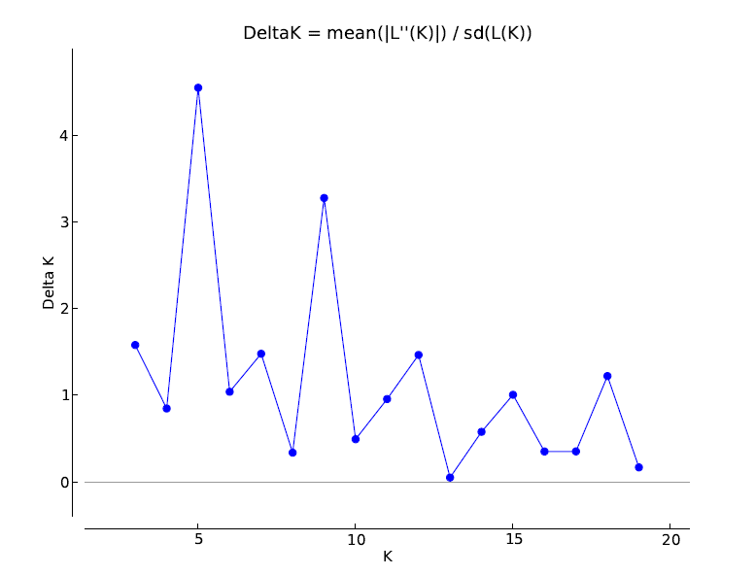
Figure S1. Evanno et al. (2005) prediction of the optimum number of clusters. The peak value indicates that the optimum number of clusters was 5

