Table S1. Collection areas, GPS Latitude and GPS Longitude of three Australian wild rice taxas from near Cairns, Queensland, Australia in May 2014.
Collection Area | Code | Wild rice Taxa | GPS Latitude | GPS Longitude | Habitat
Abattoir Swamp  Environmental Park | A | Taxa- A | S16.38.085 | E145.19.366 | NA
Brooklyn Wildlife Sanctuary, Mulligan Highway | B | O. australiensis | S16.34.761 | E145.11.335 | NA
Lakefield National Park | D | Taxa-B | S14.50.968 | E144.10.086 | NA
 | E |  | S14.51.791 | E144.10.031 | 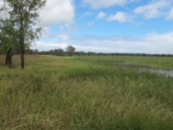
 | F | O. australiensis | S15.10.633 | E144.21.162 | NA
Peninsula  Developmental Road | C | O. australiensis | S15.43.886 | E144.40.503 | 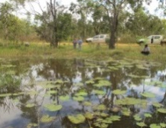  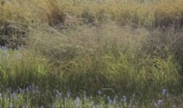
 | G | Taxa-B | S15.26.370 | E144.12.667
 | H |  | S15.28.161 | E144.14.539 | 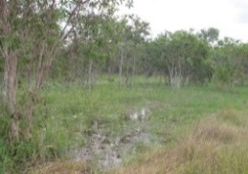
 | I | O. australiensis | S15.31.833 | E144.22.973 | NA
Mareeba wetland | J | Taxa-B | S16.56.268 | E145.21.040 | 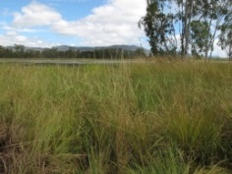
 | K | Taxa-A | S16.55.680 | 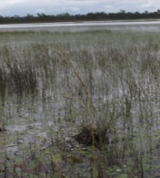  E145.21.474
NA, Not Available

