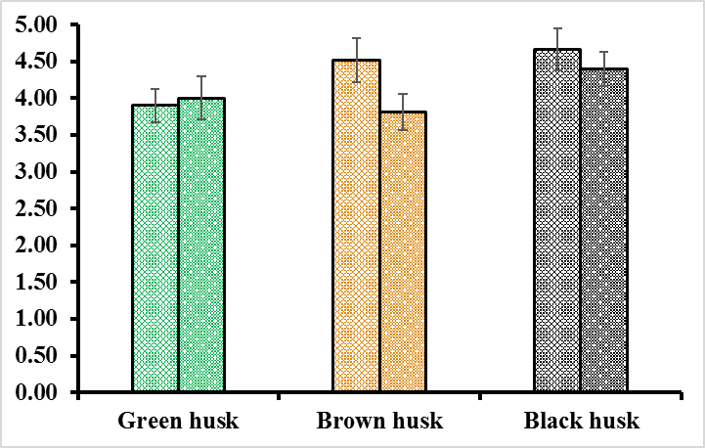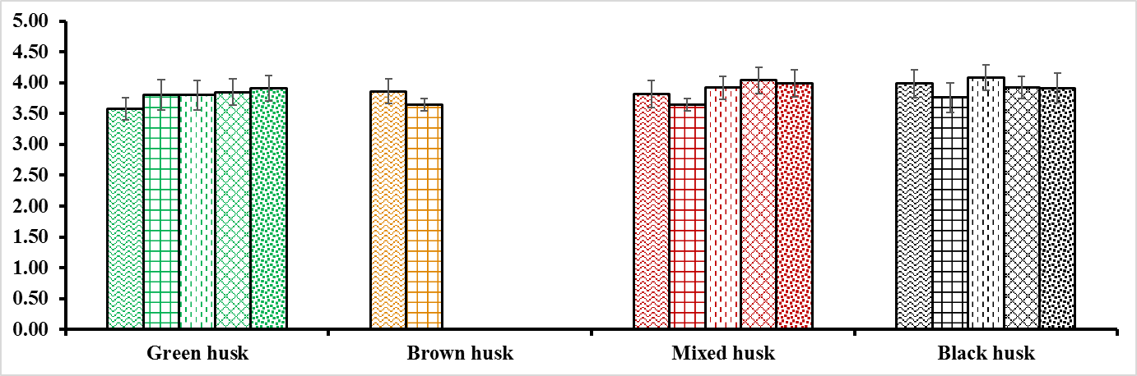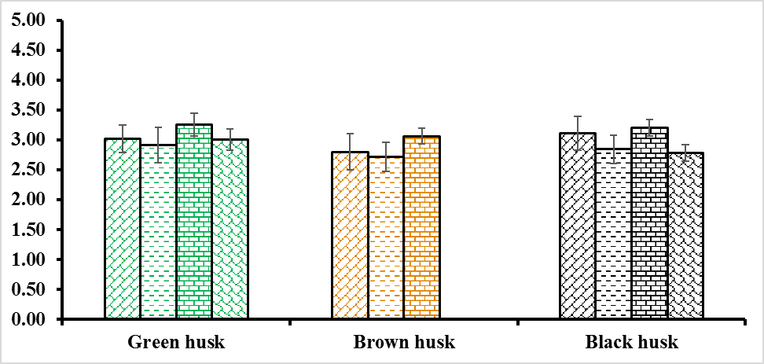

**(a)**

**(c)**

**(b)**

**A**

**C**

**B**

**Fig. S2** Paddy rice length/width (L/W) ratio of three Australian wild rices collected from eleven locations near Cairns, Queensland, Australia. Sample were grouped based on their husk colour and identified as Green, Brown, Mixed (Green/brown/black) or Black and missing data at any given location indicates the unavailability of the wild rice taxa or the paddy rice. **A** wild rice Taxa-A at site A (Abattoir swamp environmental park) and site K (Mareeba wetland); **B** wild rice Taxa-B at site D, site E (Lakefield national park), site G, site H (Peninsula developmental road), and site J (Mareeba wetland); **C** Oryza australiensis at site B (Brooklyn wildlife sanctuary, Mulligan highway), site F (Lakefield national park), site C and site I (Peninsula developmental road).