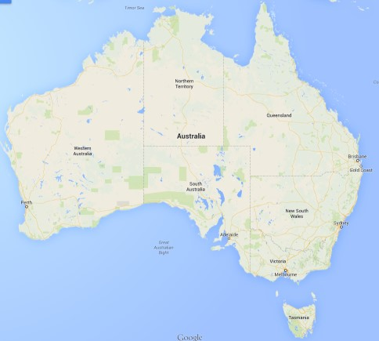

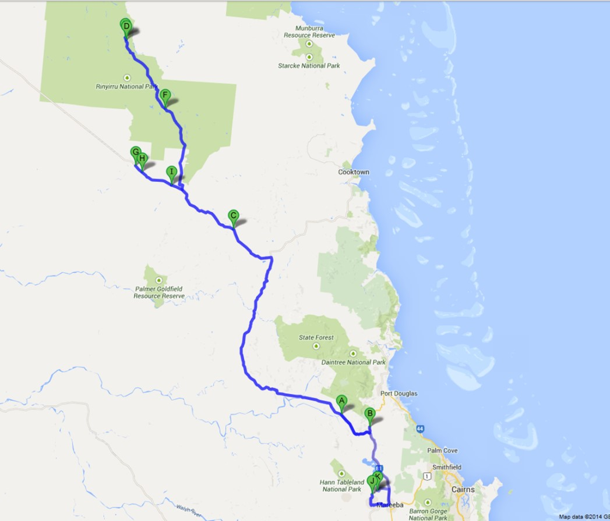

**Fig. S1.** Eleven collection sites of three Australian wild rice taxa from near Cairns, Queensland, Australia. **A** (Abattoir swamp environmental park, S16.38.085 E145.19.366), **B** (Brooklyn wildlife sanctuary, Mulligan highway, S16.34.761 E145.11.335), **C** (Peninsula developmental road, S15.43.886 E144.40.503), **D** (Lakefield national park, S14.50.968 E144.10.086), **E** (Lakefield national park, S14.51.791 E144.10.031), **F** (Lakefield national park, S15.10.633 E144.21.162), **G** (Peninsula developmental road, S15.26.370 E144.12.667), **H** (Peninsula developmental road, S15.28.161 E144.14.539), **I** (Peninsula developmental road, S15.31.833 E144.22.973), **J** (Mareeba wetland,S16.56.268 E145.21.040), **K** (Mareeba wetland, S16.55.680 E145.21.474).