Table S1. Chromosome position, number of alleles, major allele frequency, genetic diversity and polymorphic information content (PIC) for the 53 markers evaluated in Iranian wheat landraces
Marker | Chromosome | Major allele frequency | Number of allele | Gene diversity | PIC
Xwmc175 | 2D | 0.53 | 18.00 | 0.70 | 0.69
Xwmc181 | 2D | 0.50 | 5.00 | 0.65 | 0.60
Xwmc215 | 5D | 0.40 | 8.00 | 0.75 | 0.72
Xwmc327 | 5A | 0.24 | 8.00 | 0.81 | 0.79
Xbarc24 | 6B | 0.61 | 5.00 | 0.57 | 0.53
Xbarc37 | 6A | 0.73 | 5.00 | 0.43 | 0.40
Xbarc54 | 6D | 0.50 | 3.00 | 0.60 | 0.52
Xbarc59 | 5B | 0.64 | 6.00 | 0.56 | 0.53
Xbarc67 | 3A | 0.58 | 4.00 | 0.53 | 0.44
Xbarc70-1 | 4A | 0.36 | 5.00 | 0.72 | 0.67
Xbarc70-2 | 4A | 0.57 | 3.00 | 0.58 | 0.51
Xbarc78 | 4A | 0.37 | 9.00 | 0.78 | 0.75
Xbarc117 | 5A | 0.78 | 3.00 | 0.37 | 0.34
Xbarc134 | 6B | 0.36 | 6.00 | 0.75 | 0.71
Xbarc141 | 5A | 0.49 | 3.00 | 0.52 | 0.41
Xbarc186 | 5A | 0.90 | 2.00 | 0.18 | 0.16
Xgwm6 | 4B | 0.24 | 9.00 | 0.84 | 0.82
XGWM11 | 1B | 0.48 | 5.00 | 0.61 | 0.54
XGWM18 | 1B | 0.37 | 6.00 | 0.76 | 0.73
XGWM35 | 2A | 0.32 | 11.00 | 0.84 | 0.82
XGWM60 | 7A | 0.65 | 4.00 | 0.53 | 0.49
XGWM129 | 5A | 0.48 | 3.00 | 0.59 | 0.50
XGWM130 | 7B | 0.43 | 10.00 | 0.75 | 0.73
XGWM135 | 1A | 0.26 | 8.00 | 0.81 | 0.78
XGWM149 | 4B | 0.49 | 4.00 | 0.61 | 0.53
XGWM159 | 5B | 0.88 | 3.00 | 0.23 | 0.21
XGWM186 | 5A | 0.36 | 6.00 | 0.73 | 0.69
XGWM192 | 4A | 0.68 | 3.00 | 0.47 | 0.41
XGWM212 | 5D | 0.58 | 3.00 | 0.57 | 0.51
XGWM219 | 6B | 0.31 | 7.00 | 0.78 | 0.75
XGWM232 | 1D | 0.51 | 3.00 | 0.62 | 0.55
XGWM257 | 2B | 0.32 | 4.00 | 0.74 | 0.69
XGWM272 | 5D | 0.64 | 4.00 | 0.53 | 0.48
XGWM296 | 2A | 0.74 | 4.00 | 0.42 | 0.38
XGWM319 | 2B | 0.92 | 3.00 | 0.16 | 0.15
XGWM368 | 4B | 0.42 | 7.00 | 0.71 | 0.66
XGWM369 | 3A | 0.39 | 8.00 | 0.74 | 0.70
XGWM374 | 1B | 0.65 | 6.00 | 0.54 | 0.51
XGWM388 | 2B | 0.54 | 5.00 | 0.64 | 0.61
XGWM400 | 7B | 0.27 | 6.00 | 0.80 | 0.77
XGWM408 | 5B | 0.30 | 7.00 | 0.78 | 0.75
XGWM410 | 2B | 0.36 | 5.00 | 0.72 | 0.67
XGWM413 | 1B | 0.17 | 11.00 | 0.88 | 0.86
XGWM473 | 2A | 0.73 | 4.00 | 0.44 | 0.41
XGWM480 | 3A | 0.25 | 9.00 | 0.85 | 0.83
XGWM494 | 6A | 0.49 | 3.00 | 0.57 | 0.48
XGWM499 | 5B | 0.48 | 10.00 | 0.70 | 0.66
XGWM526 | 7A | 0.41 | 4.00 | 0.70 | 0.65
XGWM538 | 4B | 0.33 | 5.00 | 0.75 | 0.70
XGWM544 | 5B | 0.19 | 11.00 | 0.87 | 0.86
XGWM570 | 6B | 0.23 | 8.00 | 0.82 | 0.80
XGWM617 | 5A | 0.29 | 6.00 | 0.79 | 0.76
XGWM674 | 3A | 0.70 | 4.00 | 0.46 | 0.42
Mean |  | 0.48 | 5.89 | 0.64 | 0.60

Figure. S1. Analysis of the population structure of 395 wheat landraces. Estimation of the number of populations for K ranging from 1 to 12 by calculating delta K values.

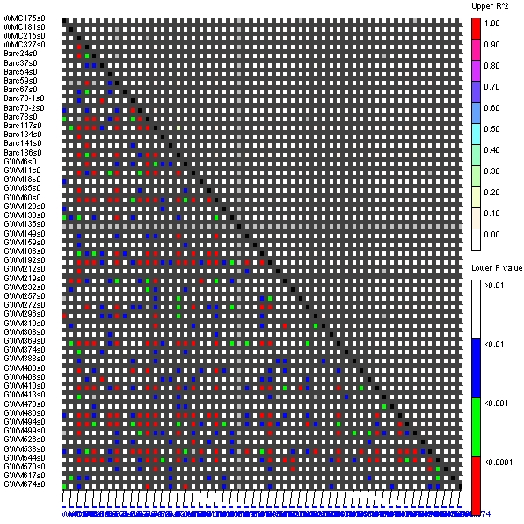
Figure. S2. LD plot for 1378 locus pairs were detected in the 395 Iranian wheat landraces collection using TASSEL software. Red colors show significant LD between markers.

