Table S1. Name species and code of five Salvia species used in this research
Name species | code | number | Name species | code | number
S.cereal | cere12 | 28 | S.virgata | v41 | 1
S.cereal | cere41 | 29 | S.virgata | v42 | 2
S.cereal | cere42 | 30 | S.virgata | v43 | 3
S.cereal | cere43 | 31 | S.virgata | v44 | 4
S.cereal | cere44 | 32 | S.virgata | v45 | 5
S.cereal | cere45 | 33 | S.virgata | v46 | 6
S.cereal | cere46 | 34 | S.virgata | v47 | 7
S.cereal | cere47 | 35 | S.virgata | v48 | 8
S.cereal | cere48 | 36 | S.virgata | v49 | 9
S.sclarea | scl22 | 37 | S.virgata | v40 | 10
S.sclarea | scl23 | 38 | S.virgata | v51 | 11
S.sclarea | scl24 | 39 | S.virgata | v52 | 12
S.officinalis | of41 | 40 | S.nemorosa | nem41 | 13
S.officinalis | of42 | 41 | S.nemorosa | nem44 | 14
S.officinalis | of43 | 42 | S.nemorosa | nem46 | 15
S.officinalis | of44 | 43 | S.nemorosa | nem49 | 16
S.officinalis | of45 | 44 | S.nemorosa | nem51 | 17
S.officinalis | of46 | 45 | S.nemorosa | nem53 | 18
S.officinalis | of47 | 46 | S.nemorosa | nem54 | 19
S.officinalis | of52 | 47 | S.nemorosa | nem55 | 20
S.officinalis | of11 | 48 | S.nemorosa | nem56 | 21
S.officinalis | of12 | 49 | S.nemorosa | nem57 | 22
S.officinalis | of13 | 50 | S.nemorosa | nem58 | 23
S.officinalis | of14 | 51 | S.nemorosa | nem59 | 24
S.officinalis | of15 | 52 | S.nemorosa | nem61 | 25
S.officinalis | of17 | 53 | S.nemorosa | nem62 | 26
S.officinalis | of18 | 54 | S.cereal | cere11 | 27

Table S2. Polymorphism number and rate for 14 SRAP PCs used to amplify 54 genomic DNA templates from five Salvia species
Primer  combination | Number of  total  fragments | Number of  polymorphic  fragments | Percentage of  polymorphic  fragments | PIC  value
Me6 - Em6 | 31 | 27 | 87 | 0.3938
Me8 - Em1 | 21 | 20 | 95 | 0.2878
Me8 - Em6 | 23 | 23 | 100 | 0.3012
Me3-Em18 | 14 | 14 | 100 | 0.2810
Me3-Em17 | 18 | 18 | 100 | 0.2627
Me4 - Em6 | 28 | 28 | 100 | 0.3845
Me6-Em17 | 20 | 19 | 95 | 0.3747
Me1 - Em5 | 11 | 11 | 100 | 0.2197
Me3 - Em2 | 15 | 15 | 100 | 0.3434
Me8-Em17 | 30 | 30 | 100 | 0.3255
Me2 - Em4 | 7 | 7 | 100 | 0.2010
Me3 - Em6 | 11 | 11 | 100 | 0.2154
Me3 - Em1 | 16 | 15 | 94 | 0.2198
Me4-Em17 | 20 | 17 | 85 | 0.2196
Total | 265 | 255
Mean | 18.92 | 18.21 | 96 | 0.308

Table S3. Measures of genetic distance among different Salvia species based on coancestry coefficients obtained from the pairwise Fst distance matrices produced by POPGENE 1.32 software
Species name | S. virgata | S. nemorosa | S. cereal | S. sclarea | S. officinalis
S. virgata | ***
S. nemorosa | 0.1263 | ***
S. cereal | 0.3171 | 0.3527 | ***
S. sclarea | 0.5424 | 0.5648 | 0.5378 | ***
S. officinalis | 0.1579 | 0.2319 | 0.3390 | 0.5564 | ***

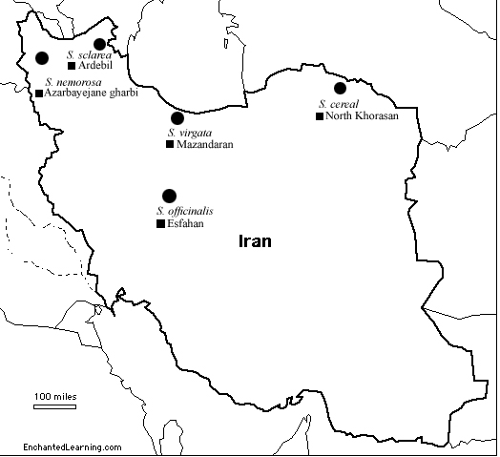

Fig. S1. Sampling location sites of five Salvia species, S.virgata, S. nemorosa, S. officinalis, S. sclarea and S. cereal from different geographical regions of Iran used in study.

