Table 1: Stripe rust resistant accessions with number and their pedigrees
Sr# | Accession Number | Pedigree
1 | E-II-1a | CETA/Ae. Squarrosa (392)
2 | E-II-2 | GAN/Ae. Squarrosa (335)
3 | E-II-3 | CETA/Ae. Squarrosa (417)
4 | E-II-4 | SKARV_2/Ae. Squarrosa (304)
5 | E-II-6 | D67.2/P66.270//Ae. Squarrosa (497)
6 | E-II-7 | D67.2/P66.270//Ae. Squarrosa (308)
7 | E-II-8 | CETA/Ae. Squarrosa (533)
8 | E-II-9 | SORA/Ae. Squarrosa (323)
9 | E-II-10 | DVERD_2/Ae. Squarrosa (214)
10 | E-II-11 | CROC_1/Ae. Squarrosa (210)
11 | E-II-12 | SORA/Ae. Squarrosa (192)
12 | E-II-13 | ARLIN_1/Ae. Squarrosa (218)
13 | E-II-14 | TK SN1081/Ae. Squarrosa (222)
14 | E-II-15 | GAN/Ae. Squarrosa (236)
15 | E-II-16 | LCK59.61/Ae. Squarrosa (693)
16 | E-II-17 | CETA/Ae. Squarrosa (1025)
17 | E-II-18 | DOY1/Ae. Squarrosa (1027)
18 | E-II-19 | CETA/Ae. Squarrosa (386)
19 | E-II-20 | CPI/GEDIZ/3/GOO//JO/CRA/4/Ae. Squarrosa (1018)
20 | E-II-21 | CETA/Ae. Squarrosa (1031)
21 | E-II-22 | CETA/Ae. Squarrosa (1038)
22 | E-II-23 | CETA/Ae. Squarrosa (1046)
23 | E-II-24 | CTA/Ae. Squarrosa (1053)
24 | E-II-26 | CETA/Ae. Squarrosa (368)
25 | E-II-27 | ARLIN_1/Ae. Squarrosa (430)
26 | E-II-29 | GAN/Ae. Squarrosa (206)
27 | E-II-30 | ARLIN_1/Ae. Squarrosa (335)
28 | E-II-31 | 68.111/RGB-U//WARD RESEL/3/STIL/4/Ae. Squarrosa (385)
29 | E-II-32 | 68.111/RGB-U//WARD RESEL/3/STIL/4/Ae. Squarrosa (432)
30 | E-II-33 | DOY1/Ae. Squarrosa (534)
31 | E-I-3 | ALTAR 84/ Ae. Squarrosa (192)
32 | E-I-5 | ALTAR 84/ Ae. Squarrosa (198)
33 | E-I-27 | GARZA/BOY// Ae. Squarrosa (311)
34 | E-I-32 | DOY1/Ae. Squarrosa (447)
35 | E-I-34 | DOY1/Ae. Squarrosa (511)
36 | E-I-35 | 68.111/RGB-U//WARD/3/Ae. Squarrosa (511)
37 | E-I-42 | YAR/ Ae. Squarrosa (783)
38 | E-I-47 | 68.111/RGB-U//WARD/3/FG/4 RAB/5/Ae. Squarrosa (882)
39 | E-I-62 | SCA/Ae. Squarrosa (518)
40 | E-I-73 | GAN/Ae. Squarrosa (897)
41 | E-I-76 | FALCIN/ Ae. Squarrosa (312)
42 | E-I-79 | DOY1/Ae. Squarrosa (333)
43 | E-I-80 | DOY1/Ae. Squarrosa (428)
44 | E-I-87 | SCA/ Ae. Squarrosa (409)
45 | E-I-88 | CPI/GEDIZ/3/GOO//J069/CRA/4/Ae. Squarrosa (409)
46 | E-I-89 | STY-US/CETA//PALS/3/SRN_5/4/Ae. Squarrosa (502)
47 | E-I-90 | ALTAR 84/ Ae. Squarrosa (502)
48 | E-I-91 | CROC-1 /Ae. Squarrosa (517)
49 | E- I-92 | CETA/Ae. Squarrosa (1024)
50 | E- I-93 | DVERD-2/ Ae. Squarrosa (1027)
51 | E- I-94 | CETA/Ae. Squarrosa (1027)

Table 2: Description of wheat microsatellite primer sets
Sr # | Locus | Forward Primer | Reverse primer | Annealing temperature
1 | Xcfd81-5D, | 5' TATCCCCAATCCCCTCTTTC 3' | 5' GTCAATTGTGGCTTGTCCCT 3' | 60ºC
2 | Xcfd82-6A | 5' GCTGATGCTGCTGTAAGTGC 3' | 5' TGAAGAATACAATGGCAGCAA 3' | 60ºC
3 | Xcfd83-1D | 5' AAGGATGGAGAGGACCCCTA 3' | 5' GGAGGTGGAGCAACCTATCA 3' | 60ºC
4 | Xcfd92-1D | 5' CTTGTTGATCTCCTTCCCCA 3' | 5' TTCTCTCATGACGGCAACAC 3' | 60ºC
5 | Xcfd106-4D | 5' ACGGGTGGTTTTGCTCAGT 3' | 5' ACTCCACCAGCGGAGAAATA 3' | 60ºC
6 | Xcfd141-3D | 5' CGTAAAGATCCGAGAGGGTG 3' | 5' TCCGAGGTGCTACCTACCAG 3' | 60ºC
7 | Xcfd143-3B | 5' TTCTCCATGGGCAGCTACTT 3' | 5' ACTACTTGCGGACGGCTG 3' | 60ºC
8 | Xcfd156-5D | 5' AGCAGTGTAATAAAAGGGCG 3' | 5' GTATTCGCACCAGAATCCGT 3' | 60ºC
9 | Xwmc477-2B | CGTCGAAAACCGTACACTCTCC | GCGAAACAGAATAGCCCTGATG | 61ºC
10 | Xbarc67-3A | 5' GCGGCATTTACATTTCAGATAGA 3' | 5' TGTGCCTGATTGTAGTAACGTATGTA 3' | 52ºC
11 | Xbarc72-7B | 5' CGTCCTCCCCCTCTCAATCTACTCTC 3' | 5' CGTCCCTCCATCGTCTCATCA 3' | 60ºC
12 | Xbarc124b-2A | 5' TGCACCCCTTCCAAATCT 3' | 5' TGCGAGTCGTGTGGTTGT 3' | 52ºC
13 | Xbarc167-2B | 5' AAAGGCCCATCAACATGCAAGTACC 3' | 5' CGCAGTATTCTTAGTCCCTCAT 3' | 50ºC
14 | Xbarc8-1B | 5' GCGGGAATCATGCATAGGAAAACAGAA 3' | 5' GCGGGGGCGAAACATACACATAAAAACA 3' | 50ºC
15 | Xcfa2149-2AL | 5' CTTGGAGCTCGGGTAGTAGC 3' | 5' AAGGCAGCTCAATCGGAGTA 3' | 60ºC
16 | Xuhw89 | 5'  TCTCCAAGAGGGGAGAGA CA 3' | 5'  TTCCTCTACCCA TGAATCTAGCA 3' | 59 ºC
Table 3: Description of microsatellite marker’s along with PIC values.
SR# | Marker | Major Allele Frequency | Sample Size | No. of obs. | Allele No | Availability | Gene Diversity | PIC
1 | CFD-81 | 0.7647 | 51.0000 | 51.0000 | 2.0000 | 1.0000 | 0.3599 | 0.2951
2 | CFD-82 | 0.4902 | 51.0000 | 51.0000 | 4.0000 | 1.0000 | 0.5375 | 0.4303
3 | CFD-83 | 0.8431 | 51.0000 | 51.0000 | 3.0000 | 1.0000 | 0.2768 | 0.2592
4 | CFD-92 | 0.4706 | 51.0000 | 51.0000 | 4.0000 | 1.0000 | 0.6820 | 0.6335
5 | CFD-106 | 0.6078 | 51.0000 | 51.0000 | 8.0000 | 1.0000 | 0.6013 | 0.5791
6 | CFD-141 | 0.5686 | 51.0000 | 51.0000 | 9.0000 | 1.0000 | 0.6344 | 0.6059
7 | CFD-143 | 0.4510 | 51.0000 | 51.0000 | 6.0000 | 1.0000 | 0.6959 | 0.6507
8 | CFD-156 | 0.8824 | 51.0000 | 51.0000 | 2.0000 | 1.0000 | 0.2076 | 0.1861
9 | BARC-08 | 1.0000 | 51.0000 | 51.0000 | 1.0000 | 1.0000 | 0.0000 | 0.0000
10 | BARC-67 | 0.4902 | 51.0000 | 51.0000 | 6.0000 | 1.0000 | 0.6282 | 0.5633
11 | BARC-72 | 0.5294 | 51.0000 | 51.0000 | 4.0000 | 1.0000 | 0.5759 | 0.4939
12 | BARC-124 | 0.4706 | 51.0000 | 51.0000 | 18.0000 | 1.0000 | 0.7589 | 0.7499
13 | BARC-167 | 0.8039 | 51.0000 | 51.0000 | 8.0000 | 1.0000 | 0.3453 | 0.3343
14 | WMC-477 | 0.1961 | 51.0000 | 51.0000 | 10.0000 | 1.0000 | 0.8635 | 0.8487
15 | CFA-2149 | 0.1569 | 51.0000 | 51.0000 | 24.0000 | 1.0000 | 0.9250 | 0.9205
16 | UHW-89 | 0.7255 | 51.0000 | 51.0000 | 7.0000 | 1.0000 | 0.4591 | 0.4435
 | Mean | 0.5919 | 51.0000 | 51.0000 | 7.2500 | 1.0000 | 0.5345 | 0.4996

Table 4: Showing number of alleles detecting chromosome specific primers.
Genome | SSR Markers | No. of alleles | Total No of Alleles
A Genome | Xbarc124b-2A | 18 | 38
 | Xbarc67-3A | 6
 | Xcfa2149-5A | 10
 | Xcfd82-6A | 4
B Genome | Xwmc477-2B | 24 | 49
 | Xbarc167-2B | 8
 | Xcfd143-3B | 6
 | Xbarc72-7B | 4
 | Xuhw-89 | 7
D Genome | Xcfd83-1D | 3 | 29
 | Xcfd92-1D | 4
 | Xbarc8-3D | 1
 | Xcfd141-3D | 9
 | Xcfd106-4D | 8
 | Xcfd81-5D | 2
 | Xcfd156-5D | 2

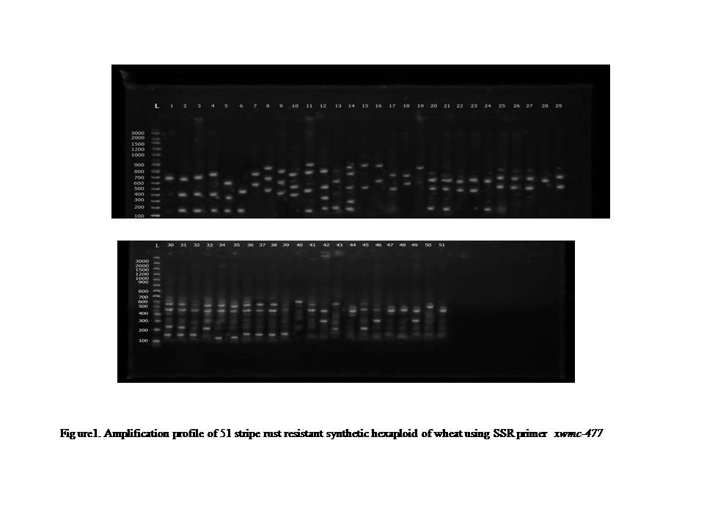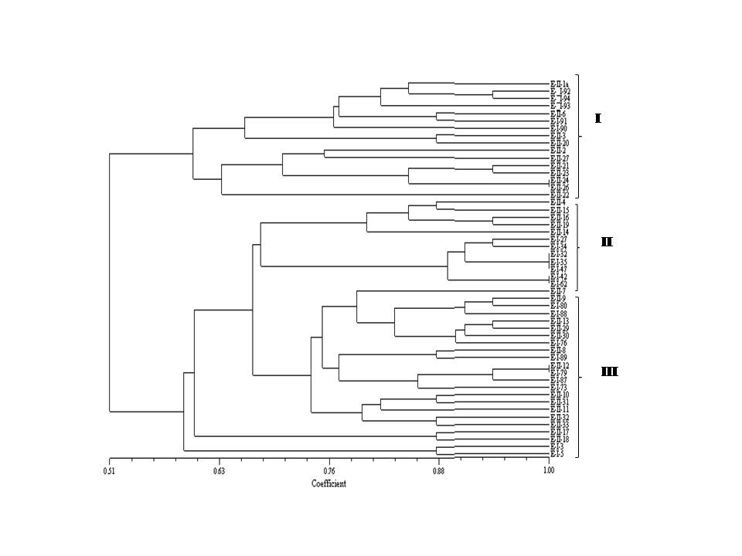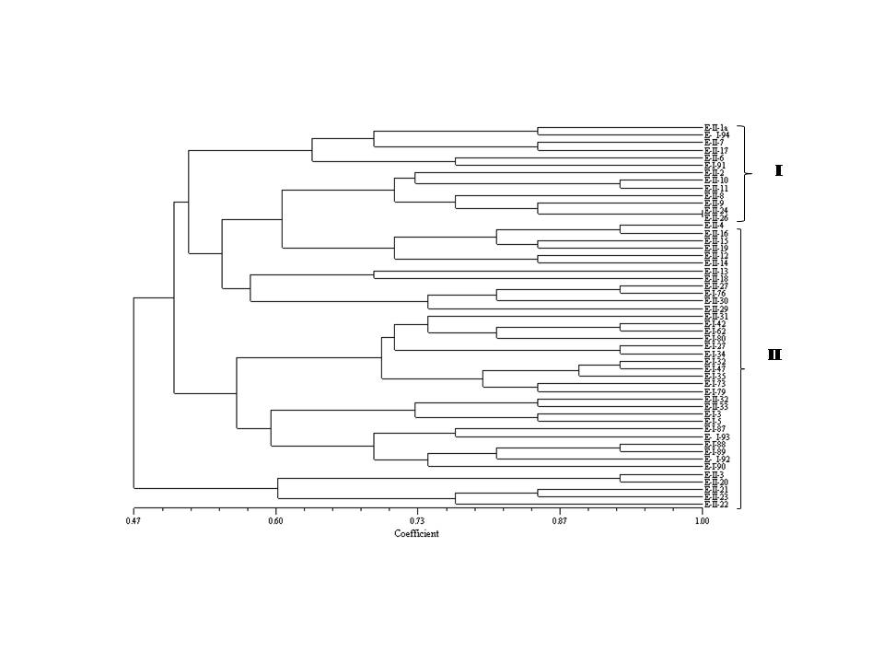
Figure 2. Dendrogram constructed for 51 synthetic hexaploid wheat accessions using SSR markers.
Figure 3. Dendrogram constructed for 51 synthetic hexaploid wheat accessions using SDS-PAGE for seed storage proteins

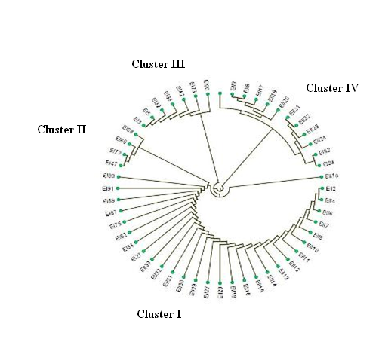
Fig 3. A Dendrogram constructed for 51 synthetic hexaploid wheat accessions using SSR markers

