Table S1 List of samples of L. cylindrica along with their states of origin in India used for SRAP analysis
S. No. | Name of sample | State | Seed shape | Seed coat color | Seed surface | Seed wing
 | DSG6 | West Bengal | Ovate | Brown | Slightly Pitted | Absent
 | Pusa Supriya | Delhi | Ovate | Black | Wrinkled | Absent
 | DSG7 | Uttar Pradesh | Ovate | Black | Wrinkled | Absent
 | VRSL1 | West Bengal | Ovate | Black | Wrinkled | Absent
 | VRSL2 | West Bengal | Ovate | Black | Smooth | Absent
 | VRSL3 | West Bengal | Ovate | Brown | Smooth | Absent
 | VRSL4 | West Bengal | Ovate | Black | Slightly Pitted | Absent
 | VRSL5 | West Bengal | Ovate | Black | Slightly Pitted | Present
 | VRSL6 | Uttar Pradesh | Ovate | Black | Wrinkled | Absent
 | VRSL7 | Uttar Pradesh | Ovate | Black | Wrinkled | Present
 | VRSL8 | Uttar Pradesh | Ovate | Black | Wrinkled | Absent
 | VRSL9 | Uttar Pradesh | Ovate | Black | Wrinkled | Absent
 | VRSL10 | Uttar Pradesh | Ovate | Black | Smooth | Absent
 | VRSL11 | Uttar Pradesh | Ovate | Black | Smooth | Present
 | VRSL12 | Uttar Pradesh | Ovate | Brown | Wrinkled | Present
 | VRSL13 | Uttar Pradesh | Ovate | Black | Smooth | Absent
 | VRSL14 | Uttar Pradesh | Ovate | Black | Smooth | Absent
 | VRSL15 | Uttar Pradesh | Ovate | Black | Smooth | Absent
 | NDSG1 | Uttar Pradesh | Ovate | Black | Slightly Pitted | Present
 | PSG9 | Punjab | Ovate | Black | Smooth | Absent
 | DSG31 | Madhya Pradesh | Ovate | Brown | Wrinkled | Present
 | CHSG1 | Jharkhand | Ovate | Black | Slightly Pitted | Absent
 | CHSG2 | Jharkhand | Ovate | Brown | Smooth | Absent
 | DSG43 | West Bengal | Ovate | Brown | Slightly Pitted | Present
 | DSG48 | West Bengal | Ovate | Black | Smooth | Present
 | Pusa Sneha | Delhi | Ovate | Black | Wrinkled | Absent
 | HASG5 | Jharkhand | Ovate | Black | Slightly Pitted | Present
 | PSG93 | Punjab | Ovate | Black | Smooth | Absent
 | PSG100 | Punjab | Ovate | Black | Wrinkled | Present
 | PSG110 | Punjab | Ovate | Black | Wrinkled | Absent
 | NSG111 | Maharashtra | Ovate | Black | Smooth | Absent
 | NSG28 | Maharashtra | Ovate | Black | Smooth | Absent
 | JSLG55 | Gujarat | Ovate | Black | Smooth | Absent
 | DSG47 | Uttar Pradesh | Ovate | Black | Wrinkled | Absent
 | Improved Chikni | Delhi | Ovate | White | Wrinkled | Present
 | DSG95 | Himachal Pradesh | Ovate | Black | Slightly Pitted | Present
 | DSG98 | Uttarakhand | Ovate | Black | Slightly Pitted | Absent
 | DSG104 | Uttarakhand | Ovate | Black | Smooth | Present
 | Chetak Selection | Delhi | Ovate | Black | Smooth | Present
 | DSG26 | West Bengal | Ovate | Black | Smooth | Absent
 | DSG30 | Jharkhand | Ovate | Black | Slightly Pitted | Absent
 | DSG32 | Madhya Pradesh | Ovate | Brown | Wrinkled | Absent
 | DSG34 | Madhya Pradesh | Ovate | Brown | Wrinkled | Present
 | DSG38 | Uttar Pradesh | Ovate | Brown | Wrinkled | Absent
 | DSG42 | West Bengal | Ovate | Black | Smooth | Absent
Table S2 SRAP primer combinations showing total no. of bands (TNB), number of polymorphic bands (PNB), percentage of polymorphism (P%), polymorphic information content (PIC), along with marker parameters i.e. Resolving power (Rp), EMR (Effective Multiplex Ratio) and Marker index (MI) calculated for 45 accessions of L. cylindrica
S. No. | Primer | TNB | PNB | P% | PIC | Rp | EMR | MI
1 | Me3-Em1 | 7 | 7 | 100 | 0.24 | 2.39 | 7 | 1.65
2 | Me4-Em1 | 9 | 8 | 89 | 0.21 | 3.12 | 7.12 | 1.49
3 | Me5-Em1 | 8 | 3 | 38 | 0.13 | 3.21 | 1.14 | 0.15
4 | Me4-Em2 | 7 | 3 | 43 | 0.16 | 2.69 | 1.29 | 0.21
5 | Me6-Em2 | 4 | 3 | 75 | 0.1 | 1.78 | 2.25 | 0.23
6 | Me9-Em2 | 7 | 4 | 57 | 0.1 | 2.94 | 2.28 | 0.23
7 | Me1-Em3 | 7 | 4 | 57 | 0.12 | 2.92 | 2.28 | 0.28
8 | Me2-Em3 | 5 | 2 | 40 | 0.07 | 2.29 | 1.14 | 0.08
9 | Me4-Em4 | 7 | 4 | 57 | 0.13 | 2.86 | 2.28 | 0.3
10 | Me7-Em4 | 3 | 2 | 67 | 0.17 | 1.09 | 1.34 | 0.23
11 | Me2-Em5 | 10 | 7 | 70 | 0.22 | 3.47 | 4.9 | 1.09
12 | Me3-Em5 | 7 | 3 | 43 | 0.33 | 1.96 | 1.29 | 0.43
13 | Me4-Em5 | 10 | 6 | 60 | 0.14 | 4.1 | 3.6 | 0.52
14 | Me8-Em5 | 5 | 5 | 100 | 0.22 | 1.79 | 5 | 1.1
15 | Me9-Em5 | 16 | 14 | 88 | 0.22 | 5.71 | 12.32 | 2.66
16 | Me10-Em5 | 9 | 6 | 67 | 0.09 | 4.03 | 4.02 | 0.34
17 | Me2-Em6 | 5 | 4 | 80 | 0.27 | 1.42 | 3.2 | 0.88
18 | Me3-Em6 | 13 | 13 | 100 | 0.25 | 4.35 | 13 | 3.28
19 | Me4-Em6 | 9 | 6 | 67 | 0.21 | 3.19 | 4.03 | 0.86
20 | Me5-Em6 | 9 | 9 | 100 | 0.35 | 2.31 | 9 | 3.18
21 | Me7-Em6 | 8 | 5 | 63 | 0.09 | 3.61 | 3.15 | 0.27
22 | Me9-Em6 | 6 | 6 | 100 | 0.13 | 2.58 | 6 | 0.76
23 | Me10-Em6 | 6 | 5 | 83 | 0.22 | 2.09 | 4.15 | 0.93
 | Total | 177 | 129 |  | 3.97
 | Mean | 7.7 | 5.6 | 71.39 | 0.18 | 2.87 | 4.42 | 1.26

Table S3 Nei’s (1978) unbiased measure genetic distance (below diagonal) between populations of L. cylindrica
POP | WB | UP | P | J | M | D | MP | U
WB | -
UP | 0.0183 | -
P | 0.0608 | 0.0695 | -
J | 0.0652 | 0.0626 | 0.0647 | -
M | 0.1192 | 0.1356 | 0.1273 | 0.1367 | -
D | 0.0430 | 0.0407 | 0.0795 | 0.0699 | 0.1181 | -
MP | 0.0941 | 0.0944 | 0.0977 | 0.0781 | 0.1906 | 0.1113 | -
U | 0.1295 | 0.1319 | 0.1245 | 0.0993 | 0.1748 | 0.1291 | 0.0695 | -

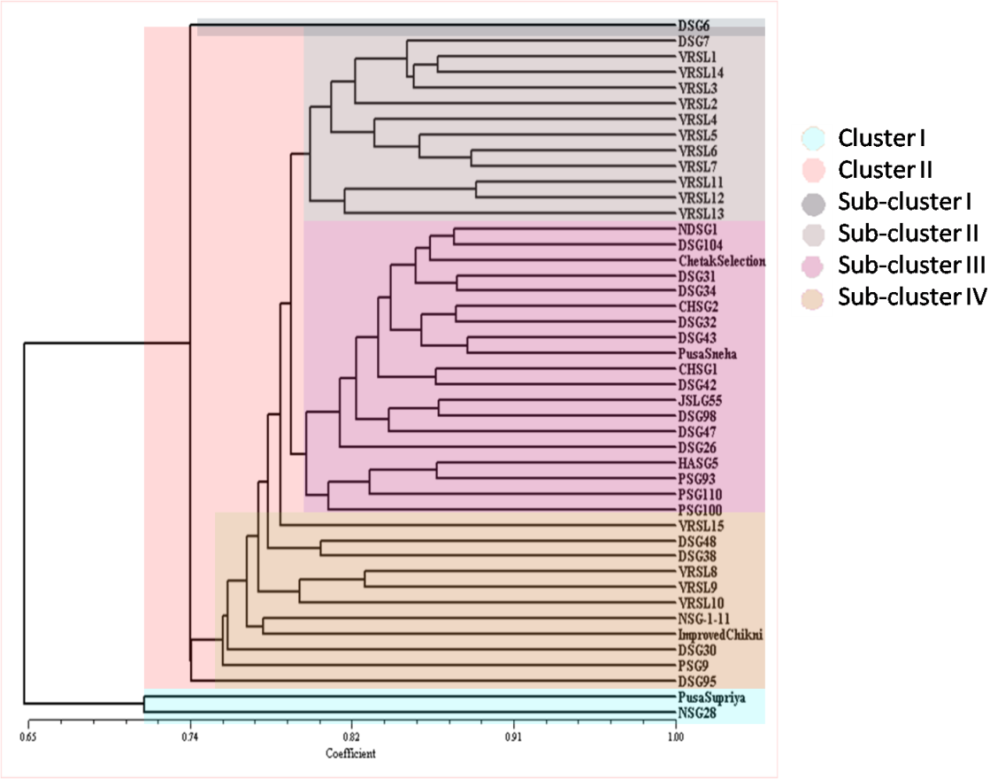
Figure S1 Dendrogram based on UPGMA cluster analysis of SRAP data among 45 individuals of L. cylindrica.

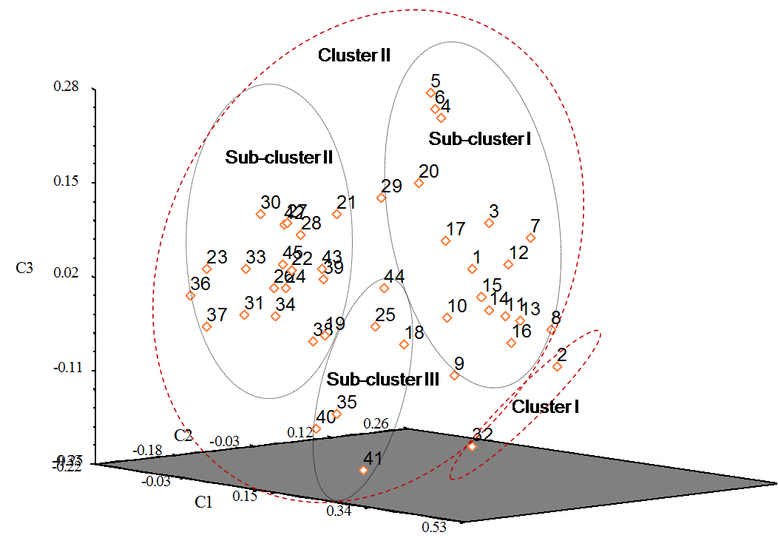
Figure S2 PCoA of the 45 accessions of L. cylindrica.

Figure S3 Determination of the optimal value of K and inferred population structure of L. cylindrica. Each vertical line represents an individual and the different colors represent populations. The length of the colored segment illustrates the estimated proportion of membership in corresponding clusters as calculated through STRUCTURE 2.3.

