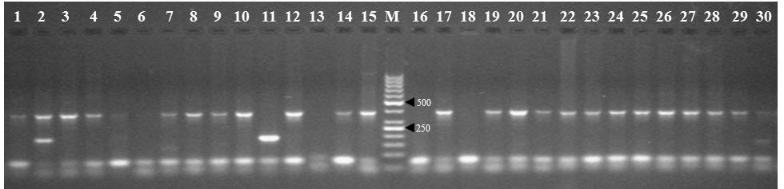
Supplemental Figure 1. Amplification profile of 30 genotypes generated with Me6F-Em8R SRAP primers. Lanes 1-30, plant genotypes used in the study. MD, 50bp molecular size marker (Life Technologies).

