SUPPLEMENT
Table S1. Overview of all the herbaria and genebanks from which Lactuca samples were retrieved.
Academy of Natural Sciences Herbarium
Australia's Virtual Herbarium
Botanical Society of the British Isles Herbaria
California Academy of Sciences
Centro de Referência em Informação Ambiental
Consortium of Pacific Northwest Herbaria
Denver Botanic Gardens Herbarium
Eurisco
Field Museum
Florida State University Herbarium
Global Biodiversity Information Facility
Harvard University Herbarium
Instituto Superior de Agronomia
International Lactuca Database
Jardim Botanico do Rio de Janeiro
Manchester University Herbarium
Museum National d'Histoire Naturelle Herbarium
Nationaal Herbarium Nederland
New York Botanical Garden Herbarium
Real Jardin Botanico de Madrid
Royal Botanic Gardens Edinburgh
Royal Botanic Gardens, Kew
Smithsonian Institution, National Herbarium
United States Department of Agriculture, National Plant Germplasm System
Universidad del Valle Herbarium
Universidade Lisboa Museu Nacional de Historia Natural e da Ciência
University of California and Jepson Herbaria
University of California, Riverside Herbarium
University of Coimbra Herbarium
V. L. Komarov Botanical Institute
Wageningen University Herbarium
West Virginia University Herbarium
World Vegetable Center

Table S2. The species in the Lactuca genepool (Table 1) and their synonyms (Van Treuren et al., 2012). Author names were included only when they distinguish between different synonyms in the consulted databases (Table S1).
accepted names | synonyms
L. acanthifolia | L. amorgina
 | L. eburnea
L. aculeata
L. altaica
L. aurea
L. azerbaijanica
L. dregeana | L. virosa Thunb.
L. georgica
L. longidentata | Scariola longidentata
L. orientalis
L. quercina | L. altissima
 | L. armena
 | L. chaixii
 | L. sagittata
 | L. stricta
 | L. vialea
 | L. wilhelmsiana
 | L. cracoviensis
 | L. cyanea
 | L. decorticata
L. saligna | L. adulteriana
 | L. angustifolia
 | L. caucasica
 | L. cracoviensis
 | L. cyanea
 | L. salicifolia
 | L. spiciformis
 | L. tommasiniana
 | L. virgata
 | L. virosa Habl.
 | L. wallrothii
L. scarioloides | L. kotschyana
L. serriola | L. albicaulis
 | L. augustana
 | L. coriacea
 | L. dubia
 | L. latifolia
 | L. plicata
 | L. scariola
 | L. sylvestris
 | L. tephrocarpa
 | L. virosa Luce
L. sibirica
L. taraxacifolia | L. alaica
 | L. kotschyi
 | L. pentaphylla
L. tatarica | L. clarkei
 | L. multipes
 | L. oblongifolia
 | L. pulchella (Pursh) DC.
 | L. pulchella DC.
L. viminea | L. alpestris
 | L. chondrilliflora
 | L. decorticata
 | L. numidica
 | L. ramosissima
L. virosa | L. agrestis
 | L. ambigua
 | L. cornigera
 | L. flavida
 | L. lactucarii
 | L. livida
 | L. serratifolia
 | L. sinuata
 | L. virosa L.
L. watsoniana

Table S3. The Maxent model statistics for each of the investigated species of the lettuce genepool. ATAUC: the 10-fold average test AUC (area under the curve), STAUC: the standard deviation of the test AUC of the 10 different folds, ASD15: the percentage of the potential distribution coverage with standard deviation above 0.15. For the gray colored species, the total number of samples is smaller than 10 (Table 1), meaning that the number of folds is equal to the number of samples.
Taxon | ATAUC | STAUC | ASD15 | ValidModel
Lactuca acanthifolia | 0.9984 | 0.0006 | 0 | yes
Lactuca aculeata | 0.9599 | 0.0667 | 0 | yes
Lactuca altaica | 0.8728 | 0.0571 | 44.195 | no
Lactuca dregeana | 0.9896 | 0.0061 | 4.433 | yes
Lactuca georgica | 0.9973 | 0.0043 | 0 | yes
Lactuca orientalis | 0.9736 | 0.0240 | 0.610 | yes
Lactuca quercina | 0.9810 | 0.0341 | 0.055 | yes
Lactuca saligna | 0.9183 | 0.0044 | 0 | yes
Lactuca saligna_EUR | 0.9422 | 0.0048 | 0.037 | yes
Lactuca saligna_GRC | 0.9208 | 0.0057 | 0 | yes
Lactuca saligna_ISR | 0.9191 | 0.0051 | 0 | yes
Lactuca scarioloides | NA | NA | NA | no
Lactuca serriola | 0.6490 | 0.0046 | 0 | no
Lactuca serriola_TC | 0.9895 | 0.0060 | 1.450 | yes
Lactuca sibirica | 0.9596 | 0.0038 | 0 | yes
Lactuca taraxacifolia | 0.5000 | 0 | NA | no
Lactuca tatarica | 0.9169 | 0.0061 | 0.126 | yes
Lactuca viminea | 0.9637 | 0.0043 | 0.003 | yes
Lactuca virosa | 0.8806 | 0.0042 | 0 | yes

Figure S1a. The global region of analysis (ALL) and all L. saligna occurrences.
Figure S1b. The Eurasian region of analysis (EUR) and its L. saligna occurrences.
Figure S1c. The Greek region of analysis (GRC) and its L. saligna occurrences.
Figure S1d. The Israeli region of analysis (ISR) and its L. saligna occurrences.

Figure S1a

Figure S1b

Figure S1c Figure S1d

Figure S2a. The Maxent response curves to BIO_1 for the model based on all occurrences (model Lactuca_saligna) and the model for which the Israeli occurrences were omitted (model Lactuca_salignaISR). The curves show how the logistic prediction changes as the mean annual temperature is varied, keeping all other environmental variables at their average sample value.
Figure S2b. The Maxent response curves to BIO_5 for the model based on all occurrences (model Lactuca_saligna) and the model for which the Israeli occurrences were omitted (model Lactuca_salignaISR). The curves show how the logistic prediction changes as the maximum temperature of the warmest month is varied, keeping all other environmental variables at their average sample value.
Figure S2c. The Maxent response curves to BIO_15 for the model based on all occurrences (model Lactuca_saligna) and the model for which the Israeli occurrences were omitted (model Lactuca_salignaISR). The curves show how the logistic prediction changes as the variation in the precipitation over the seasons is varied, keeping all other environmental variables at their average sample value.
Figure S2d. The Maxent response curves to BIO_18 for the model based on all occurrences (model Lactuca_saligna) and the model for which the Israeli occurrences were omitted (model Lactuca_salignaISR). The curves show how the logistic prediction changes as the total precipitation of the warmest quarter is varied, keeping all other environmental variables at their average sample value.
Figure S2a 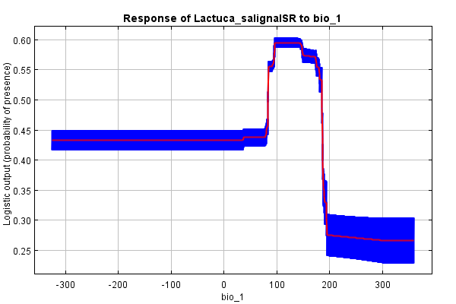
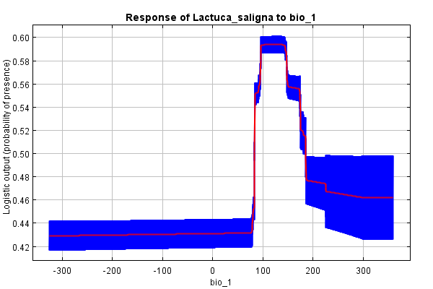

Figure S2b
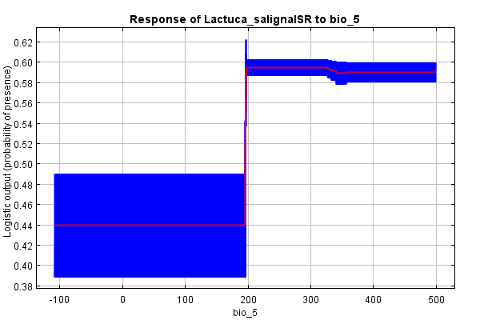
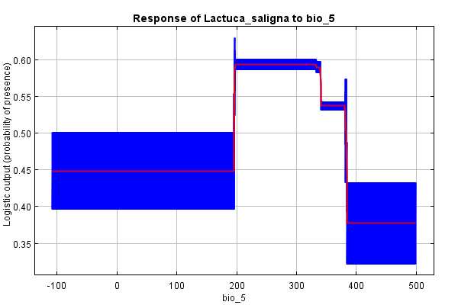

Figure S2c
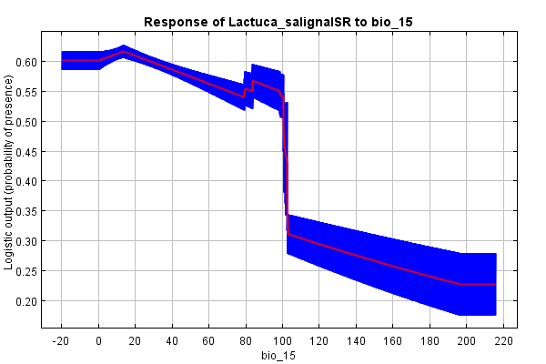
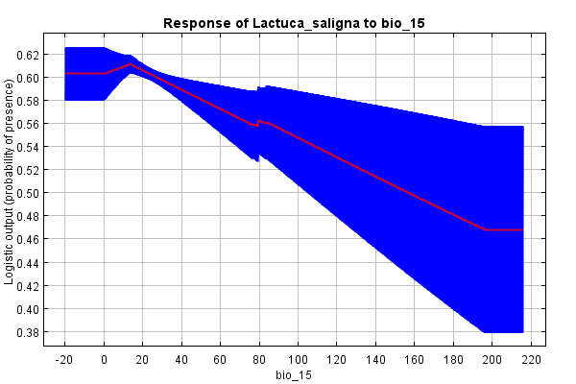

Figure S2d
