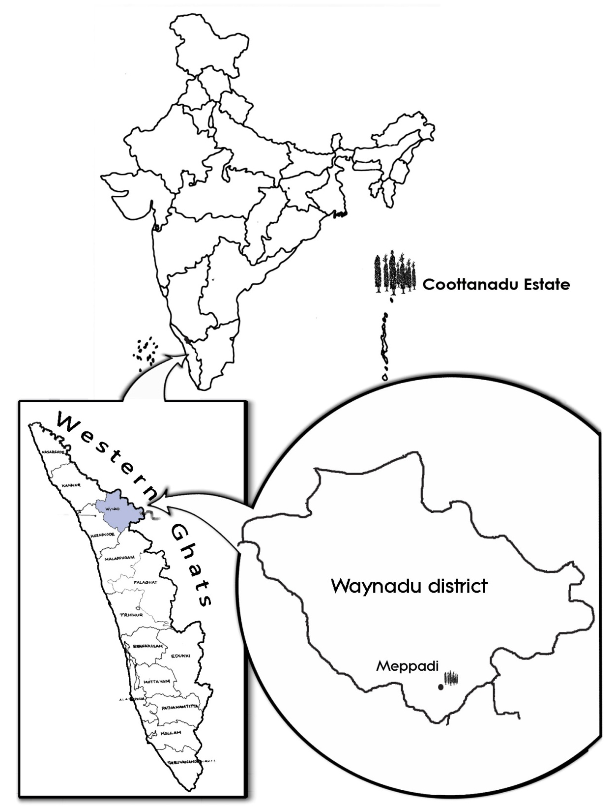

Figure S1. Map of India with Kerala/Wayanadu popped up showing the location of the estate

Spike length (cm)
Figure S2. Variability for spike length in black pepper primary genepool

