Table S1: Thirty four Accessions of Momordicacharantia with their Geographical Locations and Dimensions
S. No. | Accession No. | Geographical Location | Geographical  Dimensions
1 | TOT4244 | Bangladesh | 24º00´ N, 90º00´ E
2 | TOT4256
3 | TOT4257
4 | TOT4333
5 | TOT4362
6 | TOT4370
7 | TOT4507
8 | TOT4548
9 | TOT4549
10 | TOT4574
11 | TOT4614
12 | TOT1756 | India | 20º 00´ N, 77º 00´ E
13 | TOT2407
14 | TOT2533
15 | TOT5852
16 | TOT0950 | Thailand | 15º00´ N, 100º 00´ E
17 | TOT1095
18 | TOT1140
19 | TOT1299
20 | TOT1398
21 | TOT4206
22 | TOT4208
23 | TOT4209
24 | TOT4213
25 | TOT5128
26 | TOT5197
27 | TOT5467
28 | TOT5468
29 | TOT5658
30 | TOT5749
31 | Sahiwal 1 | Pakistan (Sahiwal) | 30° 40' N, 73° 6' E
32 | Sahiwal 2
33 | Sahiwal 3
34 | Faisalabad | Pakistan (Faisalabad) | 31° 25' N, 73° 5' E

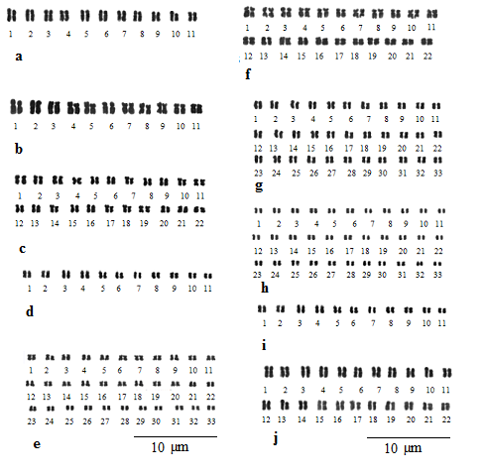
Fig S1: Ideograms of somatic metaphase chromosomes of M. charantia, accessions of Bangladesh. a. TOT4244, b. TOT4256, c. TOT4257, d. TOT4333, e. TOT4362, f. TOT4370, g. TOT4507, h.TOT4548, i.TOT4549, j.TOT4574,

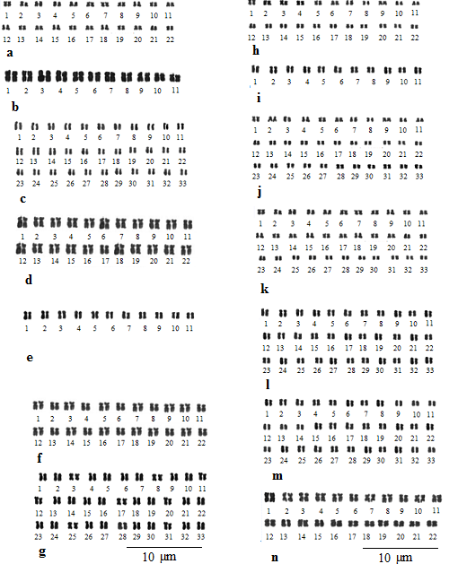
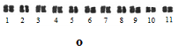

Fig S2.Ideograms of somatic metaphase chromosomes of M. charantia, accessions of Thailand.a.TOT0950, b.TOT1095, c.TOT1140, d.TOT1299, e.TOT1398, f.TOT4206, g.TOT4208, h.TOT4209. i.TOT4213, j.TOT5128, k.TOT5197, l.TOT5467, m.TOT5468, n.TOT5658, o.TOT5749
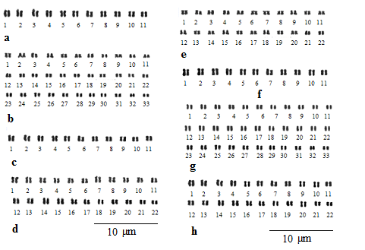
Fig S3.Ideograms of somatic metaphase chromosomes of M. charantia, accessions of India and Pakistan. a.TOT1756, b.TOT2407, c.TOT2533, d. TOT5852e.Sahiwal , f.Sahiwal2, g.Sahiwal 3, h.Faisalabad

