Legends to Supplementary Tables and Figure

Table S1. Range of variation in agronomic traits of Miscanthus accessions.

Table S2. Summary of correlation analyses among 5 agronomic traits, estimated biomass yield and collection site latitude of Miscanthus sinensis and M. sacchariflorus accessions.

Figure S1. Distribution of collected Miscanthus accessions studied in this study.

Figure S2. Plant height (A), stem diameter (B), number of stems (C) and estimated biomass yield (D) of Miscanthus accessions.

Table S1. Range of variation in agronomic traits of Miscanthus accessions.
 | M. sacchariflorus (n = 42) |  |  |  |  | M. sinensis (n = 22) |  |  |  |  | M. x giganteus  (n = 2)
 | Min. | Max. | Range | Mean±S.E. | C.V. | Min. | Max. | Range | Mean±S.E. | C.V.
Plant  height (cm) | 180.0 | 290.0 | 110.0 | 222.7±6.7 | 0.14 | 140.0 | 300.0 | 160.0 | 220.2±5.4 | 0.15 | 370.0 - 390.0
No. of stem  (stems no. plant⁻¹) | 58.0 | 160.0 | 102.0 | 96.1±6.3 | 0.31 | 13.0 | 152.0 | 139.0 | 74.7±4.6 | 0.33 | 40.0
Stem  diameter (mm) | 3.4 | 6.9 | 3.5 | 4.8±0.2 | 0.18 | 3.5 | 8.5 | 5.0 | 5.7±0.2 | 0.20 | 8.0 - 9.1
Stem dry  weight (g) | 5.3 | 27.4 | 22.1 | 12.3±1.3 | 0.50 | 6.1 | 46.5 | 40.4 | 20.2±1.6 | 0.51 | 73.3 - 74.2
Heading date (Julian date) | 188.0 | 262.0 | 74.0 | 240.9±4.9 | 0.10 | 186.0 | 274.0 | 88.0 | 246.2±3.2 | 0.10 | 263.0
Estimated yield (ton ha⁻¹) | 4.3 | 24.7 | 20.4 | 15.2±1.5 | 0.45 | 6.3 | 38.4 | 32.1 | 20.3±1.5 | 0.47 | 39.0 - 39.5

Table S2. Summary of correlation analyses among 5 agronomic traits, estimated biomass yield and collection site latitude of Miscanthus sinensis and M. sacchariflorus accessions.
 | Latitude | Plant height | No. of stem | Stem diameter | Stem dry weight | Heading date
M. sinensis (n = 42 )
Plant height | -0.164 | 1
No. of stem | 0.056 | 0.026 | 1
Stem diameter | -0.454** | 0.342* | -0.191 | 1
Stem dry weight | -0.469** | 0.253 | -0.276 | 0.880*** | 1
Heading date | -0.900** | 0.189 | 0.022 | 0.504** | 0.474** | 1
Estimated yield | -0.429** | 0.299 | 0.251 | 0.782*** | 0.842*** | 0.472**
M. sacchariflorus (n = 22)
Plant height | -0.046 | 1
No. of stem | 0.127 | -0.085 | 1
Stem diameter | -0.598** | 0.490* | -0.335 | 1
Stem dry weight | -0.388 | 0.600** | -0.079 | 0.524* | 1
Heading date | -0.785*** | -0.064 | -0.146 | 0.307 | 0.337 | 1
Estimated yield | -0.382 | 0.495* | 0.410 | 0.400 | 0.808*** | 0.287
Pooled (n = 66, including 2 M. x giganteus)
Plant height | -0.177 | 1
No. of stem | 0.162 | -0.134 | 1
Stem diameter | -0.495*** | 0.510*** | -0.385** | 1
Stem dry weight | -0.393** | 0.575*** | -0.420*** | 0.863*** | 1
Heading date | -0.914*** | 0.243* | -0.119 | 0.503*** | 0.411** | 1
Estimated yield | -0.425*** | 0.465*** | 0.063 | 0.780*** | 0.817*** | 0.450***

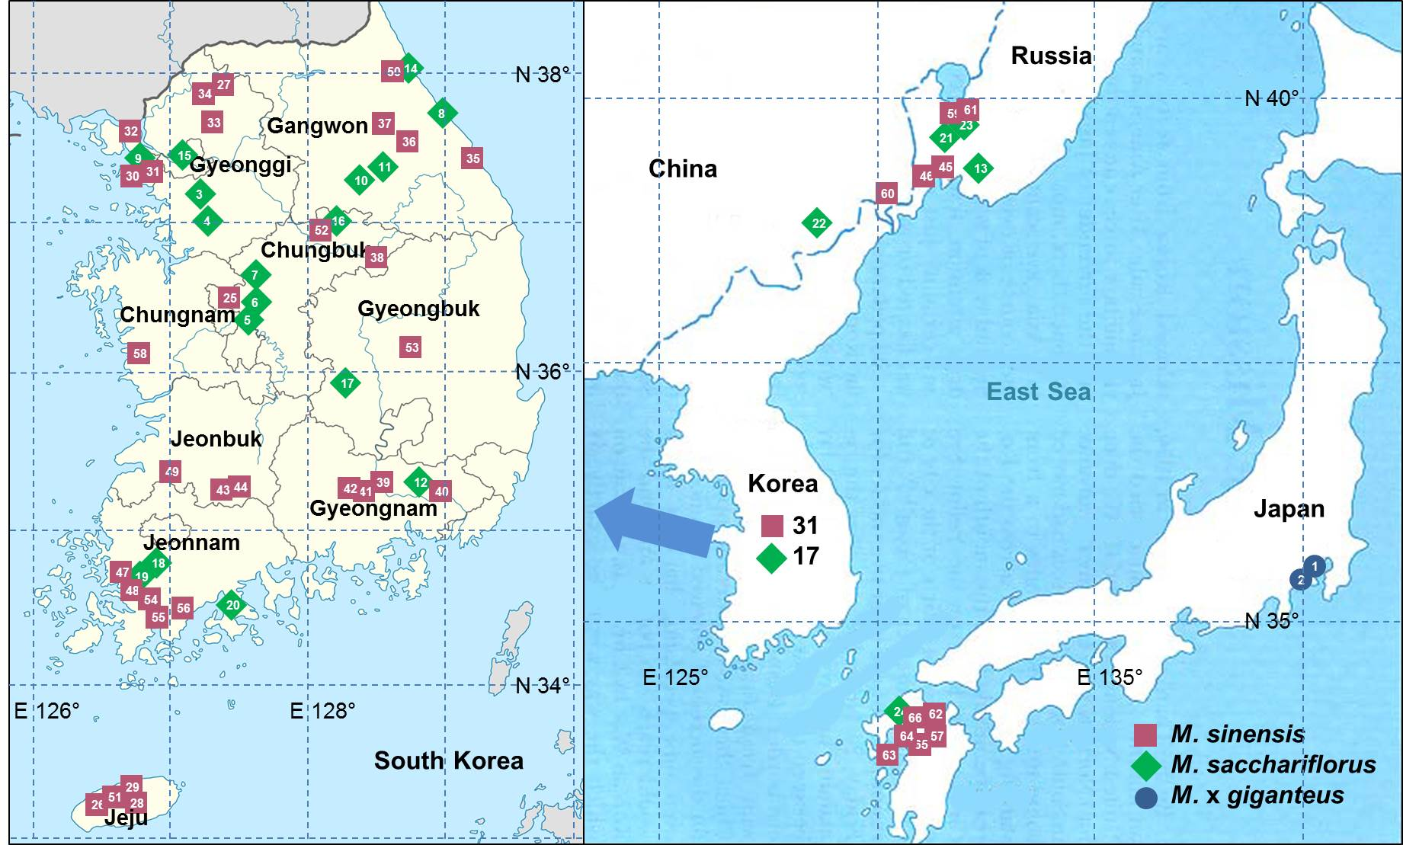
Figure S1. Distribution of collected Miscanthus accessions studied in this study.

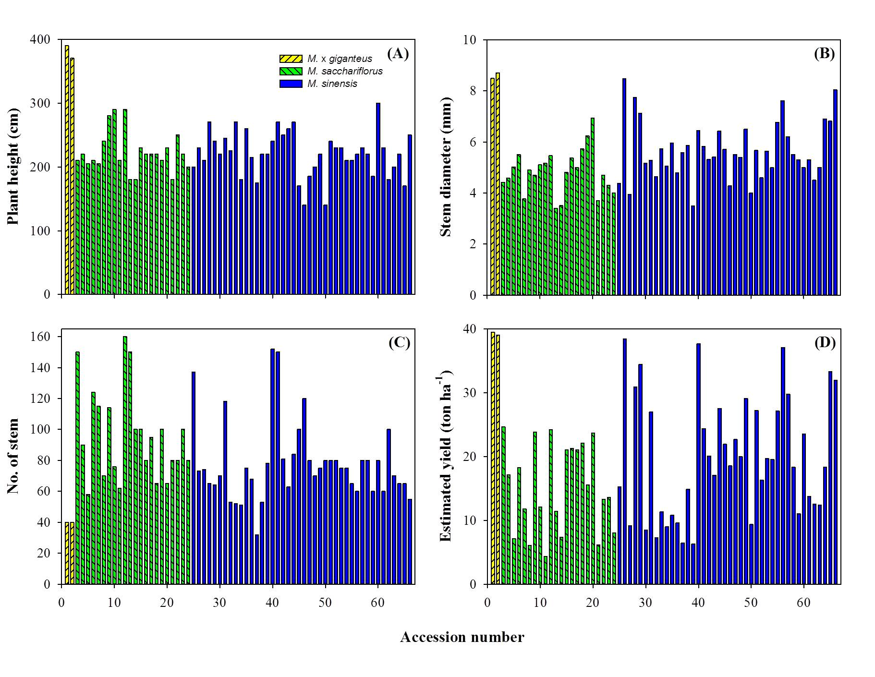Figure S2. Plant height (A), stem diameter (B), number of stems (C) and estimated biomass yield (D) of Miscanthus accessions.

